Tsepo ndebele

[Company name] | [Company address]

Unit 13 evaluation

by tsepo ndebele

Contents

**Over view/concept of game** 2

# **Over view/concept of game**

In this game there is one hero that moves around the world with the user’s control. The hero will collect items. The enemy character will be able to kill the hero character, but the hero character will have multiple lives. There also will be areas of the world that are out of bounds these can simply block the path of other characters or cause them to bounce off in the opposite direction. I will finally implement a scoring system and a suitable ending to the game. The universe I have chosen for this game is the Anglo-Zulu era; the hero will be a Zulu impi (warrior) and the enemy will be the English empire. The collectable items will be iklwas (short spear) and a bonus item the cow hide shield. The spear increases the score by 1 and the shied increases the score by 2 plus giving the hero and extra life. To win the hero must collect all spears, failure to do so will lead to a loss in game. The obstructions in the game will be an animal for example a lion. The back ground or world will be a desert type battlefield. The Zulu impi/hero will have 3 lives if the enemy kill the hero 3 times the player will get a message saying game over and there will be an option to restart or to go back to the menu. Also, before the game starts a menu with the instruction button which shows the rules and controls.

The hero will also be controlled by the user with the keyboard input for example (wasd, keys). The speed of the character will be controlled with a single button (shift key) that will boost the character for 10 secs. The hero will be able to shoot a projectile with the space button; which will be shot at the enemy at the direction of the arrow keys. When the enemy is shot they will lose one life, if you manage to kill all enemy’s (which have 3 life’s each) then you will be able to collect the spear freely to then complete the game. The score will be kept and displayed on the screen in game and at the losing screen/ wining screen.

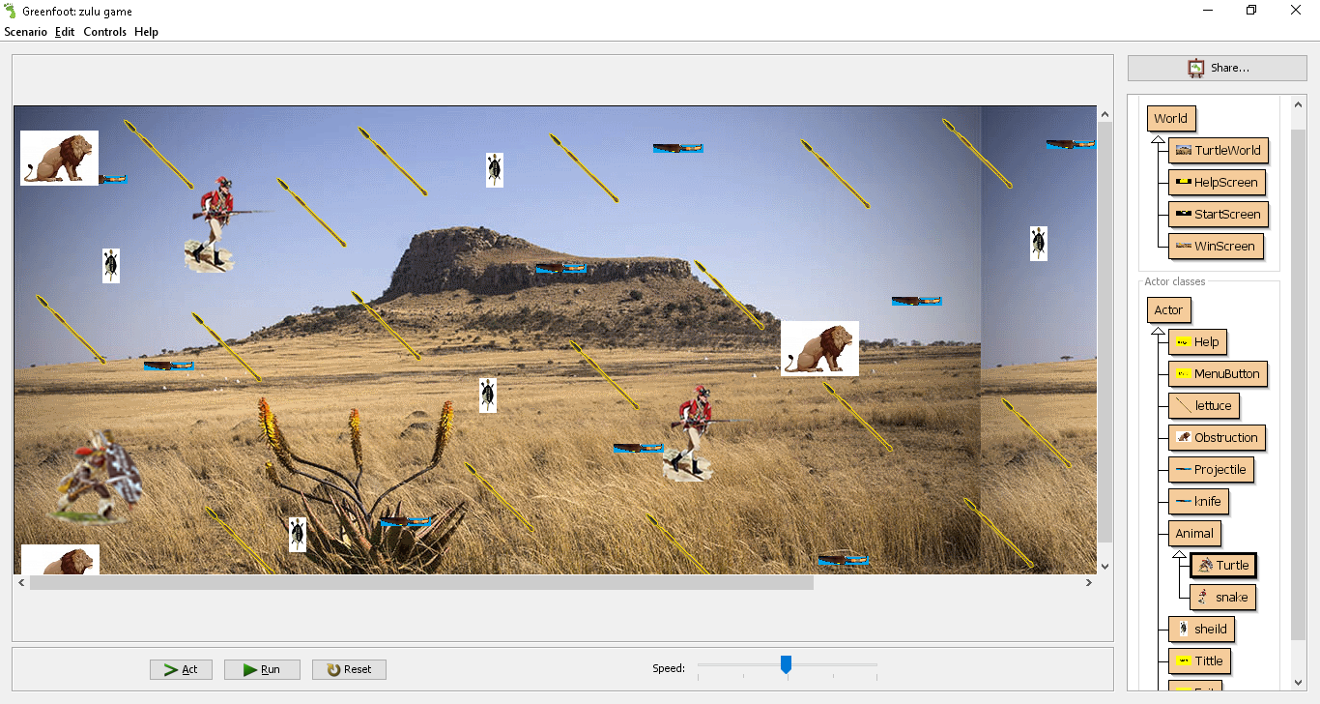

# **Analysis of the results**

## **What went well**

Overall the basic functions and requirement were successful for example the general movement of the player and enemy are working perfectly. Also, the collectables and obstructions are working as they are supposed to, even thought I had very little knowledge of green foot through research I was able to complete the basics of the Game in very little time. What helped me complete the game were some decent tutorials on YouTube and on the green foot web pages it allowed me to understand the code and to be able to produce what I have produced. I got the shooting projectile fixed due to some general research on the internet which took 10 mins max. it was challenging but the good thing is that green is Widley used so there is always information on this software.

## **What did go well**

Overall there where a few features that were not included into the game like a winning and losing screen, point system and score counter. Due to the lack of knowledge and resources on these techniques I was unable to include them. I was also running out of time as the deadline was closer and closer. I had to prioritise which feature was more important. So, I decided to include the main features like the general gameplay. I was also a bit intimidated when it came to the point system a score counter since I had so many classes and collectables I thought that it would be too much for me.

## 

## **Conclusion(improvement)**

In conclusion the experience was great, but I need to improve a lot of things. One major thing I need to improve on is time management and quality checks. This is because it was not using my time wisely and now I have a few things missing from the game. I would try and find a solution for the score counter because it would make the game more fun and it would give it a more challenging feel too it. I would also include the wining screen and losing screen this is because it would allow the player to know that they have won or lost. I also thing I may have been a bit too ambitious about my design and game, maybe if I made it a bit more simple and easier to operate. Finally, I have learned how to figure out a program no matter how hard it is and to reflect on what I could always improve in anything that I do.