Deerwalk Institute of Technology

Sifal, Kathmandu

Artificial Intelligence Practical

Submitted By: Submitted To:

Name: Sagar Giri Sudan Prajapati

Roll No: 205

Section: A

**Lists in Prolog**

1. **The built-in operator |.**

→ Operator | can be used to decompose a list into its head and tail and is a key tool for writing Prolog list manipulation predicates.

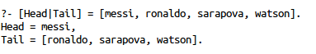





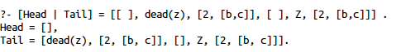

1. **Head and Tail of Empty List.**

→ The empty list has neither a head nor a tail ans it plays an important role in recursive predicates for list processing in Prolog

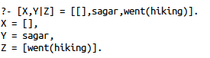

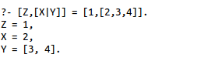

1. **Anonymous variables**

→ The underscore is the anonymous variable in Prolog. Is used when we need to use a variable, but we are not interested in what Prolog instantiates it to. Each occurrence of the anonymous variable is independent, i.e. can be bound to something different.

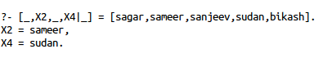

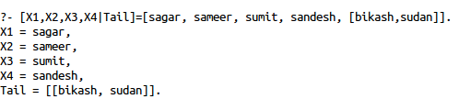

1. **Concatenation.**

**FACTS:**

conc([],L,L).

conc([X|L1],L2,[X|L3]):- conc(L1,L2,L3).

**OUTPUT:**

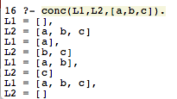

1. **Takeout**

**FACTS:**

takeout(X,[X|R],R).

takeout(X,[F|R],[F|S]) :- takeout(X,R,S).

**OUTPUT:**

