Deerwalk Institute of Technology

Sifal, Kathmandu

Artificial Intelligence Practical - 5

Submitted By: Submitted To:

Name: Sagar Giri Sudan Prajapati

Roll No: 205

Section: A

Date: March 30th 2015

**Q1.** Write a Prolog program to Find LCM.

Program Code:

hcf(X,0,X).

hcf(X, Y, G) :- X = Y, G = X, !.

hcf(X, Y, G) :- X < Y, Y1 is (Y-X), hcf(X, Y1, G), !.

hcf(X, Y, G) :- X > Y, hcf(Y, X, G).

lcm(X,Y,L):-hcf(X,Y,G), L is X*Y/G, !.

Output:

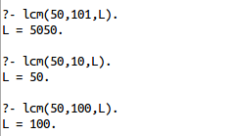

**Q2.** Write a prolog program to reverse List items.

Program Code:

rev([],Z,Z).

rev([H|T],Z,Acc) :- rev(T,Z,[H|Acc]).

Outputs:

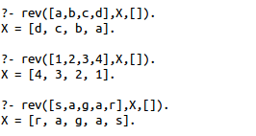

**Q3.** Write a prolog program to check palindrome

Program Code:

rev([],Z,Z).

rev([H|T],Z,Acc) :- rev(T,Z,[H|Acc]).

palindrome(L):-rev(L,L,[]).

Outputs:

