Deerwalk Institute of Technology

Sifal, Kathmandu

Simulation and Modelling Practical

Submitted By: Submitted To:

Name: Sagar Giri Binod Sitaula

Roll No: 205

Section: A

Date:

**Program to illustrate Cobweb model**

**Background theory:**

In supply demand problem, two linear equations for demand D and supply S were considered. Aim was to compute probable price and demand in the market subject to a condition that supply and demand should be equal. But supply of the product in the parameters. The equation are:

D=a-bP

S=c+dP1

D=S

**a) Model 1**

**Program:**

#include<stdio.h>

int main()

{

int a=12,i;

float p=30,b=30,c=1,d=0.9,s,dem;

printf("i\tp\td\ts");

printf("\n-------------------------");

for(i=0;i<20;i++){

s=c+d*p;

dem=s;

p=((float)a-dem)/b;

printf("\n%d\t%.4f\t%.4f\t%.4f",i,p,dem,s);

}

return 0;

}

**Output:**

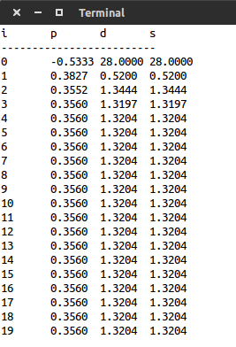

**b)Model 2**

**Program:**

#include<stdio.h>

int main()

{

int a=10,i;

float p=5,b=0.9,c=-2.4,d=1.2,s,dem;

printf("i\tp \td\t s");

printf("\n----------------------------------------");

for(i=0;i<20;i++){

s=c+d*p;

dem=s;

p=((float)a-dem)/b;

printf("\n%d\t%.2f\t %.2f\t %.2f",i,p,dem,s);

}

return 0;

}

**Output:**

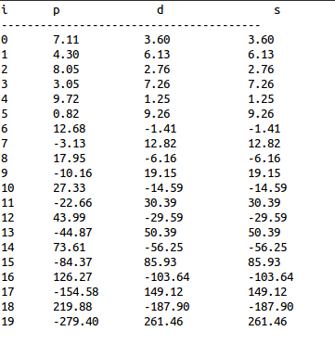

**Conclusion:**

Hence by above output we can say that model 1 is stable but model 2 is not stable.