10. Write a program to update and delete the row data in the database table using Prepared Statement.

Theory:
To delete one or more rows of a database table from a Java program, you use the following steps:
1. First, create a database connection to the SQLite database.

2. Next, prepare the DELETE statement. In case you want the statement takes parameters, you use the question mark (?) placeholder inside the statement.

3. Then, create a new instance of the PreparedStatement class by calling the prepareStatement() method of the Connection object.

4. After that, supply values in place of the question mark placeholder using the set* method of the PreparedStatement object e.g., setInt(), setString(), etc.

5. Finally, execute the DELETE statement by calling the executeUpdate() method of the PreparedStatement object.

Source Code:
File: Deletion.java
package q9Database;

import java.sql.Connection;
import java.sql.ResultSet;
import java.sql.SQLException;
import java.sql.Statement;

public class Deletion {

public Deletion() throws ClassNotFoundException, SQLException {
Connection con;
Statement statement;
ResultSet set;
con = new Database().getConnection();
statement = con.createStatement();
// String update = "DELETE Student_tbl SET LastName='Nagarkoti'" + " WHERE id = 1";
String delete = "DELETE FROM Student_tbl WHERE id = '2'";
statement.executeUpdate(delete);
set = statement.executeQuery("SELECT * FROM Student_tbl");

while (set.next()) {
System.out.println("Student ID:" + set.getInt("id"));
System.out.println("Student Last Name: " + set.getString("FirstName"));
}
}

public static void main(String[] args) throws ClassNotFoundException, SQLException {
new Deletion();
}

}

Output:
Before Deletion:
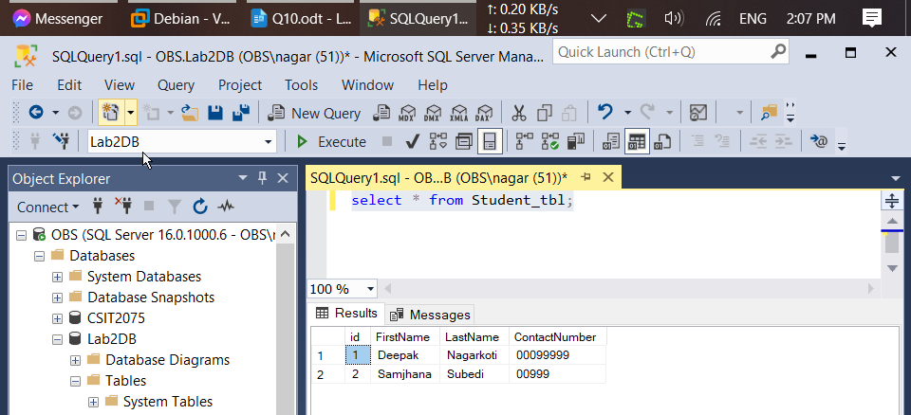
After Deletion :
