9. Write a program to save the information Firstname, Lastname and ContactNumber in a database.

Theory:
There are 5 steps to connect any java application with the database using JDBC. These steps are as follows:
- Register the Driver class
- Create connection
- Create statement
- Execute queries
- Close connection

Source Code:
File: Database.java
import java.sql.Connection;
import java.sql.DriverManager;
import java.sql.SQLException;
public class Database {
Connection con;
public Database() throws ClassNotFoundException, SQLException {
Class.forName("com.microsoft.sqlserver.jdbc.SQLServerDriver");
String server = "//Obs";
int port = 1433;
String database = "Lab2DB";
String connectionStr = "jdbc:sqlserver:" + server + ":" + port + ";" + "databaseName=" + database
+ ";IntegratedSecurity=true";
con = DriverManager.getConnection(connectionStr);
System.out.println("Connection Obtained.");
}
public static void main(String[] args) throws ClassNotFoundException, SQLException {
new Database();
}
public Connection getConnection() {
// TODO Auto-generated method stub
return con;
}
}
File: CreateTable.java
package q9Database;

import java.sql.Connection;
import java.sql.SQLException;
import java.sql.Statement;

public class CreateTable {

Connection con;

public CreateTable() throws ClassNotFoundException, SQLException {
Statement statement;
con = new Database().getConnection();
statement = con.createStatement();

String create = "Create Table Student_tbl"
+ "(id int, FirstName varchar(100), LastName varchar(100), ContactNumber varchar(10));";
statement.executeUpdate(create);
System.out.println("Table Created");
}

public static void main(String[] args) throws ClassNotFoundException, SQLException {
new CreateTable();
}

}
File: InsertTable.java
package q9Database;
import java.sql.Connection;
import java.sql.ResultSet;
import java.sql.SQLException;
import java.sql.Statement;

public class InsertionTable{
Statement statement;
ResultSet set;

public InsertionTable() throws ClassNotFoundException, SQLException {
Connection conn = new Database().getConnection();
statement = conn.createStatement();
String insert = "INSERT INTO Student_tbl VALUES(1, 'Deepak','Nagarkoti', '00099999')";
String insert2 = "INSERT INTO Student_tbl VALUES(2, 'Samjhana','Subedi', '00999')";
statement.executeUpdate(insert);
statement.executeUpdate(insert2);
System.out.println("Data Inserted Into Table");
set = statement.executeQuery("SELECT * FROM Student_tbl");

while (set.next()) {
System.out.println("Student ID: " + set.getInt("id"));
System.out.println("First Name: " + set.getString("FirstName"));
System.out.println("Last Name: " + set.getString("LastName"));
System.out.println("Contact Number: " + set.getString("ContactNumber"));
}
}
public static void main(String[] args) throws ClassNotFoundException, SQLException{
new InsertionTable();
}
}
Output:

Database Connectivity:
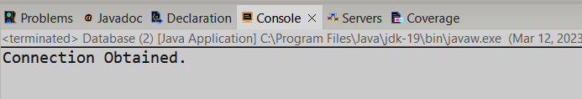
Table creation:
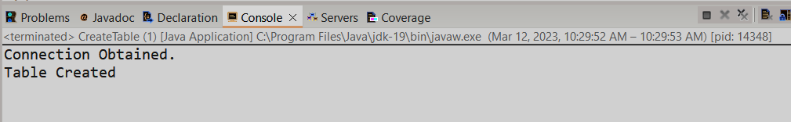
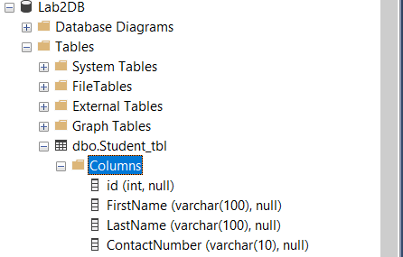

Insertion of data

