# K-Means clustering

We are using jupyter Notebook to complete this assignment. We have used elbow method to find the optimal k value for the clustering.

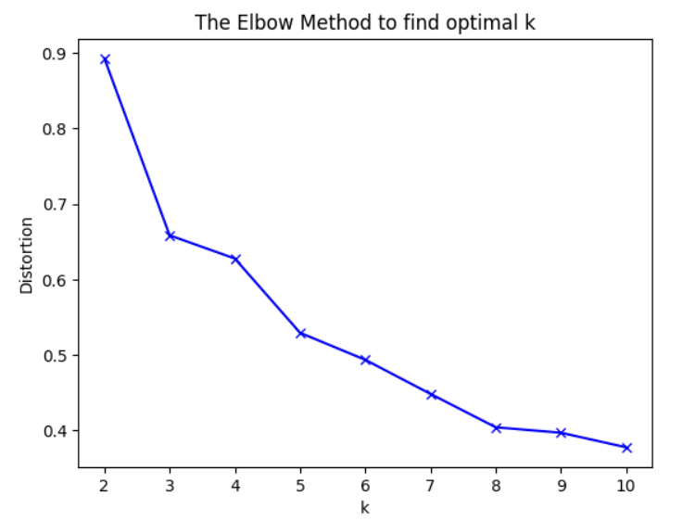

We Experimented with different distance metrics by transforming the data space (e.g., **Euclidean**, **cosine distance**).

**Evaluating Clustering Performance**:

* **Extrinsic Evaluation**: Using **BCubed precision** and **recall** with ground truth labels. These Explain how these metrics are used to evaluate clustering based on true class labels.
* **Intrinsic Evaluation**: Use metrics like **Silhouette Score** for internal evaluation. Describe this as a measure of how similar each point is to its own cluster compared to other clusters.

