Step 1: Clone the Repository
```bash
git clone https://github.com/ndeepakprasanth/dapr-eks-pubsub-ready.git
cd dapr-eks-pubsub-ready
Step 2: Set execute permissions
chmod +x oneclick.sh
chmod +x test.sh
chmod +x scripts/*.sh
Step 3: One-Click deployment
# Replace with your AWS Account ID
ACCOUNT_ID=946248011760 ./oneclick.sh
Step 4: Verify deployment
# Check pods (should show 2/2 Ready)
kubectl -n dapr-apps get pods -o wide
# Check services
kubectl -n dapr-apps get svc
# Check Dapr components
kubectl -n dapr-apps get components
Step 5: Test Pub/Sub functionality
./test.sh
Step 6: View ECR repositories
aws ecr describe-repositories --region us-east-1
Step 7: Clean up when completed
./destroy.sh

- Running pods:
- Services: 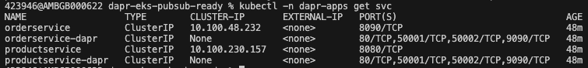
- Dapr compoents
- Test Pub/Sub 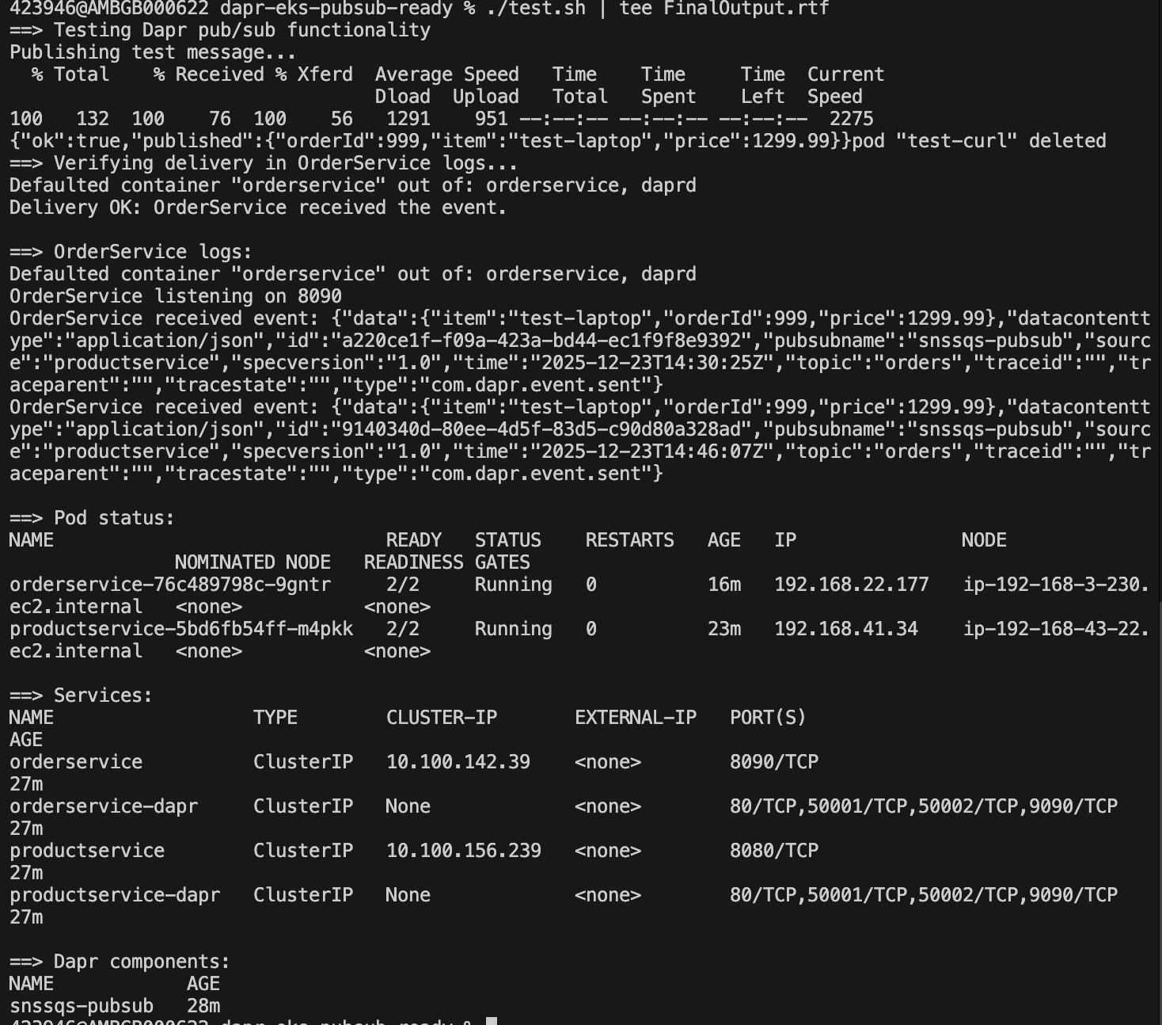
- ECR repositories with pushed images 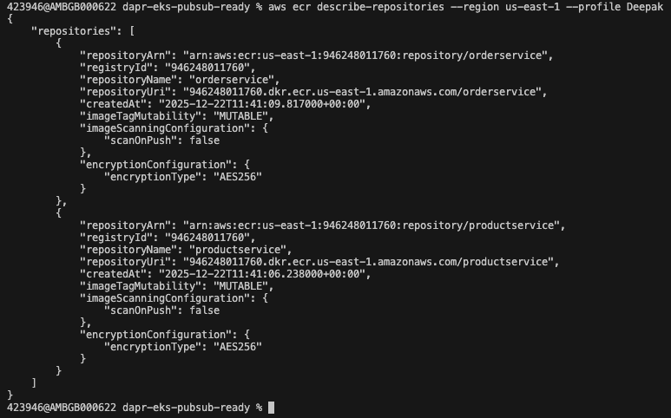
- Bedrock analysis 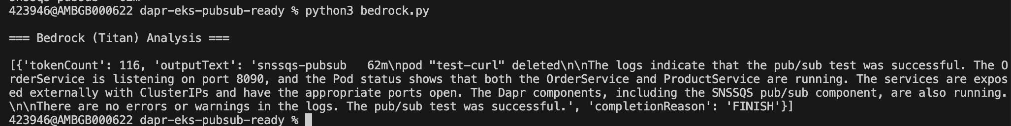
- Stress test output 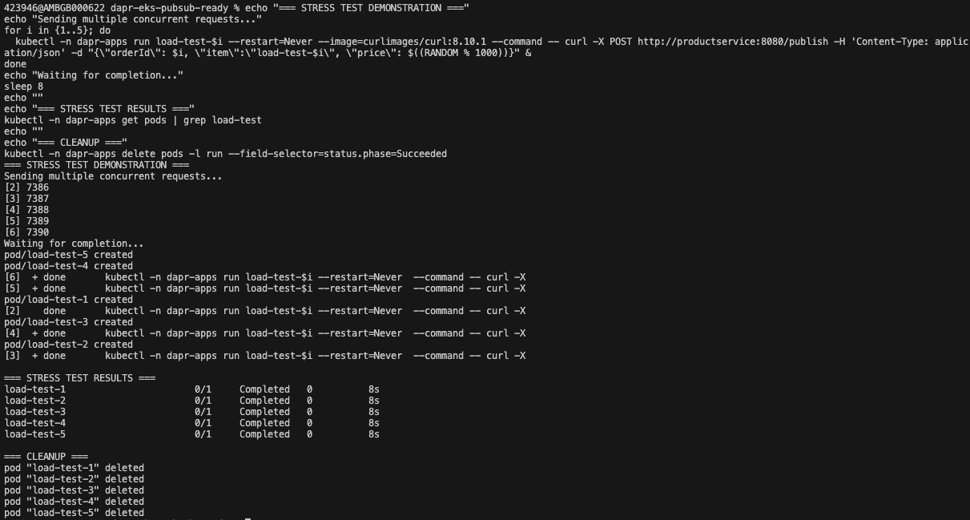
- Logs screenshot: 