latest-assignment

Anthony

2023-11-14

knitr::opts_chunk$set(echo = TRUE)  
SampleHeartDisease <- data.frame(  
 Biking = c(30.8, 65.12, 1.95, 44.80, 69.42, 54.40, 49.05, 4.78, 65.73, 35.25, 51.82),  
 Smoking = c(10.89, 2.21, 17.58, 2.80, 15.97, 29.33, 9.06, 12.83, 11.99, 23.27, 14.43),  
 Heart.disease = c(11.76, 2.85, 17.17, 6.81, 4.06, 9.55, 7.62, 15.85, 3.06, 12.09, 6.43)  
)  
attach(SampleHeartDisease)  
# the program below is used to test the difference btwn the Biking and the smoking  
# and Smoking and Heart Disease  
library(dplyr)

##   
## Attaching package: 'dplyr'

## The following objects are masked from 'package:stats':  
##   
## filter, lag

## The following objects are masked from 'package:base':  
##   
## intersect, setdiff, setequal, union

t.test(SampleHeartDisease %>% select(1), SampleHeartDisease %>% select(2)) -> test_biking_and_smoking  
print("The t test between the biking raw data and the smoking raw data is given below: \n")

## [1] "The t test between the biking raw data and the smoking raw data is given below: \n"

print(test_biking_and_smoking)

##   
## Welch Two Sample t-test  
##   
## data: SampleHeartDisease %>% select(1) and SampleHeartDisease %>% select(2)  
## t = 3.9906, df = 12.38, p-value = 0.001688  
## alternative hypothesis: true difference in means is not equal to 0  
## 95 percent confidence interval:  
## 13.37592 45.30771  
## sample estimates:  
## mean of x mean of y   
## 43.01091 13.66909

t.test(SampleHeartDisease %>% select(2), SampleHeartDisease %>% select(3)) -> test_smoking_and_heart_disease  
print("The t test between the smoking and the heart disease is given below:\n")

## [1] "The t test between the smoking and the heart disease is given below:\n"

print(test_smoking_and_heart_disease)

##   
## Welch Two Sample t-test  
##   
## data: SampleHeartDisease %>% select(2) and SampleHeartDisease %>% select(3)  
## t = 1.7049, df = 16.606, p-value = 0.1069  
## alternative hypothesis: true difference in means is not equal to 0  
## 95 percent confidence interval:  
## -1.157644 10.814008  
## sample estimates:  
## mean of x mean of y   
## 13.669091 8.840909

# This program is use to find the confidence interval for the variable  
# heart disease  
confident_interval_heart_disease <- t.test(SampleHeartDisease %>% select(3), conf.level = 0.05)  
print(confident_interval_heart_disease)

##   
## One Sample t-test  
##   
## data: SampleHeartDisease %>% select(3)  
## t = 5.9645, df = 10, p-value = 0.0001385  
## alternative hypothesis: true mean is not equal to 0  
## 5 percent confidence interval:  
## 8.745603 8.936215  
## sample estimates:  
## mean of x   
## 8.840909

##this program is us to plot the above data to show the relation in   
## between the variable  
library(ggplot2)  
par(mfrow = c(2,2))  
ggplot(SampleHeartDisease, aes(x=Biking, y=Smoking)) + geom_line() #+ labs(title = "this is the relationship between Biking and Smoking", x = Biking, y = Smoking)

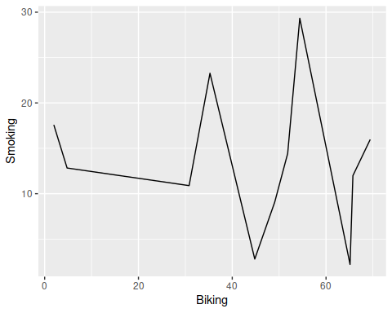

## R Markdown

This is an R Markdown document. Markdown is a simple formatting syntax for authoring HTML, PDF, and MS Word documents. For more details on using R Markdown see <http://rmarkdown.rstudio.com>.

When you click the **Knit** button a document will be generated that includes both content as well as the output of any embedded R code chunks within the document. You can embed an R code chunk like this:

summary(cars)

## speed dist   
## Min. : 4.0 Min. : 2.00   
## 1st Qu.:12.0 1st Qu.: 26.00   
## Median :15.0 Median : 36.00   
## Mean :15.4 Mean : 42.98   
## 3rd Qu.:19.0 3rd Qu.: 56.00   
## Max. :25.0 Max. :120.00

## Including Plots

You can also embed plots, for example:

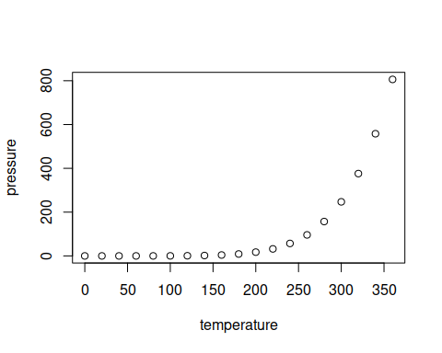

Note that the echo = FALSE parameter was added to the code chunk to prevent printing of the R code that generated the plot.