DeltaHanto Design Report

Image11.png

CS4233: Object-Oriented Analysis and Design

Nicholas DeMarinis

Table of Contents

DeltaHanto Package Diagram 2

DeltaHanto Class Diagram 4

makeMove() Sequence Diagram 47

HantoFactory 48

Strategy Pattern: Hanto Rules 49

# DeltaHanto Package Diagram

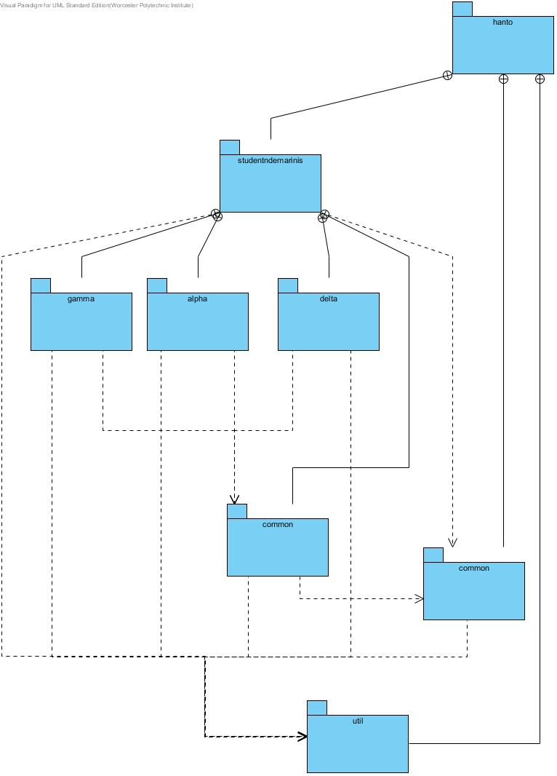

## Summary

|  |  |
| --- | --- |
| Name | Documentation |
| Image1.png hanto | This is the top-level package for all of the Hanto source. |
| Image1.png studentndemarinis | This package encapsulates my implementation of the HantoGame. |
| Image1.png gamma | This package contains all classes necessary for the realization of GammaHanto, including its specific initialization methods and rules. |
| Image1.png alpha | This package contains all classes necessary for the realization of AlphaHanto. |
| Image1.png delta | This package contains all classes necessary for the realization of DeltaHanto, including its specific initialization methods and rules. |
| Image1.png common | This package encapsulates all of the elements common to the HantoGames, such as the factory, abstract classes for the rules, and the board. |
| Image1.png common | This package contains the high-level common elements, like the main game interface, as provided. |
| Image1.png util | This package contains the ancillary enumerations for defining Hanto game elements, like the pieces, as given. |

# DeltaHanto Class Diagram

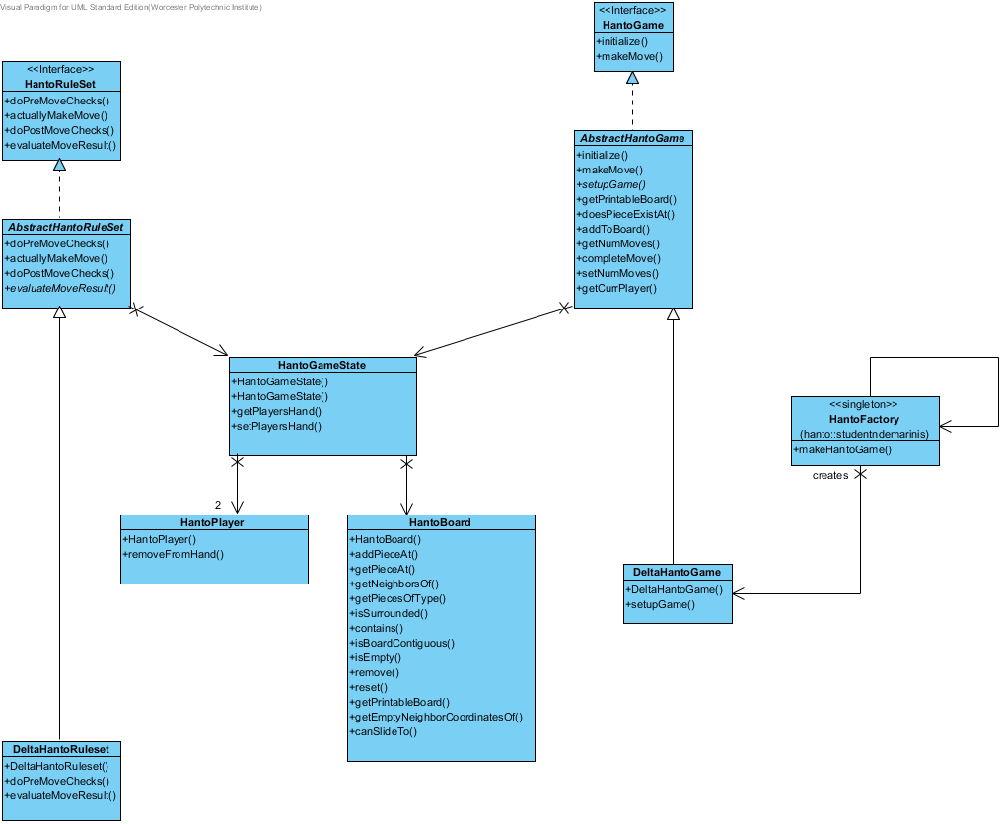

## Summary

|  |  |
| --- | --- |
| Name | Documentation |
| Image3.png HantoGame | The HantoGame interface is the primary interface between the student's code and any external (non-student written) code. Every version of Hanto will have a realization of the HantoGame interface.  @author gpollice  @version Jan 12, 2013 |
| Image3.png HantoRuleSet | This interface represents methods required for a HantoRuleset. These methods will be called by AbstractHantoGame to provide a common implementation for making and verifying moves.  @author ndemarinis  @version Jan 31, 2013 |
| Image3.png AbstractHantoGame | This abstract class encapsulates the basic functionality for a HantoGame, including initialization. Lots of public methods exist here to expose extra implementation for testing purposes.  @author ndemarinis  @version Jan 31, 2013 |
| Image3.png AbstractHantoRuleSet | This abstract class encapsulates the common functionality for a HantoRuleSet. It contains default implementations for some of the major methods as well as protected rule methods that are common to the rulesets of Alpha, Gamma, and Delta Hanto.  @author ndemarinis  @version 4 February 2013 |
| Image3.png HantoGameState | Encapsulation of state information for a HantoGame. This includes all attributes necessary for the game and rule logic.  @author ndemarinis  @version Feb 7, 2013 |
| Image3.png HantoFactory | Factory for creating Hanto Games.    Currently supports Alpha, Gamma, and Delta Hanto.  @author ndemarinis  @version Feb 9 2013 |
| Image3.png HantoPlayer | This class provides state information for each player, maintaining the types and counts of each piece in their hand.  @author ndemarinis  @version Jan 23, 2012 |
| Image3.png HantoBoard | This class represents the hexagonal Hanto Board.    It maintains the pieces in a Map and provides methods for performing operations that require traversing the hex grid.  @author ndemarinis  @version Feb 7, 2013 |
| Image3.png DeltaHantoGame | This class is a concrete realization of the game for DeltaHanto. It provides the necessary initialization methods for DeltaHanto and relies on the ruleset and abstract classes to handle the rest of the implementation.  @author ndemarinis  @version Feb 9, 2013 |
| Image3.png DeltaHantoRuleset | This class is a concrete realization of the ruleset for Delta Hanto. It provides all of the rule methods specific to DeltaHanto.  @author ndemarinis  @version Feb 9, 2013 |

## Details

### Image3.png HantoGame

#### Operations

|  |  |
| --- | --- |
| public initialize (firstPlayer : HantoPlayerColor) : void | |
| Parameters | |  |  | | --- | --- | | firstPlayer | | | Documentation | the (color of) the player who moves first. If this is null, then the  default player, as specified by the rule set, moves first. | | Multiplicity | Unspecified | | Type | Image3.png HantoPlayerColor | | Direction | inout | | Java Detail | N/A | |
| Documentation | Initialize the game for play. While the constructor may already initialize the  game, this method can be called any time. It will (re)initialize the game and make  it ready to play. If the game is already initialized, or in progress, then this  method will reset the game to its initial state. |
| Static | false |
| Leaf | false |
| Upper | 1 |
| Ordered | false |
| Unique | true |
| Return Type Documentation | @throws HantoException if any errors occur during initialization (such as the specified player violates the rules specified in the rule set). |
| Query | false |

|  |  |
| --- | --- |
| public makeMove (pieceType : HantoPieceType, from : HantoCoordinate, to : HantoCoordinate) : MoveResult | |
| Parameters | |  |  | | --- | --- | | pieceType | | | Documentation | the piece type that is being moved | | Multiplicity | Unspecified | | Type | Image3.png HantoPieceType | | Direction | inout | | Java Detail | N/A |  |  |  | | --- | --- | | from | | | Documentation | the coordinate where the piece begins. If the coordinate is null, then  the piece begins off the board (that is, it is placed on the board in  this move). | | Multiplicity | Unspecified | | Type | Image3.png HantoCoordinate | | Direction | inout | | Java Detail | N/A |  |  |  | | --- | --- | | to | | | Documentation | the coordinated where the piece is after the move has been made. | | Multiplicity | Unspecified | | Type | Image3.png HantoCoordinate | | Direction | inout | | Java Detail | N/A | |
| Documentation | This method executes a move in the game. It is called for every move that must be  made. |
| Static | false |
| Leaf | false |
| Upper | 1 |
| Ordered | false |
| Unique | true |
| Return Type Documentation | the result of the move @throws HantoException if there are any problems in making the move (such as specifying a coordinate that does not have the appropriate piece, or the color of the piece is the color of the player who is moving. |
| Query | false |

### Image3.png HantoRuleSet

#### Operations

|  |  |
| --- | --- |
| public doPreMoveChecks (piece : HantoPieceType, from : HexCoordinate, to : HexCoordinate) : void | |
| Parameters | |  |  | | --- | --- | | piece | | | Documentation | The piece to add at the new location | | Multiplicity | Unspecified | | Type | Image3.png HantoPieceType | | Direction | inout | | Java Detail | N/A |  |  |  | | --- | --- | | from | | | Documentation | Source location of said piece, null if piece is not on the board | | Multiplicity | Unspecified | | Type | Image3.png HexCoordinate | | Direction | inout | | Java Detail | N/A |  |  |  | | --- | --- | | to | | | Documentation | Destination coordinate of piece after the move | | Multiplicity | Unspecified | | Type | Image3.png HexCoordinate | | Direction | inout | | Java Detail | N/A | |
| Documentation | Perform any checks that can happen before a move is made, throws a HantoException if  the move is invalid. |
| Static | false |
| Leaf | false |
| Upper | 1 |
| Ordered | false |
| Unique | true |
| Return Type Documentation | @throws HantoException if proposed move violates a rule. |
| Query | false |

|  |  |
| --- | --- |
| public actuallyMakeMove (type : HantoPieceType, from : HexCoordinate, to : HexCoordinate) : void | |
| Parameters | |  |  | | --- | --- | | type | | | Documentation | Piece type to place at the destination | | Multiplicity | Unspecified | | Type | Image3.png HantoPieceType | | Direction | inout | | Java Detail | N/A |  |  |  | | --- | --- | | from | | | Documentation | Source coordinate of the piece, null if piece is not on the board | | Multiplicity | Unspecified | | Type | Image3.png HexCoordinate | | Direction | inout | | Java Detail | N/A |  |  |  | | --- | --- | | to | | | Documentation | Destination coordinate of the piece | | Multiplicity | Unspecified | | Type | Image3.png HexCoordinate | | Direction | inout | | Java Detail | N/A | |
| Documentation | Make a move, regardless of whether or not it is valid.  Any piece currently at the source and destination locations  are REMOVED when this method is called |
| Static | false |
| Leaf | false |
| Upper | 1 |
| Ordered | false |
| Unique | true |
| Return Type Documentation | @throws HantoException if an error occurs during the move |
| Query | false |

|  |  |
| --- | --- |
| public doPostMoveChecks (to : HexCoordinate) : void | |
| Parameters | |  |  | | --- | --- | | to | | | Documentation | Destination coordinate of the piece after the move | | Multiplicity | Unspecified | | Type | Image3.png HexCoordinate | | Direction | inout | | Java Detail | N/A | |
| Documentation | Perform any checks based on the location of a newly-moved piece,  throws HantoException of the move is invalid. |
| Static | false |
| Leaf | false |
| Upper | 1 |
| Ordered | false |
| Unique | true |
| Return Type Documentation | @throws HantoException if the proposed move violates a rule |
| Query | false |

|  |  |
| --- | --- |
| public evaluateMoveResult () : MoveResult | |
| Documentation | Check conditions to determine if the game needs to end. This is used for  returning the result of a recent move |
| Static | false |
| Leaf | false |
| Upper | 1 |
| Ordered | false |
| Unique | true |
| Return Type Documentation | MoveResult with based on the current board's conditions @throws HantoException on an invalid board configuration |
| Query | false |

### Image3.png AbstractHantoGame

#### Attributes

|  |  |  |  |
| --- | --- | --- | --- |
| protected : HantoGameState | | | |
| Type | Image3.png HantoGameState | | |
| Allow Empty Name | false | | |
| Getter | false | Setter | false |
| Derived | false | | |
| Multiplicity | Unspecified | | |
| Java Detail | N/A | | |
| Aggregation | None | | |
| Derived Union | false | | |
| Read Only | false | | |
| Leaf | false | | |
| Referencing Association End | N/A | | |

|  |  |  |  |
| --- | --- | --- | --- |
| protected rules : HantoRuleSet | | | |
| Type | Image3.png HantoRuleSet | | |
| Allow Empty Name | false | | |
| Getter | false | Setter | false |
| Derived | false | | |
| Multiplicity | Unspecified | | |
| Java Detail | N/A | | |
| Aggregation | None | | |
| Derived Union | false | | |
| Read Only | false | | |
| Leaf | false | | |
| Referencing Association End | rules | | |

|  |  |  |  |
| --- | --- | --- | --- |
| protected state : HantoGameState | | | |
| Type | Image3.png HantoGameState | | |
| Allow Empty Name | false | | |
| Getter | false | Setter | false |
| Derived | false | | |
| Multiplicity | Unspecified | | |
| Java Detail | N/A | | |
| Aggregation | None | | |
| Derived Union | false | | |
| Read Only | false | | |
| Leaf | false | | |
| Referencing Association End | state | | |

#### Operations

|  |  |
| --- | --- |
| public initialize (firstPlayer : HantoPlayerColor) : void | |
| Parameters | |  |  | | --- | --- | | firstPlayer | | | Multiplicity | Unspecified | | Type | Image3.png HantoPlayerColor | | Direction | inout | | Java Detail | N/A | |
| Documentation | Abstract HantoGame providing basic implementation |
| Static | false |
| Leaf | false |
| Upper | 1 |
| Ordered | false |
| Unique | true |
| Query | false |

|  |  |
| --- | --- |
| public makeMove (pieceType : HantoPieceType, from : HantoCoordinate, to : HantoCoordinate) : MoveResult | |
| Parameters | |  |  | | --- | --- | | pieceType | | | Multiplicity | Unspecified | | Type | Image3.png HantoPieceType | | Direction | inout | | Java Detail | N/A |  |  |  | | --- | --- | | from | | | Multiplicity | Unspecified | | Type | Image3.png HantoCoordinate | | Direction | inout | | Java Detail | N/A |  |  |  | | --- | --- | | to | | | Multiplicity | Unspecified | | Type | Image3.png HantoCoordinate | | Direction | inout | | Java Detail | N/A | |
| Static | false |
| Leaf | false |
| Upper | 1 |
| Ordered | false |
| Unique | true |
| Query | false |

|  |  |
| --- | --- |
| *public setupGame () : void* | |
| Documentation | Game-specific method for performing any necessary setup tasks,  called by initialize(). |
| Static | false |
| Leaf | false |
| Upper | 1 |
| Ordered | false |
| Unique | true |
| Query | false |

|  |  |
| --- | --- |
| public getPrintableBoard () : String | |
| Documentation | Return a string representing the current state of the board,  empty string if the board is empty. |
| Static | false |
| Leaf | false |
| Upper | 1 |
| Ordered | false |
| Unique | true |
| Query | false |

|  |  |
| --- | --- |
| public doesPieceExistAt (c : HantoCoordinate) : boolean | |
| Parameters | |  |  | | --- | --- | | c | | | Documentation | coordinate to check for a piece  TODO: Move this to the test harness?    NOTE: this name makes sense to me.  I don't understand how the suggestions in  CodePro's audit rule could make more sense here. | | Multiplicity | Unspecified | | Type | Image3.png HantoCoordinate | | Direction | inout | | Java Detail | N/A | |
| Static | false |
| Leaf | false |
| Upper | 1 |
| Ordered | false |
| Unique | true |
| Return Type Documentation | true if a piece exists on the board |
| Query | false |

|  |  |
| --- | --- |
| public addToBoard (color : HantoPlayerColor, type : HantoPieceType, c : HantoCoordinate) : void | |
| Parameters | |  |  | | --- | --- | | color | | | Documentation | color of new piece | | Multiplicity | Unspecified | | Type | Image3.png HantoPlayerColor | | Direction | inout | | Java Detail | N/A |  |  |  | | --- | --- | | type | | | Documentation | type of new piece | | Multiplicity | Unspecified | | Type | Image3.png HantoPieceType | | Direction | inout | | Java Detail | N/A |  |  |  | | --- | --- | | c | | | Documentation | location of new piece | | Multiplicity | Unspecified | | Type | Image3.png HantoCoordinate | | Direction | inout | | Java Detail | N/A | |
| Documentation | Add a coordinate to the board    TODO: Move this to the test harness |
| Static | false |
| Leaf | false |
| Upper | 1 |
| Ordered | false |
| Unique | true |
| Query | false |

|  |  |
| --- | --- |
| public getNumMoves () : int | |
| Static | false |
| Leaf | false |
| Upper | 1 |
| Ordered | false |
| Unique | true |
| Return Type Documentation | the number of moves made in this game |
| Query | false |

|  |  |
| --- | --- |
| public completeMove () : void | |
| Documentation | Perform actions necessary to finish a move,  committing it as valid    Currently switches the current player and increments  the total number of moves |
| Static | false |
| Leaf | false |
| Upper | 1 |
| Ordered | false |
| Unique | true |
| Query | false |

|  |  |
| --- | --- |
| public setNumMoves (numMoves : int) : void | |
| Parameters | |  |  | | --- | --- | | numMoves | | | Documentation | the number of moves to set | | Multiplicity | Unspecified | | Type | Image4.png int | | Direction | inout | | Java Detail | N/A | |
| Static | false |
| Leaf | false |
| Upper | 1 |
| Ordered | false |
| Unique | true |
| Query | false |

|  |  |
| --- | --- |
| public getCurrPlayer () : HantoPlayerColor | |
| Static | false |
| Leaf | false |
| Upper | 1 |
| Ordered | false |
| Unique | true |
| Return Type Documentation | the current player up for a move |
| Query | false |

### Image3.png AbstractHantoRuleSet

#### Attributes

|  |  |  |  |
| --- | --- | --- | --- |
| private NUM_MOVES_PRE_BUTTERFLY : int | | | |
| Initial Value | 3 | | |
| Type | Image4.png int | | |
| Allow Empty Name | false | | |
| Getter | false | Setter | false |
| Derived | false | | |
| Multiplicity | Unspecified | | |
| Java Detail | N/A | | |
| Aggregation | None | | |
| Derived Union | false | | |
| Read Only | false | | |
| Leaf | false | | |

|  |  |  |  |
| --- | --- | --- | --- |
| protected null : HantoGameState | | | |
| Type | Image3.png HantoGameState | | |
| Allow Empty Name | false | | |
| Getter | false | Setter | false |
| Derived | false | | |
| Multiplicity | Unspecified | | |
| Java Detail | N/A | | |
| Aggregation | None | | |
| Derived Union | false | | |
| Read Only | false | | |
| Leaf | false | | |
| Referencing Association End | N/A | | |

|  |  |  |  |
| --- | --- | --- | --- |
| protected state : HantoGameState | | | |
| Type | Image3.png HantoGameState | | |
| Allow Empty Name | false | | |
| Getter | false | Setter | false |
| Derived | false | | |
| Multiplicity | Unspecified | | |
| Java Detail | N/A | | |
| Aggregation | None | | |
| Derived Union | false | | |
| Read Only | false | | |
| Leaf | false | | |
| Referencing Association End | state | | |

#### Operations

|  |  |
| --- | --- |
| public doPreMoveChecks (piece : HantoPieceType, from : HexCoordinate, to : HexCoordinate) : void | |
| Parameters | |  |  | | --- | --- | | piece | | | Multiplicity | Unspecified | | Type | Image3.png HantoPieceType | | Direction | inout | | Java Detail | N/A |  |  |  | | --- | --- | | from | | | Multiplicity | Unspecified | | Type | Image3.png HexCoordinate | | Direction | inout | | Java Detail | N/A |  |  |  | | --- | --- | | to | | | Multiplicity | Unspecified | | Type | Image3.png HexCoordinate | | Direction | inout | | Java Detail | N/A | |
| Documentation | Perform checks that must take place before a move.  See HantoRuleSet for details |
| Static | false |
| Leaf | false |
| Upper | 1 |
| Ordered | false |
| Unique | true |
| Query | false |

|  |  |
| --- | --- |
| public actuallyMakeMove (type : HantoPieceType, from : HexCoordinate, to : HexCoordinate) : void | |
| Parameters | |  |  | | --- | --- | | type | | | Multiplicity | Unspecified | | Type | Image3.png HantoPieceType | | Direction | inout | | Java Detail | N/A |  |  |  | | --- | --- | | from | | | Multiplicity | Unspecified | | Type | Image3.png HexCoordinate | | Direction | inout | | Java Detail | N/A |  |  |  | | --- | --- | | to | | | Multiplicity | Unspecified | | Type | Image3.png HexCoordinate | | Direction | inout | | Java Detail | N/A | |
| Documentation | Perform a move for real  See HantoRuleSet for details. |
| Static | false |
| Leaf | false |
| Upper | 1 |
| Ordered | false |
| Unique | true |
| Query | false |

|  |  |
| --- | --- |
| public doPostMoveChecks (to : HexCoordinate) : void | |
| Parameters | |  |  | | --- | --- | | to | | | Documentation | Destination coordinate | | Multiplicity | Unspecified | | Type | Image3.png HexCoordinate | | Direction | inout | | Java Detail | N/A | |
| Documentation | Perform any checks that must take place after a move |
| Static | false |
| Leaf | false |
| Upper | 1 |
| Ordered | false |
| Unique | true |
| Return Type Documentation | @throws HantoException if any of these rules have been violated |
| Query | false |

|  |  |
| --- | --- |
| *public evaluateMoveResult () : MoveResult* | |
| Documentation | Determine the result of a move based on the game's rules.  Must be overridden by concrete realization. |
| Static | false |
| Leaf | false |
| Upper | 1 |
| Ordered | false |
| Unique | true |
| Query | false |

|  |  |
| --- | --- |
| protected verifyGameIsNotOver () : void | |
| Documentation | Verify the game is not over |
| Static | false |
| Leaf | false |
| Upper | 1 |
| Ordered | false |
| Unique | true |
| Return Type Documentation | @throws HantoException if the game is over |
| Query | false |

|  |  |
| --- | --- |
| protected verifySourceAndDestinationCoords (from : HexCoordinate, to : HexCoordinate) : void | |
| Parameters | |  |  | | --- | --- | | from | | | Documentation | Source coordinate | | Multiplicity | Unspecified | | Type | Image3.png HexCoordinate | | Direction | inout | | Java Detail | N/A |  |  |  | | --- | --- | | to | | | Documentation | Destination coordinate | | Multiplicity | Unspecified | | Type | Image3.png HexCoordinate | | Direction | inout | | Java Detail | N/A | |
| Documentation | Verify the source and destination coordinates exist.  If a source is provided, it must exist on the board;  a destination coordinate must exist for a valid move. |
| Static | false |
| Leaf | false |
| Upper | 1 |
| Ordered | false |
| Unique | true |
| Return Type Documentation | @throws HantoException if either of these conditions have been violated |
| Query | false |

|  |  |
| --- | --- |
| protected verifyMoveIsLegal (from : HexCoordinate, to : HexCoordinate) : void | |
| Parameters | |  |  | | --- | --- | | from | | | Documentation | Source coordinate of move to verify | | Multiplicity | Unspecified | | Type | Image3.png HexCoordinate | | Direction | inout | | Java Detail | N/A |  |  |  | | --- | --- | | to | | | Documentation | Destination coordinate of move to verify | | Multiplicity | Unspecified | | Type | Image3.png HexCoordinate | | Direction | inout | | Java Detail | N/A | |
| Documentation | Verify a move is legal, meaning that the first piece must be at the origin,  players can only move pieces of their own color, and that the destination  coordinate must be empty |
| Static | false |
| Leaf | false |
| Upper | 1 |
| Ordered | false |
| Unique | true |
| Return Type Documentation | @throws HantoException if any of these conditions have been violated |
| Query | false |

|  |  |
| --- | --- |
| protected verifyBoardIsContiguous () : void | |
| Documentation | Verify all of the pieces on the board are in a  single contiguous grouping. |
| Static | false |
| Leaf | false |
| Upper | 1 |
| Ordered | false |
| Unique | true |
| Return Type Documentation | @throws HantoException if any pieces are separated from the group |
| Query | false |

|  |  |
| --- | --- |
| protected determineIfGameHasEnded (res : MoveResult) : void | |
| Parameters | |  |  | | --- | --- | | res | | | Documentation | Result to determine game's ending state | | Multiplicity | Unspecified | | Type | Image3.png MoveResult | | Direction | inout | | Java Detail | N/A | |
| Documentation | Set whether or not the game has ended based on the current move result |
| Static | false |
| Leaf | false |
| Upper | 1 |
| Ordered | false |
| Unique | true |
| Query | false |

|  |  |
| --- | --- |
| protected winIfButterflyIsSurrounded () : MoveResult | |
| Documentation | Check if a player has won by surrounding their opponent's  butterfly. If both butterflies are surrounded, it's a DRAW. |
| Static | false |
| Leaf | false |
| Upper | 1 |
| Ordered | false |
| Unique | true |
| Return Type Documentation | winning player if they have surrounded their opponent's butterfly, DRAW if both are surrounded, OK if none of these conditions have been met |
| Query | false |

|  |  |
| --- | --- |
| protected verifyButterflyHasBeenPlacedByFourthTurn (piece : HantoPieceType) : void | |
| Parameters | |  |  | | --- | --- | | piece | | | Documentation | The piece involved in the move | | Multiplicity | Unspecified | | Type | Image3.png HantoPieceType | | Direction | inout | | Java Detail | N/A | |
| Documentation | Ensure that a butterfly must be placed by the fourth term,  as the rules specify. Therefore, a player moving on/after  the fourth turn with no butterfly on the board MUST  place their butterfly. |
| Static | false |
| Leaf | false |
| Upper | 1 |
| Ordered | false |
| Unique | true |
| Return Type Documentation | @throws HantoException if trying to place a butterfly without one for that player on the board |
| Query | false |

### Image3.png HantoGameState

#### Attributes

|  |  |  |  |
| --- | --- | --- | --- |
| package numMoves : int | | | |
| Stereotypes | Property | | |
| Type | Image4.png int | | |
| Allow Empty Name | false | | |
| Getter | true | Setter | true |
| Derived | false | | |
| Multiplicity | Unspecified | | |
| Java Detail | N/A | | |
| Aggregation | None | | |
| Derived Union | false | | |
| Read Only | false | | |
| Leaf | false | | |

|  |  |  |  |
| --- | --- | --- | --- |
| package gameOver : boolean | | | |
| Documentation | Player that making the current/next move | | |
| Stereotypes | Property | | |
| Type | Image4.png boolean | | |
| Allow Empty Name | false | | |
| Getter | true | Setter | true |
| Derived | false | | |
| Multiplicity | Unspecified | | |
| Java Detail | N/A | | |
| Aggregation | None | | |
| Derived Union | false | | |
| Read Only | false | | |
| Leaf | false | | |

|  |  |  |  |
| --- | --- | --- | --- |
| package currPlayer : HantoPlayerColor | | | |
| Documentation | Total number of moves elapsed in the game so far | | |
| Stereotypes | Property | | |
| Type | Image3.png HantoPlayerColor | | |
| Allow Empty Name | false | | |
| Getter | true | Setter | true |
| Derived | false | | |
| Multiplicity | Unspecified | | |
| Java Detail | N/A | | |
| Aggregation | None | | |
| Derived Union | false | | |
| Read Only | false | | |
| Leaf | false | | |
| Referencing Association End | currPlayer | | |

|  |  |  |  |
| --- | --- | --- | --- |
| package null : HantoBoard | | | |
| Documentation | Collection of pieces representing the board for now | | |
| Stereotypes | Property | | |
| Type | Image3.png HantoBoard | | |
| Allow Empty Name | false | | |
| Getter | true | Setter | false |
| Derived | false | | |
| Multiplicity | Unspecified | | |
| Java Detail | N/A | | |
| Aggregation | None | | |
| Derived Union | false | | |
| Read Only | false | | |
| Leaf | false | | |
| Referencing Association End | N/A | | |

|  |  |  |  |
| --- | --- | --- | --- |
| package null : HantoPlayer | | | |
| Documentation | Maintain the player's hands here (as separate objects for now) | | |
| Type | Image3.png HantoPlayer | | |
| Allow Empty Name | false | | |
| Getter | false | Setter | false |
| Derived | false | | |
| Multiplicity | Unspecified | | |
| Java Detail | N/A | | |
| Aggregation | None | | |
| Derived Union | false | | |
| Read Only | false | | |
| Leaf | false | | |
| Referencing Association End | N/A | | |

|  |  |  |  |
| --- | --- | --- | --- |
| package resignee : HantoPlayerColor | | | |
| Documentation | Whether or not the game has ended        Whether or not the current player resigned    This is kind of gross, but it's simple. I like TDD. =) | | |
| Stereotypes | Property | | |
| Initial Value | null | | |
| Type | Image3.png HantoPlayerColor | | |
| Allow Empty Name | false | | |
| Getter | true | Setter | true |
| Derived | false | | |
| Multiplicity | Unspecified | | |
| Java Detail | N/A | | |
| Aggregation | None | | |
| Derived Union | false | | |
| Read Only | false | | |
| Leaf | false | | |
| Referencing Association End | resignee | | |

|  |  |  |  |
| --- | --- | --- | --- |
| package board : HantoBoard | | | |
| Documentation | Collection of pieces representing the board for now | | |
| Stereotypes | Property | | |
| Type | Image3.png HantoBoard | | |
| Allow Empty Name | false | | |
| Getter | true | Setter | false |
| Derived | false | | |
| Multiplicity | Unspecified | | |
| Java Detail | N/A | | |
| Aggregation | None | | |
| Derived Union | false | | |
| Read Only | false | | |
| Leaf | false | | |
| Referencing Association End | board | | |

|  |  |  |  |
| --- | --- | --- | --- |
| package bluePlayer : HantoPlayer | | | |
| Documentation | Maintain the player's hands here (as separate objects for now) | | |
| Type | Image3.png HantoPlayer | | |
| Allow Empty Name | false | | |
| Getter | false | Setter | false |
| Derived | false | | |
| Multiplicity | Unspecified | | |
| Java Detail | N/A | | |
| Aggregation | None | | |
| Derived Union | false | | |
| Read Only | false | | |
| Leaf | false | | |
| Referencing Association End | bluePlayer | | |

#### Operations

|  |  |
| --- | --- |
| public HantoGameState (startingPlayer : HantoPlayerColor, startingHand : java.util.Map) | |
| Parameters | |  |  | | --- | --- | | startingPlayer | | | Documentation | Color of player to start | | Multiplicity | Unspecified | | Type | Image3.png HantoPlayerColor | | Direction | inout | | Java Detail | N/A |  |  |  | | --- | --- | | startingHand | | | Documentation | Map of Piece->Count indicating how many of each piece the player has available for play. | | Multiplicity | Unspecified | | Template Type Bind Info | N/A | | Type | java.util.Map | | Direction | inout | | Java Detail | N/A | |
| Documentation | Construct a state object for a HantoGame |
| Static | false |
| Leaf | false |
| Upper | 1 |
| Ordered | false |
| Unique | true |
| Query | false |

|  |  |
| --- | --- |
| public HantoGameState (startingPlayer : HantoPlayerColor) | |
| Parameters | |  |  | | --- | --- | | startingPlayer | | | Documentation | Color of player to start | | Multiplicity | Unspecified | | Type | Image3.png HantoPlayerColor | | Direction | inout | | Java Detail | N/A | |
| Documentation | Construct a state object for a HantoGame |
| Static | false |
| Leaf | false |
| Upper | 1 |
| Ordered | false |
| Unique | true |
| Query | false |

|  |  |
| --- | --- |
| public getPlayersHand (p : HantoPlayerColor) : HantoPlayer | |
| Parameters | |  |  | | --- | --- | | p | | | Documentation | The desired player | | Multiplicity | Unspecified | | Type | Image3.png HantoPlayerColor | | Direction | inout | | Java Detail | N/A | |
| Documentation | Get the hand information for a given player |
| Static | false |
| Leaf | false |
| Upper | 1 |
| Ordered | false |
| Unique | true |
| Return Type Documentation | Hand information for that player |
| Query | false |

|  |  |
| --- | --- |
| public setPlayersHand (p : HantoPlayerColor, hand : java.util.Map) : void | |
| Parameters | |  |  | | --- | --- | | p | | | Documentation | The desired player | | Multiplicity | Unspecified | | Type | Image3.png HantoPlayerColor | | Direction | inout | | Java Detail | N/A |  |  |  | | --- | --- | | hand | | | Documentation | The hand to give the player | | Multiplicity | Unspecified | | Template Type Bind Info | N/A | | Type | java.util.Map | | Direction | inout | | Java Detail | N/A | |
| Documentation | Set the hand information for a given player |
| Static | false |
| Leaf | false |
| Upper | 1 |
| Ordered | false |
| Unique | true |
| Query | false |

### Image3.png HantoFactory

#### Attributes

|  |  |  |  |
| --- | --- | --- | --- |
| private null : HantoFactory | | | |
| Stereotypes | Property | | |
| Initial Value | null | | |
| Type | Image3.png HantoFactory | | |
| Allow Empty Name | false | | |
| Getter | true | Setter | false |
| Derived | false | | |
| Multiplicity | Unspecified | | |
| Java Detail | N/A | | |
| Aggregation | None | | |
| Derived Union | false | | |
| Read Only | false | | |
| Leaf | false | | |
| Referencing Association End | N/A | | |

|  |  |  |  |
| --- | --- | --- | --- |
| private instance : HantoFactory | | | |
| Stereotypes | Property | | |
| Initial Value | null | | |
| Type | Image3.png HantoFactory | | |
| Allow Empty Name | false | | |
| Getter | true | Setter | false |
| Derived | false | | |
| Multiplicity | Unspecified | | |
| Java Detail | N/A | | |
| Aggregation | None | | |
| Derived Union | false | | |
| Read Only | false | | |
| Leaf | false | | |
| Referencing Association End | instance | | |

#### Operations

|  |  |
| --- | --- |
| private HantoFactory () | |
| Documentation | Factory for Hanto Games  This constructor is private so this is a singleton |
| Static | false |
| Leaf | false |
| Upper | 1 |
| Ordered | false |
| Unique | true |
| Query | false |

|  |  |
| --- | --- |
| public makeHantoGame (gameID : HantoGameID) : HantoGame | |
| Parameters | |  |  | | --- | --- | | gameID | | | Documentation | Type of HantoGame to create | | Multiplicity | Unspecified | | Type | Image3.png HantoGameID | | Direction | inout | | Java Detail | N/A | |
| Documentation | Create an instance of a HantoGame based on the  give game type. Only Alpha, and Gamma Hanto  are currently supported. |
| Static | false |
| Leaf | false |
| Upper | 1 |
| Ordered | false |
| Unique | true |
| Return Type Documentation | Instance of the specified Hanto Game, null if game could not be made |
| Query | false |

### Image3.png HantoPlayer

#### Attributes

|  |  |  |  |
| --- | --- | --- | --- |
| private hand : java.util.Map | | | |
| Documentation | Map representing number of pieces of each type available for play | | |
| Stereotypes | Property | | |
| Template Type Bind Info | N/A | | |
| Type | java.util.Map | | |
| Allow Empty Name | false | | |
| Getter | false | Setter | true |
| Derived | false | | |
| Multiplicity | Unspecified | | |
| Java Detail | N/A | | |
| Aggregation | None | | |
| Derived Union | false | | |
| Read Only | false | | |
| Leaf | false | | |

#### Operations

|  |  |
| --- | --- |
| public HantoPlayer (hand : java.util.Map) | |
| Parameters | |  |  | | --- | --- | | hand | | | Documentation | Map of pieces to the number of which the player has available to use | | Multiplicity | Unspecified | | Template Type Bind Info | N/A | | Type | java.util.Map | | Direction | inout | | Java Detail | N/A | |
| Documentation | This class provides an abstraction for each player in GammaHanto.  It maintains the types and numbers of pieces available for play. |
| Static | false |
| Leaf | false |
| Upper | 1 |
| Ordered | false |
| Unique | true |
| Query | false |

|  |  |
| --- | --- |
| public removeFromHand (type : HantoPieceType) : void | |
| Parameters | |  |  | | --- | --- | | type | | | Documentation | Type to remove from their hand | | Multiplicity | Unspecified | | Type | Image3.png HantoPieceType | | Direction | inout | | Java Detail | N/A | |
| Documentation | Remove a piece of some type from the player's hand |
| Static | false |
| Leaf | false |
| Upper | 1 |
| Ordered | false |
| Unique | true |
| Return Type Documentation | @throws HantoException if player doesn't have any pieces of that type |
| Query | false |

### Image3.png HantoBoard

#### Attributes

|  |  |  |  |
| --- | --- | --- | --- |
| private MAX_NEIGHBORS : int | | | |
| Documentation | Maximum number of possible neighbors on a hex grid | | |
| Initial Value | 6 | | |
| Type | Image4.png int | | |
| Allow Empty Name | false | | |
| Getter | false | Setter | false |
| Derived | false | | |
| Multiplicity | Unspecified | | |
| Java Detail | N/A | | |
| Aggregation | None | | |
| Derived Union | false | | |
| Read Only | false | | |
| Leaf | false | | |

|  |  |  |  |
| --- | --- | --- | --- |
| private pieces : java.util.Map | | | |
| Template Type Bind Info | N/A | | |
| Type | java.util.Map | | |
| Allow Empty Name | false | | |
| Getter | false | Setter | false |
| Derived | false | | |
| Multiplicity | Unspecified | | |
| Java Detail | N/A | | |
| Aggregation | None | | |
| Derived Union | false | | |
| Read Only | false | | |
| Leaf | false | | |

#### Operations

|  |  |
| --- | --- |
| public HantoBoard () | |
| Static | false |
| Leaf | false |
| Upper | 1 |
| Ordered | false |
| Unique | true |
| Query | false |

|  |  |
| --- | --- |
| public addPieceAt (p : HantoPiece, c : HexCoordinate) : void | |
| Parameters | |  |  | | --- | --- | | p | | | Documentation | The piece to add | | Multiplicity | Unspecified | | Type | Image3.png HantoPiece | | Direction | inout | | Java Detail | N/A |  |  |  | | --- | --- | | c | | | Documentation | TODO | | Multiplicity | Unspecified | | Type | Image3.png HexCoordinate | | Direction | inout | | Java Detail | N/A | |
| Documentation | Add a piece to the board  Note that this method DOES NOT perform any  error checking to ensure the piece is in a valid position |
| Static | false |
| Leaf | false |
| Upper | 1 |
| Ordered | false |
| Unique | true |
| Query | false |

|  |  |
| --- | --- |
| public getPieceAt (c : HexCoordinate) : HantoPiece | |
| Parameters | |  |  | | --- | --- | | c | | | Documentation | Coordinate to search on the board | | Multiplicity | Unspecified | | Type | Image3.png HexCoordinate | | Direction | inout | | Java Detail | N/A | |
| Documentation | Find a piece matching a given coordinate on the board |
| Static | false |
| Leaf | false |
| Upper | 1 |
| Ordered | false |
| Unique | true |
| Return Type Documentation | the piece matching that coordinate, null if none exists |
| Query | false |

|  |  |
| --- | --- |
| public getNeighborsOf (c : HexCoordinate) : java.util.Collection | |
| Parameters | |  |  | | --- | --- | | c | | | Documentation | Coordinate to find neighbors | | Multiplicity | Unspecified | | Type | Image3.png HexCoordinate | | Direction | inout | | Java Detail | N/A | |
| Documentation | Find neighboring pieces of a specific coordinate on the board |
| Static | false |
| Leaf | false |
| Upper | 1 |
| Template Type Bind Info | N/A |
| Ordered | false |
| Unique | true |
| Return Type Documentation | Collection of neighbors, empty if none |
| Query | false |

|  |  |
| --- | --- |
| public getPiecesOfType (t : HantoPieceType) : java.util.Collection | |
| Parameters | |  |  | | --- | --- | | t | | | Documentation | The type for which to search on the board | | Multiplicity | Unspecified | | Type | Image3.png HantoPieceType | | Direction | inout | | Java Detail | N/A | |
| Documentation | Get pieces with a specific PieceType |
| Static | false |
| Leaf | false |
| Upper | 1 |
| Template Type Bind Info | N/A |
| Ordered | false |
| Unique | true |
| Return Type Documentation | Collection of matching pieces |
| Query | false |

|  |  |
| --- | --- |
| public isSurrounded (c : HantoPiece) : boolean | |
| Parameters | |  |  | | --- | --- | | c | | | Documentation | Coordinate to check | | Multiplicity | Unspecified | | Type | Image3.png HantoPiece | | Direction | inout | | Java Detail | N/A | |
| Documentation | Check if a coordinate is surrounded |
| Static | false |
| Leaf | false |
| Upper | 1 |
| Ordered | false |
| Unique | true |
| Return Type Documentation | true if the specified coordinate is surrounded |
| Query | false |

|  |  |
| --- | --- |
| public contains (c : HantoPlayerColor, t : HantoPieceType) : boolean | |
| Parameters | |  |  | | --- | --- | | c | | | Documentation | Color of piece to find | | Multiplicity | Unspecified | | Type | Image3.png HantoPlayerColor | | Direction | inout | | Java Detail | N/A |  |  |  | | --- | --- | | t | | | Documentation | Type of piece to find | | Multiplicity | Unspecified | | Type | Image3.png HantoPieceType | | Direction | inout | | Java Detail | N/A | |
| Documentation | Check if a particular piece is somewhere on the board |
| Static | false |
| Leaf | false |
| Upper | 1 |
| Ordered | false |
| Unique | true |
| Return Type Documentation | true if at least one piece matching the type and color are on the board NOTE: this name makes sense to me. I don't understand how the suggestions in CodePro's audit rule could make more sense here. |
| Query | false |

|  |  |
| --- | --- |
| public isBoardContiguous () : boolean | |
| Documentation | Test if the pieces on the board are in a contiguous grouping,  using BFS. |
| Static | false |
| Leaf | false |
| Upper | 1 |
| Ordered | false |
| Unique | true |
| Return Type Documentation | true if pieces are in a contiguous grouping, false otherwise. |
| Query | false |

|  |  |
| --- | --- |
| public isEmpty () : boolean | |
| Static | false |
| Leaf | false |
| Upper | 1 |
| Ordered | false |
| Unique | true |
| Return Type Documentation | true if the board is empty, false otherwise |
| Query | false |

|  |  |
| --- | --- |
| public remove (p : HexCoordinate) : void | |
| Parameters | |  |  | | --- | --- | | p | | | Documentation | Piece at HantoCoordinate to remove from the board | | Multiplicity | Unspecified | | Type | Image3.png HexCoordinate | | Direction | inout | | Java Detail | N/A | |
| Static | false |
| Leaf | false |
| Upper | 1 |
| Ordered | false |
| Unique | true |
| Query | false |

|  |  |
| --- | --- |
| public reset () : void | |
| Documentation | Remove all pieces from the board |
| Static | false |
| Leaf | false |
| Upper | 1 |
| Ordered | false |
| Unique | true |
| Query | false |

|  |  |
| --- | --- |
| public getPrintableBoard () : String | |
| Documentation | Return a string representing the current state of the board,  empty string if the board is empty. |
| Static | false |
| Leaf | false |
| Upper | 1 |
| Ordered | false |
| Unique | true |
| Return Type Documentation | string representing the board |
| Query | false |

|  |  |
| --- | --- |
| public getEmptyNeighborCoordinatesOf (c : HexCoordinate) : java.util.Collection | |
| Parameters | |  |  | | --- | --- | | c | | | Documentation | Coordinate to find empty neighbors | | Multiplicity | Unspecified | | Type | Image3.png HexCoordinate | | Direction | inout | | Java Detail | N/A | |
| Documentation | Get the empty neighbor coordinates of a specific coordinate |
| Static | false |
| Leaf | false |
| Upper | 1 |
| Template Type Bind Info | N/A |
| Ordered | false |
| Unique | true |
| Return Type Documentation | Collection of neighbors, empty if none |
| Query | false |

|  |  |
| --- | --- |
| public canSlideTo (from : HexCoordinate, to : HexCoordinate) : boolean | |
| Parameters | |  |  | | --- | --- | | from | | | Documentation | Source coordinate | | Multiplicity | Unspecified | | Type | Image3.png HexCoordinate | | Direction | inout | | Java Detail | N/A |  |  |  | | --- | --- | | to | | | Documentation | Destination coordinate | | Multiplicity | Unspecified | | Type | Image3.png HexCoordinate | | Direction | inout | | Java Detail | N/A | |
| Documentation | Determine if there is enough room for a piece to slide to its destination  Currently only supports sliding for distances of one |
| Static | false |
| Leaf | false |
| Upper | 1 |
| Ordered | false |
| Unique | true |
| Return Type Documentation | true if piece can slide from from to to, false otherwise @throws HantoException if run with coordinates with distance > 1 |
| Query | false |

### Image3.png DeltaHantoGame

#### Attributes

|  |  |  |  |
| --- | --- | --- | --- |
| private startingHand : java.util.Map | | | |
| Template Type Bind Info | N/A | | |
| Initial Value | null | | |
| Type | java.util.Map | | |
| Allow Empty Name | false | | |
| Getter | false | Setter | false |
| Derived | false | | |
| Multiplicity | Unspecified | | |
| Java Detail | N/A | | |
| Aggregation | None | | |
| Derived Union | false | | |
| Read Only | false | | |
| Leaf | false | | |

|  |  |  |  |
| --- | --- | --- | --- |
| private MAX_BUTTERFLIES : int | | | |
| Documentation | Counts of pieces in a player's hand | | |
| Initial Value | 1 | | |
| Type | Image4.png int | | |
| Allow Empty Name | false | | |
| Getter | false | Setter | false |
| Derived | false | | |
| Multiplicity | Unspecified | | |
| Java Detail | N/A | | |
| Aggregation | None | | |
| Derived Union | false | | |
| Read Only | false | | |
| Leaf | false | | |

|  |  |  |  |
| --- | --- | --- | --- |
| private MAX_SPARROWS : int | | | |
| Initial Value | 4 | | |
| Type | Image4.png int | | |
| Allow Empty Name | false | | |
| Getter | false | Setter | false |
| Derived | false | | |
| Multiplicity | Unspecified | | |
| Java Detail | N/A | | |
| Aggregation | None | | |
| Derived Union | false | | |
| Read Only | false | | |
| Leaf | false | | |

|  |  |  |  |
| --- | --- | --- | --- |
| private MAX_CRABS : int | | | |
| Initial Value | 4 | | |
| Type | Image4.png int | | |
| Allow Empty Name | false | | |
| Getter | false | Setter | false |
| Derived | false | | |
| Multiplicity | Unspecified | | |
| Java Detail | N/A | | |
| Aggregation | None | | |
| Derived Union | false | | |
| Read Only | false | | |
| Leaf | false | | |

#### Operations

|  |  |
| --- | --- |
| public DeltaHantoGame () | |
| Documentation | Create an instance of DeltaHanto |
| Static | false |
| Leaf | false |
| Upper | 1 |
| Ordered | false |
| Unique | true |
| Query | false |

|  |  |
| --- | --- |
| public setupGame () : void | |
| Static | false |
| Leaf | false |
| Upper | 1 |
| Ordered | false |
| Unique | true |
| Query | false |

|  |  |
| --- | --- |
| protected makeStartingHand () : java.util.Map | |
| Static | false |
| Leaf | false |
| Upper | 1 |
| Template Type Bind Info | N/A |
| Ordered | false |
| Unique | true |
| Query | false |

### Image3.png DeltaHantoRuleset

#### Operations

|  |  |
| --- | --- |
| protected verifyPieceCanMoveToDest (piece : HantoPieceType, from : HexCoordinate, to : HexCoordinate) : void | |
| Parameters | |  |  | | --- | --- | | piece | | | Documentation | Piece being moved | | Multiplicity | Unspecified | | Type | Image3.png HantoPieceType | | Direction | inout | | Java Detail | N/A |  |  |  | | --- | --- | | from | | | Documentation | Source coordinate | | Multiplicity | Unspecified | | Type | Image3.png HexCoordinate | | Direction | inout | | Java Detail | N/A |  |  |  | | --- | --- | | to | | | Documentation | Destination coordinate | | Multiplicity | Unspecified | | Type | Image3.png HexCoordinate | | Direction | inout | | Java Detail | N/A | |
| Documentation | Verify that a move that requires moving a piece is legal.  This ensures that only butterflies and crabs can move one hex. |
| Static | false |
| Leaf | false |
| Upper | 1 |
| Ordered | false |
| Unique | true |
| Return Type Documentation | @throws HantoException if this condition has been violated |
| Query | false |

|  |  |
| --- | --- |
| protected verifyPlayerCanMovePieces (from : HexCoordinate, to : HexCoordinate) : void | |
| Parameters | |  |  | | --- | --- | | from | | | Documentation | source coordinate | | Multiplicity | Unspecified | | Type | Image3.png HexCoordinate | | Direction | inout | | Java Detail | N/A |  |  |  | | --- | --- | | to | | | Multiplicity | Unspecified | | Type | Image3.png HexCoordinate | | Direction | inout | | Java Detail | N/A | |
| Documentation | Verify that the player is allowed to move pieces.  In this case, they are allowed to do so if they have  placed their butterfly. |
| Static | false |
| Leaf | false |
| Upper | 1 |
| Ordered | false |
| Unique | true |
| Return Type Documentation | @throws HantoException if this condition has been violated |
| Query | false |

|  |  |
| --- | --- |
| protected playerHasResigned (type : HantoPieceType, from : HexCoordinate, to : HexCoordinate) : boolean | |
| Parameters | |  |  | | --- | --- | | type | | | Documentation | piece type for the move | | Multiplicity | Unspecified | | Type | Image3.png HantoPieceType | | Direction | inout | | Java Detail | N/A |  |  |  | | --- | --- | | from | | | Documentation | source coordinate | | Multiplicity | Unspecified | | Type | Image3.png HexCoordinate | | Direction | inout | | Java Detail | N/A |  |  |  | | --- | --- | | to | | | Documentation | destination coordinate | | Multiplicity | Unspecified | | Type | Image3.png HexCoordinate | | Direction | inout | | Java Detail | N/A | |
| Static | false |
| Leaf | false |
| Upper | 1 |
| Ordered | false |
| Unique | true |
| Return Type Documentation | true if the player has resigned, false otherwise |
| Query | false |

|  |  |
| --- | --- |
| protected otherPlayerWinsIfThisPlayerResigned () : MoveResult | |
| Documentation | Check whether or not this player has resigned and  set the win condition appropriately. |
| Static | false |
| Leaf | false |
| Upper | 1 |
| Ordered | false |
| Unique | true |
| Return Type Documentation | win for the opponent if the current player has resigned, OK otherwise |
| Query | false |

|  |  |
| --- | --- |
| public DeltaHantoRuleset (state : HantoGameState) | |
| Parameters | |  |  | | --- | --- | | state | | | Documentation | the game's state object | | Multiplicity | Unspecified | | Type | Image3.png HantoGameState | | Direction | inout | | Java Detail | N/A | |
| Documentation | Create a ruleset for Delta Hanto |
| Static | false |
| Leaf | false |
| Upper | 1 |
| Ordered | false |
| Unique | true |
| Query | false |

|  |  |
| --- | --- |
| public doPreMoveChecks (piece : HantoPieceType, from : HexCoordinate, to : HexCoordinate) : void | |
| Parameters | |  |  | | --- | --- | | piece | | | Documentation | Piece to move | | Multiplicity | Unspecified | | Type | Image3.png HantoPieceType | | Direction | inout | | Java Detail | N/A |  |  |  | | --- | --- | | from | | | Documentation | Source coordinate | | Multiplicity | Unspecified | | Type | Image3.png HexCoordinate | | Direction | inout | | Java Detail | N/A |  |  |  | | --- | --- | | to | | | Documentation | Destination coordinate | | Multiplicity | Unspecified | | Type | Image3.png HexCoordinate | | Direction | inout | | Java Detail | N/A | |
| Documentation | Perform checks to be made before a move |
| Static | false |
| Leaf | false |
| Upper | 1 |
| Ordered | false |
| Unique | true |
| Return Type Documentation | @throws HantoException if any conditions have been violated |
| Query | false |

|  |  |
| --- | --- |
| public evaluateMoveResult () : MoveResult | |
| Documentation | Determine result of a move based on specification;  sets gameOver state if game has ended. |
| Static | false |
| Leaf | false |
| Upper | 1 |
| Ordered | false |
| Unique | true |
| Return Type Documentation | @throws HantoException if board state is invalid |
| Query | false |

# makeMove() Sequence Diagram

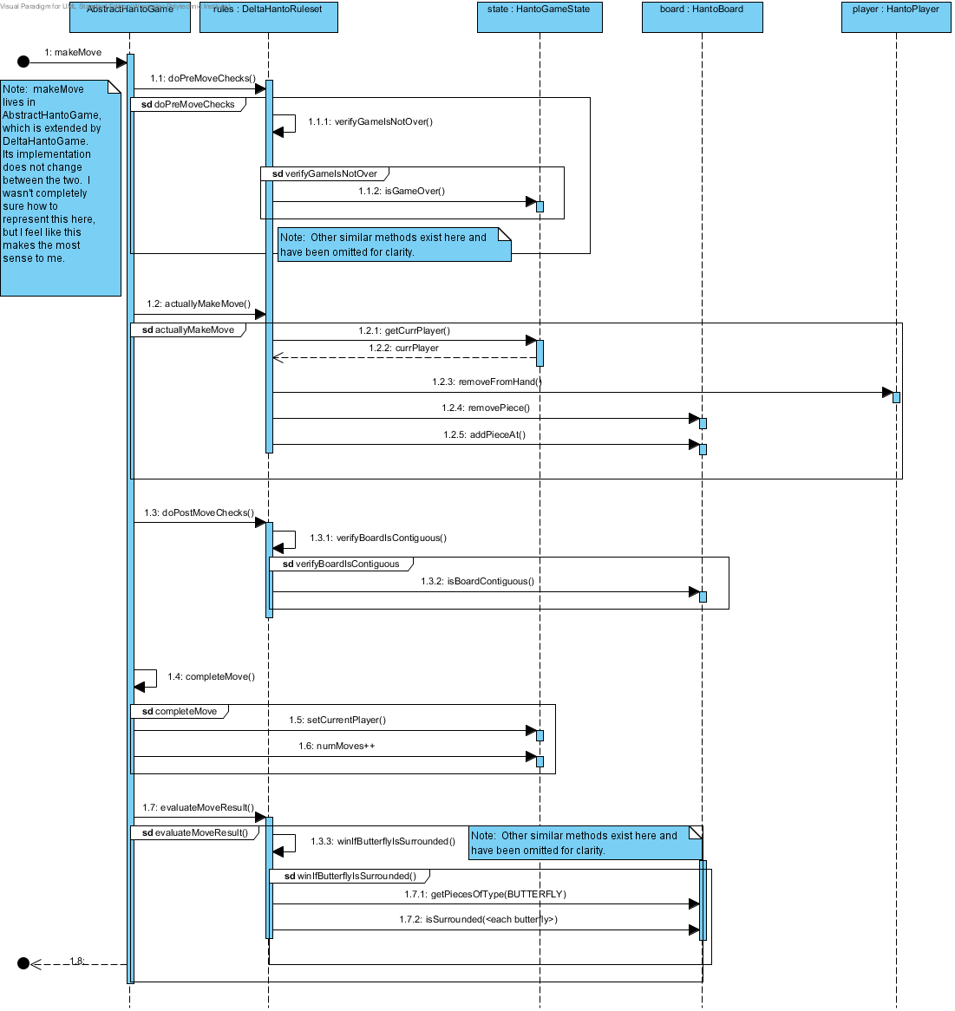

## Summary

|  |
| --- |
| Documentation |
| Note: makeMove lives in AbstractHantoGame, which is extended by DeltaHantoGame. Its implementation does not change between the two. I wasn't completely sure how to represent this here, but I feel like this makes the most sense to me. |
| Note: Other similar methods exist here and have been omitted for clarity. |
| Note: Other similar methods exist here and have been omitted for clarity. |

# HantoFactory

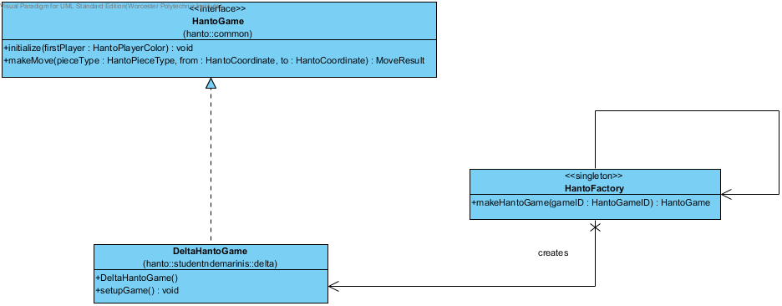

## Summary

|  |  |
| --- | --- |
| Name | Documentation |
| Image3.png HantoGame | The HantoGame interface is the primary interface between the student's code and any external (non-student written) code. Every version of Hanto will have a realization of the HantoGame interface.  @author gpollice  @version Jan 12, 2013 |
| Image3.png HantoFactory | Factory for creating Hanto Games.    Currently supports Alpha, Gamma, and Delta Hanto.  @author ndemarinis  @version Feb 9 2013 |
| Image3.png DeltaHantoGame | This class is a concrete realization of the game for DeltaHanto. It provides the necessary initialization methods for DeltaHanto and relies on the ruleset and abstract classes to handle the rest of the implementation.  @author ndemarinis  @version Feb 9, 2013 |

# Strategy Pattern: Hanto Rules

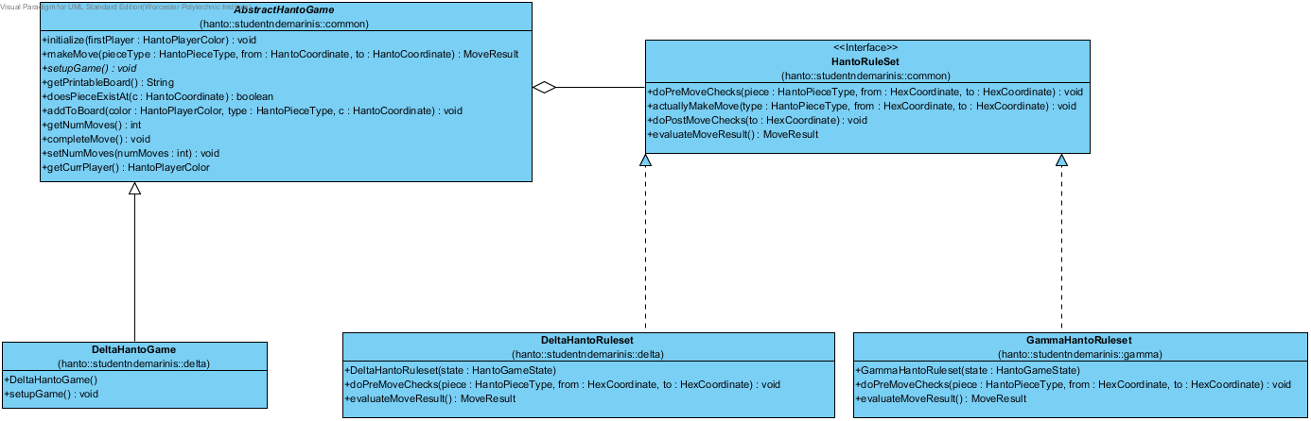

## Summary

|  |  |
| --- | --- |
| Name | Documentation |
| Image3.png AbstractHantoGame | This abstract class encapsulates the basic functionality for a HantoGame, including initialization. Lots of public methods exist here to expose extra implementation for testing purposes.  @author ndemarinis  @version Jan 31, 2013 |
| Image3.png HantoRuleSet | This interface represents methods required for a HantoRuleset. These methods will be called by AbstractHantoGame to provide a common implementation for making and verifying moves.  @author ndemarinis  @version Jan 31, 2013 |
| Image3.png DeltaHantoRuleset | This class is a concrete realization of the ruleset for Delta Hanto. It provides all of the rule methods specific to DeltaHanto.  @author ndemarinis  @version Feb 9, 2013 |
| Image3.png GammaHantoRuleset | Abstraction for GammaHanto's move rules  @author ndemarinis  @version Jan 31, 2013 |
| Image3.png DeltaHantoGame | This class is a concrete realization of the game for DeltaHanto. It provides the necessary initialization methods for DeltaHanto and relies on the ruleset and abstract classes to handle the rest of the implementation.  @author ndemarinis  @version Feb 9, 2013 |

## Details

### Image3.png GammaHantoRuleset

#### Attributes

|  |  |  |  |
| --- | --- | --- | --- |
| private MAX_MOVES : int | | | |
| Documentation | Max number of moves before ending in a draw | | |
| Initial Value | 10 * 2 | | |
| Type | Image4.png int | | |
| Allow Empty Name | false | | |
| Getter | false | Setter | false |
| Derived | false | | |
| Multiplicity | Unspecified | | |
| Java Detail | N/A | | |
| Aggregation | None | | |
| Derived Union | false | | |
| Read Only | false | | |
| Leaf | false | | |

#### Operations

|  |  |
| --- | --- |
| public GammaHantoRuleset (state : HantoGameState) | |
| Parameters | |  |  | | --- | --- | | state | | | Documentation | The HantoGame we'll be checking | | Multiplicity | Unspecified | | Type | Image3.png HantoGameState | | Direction | inout | | Java Detail | N/A | |
| Documentation | Make a new set of GammaHanto's rules, given  the game itself |
| Static | false |
| Leaf | false |
| Upper | 1 |
| Ordered | false |
| Unique | true |
| Query | false |

|  |  |
| --- | --- |
| public doPreMoveChecks (piece : HantoPieceType, from : HexCoordinate, to : HexCoordinate) : void | |
| Parameters | |  |  | | --- | --- | | piece | | | Documentation | Piece to be placed at the given location | | Multiplicity | Unspecified | | Type | Image3.png HantoPieceType | | Direction | inout | | Java Detail | N/A |  |  |  | | --- | --- | | from | | | Documentation | source coordinate of piece on the board, null if not on the board | | Multiplicity | Unspecified | | Type | Image3.png HexCoordinate | | Direction | inout | | Java Detail | N/A |  |  |  | | --- | --- | | to | | | Documentation | destination coordinate for piece to move | | Multiplicity | Unspecified | | Type | Image3.png HexCoordinate | | Direction | inout | | Java Detail | N/A | |
| Documentation | Checks to be performed before a move is made |
| Static | false |
| Leaf | false |
| Upper | 1 |
| Ordered | false |
| Unique | true |
| Return Type Documentation | @throws HantoException if a rule has been violated, leaving the board in an illegal state |
| Query | false |

|  |  |
| --- | --- |
| public evaluateMoveResult () : MoveResult | |
| Documentation | Evaluate whether the game needs to end based on the board configuration.  Intended to be called after each move to determine if a win has occurred. |
| Static | false |
| Leaf | false |
| Upper | 1 |
| Ordered | false |
| Unique | true |
| Return Type Documentation | @throws HantoException if the board is in an illegal state |
| Query | false |

|  |  |
| --- | --- |
| protected verifyPieceCanMove (piece : HantoPieceType, from : HexCoordinate, to : HexCoordinate) : void | |
| Parameters | |  |  | | --- | --- | | piece | | | Documentation | Piece being moved | | Multiplicity | Unspecified | | Type | Image3.png HantoPieceType | | Direction | inout | | Java Detail | N/A |  |  |  | | --- | --- | | from | | | Documentation | Source coordinate | | Multiplicity | Unspecified | | Type | Image3.png HexCoordinate | | Direction | inout | | Java Detail | N/A |  |  |  | | --- | --- | | to | | | Documentation | Destination coordinate | | Multiplicity | Unspecified | | Type | Image3.png HexCoordinate | | Direction | inout | | Java Detail | N/A | |
| Documentation | Verify that a move that requires moving a piece is legal.  This ensures that only butterflies can move one hex. |
| Static | false |
| Leaf | false |
| Upper | 1 |
| Ordered | false |
| Unique | true |
| Return Type Documentation | @throws HantoException if this condition has been violated |
| Query | false |

|  |  |
| --- | --- |
| protected endInDrawAfter10Moves () : MoveResult | |
| Documentation | Give result ending the game in a draw after 10 moves. |
| Static | false |
| Leaf | false |
| Upper | 1 |
| Ordered | false |
| Unique | true |
| Return Type Documentation | OK if game has been running for less than 10 moves, DRAW otherwise. |
| Query | false |