|  |  |
| --- | --- |
| Départ | HTML : <i class="fa-solid fa-plane-departure"></i>  React : <FontAwesomeIcon icon="fa-solid fa-plane-departure" /> |
| Arrivée | HTML : <i class="fa-solid fa-plane-arrival"></i>  React : <FontAwesomeIcon icon="fa-solid fa-plane-arrival" /> |
| Crossing point | HTML :<i class="fa-solid fa-shuffle"></i>  React : <FontAwesomeIcon icon="fa-solid fa-shuffle" /> |
| Segment | HTML : <i class="fa-solid fa-wave-sine"></i>  React : <FontAwesomeIcon icon="fa-solid fa-wave-sine" /> |
| Obstacle | HTML : <i class="fa-solid fa-fence"></i>  React : <FontAwesomeIcon icon="fa-solid fa-fence" /> |
| Fleche menu | HTML : <i class="fa-solid fa-arrow-right-to-line"></i>  React : <FontAwesomeIcon icon="fa-solid fa-arrow-right-to-line" /> |
| Flèche | HTML : <i class="fa-solid fa-arrow-left-from-line"></i>  React : <FontAwesomeIcon icon="fa-solid fa-arrow-left-from-line" /> |
| Vélo | HTML : <i class="fa-solid fa-person-biking"></i>  React : <FontAwesomeIcon icon="fa-solid fa-person-biking" /> |
| Course | HTML : <i class="fa-solid fa-person-running"></i>  React : <FontAwesomeIcon icon="fa-solid fa-person-running" /> |
| Marche | HTML : <i class="fa-solid fa-person-walking"></i>  React : <FontAwesomeIcon icon="fa-solid fa-person-walking" /> |
| Participants | HTML : <i class="fa-solid fa-users"></i>  React :<FontAwesomeIcon icon="fa-solid fa-users" /> |
| Désinscription | HTML : <i class="fa-solid fa-right-from-bracket"></i>  React : <FontAwesomeIcon icon="fa-solid fa-right-from-bracket" /> |
| Suppression | HTML : <i class="fa-solid fa-trash-can"></i>  React : <FontAwesomeIcon icon="fa-solid fa-trash-can" /> |
| Voir | HTML : <i class="fa-solid fa-eye"></i>  React : <FontAwesomeIcon icon="fa-solid fa-eye" /> |
| Modification | HTML : <i class="fa-solid fa-pen-field"></i>  React : <FontAwesomeIcon icon="fa-solid fa-pen-field" /> |
| Refus obstacle | HTML: <i class="fa-solid fa-circle-xmark"></i>  React : <FontAwesomeIcon icon="fa-solid fa-circle-xmark" /> |
|  | HTML : <i class="fa-solid fa-circle-check"></i>  React : <FontAwesomeIcon icon="fa-solid fa-circle-check" /> |
| Download | HTML : <i class="fa-solid fa-cloud-arrow-up"></i>  React : <FontAwesomeIcon icon="fa-solid fa-cloud-arrow-up" /> |

Désinscription

<i class="fa-solid fa-right-from-bracket"></i>

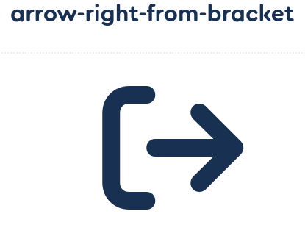

Suppression

<i class="fa-solid fa-trash-can"></i>



Voir

<i class="fa-solid fa-eye"></i>

