Codebook for tidydataset

Autogenerated data summary from dataMaid

2018-11-23 22:46:51

# Data report overview

The dataset examined has the following dimensions:

|  |  |
| --- | --- |
| Feature | Result |
| Number of observations | 180 |
| Number of variables | 68 |

# Codebook summary table

|  |  |  |  |  |  |
| --- | --- | --- | --- | --- | --- |
| Label | Variable | Class | # unique values | Missing | Description |
|  | **activityname** | character | 6 | 0.00 % | One of six activities performed by the participants (WALKING, WALKING_UPSTAIRS, WALKING_DOWNSTAIRS, SITTING, STANDING, LAYING) wearing a smartphone (Samsung Galaxy S II) on the waist. |
|  | **subjectid** | numeric | 30 | 0.00 % | Subject who carried out the experiment. |
|  | **timebodyaccelerationmeanx** | numeric | 173 | 0.00 % | Mean of the body acceleration recorded by the accelerometer in the time domain for the x-axis. |
|  | **timebodyaccelerationmeany** | numeric | 173 | 0.00 % | Mean of the body acceleration recorded by the accelerometer in the time domain for the y-axis. |
|  | **timebodyaccelerationmeanz** | numeric | 173 | 0.00 % | Mean of the body acceleration recorded by the accelerometer in the time domain for the z-axis. |
|  | **timegravityaccelerationmeanx** | numeric | 173 | 0.00 % |  |
|  | **timegravityaccelerationmeany** | numeric | 173 | 0.00 % |  |
|  | **timegravityaccelerationmeanz** | numeric | 173 | 0.00 % |  |
|  | **timebodyaccelerationjerkmeanx** | numeric | 173 | 0.00 % |  |
|  | **timebodyaccelerationjerkmeany** | numeric | 173 | 0.00 % |  |
|  | **timebodyaccelerationjerkmeanz** | numeric | 173 | 0.00 % |  |
|  | **timebodygyroscopeangularvelocitymeanx** | numeric | 173 | 0.00 % |  |
|  | **timebodygyroscopeangularvelocitymeany** | numeric | 173 | 0.00 % |  |
|  | **timebodygyroscopeangularvelocitymeanz** | numeric | 173 | 0.00 % |  |
|  | **timebodygyroscopeangularvelocityjerkmeanx** | numeric | 173 | 0.00 % |  |
|  | **timebodygyroscopeangularvelocityjerkmeany** | numeric | 173 | 0.00 % |  |
|  | **timebodygyroscopeangularvelocityjerkmeanz** | numeric | 173 | 0.00 % |  |
|  | **timebodyaccelerationmagmean** | numeric | 173 | 0.00 % |  |
|  | **timegravityaccelerationmagmean** | numeric | 173 | 0.00 % |  |
|  | **timebodyaccelerationjerkmagmean** | numeric | 173 | 0.00 % |  |
|  | **timebodygyroscopeangularvelocitymagmean** | numeric | 173 | 0.00 % |  |
|  | **timebodygyroscopeangularvelocityjerkmagmean** | numeric | 173 | 0.00 % |  |
|  | **frequencybodyaccelerationmeanx** | numeric | 173 | 0.00 % |  |
|  | **frequencybodyaccelerationmeany** | numeric | 173 | 0.00 % |  |
|  | **frequencybodyaccelerationmeanz** | numeric | 173 | 0.00 % |  |
|  | **frequencybodyaccelerationjerkmeanx** | numeric | 173 | 0.00 % |  |
|  | **frequencybodyaccelerationjerkmeany** | numeric | 173 | 0.00 % |  |
|  | **frequencybodyaccelerationjerkmeanz** | numeric | 173 | 0.00 % |  |
|  | **frequencybodygyroscopeangularvelocitymeanx** | numeric | 173 | 0.00 % |  |
|  | **frequencybodygyroscopeangularvelocitymeany** | numeric | 173 | 0.00 % |  |
|  | **frequencybodygyroscopeangularvelocitymeanz** | numeric | 173 | 0.00 % |  |
|  | **frequencybodyaccelerationmagmean** | numeric | 173 | 0.00 % |  |
|  | **frequencybodyaccjerkmagmean** | numeric | 173 | 0.00 % |  |
|  | **frequencybodygyromagmean** | numeric | 173 | 0.00 % |  |
|  | **frequencybodygyrojerkmagmean** | numeric | 173 | 0.00 % |  |
|  | **timebodyaccelerationstandarddeviationx** | numeric | 173 | 0.00 % |  |
|  | **timebodyaccelerationstandarddeviationy** | numeric | 173 | 0.00 % |  |
|  | **timebodyaccelerationstandarddeviationz** | numeric | 173 | 0.00 % |  |
|  | **timegravityaccelerationstandarddeviationx** | numeric | 173 | 0.00 % |  |
|  | **timegravityaccelerationstandarddeviationy** | numeric | 173 | 0.00 % |  |
|  | **timegravityaccelerationstandarddeviationz** | numeric | 173 | 0.00 % |  |
|  | **timebodyaccelerationjerkstandarddeviationx** | numeric | 173 | 0.00 % |  |
|  | **timebodyaccelerationjerkstandarddeviationy** | numeric | 173 | 0.00 % |  |
|  | **timebodyaccelerationjerkstandarddeviationz** | numeric | 173 | 0.00 % |  |
|  | **timebodygyroscopeangularvelocitystandarddeviationx** | numeric | 173 | 0.00 % |  |
|  | **timebodygyroscopeangularvelocitystandarddeviationy** | numeric | 173 | 0.00 % |  |
|  | **timebodygyroscopeangularvelocitystandarddeviationz** | numeric | 173 | 0.00 % |  |
|  | **timebodygyroscopeangularvelocityjerkstandarddeviationx** | numeric | 173 | 0.00 % |  |
|  | **timebodygyroscopeangularvelocityjerkstandarddeviationy** | numeric | 173 | 0.00 % |  |
|  | **timebodygyroscopeangularvelocityjerkstandarddeviationz** | numeric | 173 | 0.00 % |  |
|  | **timebodyaccelerationmagstandarddeviation** | numeric | 173 | 0.00 % |  |
|  | **timegravityaccelerationmagstandarddeviation** | numeric | 173 | 0.00 % |  |
|  | **timebodyaccelerationjerkmagstandarddeviation** | numeric | 173 | 0.00 % |  |
|  | **timebodygyroscopeangularvelocitymagstandarddeviation** | numeric | 173 | 0.00 % |  |
|  | **timebodygyroscopeangularvelocityjerkmagstandarddeviation** | numeric | 173 | 0.00 % |  |
|  | **frequencybodyaccelerationstandarddeviationx** | numeric | 173 | 0.00 % |  |
|  | **frequencybodyaccelerationstandarddeviationy** | numeric | 173 | 0.00 % |  |
|  | **frequencybodyaccelerationstandarddeviationz** | numeric | 173 | 0.00 % |  |
|  | **frequencybodyaccelerationjerkstandarddeviationx** | numeric | 173 | 0.00 % |  |
|  | **frequencybodyaccelerationjerkstandarddeviationy** | numeric | 173 | 0.00 % |  |
|  | **frequencybodyaccelerationjerkstandarddeviationz** | numeric | 173 | 0.00 % |  |
|  | **frequencybodygyroscopeangularvelocitystandarddeviationx** | numeric | 173 | 0.00 % |  |
|  | **frequencybodygyroscopeangularvelocitystandarddeviationy** | numeric | 173 | 0.00 % |  |
|  | **frequencybodygyroscopeangularvelocitystandarddeviationz** | numeric | 173 | 0.00 % |  |
|  | **frequencybodyaccelerationmagstandarddeviation** | numeric | 173 | 0.00 % |  |
|  | **frequencybodyaccjerkmagstandarddeviation** | numeric | 173 | 0.00 % |  |
|  | **frequencybodygyromagstandarddeviation** | numeric | 173 | 0.00 % |  |
|  | **frequencybodygyrojerkmagstandarddeviation** | numeric | 173 | 0.00 % |  |

# Variable list

## activityname

|  |  |
| --- | --- |
| Feature | Result |
| Variable type | character |
| Number of missing obs. | 0 (0 %) |
| Number of unique values | 6 |
| Mode | “LAYING” |

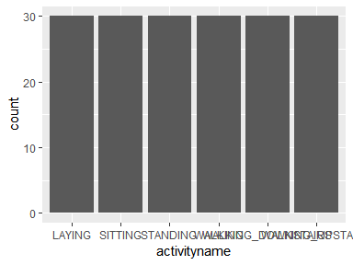

* Observed factor levels: "LAYING", "SITTING", "STANDING", "WALKING", "WALKING_DOWNSTAIRS", "WALKING_UPSTAIRS".

## subjectid

|  |  |
| --- | --- |
| Feature | Result |
| Variable type | numeric |
| Number of missing obs. | 0 (0 %) |
| Number of unique values | 30 |
| Median | 15.5 |
| 1st and 3rd quartiles | 8; 23 |
| Min. and max. | 1; 30 |

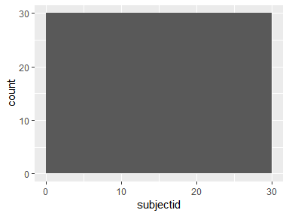

## timebodyaccelerationmeanx

|  |  |
| --- | --- |
| Feature | Result |
| Variable type | numeric |
| Number of missing obs. | 0 (0 %) |
| Number of unique values | 173 |
| Median | 0.28 |
| 1st and 3rd quartiles | 0.27; 0.28 |
| Min. and max. | 0.24; 0.3 |

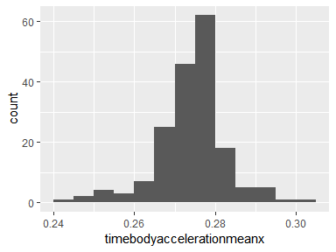

## timebodyaccelerationmeany

|  |  |
| --- | --- |
| Feature | Result |
| Variable type | numeric |
| Number of missing obs. | 0 (0 %) |
| Number of unique values | 173 |
| Median | -0.02 |
| 1st and 3rd quartiles | -0.02; -0.02 |
| Min. and max. | -0.03; -0.01 |

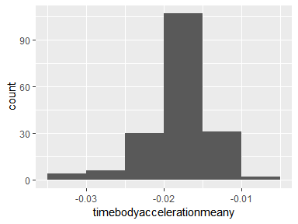

## timebodyaccelerationmeanz

|  |  |
| --- | --- |
| Feature | Result |
| Variable type | numeric |
| Number of missing obs. | 0 (0 %) |
| Number of unique values | 173 |
| Median | -0.11 |
| 1st and 3rd quartiles | -0.11; -0.11 |
| Min. and max. | -0.15; -0.09 |

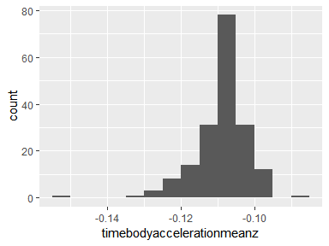

## timegravityaccelerationmeanx

|  |  |
| --- | --- |
| Feature | Result |
| Variable type | numeric |
| Number of missing obs. | 0 (0 %) |
| Number of unique values | 173 |
| Median | 0.84 |
| 1st and 3rd quartiles | 0.66; 0.92 |
| Min. and max. | -0.68; 0.97 |

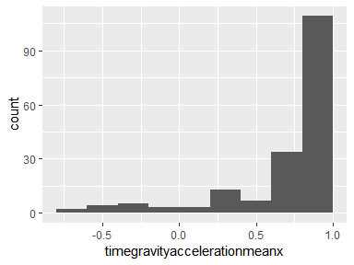

## timegravityaccelerationmeany

|  |  |
| --- | --- |
| Feature | Result |
| Variable type | numeric |
| Number of missing obs. | 0 (0 %) |
| Number of unique values | 173 |
| Median | -0.06 |
| 1st and 3rd quartiles | -0.18; 0.08 |
| Min. and max. | -0.43; 0.81 |

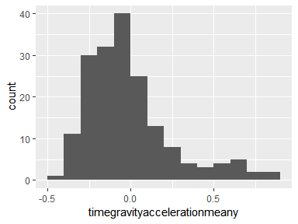

## timegravityaccelerationmeanz

|  |  |
| --- | --- |
| Feature | Result |
| Variable type | numeric |
| Number of missing obs. | 0 (0 %) |
| Number of unique values | 173 |
| Median | 0.04 |
| 1st and 3rd quartiles | -0.06; 0.14 |
| Min. and max. | -0.36; 0.92 |

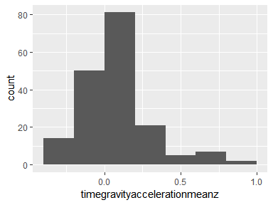

## timebodyaccelerationjerkmeanx

|  |  |
| --- | --- |
| Feature | Result |
| Variable type | numeric |
| Number of missing obs. | 0 (0 %) |
| Number of unique values | 173 |
| Median | 0.08 |
| 1st and 3rd quartiles | 0.08; 0.08 |
| Min. and max. | 0.06; 0.12 |

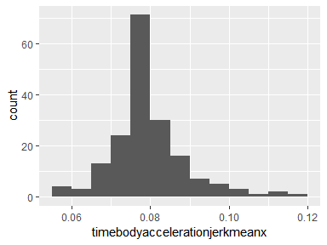

## timebodyaccelerationjerkmeany

|  |  |
| --- | --- |
| Feature | Result |
| Variable type | numeric |
| Number of missing obs. | 0 (0 %) |
| Number of unique values | 173 |
| Median | 0.01 |
| 1st and 3rd quartiles | 0; 0.01 |
| Min. and max. | -0.04; 0.06 |

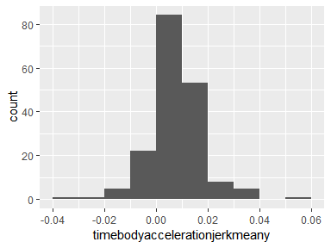

## timebodyaccelerationjerkmeanz

|  |  |
| --- | --- |
| Feature | Result |
| Variable type | numeric |
| Number of missing obs. | 0 (0 %) |
| Number of unique values | 173 |
| Median | 0 |
| 1st and 3rd quartiles | -0.01; 0 |
| Min. and max. | -0.04; 0.03 |

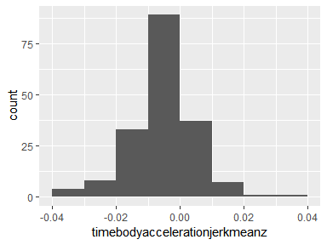

## timebodygyroscopeangularvelocitymeanx

|  |  |
| --- | --- |
| Feature | Result |
| Variable type | numeric |
| Number of missing obs. | 0 (0 %) |
| Number of unique values | 173 |
| Median | -0.03 |
| 1st and 3rd quartiles | -0.05; -0.02 |
| Min. and max. | -0.21; 0.13 |

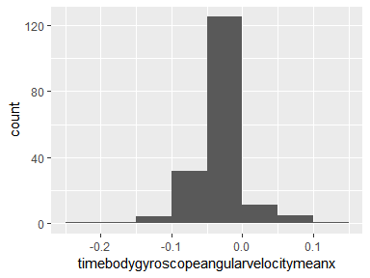

## timebodygyroscopeangularvelocitymeany

|  |  |
| --- | --- |
| Feature | Result |
| Variable type | numeric |
| Number of missing obs. | 0 (0 %) |
| Number of unique values | 173 |
| Median | -0.07 |
| 1st and 3rd quartiles | -0.08; -0.06 |
| Min. and max. | -0.18; 0.03 |

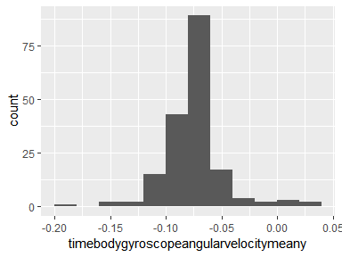

## timebodygyroscopeangularvelocitymeanz

|  |  |
| --- | --- |
| Feature | Result |
| Variable type | numeric |
| Number of missing obs. | 0 (0 %) |
| Number of unique values | 173 |
| Median | 0.09 |
| 1st and 3rd quartiles | 0.08; 0.1 |
| Min. and max. | -0.03; 0.16 |

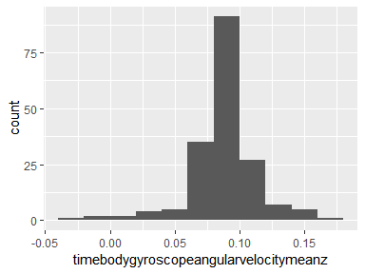

## timebodygyroscopeangularvelocityjerkmeanx

|  |  |
| --- | --- |
| Feature | Result |
| Variable type | numeric |
| Number of missing obs. | 0 (0 %) |
| Number of unique values | 173 |
| Median | -0.1 |
| 1st and 3rd quartiles | -0.1; -0.09 |
| Min. and max. | -0.15; -0.03 |

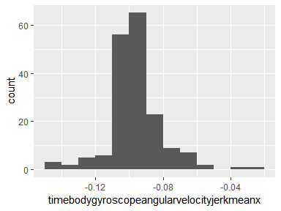

## timebodygyroscopeangularvelocityjerkmeany

|  |  |
| --- | --- |
| Feature | Result |
| Variable type | numeric |
| Number of missing obs. | 0 (0 %) |
| Number of unique values | 173 |
| Median | -0.04 |
| 1st and 3rd quartiles | -0.04; -0.04 |
| Min. and max. | -0.07; -0.01 |

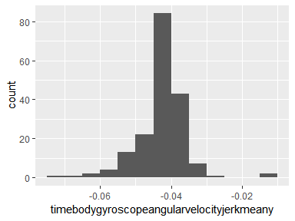

## timebodygyroscopeangularvelocityjerkmeanz

|  |  |
| --- | --- |
| Feature | Result |
| Variable type | numeric |
| Number of missing obs. | 0 (0 %) |
| Number of unique values | 173 |
| Median | -0.05 |
| 1st and 3rd quartiles | -0.06; -0.05 |
| Min. and max. | -0.09; -0.01 |

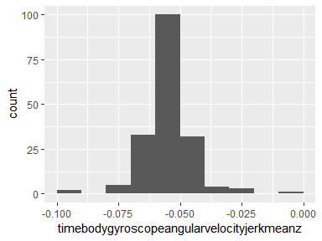

## timebodyaccelerationmagmean

|  |  |
| --- | --- |
| Feature | Result |
| Variable type | numeric |
| Number of missing obs. | 0 (0 %) |
| Number of unique values | 173 |
| Median | -0.49 |
| 1st and 3rd quartiles | -0.84; -0.26 |
| Min. and max. | -0.99; 0.64 |

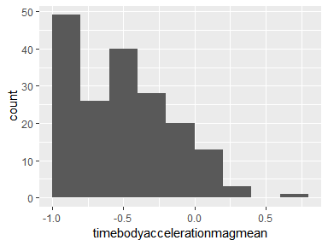

## timegravityaccelerationmagmean

|  |  |
| --- | --- |
| Feature | Result |
| Variable type | numeric |
| Number of missing obs. | 0 (0 %) |
| Number of unique values | 173 |
| Median | -0.49 |
| 1st and 3rd quartiles | -0.84; -0.26 |
| Min. and max. | -0.99; 0.64 |

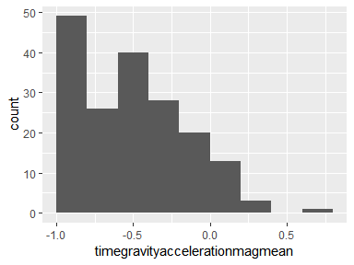

## timebodyaccelerationjerkmagmean

|  |  |
| --- | --- |
| Feature | Result |
| Variable type | numeric |
| Number of missing obs. | 0 (0 %) |
| Number of unique values | 173 |
| Median | -0.61 |
| 1st and 3rd quartiles | -0.89; -0.42 |
| Min. and max. | -0.99; 0.43 |

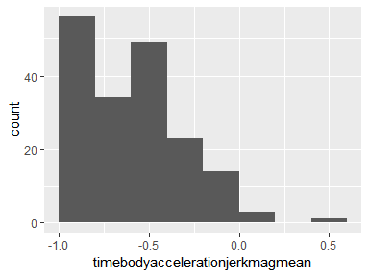

## timebodygyroscopeangularvelocitymagmean

|  |  |
| --- | --- |
| Feature | Result |
| Variable type | numeric |
| Number of missing obs. | 0 (0 %) |
| Number of unique values | 173 |
| Median | -0.57 |
| 1st and 3rd quartiles | -0.85; -0.37 |
| Min. and max. | -0.98; 0.42 |

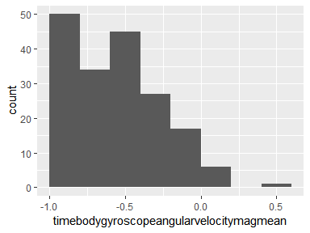

## timebodygyroscopeangularvelocityjerkmagmean

|  |  |
| --- | --- |
| Feature | Result |
| Variable type | numeric |
| Number of missing obs. | 0 (0 %) |
| Number of unique values | 173 |
| Median | -0.75 |
| 1st and 3rd quartiles | -0.93; -0.62 |
| Min. and max. | -1; 0.09 |

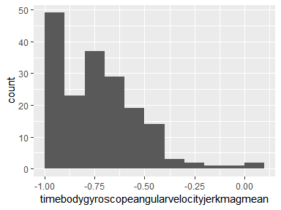

## frequencybodyaccelerationmeanx

|  |  |
| --- | --- |
| Feature | Result |
| Variable type | numeric |
| Number of missing obs. | 0 (0 %) |
| Number of unique values | 173 |
| Median | -0.59 |
| 1st and 3rd quartiles | -0.88; -0.38 |
| Min. and max. | -1; 0.54 |

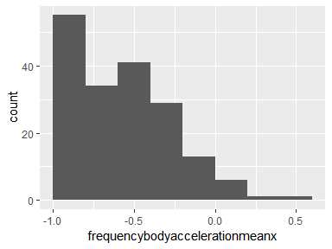

## frequencybodyaccelerationmeany

|  |  |
| --- | --- |
| Feature | Result |
| Variable type | numeric |
| Number of missing obs. | 0 (0 %) |
| Number of unique values | 173 |
| Median | -0.48 |
| 1st and 3rd quartiles | -0.84; -0.25 |
| Min. and max. | -0.99; 0.49 |

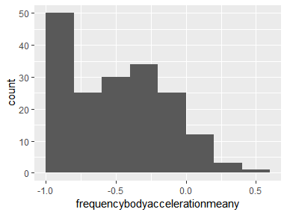

## frequencybodyaccelerationmeanz

|  |  |
| --- | --- |
| Feature | Result |
| Variable type | numeric |
| Number of missing obs. | 0 (0 %) |
| Number of unique values | 173 |
| Median | -0.66 |
| 1st and 3rd quartiles | -0.89; -0.47 |
| Min. and max. | -0.99; 0.28 |

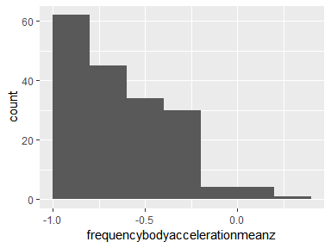

## frequencybodyaccelerationjerkmeanx

|  |  |
| --- | --- |
| Feature | Result |
| Variable type | numeric |
| Number of missing obs. | 0 (0 %) |
| Number of unique values | 173 |
| Median | -0.62 |
| 1st and 3rd quartiles | -0.89; -0.44 |
| Min. and max. | -0.99; 0.47 |

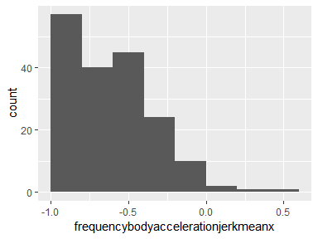

## frequencybodyaccelerationjerkmeany

|  |  |
| --- | --- |
| Feature | Result |
| Variable type | numeric |
| Number of missing obs. | 0 (0 %) |
| Number of unique values | 173 |
| Median | -0.61 |
| 1st and 3rd quartiles | -0.87; -0.41 |
| Min. and max. | -0.99; 0.28 |

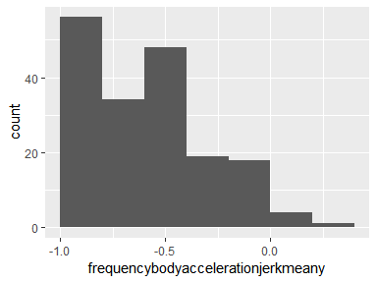

## frequencybodyaccelerationjerkmeanz

|  |  |
| --- | --- |
| Feature | Result |
| Variable type | numeric |
| Number of missing obs. | 0 (0 %) |
| Number of unique values | 173 |
| Median | -0.75 |
| 1st and 3rd quartiles | -0.93; -0.6 |
| Min. and max. | -0.99; 0.16 |

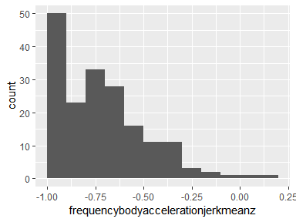

## frequencybodygyroscopeangularvelocitymeanx

|  |  |
| --- | --- |
| Feature | Result |
| Variable type | numeric |
| Number of missing obs. | 0 (0 %) |
| Number of unique values | 173 |
| Median | -0.63 |
| 1st and 3rd quartiles | -0.89; -0.47 |
| Min. and max. | -0.99; 0.47 |

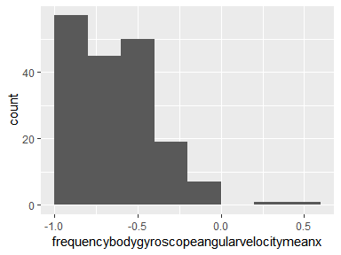

## frequencybodygyroscopeangularvelocitymeany

|  |  |
| --- | --- |
| Feature | Result |
| Variable type | numeric |
| Number of missing obs. | 0 (0 %) |
| Number of unique values | 173 |
| Median | -0.71 |
| 1st and 3rd quartiles | -0.9; -0.54 |
| Min. and max. | -0.99; 0.33 |

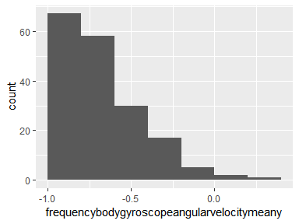

## frequencybodygyroscopeangularvelocitymeanz

|  |  |
| --- | --- |
| Feature | Result |
| Variable type | numeric |
| Number of missing obs. | 0 (0 %) |
| Number of unique values | 173 |
| Median | -0.6 |
| 1st and 3rd quartiles | -0.88; -0.41 |
| Min. and max. | -0.99; 0.24 |

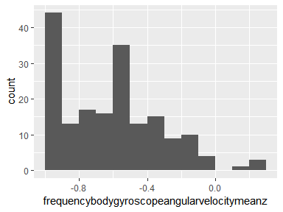

## frequencybodyaccelerationmagmean

|  |  |
| --- | --- |
| Feature | Result |
| Variable type | numeric |
| Number of missing obs. | 0 (0 %) |
| Number of unique values | 173 |
| Median | -0.55 |
| 1st and 3rd quartiles | -0.86; -0.35 |
| Min. and max. | -0.99; 0.59 |

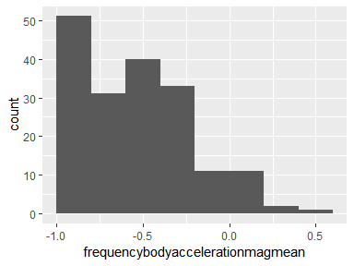

## frequencybodyaccjerkmagmean

|  |  |
| --- | --- |
| Feature | Result |
| Variable type | numeric |
| Number of missing obs. | 0 (0 %) |
| Number of unique values | 173 |
| Median | -0.59 |
| 1st and 3rd quartiles | -0.89; -0.36 |
| Min. and max. | -0.99; 0.54 |

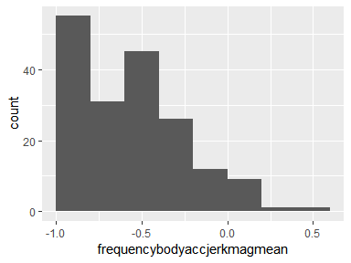

## frequencybodygyromagmean

|  |  |
| --- | --- |
| Feature | Result |
| Variable type | numeric |
| Number of missing obs. | 0 (0 %) |
| Number of unique values | 173 |
| Median | -0.69 |
| 1st and 3rd quartiles | -0.89; -0.53 |
| Min. and max. | -0.98; 0.2 |

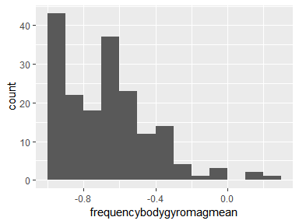

## frequencybodygyrojerkmagmean

|  |  |
| --- | --- |
| Feature | Result |
| Variable type | numeric |
| Number of missing obs. | 0 (0 %) |
| Number of unique values | 173 |
| Median | -0.78 |
| 1st and 3rd quartiles | -0.93; -0.66 |
| Min. and max. | -1; 0.15 |

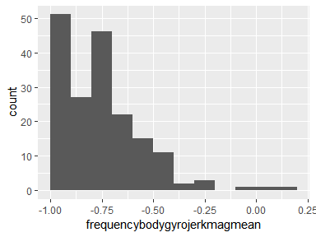

## timebodyaccelerationstandarddeviationx

|  |  |
| --- | --- |
| Feature | Result |
| Variable type | numeric |
| Number of missing obs. | 0 (0 %) |
| Number of unique values | 173 |
| Median | -0.57 |
| 1st and 3rd quartiles | -0.88; -0.35 |
| Min. and max. | -1; 0.63 |

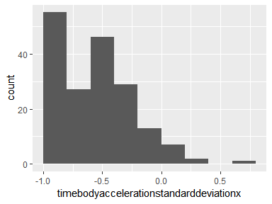

## timebodyaccelerationstandarddeviationy

|  |  |
| --- | --- |
| Feature | Result |
| Variable type | numeric |
| Number of missing obs. | 0 (0 %) |
| Number of unique values | 173 |
| Median | -0.48 |
| 1st and 3rd quartiles | -0.83; -0.18 |
| Min. and max. | -0.99; 0.51 |

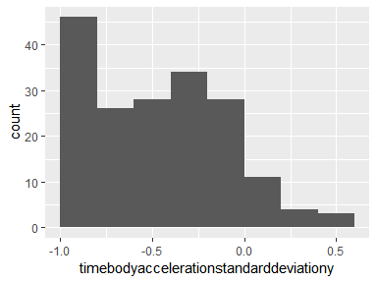

## timebodyaccelerationstandarddeviationz

|  |  |
| --- | --- |
| Feature | Result |
| Variable type | numeric |
| Number of missing obs. | 0 (0 %) |
| Number of unique values | 173 |
| Median | -0.6 |
| 1st and 3rd quartiles | -0.86; -0.36 |
| Min. and max. | -0.99; 0.23 |

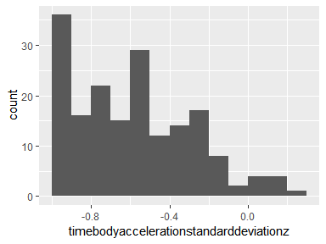

## timegravityaccelerationstandarddeviationx

|  |  |
| --- | --- |
| Feature | Result |
| Variable type | numeric |
| Number of missing obs. | 0 (0 %) |
| Number of unique values | 173 |
| Median | -0.97 |
| 1st and 3rd quartiles | -0.98; -0.95 |
| Min. and max. | -1; -0.83 |

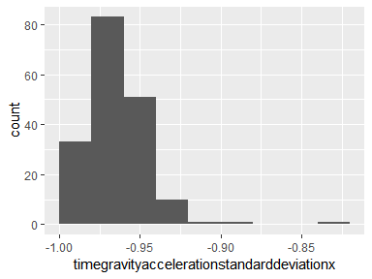

## timegravityaccelerationstandarddeviationy

|  |  |
| --- | --- |
| Feature | Result |
| Variable type | numeric |
| Number of missing obs. | 0 (0 %) |
| Number of unique values | 173 |
| Median | -0.96 |
| 1st and 3rd quartiles | -0.97; -0.94 |
| Min. and max. | -0.99; -0.64 |

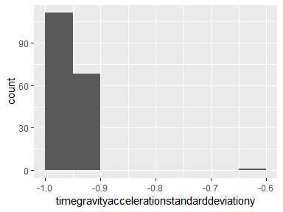

## timegravityaccelerationstandarddeviationz

|  |  |
| --- | --- |
| Feature | Result |
| Variable type | numeric |
| Number of missing obs. | 0 (0 %) |
| Number of unique values | 173 |
| Median | -0.94 |
| 1st and 3rd quartiles | -0.96; -0.93 |
| Min. and max. | -0.99; -0.61 |

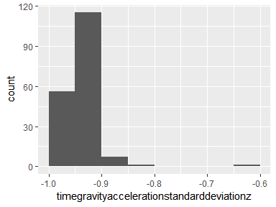

## timebodyaccelerationjerkstandarddeviationx

|  |  |
| --- | --- |
| Feature | Result |
| Variable type | numeric |
| Number of missing obs. | 0 (0 %) |
| Number of unique values | 173 |
| Median | -0.6 |
| 1st and 3rd quartiles | -0.89; -0.41 |
| Min. and max. | -0.99; 0.54 |

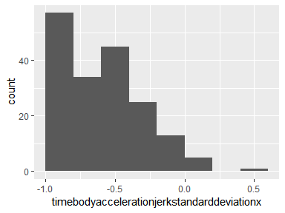

## timebodyaccelerationjerkstandarddeviationy

|  |  |
| --- | --- |
| Feature | Result |
| Variable type | numeric |
| Number of missing obs. | 0 (0 %) |
| Number of unique values | 173 |
| Median | -0.59 |
| 1st and 3rd quartiles | -0.87; -0.37 |
| Min. and max. | -0.99; 0.36 |

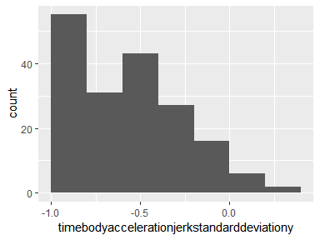

## timebodyaccelerationjerkstandarddeviationz

|  |  |
| --- | --- |
| Feature | Result |
| Variable type | numeric |
| Number of missing obs. | 0 (0 %) |
| Number of unique values | 173 |
| Median | -0.77 |
| 1st and 3rd quartiles | -0.94; -0.63 |
| Min. and max. | -0.99; 0.03 |

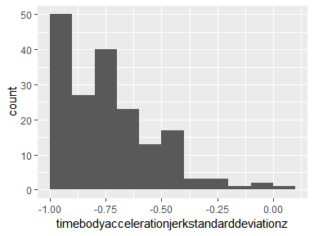

## timebodygyroscopeangularvelocitystandarddeviationx

|  |  |
| --- | --- |
| Feature | Result |
| Variable type | numeric |
| Number of missing obs. | 0 (0 %) |
| Number of unique values | 173 |
| Median | -0.69 |
| 1st and 3rd quartiles | -0.9; -0.57 |
| Min. and max. | -0.99; 0.27 |

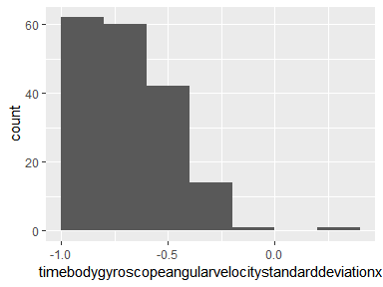

## timebodygyroscopeangularvelocitystandarddeviationy

|  |  |
| --- | --- |
| Feature | Result |
| Variable type | numeric |
| Number of missing obs. | 0 (0 %) |
| Number of unique values | 173 |
| Median | -0.68 |
| 1st and 3rd quartiles | -0.89; -0.52 |
| Min. and max. | -0.99; 0.26 |

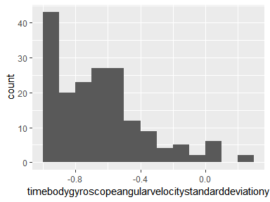

## timebodygyroscopeangularvelocitystandarddeviationz

|  |  |
| --- | --- |
| Feature | Result |
| Variable type | numeric |
| Number of missing obs. | 0 (0 %) |
| Number of unique values | 173 |
| Median | -0.63 |
| 1st and 3rd quartiles | -0.88; -0.44 |
| Min. and max. | -0.99; 0.26 |

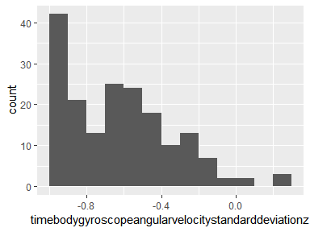

## timebodygyroscopeangularvelocityjerkstandarddeviationx

|  |  |
| --- | --- |
| Feature | Result |
| Variable type | numeric |
| Number of missing obs. | 0 (0 %) |
| Number of unique values | 173 |
| Median | -0.71 |
| 1st and 3rd quartiles | -0.92; -0.56 |
| Min. and max. | -1; 0.18 |

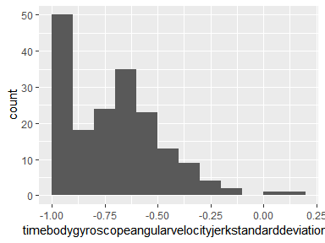

## timebodygyroscopeangularvelocityjerkstandarddeviationy

|  |  |
| --- | --- |
| Feature | Result |
| Variable type | numeric |
| Number of missing obs. | 0 (0 %) |
| Number of unique values | 173 |
| Median | -0.8 |
| 1st and 3rd quartiles | -0.94; -0.67 |
| Min. and max. | -1; 0.3 |

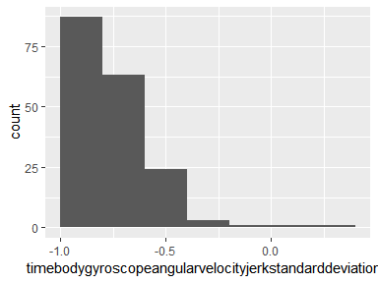

## timebodygyroscopeangularvelocityjerkstandarddeviationz

|  |  |
| --- | --- |
| Feature | Result |
| Variable type | numeric |
| Number of missing obs. | 0 (0 %) |
| Number of unique values | 173 |
| Median | -0.71 |
| 1st and 3rd quartiles | -0.93; -0.58 |
| Min. and max. | -1; 0.12 |

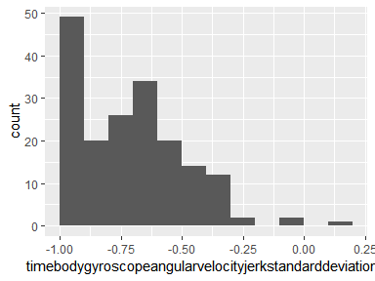

## timebodyaccelerationmagstandarddeviation

|  |  |
| --- | --- |
| Feature | Result |
| Variable type | numeric |
| Number of missing obs. | 0 (0 %) |
| Number of unique values | 173 |
| Median | -0.56 |
| 1st and 3rd quartiles | -0.85; -0.35 |
| Min. and max. | -0.98; 0.41 |

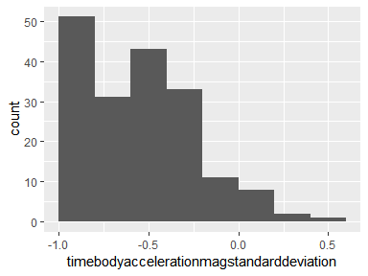

## timegravityaccelerationmagstandarddeviation

|  |  |
| --- | --- |
| Feature | Result |
| Variable type | numeric |
| Number of missing obs. | 0 (0 %) |
| Number of unique values | 173 |
| Median | -0.56 |
| 1st and 3rd quartiles | -0.85; -0.35 |
| Min. and max. | -0.98; 0.41 |

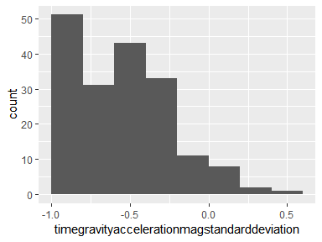

## timebodyaccelerationjerkmagstandarddeviation

|  |  |
| --- | --- |
| Feature | Result |
| Variable type | numeric |
| Number of missing obs. | 0 (0 %) |
| Number of unique values | 173 |
| Median | -0.6 |
| 1st and 3rd quartiles | -0.89; -0.39 |
| Min. and max. | -0.99; 0.45 |

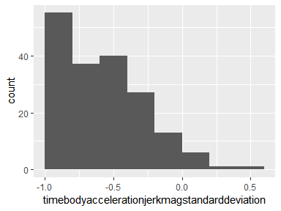

## timebodygyroscopeangularvelocitymagstandarddeviation

|  |  |
| --- | --- |
| Feature | Result |
| Variable type | numeric |
| Number of missing obs. | 0 (0 %) |
| Number of unique values | 173 |
| Median | -0.65 |
| 1st and 3rd quartiles | -0.87; -0.49 |
| Min. and max. | -0.98; 0.24 |

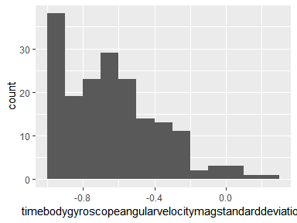

## timebodygyroscopeangularvelocityjerkmagstandarddeviation

|  |  |
| --- | --- |
| Feature | Result |
| Variable type | numeric |
| Number of missing obs. | 0 (0 %) |
| Number of unique values | 173 |
| Median | -0.78 |
| 1st and 3rd quartiles | -0.93; -0.66 |
| Min. and max. | -1; 0.25 |

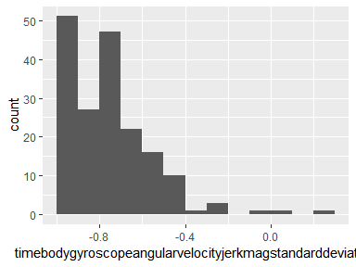

## frequencybodyaccelerationstandarddeviationx

|  |  |
| --- | --- |
| Feature | Result |
| Variable type | numeric |
| Number of missing obs. | 0 (0 %) |
| Number of unique values | 173 |
| Median | -0.56 |
| 1st and 3rd quartiles | -0.88; -0.34 |
| Min. and max. | -1; 0.66 |

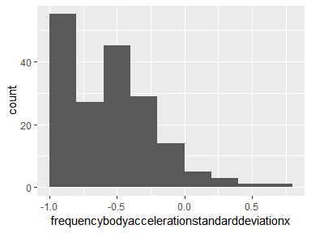

## frequencybodyaccelerationstandarddeviationy

|  |  |
| --- | --- |
| Feature | Result |
| Variable type | numeric |
| Number of missing obs. | 0 (0 %) |
| Number of unique values | 173 |
| Median | -0.5 |
| 1st and 3rd quartiles | -0.83; -0.22 |
| Min. and max. | -0.99; 0.43 |

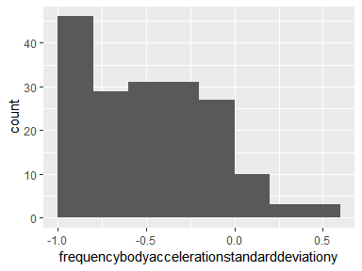

## frequencybodyaccelerationstandarddeviationz

|  |  |
| --- | --- |
| Feature | Result |
| Variable type | numeric |
| Number of missing obs. | 0 (0 %) |
| Number of unique values | 173 |
| Median | -0.6 |
| 1st and 3rd quartiles | -0.85; -0.38 |
| Min. and max. | -0.99; 0.2 |

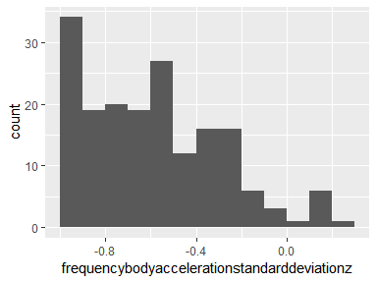

## frequencybodyaccelerationjerkstandarddeviationx

|  |  |
| --- | --- |
| Feature | Result |
| Variable type | numeric |
| Number of missing obs. | 0 (0 %) |
| Number of unique values | 173 |
| Median | -0.61 |
| 1st and 3rd quartiles | -0.89; -0.43 |
| Min. and max. | -0.99; 0.48 |

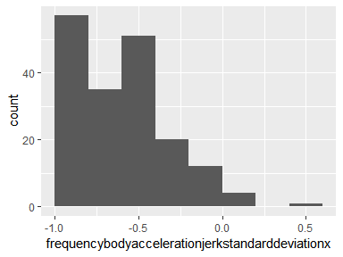

## frequencybodyaccelerationjerkstandarddeviationy

|  |  |
| --- | --- |
| Feature | Result |
| Variable type | numeric |
| Number of missing obs. | 0 (0 %) |
| Number of unique values | 173 |
| Median | -0.59 |
| 1st and 3rd quartiles | -0.87; -0.37 |
| Min. and max. | -0.99; 0.35 |

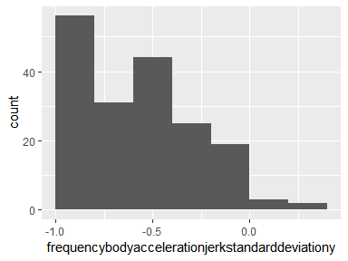

## frequencybodyaccelerationjerkstandarddeviationz

|  |  |
| --- | --- |
| Feature | Result |
| Variable type | numeric |
| Number of missing obs. | 0 (0 %) |
| Number of unique values | 173 |
| Median | -0.79 |
| 1st and 3rd quartiles | -0.94; -0.65 |
| Min. and max. | -0.99; -0.01 |

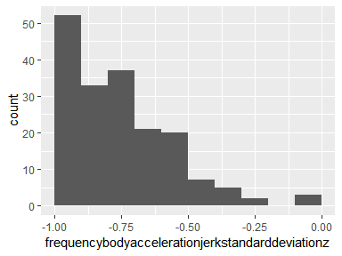

## frequencybodygyroscopeangularvelocitystandarddeviationx

|  |  |
| --- | --- |
| Feature | Result |
| Variable type | numeric |
| Number of missing obs. | 0 (0 %) |
| Number of unique values | 173 |
| Median | -0.71 |
| 1st and 3rd quartiles | -0.91; -0.59 |
| Min. and max. | -0.99; 0.2 |

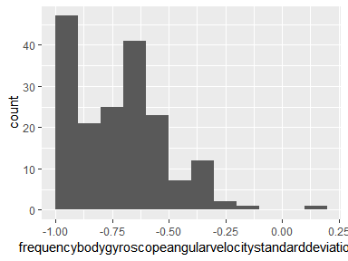

## frequencybodygyroscopeangularvelocitystandarddeviationy

|  |  |
| --- | --- |
| Feature | Result |
| Variable type | numeric |
| Number of missing obs. | 0 (0 %) |
| Number of unique values | 173 |
| Median | -0.68 |
| 1st and 3rd quartiles | -0.89; -0.53 |
| Min. and max. | -0.99; 0.29 |

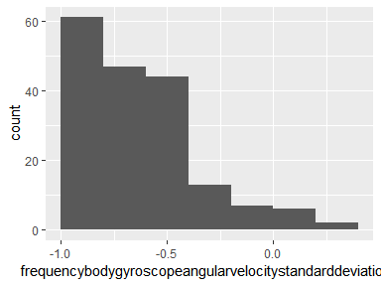

## frequencybodygyroscopeangularvelocitystandarddeviationz

|  |  |
| --- | --- |
| Feature | Result |
| Variable type | numeric |
| Number of missing obs. | 0 (0 %) |
| Number of unique values | 173 |
| Median | -0.69 |
| 1st and 3rd quartiles | -0.9; -0.51 |
| Min. and max. | -0.99; 0.19 |

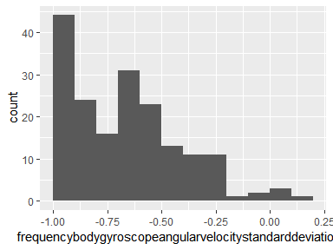

## frequencybodyaccelerationmagstandarddeviation

|  |  |
| --- | --- |
| Feature | Result |
| Variable type | numeric |
| Number of missing obs. | 0 (0 %) |
| Number of unique values | 173 |
| Median | -0.64 |
| 1st and 3rd quartiles | -0.87; -0.46 |
| Min. and max. | -0.98; 0.08 |

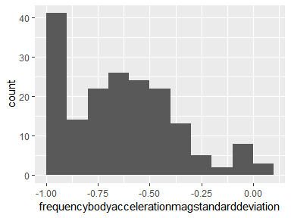

## frequencybodyaccjerkmagstandarddeviation

|  |  |
| --- | --- |
| Feature | Result |
| Variable type | numeric |
| Number of missing obs. | 0 (0 %) |
| Number of unique values | 173 |
| Median | -0.62 |
| 1st and 3rd quartiles | -0.9; -0.43 |
| Min. and max. | -0.99; 0.32 |

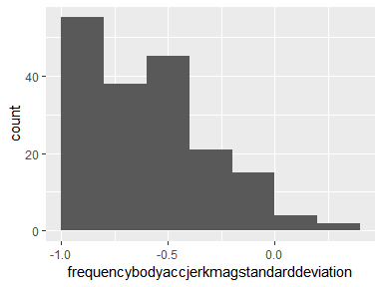

## frequencybodygyromagstandarddeviation

|  |  |
| --- | --- |
| Feature | Result |
| Variable type | numeric |
| Number of missing obs. | 0 (0 %) |
| Number of unique values | 173 |
| Median | -0.7 |
| 1st and 3rd quartiles | -0.87; -0.53 |
| Min. and max. | -0.98; 0.03 |

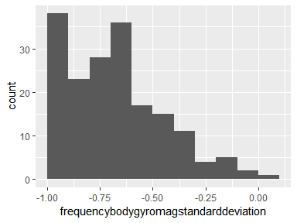

## frequencybodygyrojerkmagstandarddeviation

|  |  |
| --- | --- |
| Feature | Result |
| Variable type | numeric |
| Number of missing obs. | 0 (0 %) |
| Number of unique values | 173 |
| Median | -0.79 |
| 1st and 3rd quartiles | -0.93; -0.69 |
| Min. and max. | -1; 0.29 |

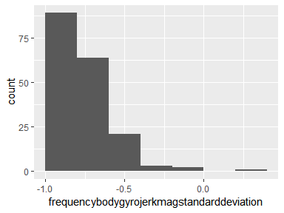

Report generation information:

* Created by ndescussebrown (username: natha).
* Report creation time: Fri Nov 23 2018 22:46:52
* Report was run from directory: C:/Users/natha/gettingandcleaningdata
* dataMaid v1.2.0 [Pkg: 2018-10-03 from CRAN (R 3.5.1)]
* R version 3.5.1 (2018-07-02).
* Platform: x86_64-w64-mingw32/x64 (64-bit)(Windows >= 8 x64 (build 9200)).
* Function call: makeDataReport(data = tidydataset, mode = c("summarize", "visualize", "check"), smartNum = FALSE, file = "codebook_tidydataset.Rmd", replace = TRUE, checks = list(character = "showAllFactorLevels", factor = "showAllFactorLevels", labelled = "showAllFactorLevels", haven_labelled = "showAllFactorLevels", numeric = NULL, integer = NULL, logical = NULL, Date = NULL), listChecks = FALSE, maxProbVals = Inf, codebook = TRUE, reportTitle = "Codebook for tidydataset")