**JAYPEE INSTITUTE OF INFORMATION TECHNOLOGY**

**BTECH-SEMESTER-IV**



UNDERSTANDING AND COPING OF:

**ANXIETY, STRESS AND DEPRESSION**

**SUBMITTED TO:**  **SUBMITTED BY:**

Dr Badri Bajaj GAUTAM PARIHAR (22103316, B11)

N. DEVASAIKUMAR (22103337, B11)

**Acknowledgement**

In successfully completing this project, many people have helped us. We would like to thank all those who are related to this project.

Primarily, we would thank God for being able to complete this project with success. Then we will thank my Psychology teacher Dr. Badri Bajaj, under whose guidance we learned a lot about this project. His suggestions and directions have helped in the completion of this project.

Also, we extend my gratitude to the Department of HSS, Jaypee Institute of Information Technology for giving us this opportunity.

Finally, we would like to thank our parents and friends who have helped us with their valuable suggestions and guidance and have been very helpful in various stages of project completion.

TABLE OF CONTENTS

|  |  |  |
| --- | --- | --- |
| **S.no.** | **Topics** | **Page no.** |
| **1.** | Introduction | 4 |
| **2.** | Stress | 5 |
| **3.** | Anxiety | 6 |
| **4.** | Depression | 8 |
| **5.** | Impact on professional life | 11 |
| **6.** | Impact on societal / group level | 12 |

**INTRODUCTION**

Mental health refers to the state of psychological and emotional well-being. It encompasses our thoughts, feelings, and behaviours, and how we relate to the world around us. It can be influenced by a variety of factors, including genetics, environment, and life experiences. Mental health disorders can range from mild to severe and can impact a person's ability to function in daily life. Some common mental health disorders include anxiety disorders, depression, bipolar disorder, schizophrenia, and personality disorders.

It is important to prioritise and maintain good mental health, as it can have a significant impact on our overall well-being. This can be achieved through self-care practices such as exercise, healthy eating, getting enough sleep, and engaging in activities we enjoy. Seeking support from mental health professionals, such as therapists or counsellors, can also be helpful in managing mental health concerns.

**STRESS**

**Definition:** Stress is a sensation of close-to-home strain and tension. Stress is a sort of mental agony. Stresses can be outside (from the climate, mental, or social circumstances) or inner (disease, or from a clinical method).

**Symptoms:** The riskiest thing about stress is how effectively it can crawl up on you. You become acclimated to it. It begins to feel recognizable, even typical. You don't see the amount it's influencing you, even as it incurs significant damage.

**Causes:**

· Ridiculous assumptions. Nobody is great. Assuming you hope to do everything right all the time, you are bound to feel anxious when things don't go true to form.

· Any significant life change can be unpleasant - - even a blissful occasion like a wedding or a task advancement. More terrible occasions, like a separation, major monetary difficulty, or demise in the family can be critical wellsprings of stress.

**Examples:**

1. **Stress at Work:** While some working environment stress is typical, unreasonable pressure can impede your efficiency and execution, influence your physical and profound wellbeing, and influence your connections and home life.

2. **Job loss or Unemployment Stress:** Losing an employment is one of life's most unpleasant encounters. It is generally expected to feel furious, hurt, or disco6uraged, lament for all that you've lost, or have a restless outlook on what's in store.

3. **Financial Stress:** Large numbers of us, from everywhere the world and from varying backgrounds, are managing monetary pressure and vulnerability at this troublesome time. Whether your concerns originate from a deficiency of work, heightening obligation, surprising costs, or a mix of variables, monetary concern is one of the most well-known stressors in present day life.

4. **Grief and Loss:** Adapting to the deficiency of a person or thing you love is probably life's greatest stressor.

**Work stress Financial stress**

**How to handle Stress:**

**Relaxation:** At the point when you feel restless, attempt to consider circumstances where you felt quiet. Maybe paying attention to music loosens up you, playing games, or perusing a book.

**Get moving:** Increasing your action level is one strategy you can utilise right now to assist with easing stress and begin to feel improved. Standard activity can lift your state of mind and act as an interruption from stress, permitting you to break out of the pattern of negative considerations that feed pressure.

**Connect to others:** The straightforward demonstration of talking eye to eye with another human can set off chemicals that ease pressure while you're feeling unsettled or shaky. Indeed, even a short trade of kind words or an agreeable look from another person can help quiet and calm your sensory system.

**Engage your senses:** Another fast way to relieve stress is by engaging one or more of your senses—sight, sound, taste, smell, touch, or movement. Does listening to an uplifting song make you feel calm? Or smelling ground coffee? Or maybe petting an animal works quickly to make you feel centred? Everyone responds to sensory input a little differently, so experiment to find what works best for you.

**Get your rest:** Feeling tired can increase stress by making you think unreasonably. Simultaneously, persistent pressure can disturb your rest.

**ANXIETY…**

**Definition**: It is a mental health disorder characterised by feelings of worry, anxiety or fear that are strong enough to interfere with one's daily activities. It's a feeling of fear or apprehension about what's to come. The first day of school, going to a job interview, or giving a speech may cause most people to feel fearful and nervous.

**Relevance:** Anxiety is linked to many medical conditions. Anxiety can lead to under-performance and people can have serious effects of anxiety. In students, anxiety can make them forget the answers before an exam and in professional life, employees tend to forget major points for a presentation before an important client.

**Symptoms:** People may experience:

*Behavioural:* hyper vigilance, irritability, or restlessness

*Cognitive:* lack of concentration, racing thoughts, or unwanted thoughts Whole body:

fatigue or sweating

*Also common:* anxiety, excessive worry, fear, feeling of impending doom, insomnia, nausea,

palpitations, or trembling.

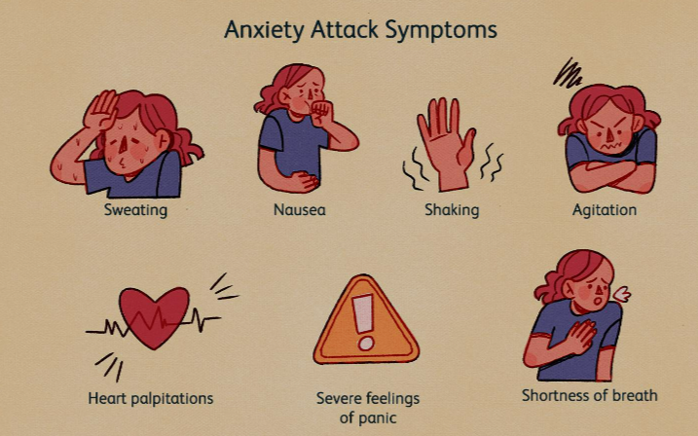

**Anxiety Attack Symptoms**

**Causes:** The causes of anxiety disorders are complicated. Many might occur at once, some may lead to others, and some might not lead to an anxiety disorder unless another is present.

*Possible causes include* environmental stressors, such as difficulties at work, relationship problems, or family issues, some withdrawal from an illicit substance, genetics, as people who have family members with an anxiety disorder are more likely to experience one themselves or some misalignments of hormones and electrical signals in the body.

***Examples:***

(1) **Anxiety due to fear of something**: Fear and anxiety are interrelated. When faced with fear, most people will feel the physical reactions that are described under anxiety. It's often a response to an unknown threat.

(2) **Anxiety due to examination**: Positive attitude is necessary, keep on telling yourself that "you can do this". Don't get disheartened if you are unable to solve something, if it is hard for you, it may be hard for others too. Learn to accept that even with the best preparation it isn't necessary that you face a question that you aren't able to answer.

(3) **Anxiety due to family members:** COVID-19 has brought all of us closer to our families. The time we spend with our families is sometimes like walking on hot coals; we couldn’t wait for it to be over. It’s like all their reasoning and maturity went away when faced with close-minded comments and overly opinionated uncles. All you gotta do is just take your time away from everyone and try to figure out why it is happening.

(4) **Anxiety due to introversion during public speaking and gathering:** Many people with this fear avoid public speaking situations altogether, or they suffer through them with shaking hands and a quavering voice.

**How to combat Anxiety:**

**Awareness/Education:** The more you know and learn about your anxiety, the better you

will be able to cope with and overcome it. The first step you should take is to contact a

health care professional.

**Positive thinking:** You know that avoiding things that make you anxious doesn’t solve the

problem – it makes it worse. Try not to avoid these situations, have confidence in your

ability to cope with them and don’t be too hard on yourself.

**Structuring the day:** Setting yourself goals and challenges is a good way to fight anxiety –

use lists to help identify things you want to overcome.

**Exercise:** Taking regular exercise helps the body to naturally produce a sense of well-being

and it can trigger brain chemicals that will improve your mood. Being fit can also help you

feel more positive about yourself. Meditation or yoga can also help enhance relaxation.

**Talk to someone:** ‘A problem shared is a problem halved’ the old expression goes. Talking

to family and friends is a good way to confront any problems you may have with anxiety and

those closest to you can offer support. Talking to your GP, a counsellor or psychotherapist

may also help you better understand your anxiety, how it affects you and how you may deal

with it more effectively?

**DEPRESSION…**

**Definition:** It is characterised by feelings of low self-worth or guilt and a reduced capacity to enjoy life. Depression often manifests as the following symptoms: sadness, hopelessness, pessimism, diminished self-esteem, diminished ability to enjoy ordinary activities, lowered energy and vitality, slowness of thinking, lack of appetite, and disturbed sleep or insomnia. Grief or mourning, which are appropriate emotional responses to losing loved ones or objects, is distinct from depression.

**Relevance:** A person's unhappiness is usually a result of a clearly identifiable cause, but depression is considered present if the depressive mood lasts disproportionately long or is extremely severe compared to the precipitating event

**Types of depression:** bipolar disorder, major depressive disorder, and persistent depressive disorder are the primary types of depression. A person who experiences alternating states of depression and mania (abnormal elevation of mood) or hypomania is said to suffer from bipolar disorder. Major depressive disorder is characterised by severe symptoms that disrupt the individual’s daily life, typically with effects on appetite, sleep, work, or the ability to enjoy life. Episodes of major depression can occur at any age and may occur once or multiple times in an affected person’s life. Persistent depressive disorder involves symptoms that last two or more years, sometimes marked by episodes of major depression.

**Characteristics and causes of depression:** A person's recovery from the disorder varies greatly from person to person; it may be mild or severe, acute or chronic. The average duration of depression is four months or longer if left untreated. Unfavourable life events can increase a person’s vulnerability to depression or trigger a depressive episode. Negative thoughts about oneself and the world are also important in producing and maintaining depressive symptoms. However, both psychosocial and biochemical mechanisms seem to be important causes.

A depressed person's amygdala may be enlarged, hyperactive, or otherwise dysfunctional because it is associated with processing negative thoughts. Although the significance of these associations has yet to be determined, the link between depression, disordered REM sleep, and abnormalities in the amygdala has paved the way for new research into the neurobiology and treatment of depression.

According to research, depression is also linked to physical activity, implying that physical activity may reduce a person's risk of depression. People who exercise report better mental health and are less likely to be depressed than those who do not exercise.

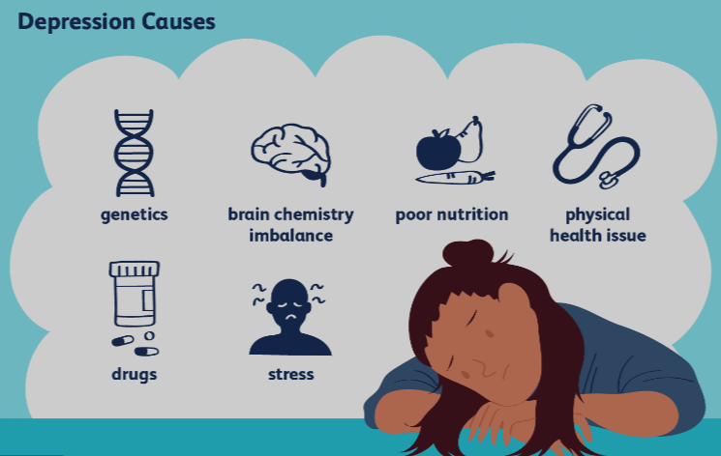

**Depression Causes**

**How to combat Depression:** These tips can help you feel better -- starting right now.

1. **Get in a routine**. If you’re depressed, you need a routine. One day melts into the next. Setting a gentle daily schedule can help you get back on track.

2. **Exercise.** It temporarily boosts feel-good chemicals called endorphins. It may also have long-term benefits for people with depression. Regular exercise seems to encourage the brain to rewire itself in a positive way.

3. **Challenge negative thoughts.** In your fight against depression, a lot of the work is mental -- changing how you think. When you are depressed, you leap to the worst possible conclusions. The next time you are feeling terrible about yourself, use logic as a natural depression treatment.

4. **Do something new**. When you are depressed, you’re in a rut. Push yourself to do something different. Go to a museum. Pick up a used book and read it on a park bench. Volunteer at a soup kitchen. Take a language class.

5. **Avoid alcohol and other drugs.** Substance misuse is common in people who have depression. It’s unclear if drinking and using drugs causes depression. But long-term drug use could change the way your brain works and worsen or lead to mental health problems.

**IMPACT ON PROFESSIONAL LIFE**

**STRESS**

It found that stress is the foremost factor that has influenced employee functioning during the pandemic. Stress has adversely affected individuals’ morale, performance, and motivation. In particular, the negative changes caused by COVID-19 have altered workers’ lives by significantly impeding their work performance. Demonstrate that the growing pandemic stress has created a sense of chaos, leading organizations to report poor worker performance. The hustle culture has caused increasing uncertainty, with reporting psychological symptoms, emotional exhaustion, and workload stress.

**DEPRESSION** Depression has become a major obstacle to employee performance. It considerably affects the work status of employees overwhelming them and negatively impacting their work performance. Research findings indicate that depression results in poorer work outcomes, negatively affecting healthcare performance. One study demonstrated how intense workloads have increased depression among individuals, in turn negatively affecting work quality.

**ANXIETY:** Several factors affect employee performance, but among them, anxiety is a critical factor that demands the attention of researchers. Anxiety has been demonstrated to have a toxic effect on employee performance.

**IMPACT ON PERSONAL LIFE**

**Physical health**: Poor mental health can lead to a variety of physical health problems, such as heart disease, high blood pressure, digestive issues, headaches, and weakened immune system.

**Mental health**: Chronic stress can contribute to the development of mental health problems, such as anxiety disorders, depression, and burnout, suicidal thoughts, etc.

**Relationships**: stress, anxiety and depression can put a strain on relationships, leading to increased conflict, communication problems, and decreased intimacy.

**Work performance**: Anxiety and depression can impact work performance, leading to decreased productivity, absenteeism, and increased job dissatisfaction.

**Quality of life**: Depression can reduce a person's quality of life, leading to decreased enjoyment of leisure activities, increased social isolation, and decreased overall life satisfaction.

**IMPACT ON SOCIETAL/GROUP**

Stress and anxiety can have a significant impact on both society and groups, both in terms of the individuals who experience them and the wider social and economic consequences.

· At the societal level, stress and anxiety can lead to increased healthcare costs, decreased productivity, and lost workdays. It can also result in higher rates of crime, domestic violence, and substance abuse.

· Stress and anxiety can have a negative impact on the economy by reducing consumer spending and lowering economic growth.

· In group settings, stress and anxiety can lead to conflicts and reduced cohesion. When members of a group are experiencing high levels of stress and anxiety, they may be less willing to cooperate with one another, resulting in decreased productivity and effectiveness.

· Furthermore, when one member of a group is stressed or anxious, it can spread to other members, leading to a cascade effect, and further exacerbating the problem.

· Overall, the impact of stress and anxiety on society and groups is significant, and addressing these issues requires a multifaceted approach that involves addressing the underlying causes of stress and anxiety, providing appropriate resources and support to those who experience them, and promoting healthy coping mechanisms.