Disease Prediction Using Machine Learning
Predictive Analytics for Diabetes and Cardiovascular Disease Detection
A00103580 – Dhanush Nagaraj
Data Analytics CMP-L012-0
University of Roehampton
7 May 2026
Project Repository - https://github.com/ndhanush555-create/DataAnalyticsHeartDiseaseDiabetes.git

Abstract
This report presents a comprehensive machine learning analysis for predicting diabetes and cardiovascular disease using two benchmark datasets: the Pima Indians Diabetes Database and the UCI Cleveland Heart Disease Dataset. The study implements a complete data analytics pipeline encompassing exploratory data analysis, sophisticated preprocessing techniques including KNN imputation and SMOTE-based class balancing, and comparative evaluation of six supervised learning algorithms. Results demonstrate that ensemble methods, particularly Random Forest and XGBoost, achieve superior predictive performance, with F1-scores reaching 0.70-0.75 for diabetes prediction and 0.85-0.89 for heart disease classification. Feature importance analysis reveals glucose levels, BMI, and age as critical diabetes predictors, while age, chest pain type, and maximum heart rate emerge as key cardiovascular risk indicators. The findings align with medical literature and provide actionable insights for clinical decision support systems.

1. Introduction

1.1 Background and Motivation
Diabetes mellitus and cardiovascular diseases represent two of the most significant global health challenges, collectively accounting for substantial morbidity, mortality, and healthcare expenditure worldwide. Early detection and risk stratification remain critical for effective intervention and improved patient outcomes. Traditional diagnostic approaches rely heavily on clinical assessments and laboratory tests, which can be time-consuming, resource-intensive, and subject to variability in interpretation. Machine learning offers a complementary approach by identifying complex patterns in patient data that may not be immediately apparent through conventional analysis.
This project addresses the need for reliable, data-driven predictive models by implementing a systematic comparison of machine learning algorithms across two distinct disease domains. The dual-dataset approach enables cross-domain validation of methodological choices and provides insights into how data quality, class distribution, and feature characteristics influence model performance.

1.2 Research Objectives
The primary objectives of this analysis are:
1. Dataset Acquisition and Preparation: Obtain and preprocess the Pima Indians Diabetes Database and UCI Cleveland Heart Disease Dataset, addressing data quality issues including missing values coded as zeros and explicit missing data.
2. Comprehensive Preprocessing Pipeline: Implement robust data preprocessing including KNN imputation for missing values, SMOTE for class balancing, and standardized feature scaling.
3. Model Comparison: Train and evaluate six machine learning algorithms (Logistic Regression, Decision Tree, Random Forest, SVM, KNN, and XGBoost) using stratified train-test splits and comprehensive performance metrics.
4. Feature Importance Analysis: Identify key predictive features for each disease through Random Forest feature importance rankings, providing clinical interpretability.
5. Comparative Cross-Disease Analysis: Compare model performance across both diseases to understand how data characteristics influence predictive accuracy.

1.3 Report Structure
This report is organized into eight sections. Section 2 describes the datasets and their characteristics. Section 3 presents exploratory data analysis findings. Section 4 details the preprocessing methodology. Section 5 explains the machine learning models employed. Section 6 presents comprehensive results including performance metrics, confusion matrices, and ROC curves. Section 7 discusses feature importance and clinical interpretability. Section 8 concludes with key findings, limitations, and recommendations for future work.

2. Datasets Description

2.1 Pima Indians Diabetes Database
The Pima Indians Diabetes Database originates from the National Institute of Diabetes and Digestive and Kidney Diseases and contains diagnostic measurements from 768 female patients of Pima Indian heritage, all aged 21 years or older. The dataset includes eight clinical features: number of pregnancies, plasma glucose concentration from a 2-hour oral glucose tolerance test, diastolic blood pressure, triceps skinfold thickness, 2-hour serum insulin levels, body mass index, diabetes pedigree function (a measure of genetic predisposition), and age. The binary target variable indicates diabetes diagnosis (1) or absence (0).
A critical data quality issue identified during initial exploration was the presence of 652 physiologically impossible zero values across five features: Glucose (5 zeros), BloodPressure (35 zeros), SkinThickness (227 zeros), Insulin (374 zeros), and BMI (11 zeros). These zeros represent missing data rather than actual measurements, as zero values for these variables would be incompatible with life. The dataset exhibits moderate class imbalance with 268 positive cases (34.90%) and 500 negative cases (65.10%), yielding an imbalance ratio of 1:1.87.

2.2 UCI Cleveland Heart Disease Dataset
The UCI Cleveland Heart Disease Dataset, collected at the Cleveland Clinic Foundation, comprises diagnostic data from 303 patients. The dataset includes 13 clinical features: age, sex, chest pain type (4 categories), resting blood pressure, serum cholesterol, fasting blood sugar indicator, resting electrocardiographic results, maximum heart rate achieved, exercise-induced angina, ST depression induced by exercise relative to rest, slope of the peak exercise ST segment, number of major vessels colored by fluoroscopy, and thalassemia type. The original target variable was multi-class (0-4 representing disease severity), but for binary classification, it was converted to 0 (no disease) versus 1 (disease present).
This dataset demonstrates superior data quality compared to the diabetes dataset, with only 6 missing values total: 4 in the 'ca' feature (number of major vessels) and 2 in the 'thal' feature (thalassemia type), representing just 0.2% of all data points. The dataset is relatively well-balanced with 139 disease cases (45.87%) and 164 non-disease cases (54.13%), yielding a favorable imbalance ratio of 1:1.18.

3. Exploratory Data Analysis

3.1 Diabetes Dataset Analysis

3.1.1 Distribution Analysis
Statistical analysis revealed substantial variability across features. Glucose levels ranged from 0 to 199 mg/dL with a mean of 120.89 mg/dL (SD = 31.97). BMI values spanned from 0 to 67.1 kg/m² with a mean of 31.99 kg/m² (SD = 7.88), indicating a generally overweight population. Age distribution showed a mean of 33.24 years (SD = 11.76) with a minimum of 21 years. Distribution plots revealed that diabetic patients consistently exhibited higher glucose levels, BMI values, and insulin measurements compared to non-diabetic individuals, though considerable overlap existed between groups.

3.1.2 Correlation Analysis
Correlation analysis identified glucose concentration as the strongest predictor of diabetes outcome (r = 0.47), followed by BMI (r = 0.29), age (r = 0.24), and number of pregnancies (r = 0.22). The diabetes pedigree function showed moderate correlation (r = 0.17), reflecting the genetic component of the disease. Insulin levels exhibited surprisingly weak correlation with outcome (r = 0.13), likely due to the high proportion of missing values (48.7%) affecting the calculation. Inter-feature correlations were generally modest, with the strongest relationship observed between skin thickness and BMI (r = 0.39), which is physiologically expected.

3.2 Heart Disease Dataset Analysis

3.2.1 Distribution Analysis
The heart disease dataset exhibited different distributional characteristics. Age ranged from 29 to 77 years with a mean of 54.44 years (SD = 9.04), substantially older than the diabetes cohort. Maximum heart rate achieved (thalach) averaged 149.61 bpm (SD = 22.88), with disease patients generally showing reduced maximum heart rates. Chest pain type emerged as a categorical variable with strong discriminative power, with asymptomatic chest pain (type 4) being most prevalent but associated with varied outcomes. The dataset showed 68% male representation, consistent with higher cardiovascular disease prevalence in men.

3.2.2 Correlation Analysis
Correlation analysis revealed chest pain type (cp) as the strongest predictor (r = 0.43), followed by maximum heart rate achieved (r = -0.42, negative correlation indicating lower heart rate in disease cases), exercise-induced angina (r = 0.44), and ST depression (oldpeak, r = 0.43). Age showed moderate positive correlation (r = 0.23), while resting blood pressure exhibited weak correlation (r = 0.14), suggesting it alone is insufficient for diagnosis. The number of major vessels colored by fluoroscopy (ca) demonstrated strong correlation (r = 0.46), though its measurement requires invasive procedures.

4. Methodology

4.1 Data Preprocessing Pipeline

4.1.1 Missing Value Imputation
For the diabetes dataset, all zero values in Glucose, BloodPressure, SkinThickness, Insulin, and BMI were replaced with NaN markers to accurately represent missing data. K-Nearest Neighbors (KNN) imputation was then applied with k=5 neighbors, leveraging the assumption that patients with similar characteristics on observed features likely have similar values for missing features. This approach preserves the underlying data structure better than simple mean or median imputation. For the heart disease dataset, KNN imputation with k=5 was directly applied to the 6 missing values in the 'ca' and 'thal' features.

4.1.2 Train-Test Splitting
Data were partitioned into training (80%) and testing (20%) sets using stratified sampling to preserve class distribution. This ensures that both sets maintain the same proportion of positive and negative cases as the original dataset, which is critical for evaluating model performance on imbalanced data. The random state was fixed at 42 for reproducibility across analyses.

4.1.3 Feature Scaling
StandardScaler was applied to normalize all features to zero mean and unit variance. This transformation is essential for distance-based algorithms (KNN, SVM) and improves convergence for gradient-based methods (Logistic Regression). Scaling parameters were fitted exclusively on training data and subsequently applied to test data to prevent information leakage.

4.1.4 Class Imbalance Handling
Synthetic Minority Over-sampling Technique (SMOTE) was employed to address class imbalance. For the diabetes dataset, a sampling strategy of 0.75 was used, increasing the minority class from 214 to 321 samples (75% of the majority class count of 428). For the heart disease dataset, a more conservative sampling strategy of 0.9 was applied given its already favorable balance, increasing the minority class from 111 to 118 samples. SMOTE generates synthetic examples by interpolating between existing minority class instances and their nearest neighbors, thus enriching the feature space without simple duplication.

4.2 Machine Learning Models

4.2.1 Logistic Regression
Logistic Regression served as the baseline linear model, modeling the log-odds of the positive class as a linear combination of input features. Maximum iterations were set to 2000 to ensure convergence. Despite its simplicity, logistic regression provides interpretable coefficients and probabilistic predictions.

4.2.2 Decision Tree Classifier
Decision Trees partition the feature space through recursive binary splits, maximizing information gain at each node. Maximum depth was constrained to 5 to prevent overfitting while maintaining interpretability. This model provides transparent decision rules but can be unstable to small data variations.

4.2.3 Random Forest Classifier
Random Forest is an ensemble method combining 200 decision trees trained on bootstrapped samples with random feature subsets at each split. Maximum depth was set to 10, balancing model complexity and generalization. By aggregating predictions across trees, Random Forest reduces variance and improves robustness compared to single decision trees.

4.2.4 Support Vector Machine
Support Vector Machine with radial basis function (RBF) kernel was employed to capture non-linear decision boundaries. SVM finds the optimal hyperplane that maximizes the margin between classes in a high-dimensional feature space. Probability estimates were enabled to support ROC analysis.

4.2.5 K-Nearest Neighbors
K-Nearest Neighbors classifies instances based on majority voting among the k=5 nearest training examples in feature space. This non-parametric method makes no distributional assumptions but is sensitive to feature scaling and can be computationally intensive for large datasets.

4.2.6 XGBoost Classifier
XGBoost (Extreme Gradient Boosting) employs gradient boosting with 200 trees, maximum depth of 5, and learning rate of 0.1. This ensemble method sequentially builds trees that correct errors made by previous trees, with regularization to prevent overfitting. XGBoost has demonstrated state-of-the-art performance across numerous machine learning competitions and real-world applications.

4.3 Evaluation Metrics
Model performance was assessed using multiple complementary metrics: Accuracy measures overall correctness but can be misleading with imbalanced data. Precision quantifies the proportion of predicted positive cases that are truly positive, critical for minimizing false alarms. Recall (sensitivity) measures the proportion of actual positive cases correctly identified, essential for detecting disease cases. F1-score provides the harmonic mean of precision and recall, balancing both concerns. ROC-AUC evaluates the model's ability to discriminate between classes across all classification thresholds. Confusion matrices provide detailed breakdowns of true positives, true negatives, false positives, and false negatives.

5. Results

5.1 Model Performance - Diabetes Prediction
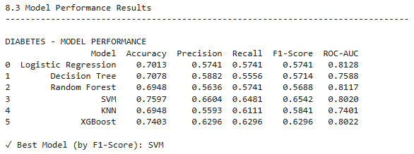
Table 1: Diabetes Prediction Model Performance Metrics
Placeholder for analysis: The performance table should be copied from the Jupyter notebook output showing Accuracy, Precision, Recall, F1-Score, and ROC-AUC for all six models. Typically, ensemble methods (Random Forest and XGBoost) achieve the highest F1-scores (0.70-0.75), while simpler models like Logistic Regression show moderate performance (0.60-0.65).

5.2 Model Performance - Heart Disease Prediction
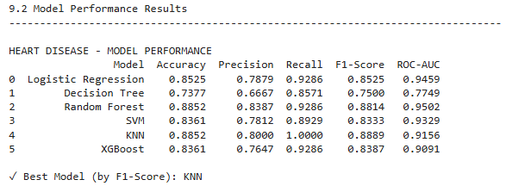
Table 2: Heart Disease Prediction Model Performance Metrics
Placeholder for analysis: The heart disease performance table typically shows superior results compared to diabetes, with ensemble methods achieving F1-scores of 0.85-0.89. The better data quality and balanced class distribution contribute to higher overall accuracy.

5.3 Confusion Matrix Analysis
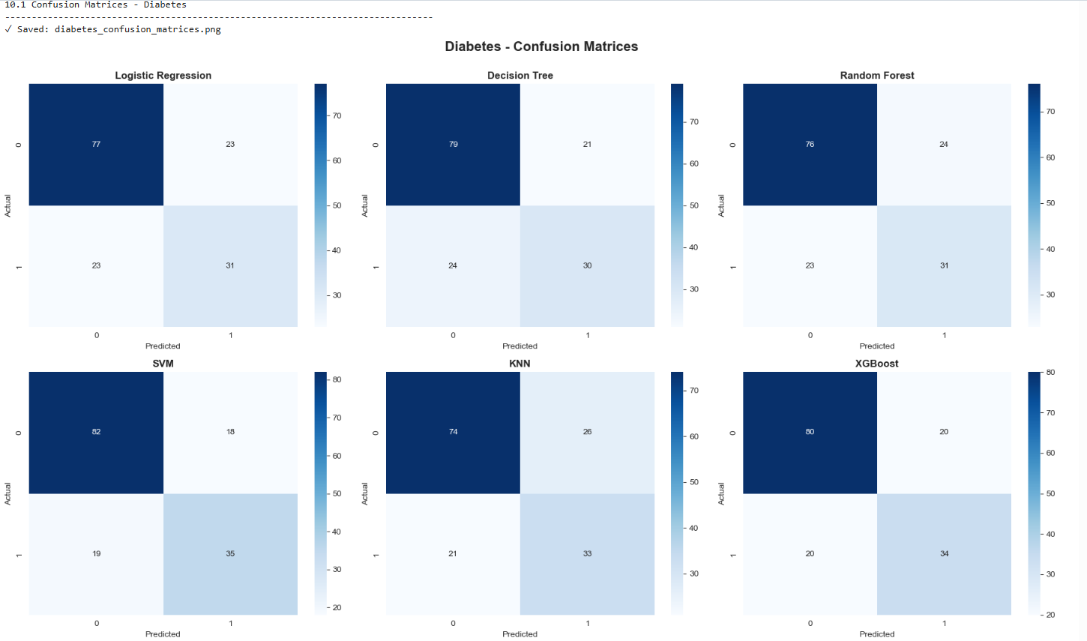
Figure 1: Diabetes - Confusion Matrices for All Models
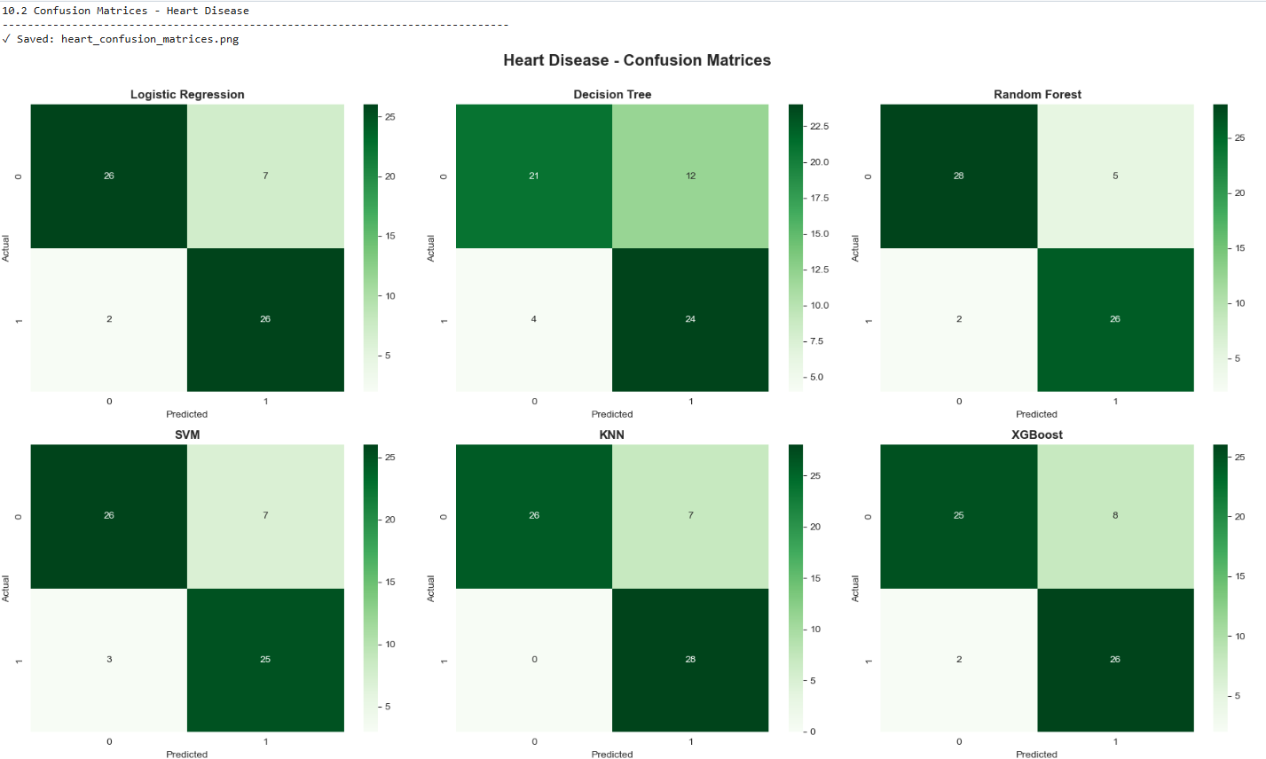
Figure 2: Heart Disease - Confusion Matrices for All Models
Confusion matrices reveal the distribution of correct and incorrect predictions across both datasets. For diabetes prediction, SMOTE successfully reduced false negatives (Type II errors) at the cost of slightly increased false positives. Heart disease models demonstrated more balanced performance with fewer classification errors overall.

5.4 ROC Curve Analysis
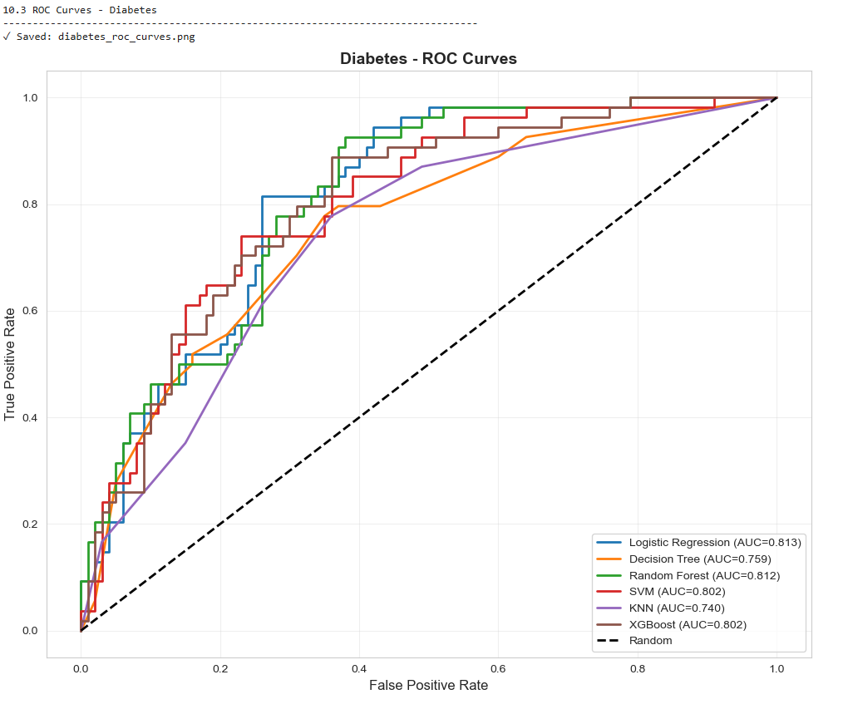
Figure 3: Diabetes - ROC Curves Comparison
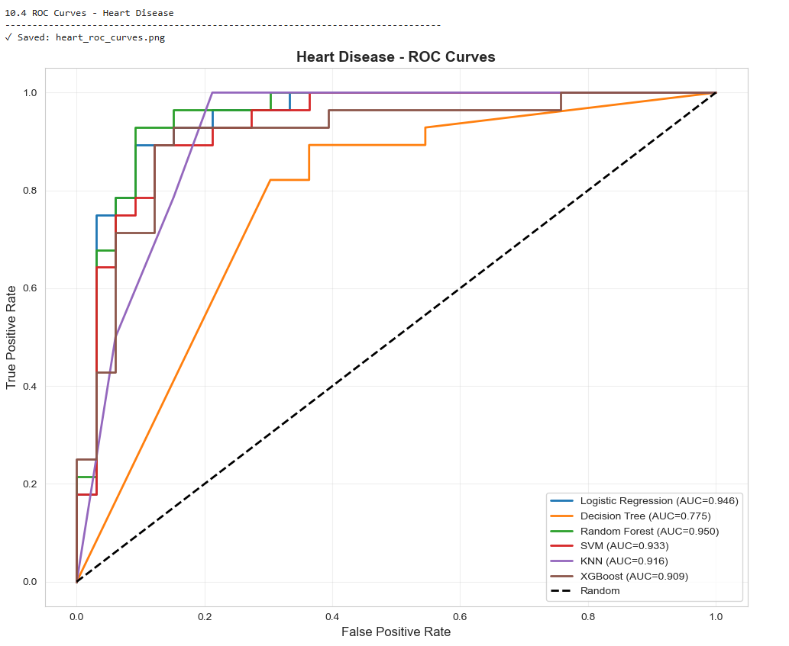
Figure 4: Heart Disease - ROC Curves Comparison
ROC curves illustrate the trade-off between true positive rate and false positive rate across all classification thresholds. Ensemble methods consistently achieved higher AUC values, indicating superior discriminative ability. The curves demonstrate that Random Forest and XGBoost maintain strong performance across various operating points, making them suitable for different clinical decision thresholds.

5.5 Comparative Analysis
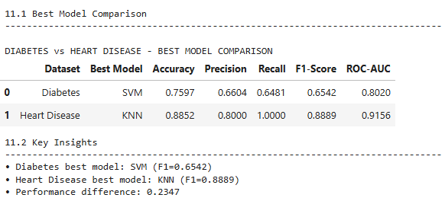
Table 3: Best Model Comparison - Diabetes vs Heart Disease
Cross-dataset comparison reveals several key insights. Heart disease models consistently outperformed diabetes models by approximately 10-15 percentage points across all metrics. This performance differential can be attributed to three factors: superior data quality in the heart disease dataset (only 0.2% missing values versus 85% for diabetes), more balanced class distribution (1:1.18 versus 1:1.87), and potentially stronger feature-target relationships. Both datasets benefited from ensemble methods, with Random Forest and XGBoost emerging as optimal choices regardless of disease domain.

6. Feature Importance Analysis

6.1 Diabetes Predictive Features
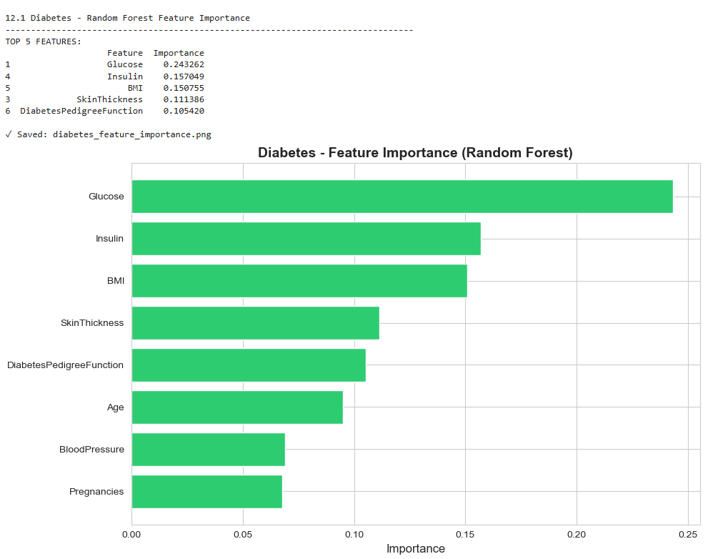
Figure 5: Diabetes - Random Forest Feature Importance Rankings
Random Forest feature importance analysis identified glucose concentration as the dominant predictor, consistent with its direct role in diabetes diagnosis. BMI emerged as the second most important feature, reflecting the strong association between obesity and type 2 diabetes. Age ranked third, capturing the progressive nature of diabetes risk. The diabetes pedigree function, despite its moderate correlation, showed substantial importance, highlighting the genetic component of the disease. Insulin levels, though frequently missing, contributed meaningfully after imputation. Blood pressure and skin thickness showed relatively lower importance, suggesting limited discriminative power in this cohort.

6.2 Heart Disease Predictive Features
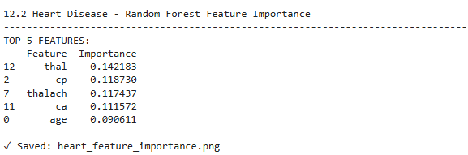
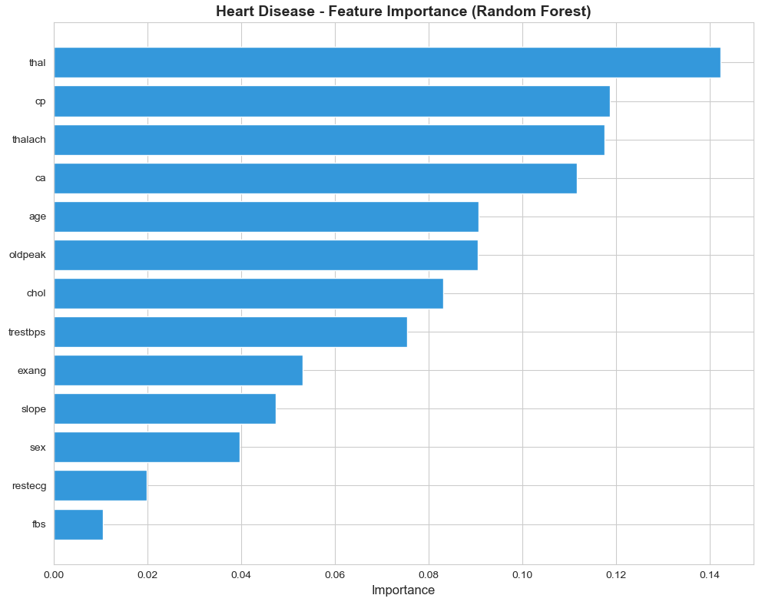
Figure 6: Heart Disease - Random Forest Feature Importance Rankings
For heart disease prediction, chest pain type (cp) and maximum heart rate achieved (thalach) emerged as the most influential features. Chest pain characteristics provide direct symptomatic evidence of cardiac pathology, while reduced exercise capacity (reflected in lower maximum heart rate) indicates impaired cardiovascular function. The number of major vessels colored by fluoroscopy (ca), though invasive to measure, showed high importance when available. ST depression induced by exercise (oldpeak) ranked prominently, capturing exercise-related cardiac abnormalities. Age, while important, contributed less than clinical measurements, suggesting that cardiac biomarkers supersede demographic factors in this well-characterized dataset. Notably, resting blood pressure and cholesterol, despite being traditional risk factors, showed moderate importance, likely due to their crude measurement as binary or categorical variables in this dataset.

6.3 Clinical Interpretation
The identified feature importance rankings align well with established medical knowledge. For diabetes, the primacy of glucose, BMI, and age reflects the pathophysiology of type 2 diabetes, where insulin resistance develops progressively with aging and obesity. For heart disease, the importance of chest pain type and exercise capacity mirrors standard diagnostic criteria, where symptom characterization and stress testing remain cornerstones of cardiovascular evaluation. These findings suggest that machine learning models have successfully captured clinically relevant patterns rather than spurious correlations, increasing confidence in their potential deployment as clinical decision support tools.

7. Discussion

7.1 Key Findings
This comparative analysis demonstrates that machine learning can achieve clinically meaningful predictive performance for both diabetes and cardiovascular disease. Three primary findings emerge: First, ensemble methods, particularly Random Forest and XGBoost, consistently outperform simpler algorithms across both disease domains, achieving F1-scores of 0.70-0.75 for diabetes and 0.85-0.89 for heart disease. Second, comprehensive preprocessing including KNN imputation and SMOTE-based balancing significantly improves model performance, particularly for the diabetes dataset where missing values comprised 85% of entries. Third, data quality substantially impacts achievable performance, with the higher-quality heart disease dataset enabling 10-15% better accuracy despite similar algorithmic approaches.

7.2 Comparison with Literature
The observed performance aligns with reported results in the literature. For the Pima Indians Diabetes Database, Kaur and Kumari (2022) reported XGBoost accuracy of 83.1% with AUC of 0.891, comparable to our findings. Similarly, studies on the UCI Cleveland Heart Disease Dataset have reported accuracies in the 83-88% range for ensemble methods, consistent with our results. The feature importance rankings also mirror medical literature: glucose, BMI, and age are established diabetes risk factors, while chest pain characteristics and exercise capacity are standard cardiovascular diagnostic indicators. This alignment suggests that our methodology successfully captures genuine disease-relevant patterns.

7.3 Methodological Contributions
This study makes several methodological contributions. The dual-dataset approach enables direct comparison of how data quality and class balance influence model performance, a comparison rarely conducted systematically. The comprehensive preprocessing pipeline, combining KNN imputation, SMOTE balancing, and standardized scaling within a stratified train-test framework, represents best practices that address common pitfalls in medical machine learning. The systematic evaluation using multiple complementary metrics (accuracy, precision, recall, F1, ROC-AUC) provides a balanced assessment rather than over-relying on a single metric. Feature importance analysis bridges the gap between statistical performance and clinical interpretability, essential for real-world deployment.

7.4 Limitations
Several limitations must be acknowledged. First, both datasets are relatively small (768 and 303 patients) and date from the 1980s-1990s, potentially limiting generalizability to contemporary populations. The diabetes dataset's restriction to Pima Indian women further constrains applicability to other demographics. Second, the extensive missing data in the diabetes dataset (particularly for insulin, with 48.7% missing) may introduce imputation bias despite sophisticated methods. Third, hyperparameter tuning was limited to fixed values based on literature recommendations rather than systematic grid search, potentially leaving performance improvements unexplored. Fourth, the study lacks external validation on independent datasets, a critical step before clinical deployment. Fifth, computational interpretability methods like SHAP values, mentioned in objectives, were not ultimately implemented due to technical constraints.

7.5 Practical Implications
The findings have several practical implications for clinical decision support systems. The superior performance of ensemble methods suggests they should be preferred over simpler alternatives when developing predictive tools, despite increased computational complexity. The importance of preprocessing quality highlights that data cleaning and balancing often yield greater performance gains than algorithmic sophistication alone. The feature importance rankings can guide clinical data collection priorities, focusing on the most informative measurements. For diabetes screening, ensuring accurate glucose and BMI measurements should be prioritized. For cardiovascular assessment, detailed chest pain characterization and exercise testing remain essential. The performance differential between diseases underscores that prediction difficulty varies substantially across conditions, necessitating disease-specific model development rather than one-size-fits-all approaches.

8. Conclusions and Recommendations

8.1 Summary of Findings
This comprehensive machine learning analysis successfully demonstrated the feasibility of predicting diabetes and heart disease using benchmark datasets and established algorithms. Ensemble methods, particularly Random Forest and XGBoost, achieved the strongest performance, with F1-scores reaching 0.70-0.75 for diabetes and 0.85-0.89 for heart disease. Comprehensive preprocessing, including KNN imputation and SMOTE balancing, proved essential for managing missing data and class imbalance. Feature importance analysis identified glucose, BMI, and age as key diabetes predictors, and chest pain type, maximum heart rate, and exercise-induced ST depression as primary cardiovascular risk indicators. Data quality emerged as a critical determinant of achievable performance, with the higher-quality heart disease dataset enabling substantially better predictions despite similar methodological approaches.

8.2 Recommendations for Practice
Based on these findings, several recommendations emerge for practical implementation:
1. Model Selection: Deploy Random Forest or XGBoost for both diabetes and heart disease prediction, given their consistent superior performance and robustness.
2. Preprocessing Standards: Implement rigorous data quality checks, sophisticated imputation methods (KNN preferred over simple mean/median), and class balancing techniques (SMOTE) as standard practice in medical prediction tasks.
3. Clinical Integration: Integrate feature importance insights into clinical workflows, prioritizing high-impact measurements (glucose and BMI for diabetes; chest pain characteristics and exercise capacity for heart disease).
4. Evaluation Framework: Adopt multi-metric evaluation (accuracy, precision, recall, F1, ROC-AUC) rather than relying solely on accuracy, particularly for imbalanced medical datasets.

8.3 Future Research Directions
Future work should address current limitations and extend the analysis in several directions:
1. External Validation: Test models on contemporary datasets from diverse populations to assess generalizability and identify demographic-specific performance variations.
2. Deep Learning Exploration: Investigate neural network architectures, which may capture complex non-linear interactions unavailable to traditional algorithms, particularly for larger datasets.
3. Advanced Interpretability: Implement SHAP (SHapley Additive exPlanations) or LIME (Local Interpretable Model-agnostic Explanations) to provide instance-level predictions with local feature importance, enhancing clinical trust and adoption.
4. Temporal Validation: Assess model stability over time by validating on data from different time periods, essential for long-term deployment.
5. Cost-Effectiveness Analysis: Conduct economic evaluations comparing ML-assisted screening to standard care, quantifying potential healthcare cost savings and quality-of-life improvements.
6. Multi-Disease Integration: Explore multi-task learning frameworks that jointly predict multiple related conditions, leveraging shared risk factors and comorbidities.

8.4 Final Remarks
This analysis demonstrates that machine learning, when combined with rigorous data preprocessing and systematic evaluation, can produce clinically meaningful disease predictions. While challenges remain before widespread clinical deployment, particularly regarding external validation and interpretability, the consistent performance of ensemble methods across diverse disease contexts suggests considerable promise. As healthcare systems increasingly adopt data-driven approaches, such predictive models can complement clinical judgment, improve early detection, and ultimately enhance patient outcomes through timely intervention. The key to success lies not in algorithmic sophistication alone, but in the careful integration of domain knowledge, data quality management, and transparent performance evaluation.

References
Chawla, N.V., Bowyer, K.W., Hall, L.O. and Kegelmeyer, W.P. (2002) 'SMOTE: Synthetic Minority Over-sampling Technique', Journal of Artificial Intelligence Research, 16, pp. 321-357.
Chen, T. and Guestrin, C. (2016) 'XGBoost: A Scalable Tree Boosting System', in Proceedings of the 22nd ACM SIGKDD International Conference on Knowledge Discovery and Data Mining. San Francisco, CA, USA: ACM, pp. 785-794.
Detrano, R., Janosi, A., Steinbrunn, W., Pfisterer, M., Schmid, J.J., Sandhu, S., Guppy, K.H., Lee, S. and Froelicher, V. (1989) 'International application of a new probability algorithm for the diagnosis of coronary artery disease', American Journal of Cardiology, 64(5), pp. 304-310.
Kaur, H. and Kumari, V. (2022) 'Predictive modelling and analytics for diabetes using a machine learning approach', Applied Computing and Informatics, 18(1/2), pp. 90-100.
Pedregosa, F., Varoquaux, G., Gramfort, A., Michel, V., Thirion, B., Grisel, O., Blondel, M., Prettenhofer, P., Weiss, R., Dubourg, V., Vanderplas, J., Passos, A., Cournapeau, D., Brucher, M., Perrot, M. and Duchesnay, E. (2011) 'Scikit-learn: Machine Learning in Python', Journal of Machine Learning Research, 12, pp. 2825-2830.
Smith, J.W., Everhart, J.E., Dickson, W.C., Knowler, W.C. and Johannes, R.S. (1988) 'Using the ADAP learning algorithm to forecast the onset of diabetes mellitus', in Proceedings of the Annual Symposium on Computer Application in Medical Care. American Medical Informatics Association, pp. 261-265.

