Software Design Post-Homework 5 Reflection
- Project Overview: What were you trying to accomplish? What was your general approach?

We were trying to accomplish valuing public sentiment on general topics from public Facebook posts and comments. Our general approach was first gathering the posts and comments into a list, use pattern's sentiment on the content of the list, and plot a histogram of the results. Our general approach was a step by step approach, building our code upon previous functions.

- Implementation: How does your code work? What libraries did you use? How would someone (for instance a NINJA) run your code? What data structures (e.g. lists, dictionaries) did you use in your program and why?

Our code is grouped into functions. Our first function, facebook_status1, searches through your Facebook friends for a specified keyword. We put the statuses and sentiment tuples into lists. Our first function, facebook_search, searches public Facebook posts and gathers the posts that contain the topic specified. We also put the statuses and sentiment tuple values into a list as well. We wanted to be able to index through them to access them. The second function, get_feelings, gets the first value in each tuple that sentiment returns. The third function, get_feelings_unit_test, takes in as an input a list of tuples and uses the previous function to return the first value. Our third function, plot_histogram, takes in the option of sentiment or objectivity, and plots a sentiment or objectivity of the data from facebook_search.

We used pattern.web to search through Facebook, pattern.en for sentiment analysis, matplotlib.pyplot to plot a histogram, and time to add a pause.

Before running anything, our NINJA would need to input their facebook license (shown in code comments) in the facebook_search and facebook_status1 functions. Our NINJA would run our code by importing the entire program and running plot_histogram with two inputs: the first input should be either 'feelings' or 'subjectivity', the second input be either 'status' or 'search public'. This would result in feelings or sentiment of their friends or public, respectively, and if they look at public, they can search a certain topic. In our code, there are comments showing what to change in facebook_search if they want to search a different topic. If they just want to search Facebook for a specific key word and see the posts themselves, then they should use facebook_search. If they want to search their Facebook friends posts, then they should run facebook_status1 and input their own Facebook license.

- Results: If you did some text analysis, what interesting things did you find? If you created a program that does something interesting (e.g. a Markov text synthesizer), provide a few interesting examples of the program's output.
We searched through public Facebook posts to gather more variety of posts. We evaluated the s sentiment of each post and we made a histogram of the sentiment. The following histogram is of the sentiment of the Sochi Winter Olympics.

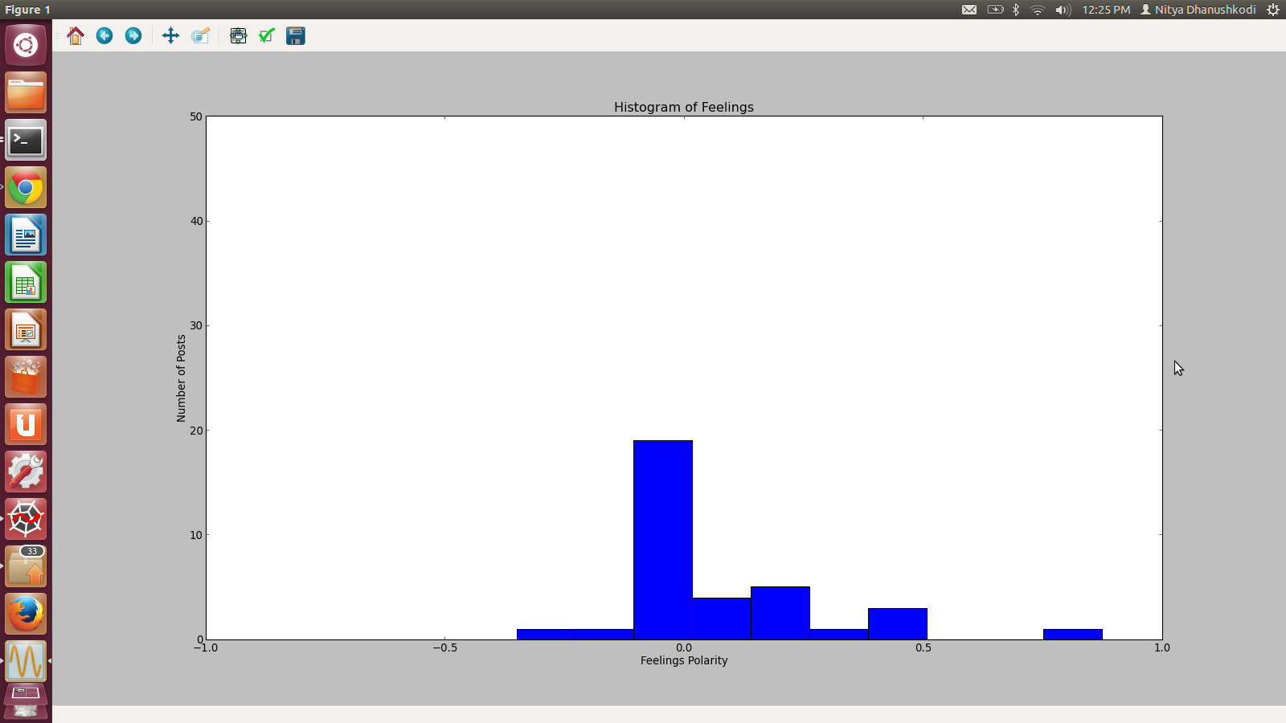Illustration 1: Sentiment on Sochi Winter Olympics 2014

The following is a graph of the subjectivity on the Sochi Winter Olympics 2014 of the posts analyzed.

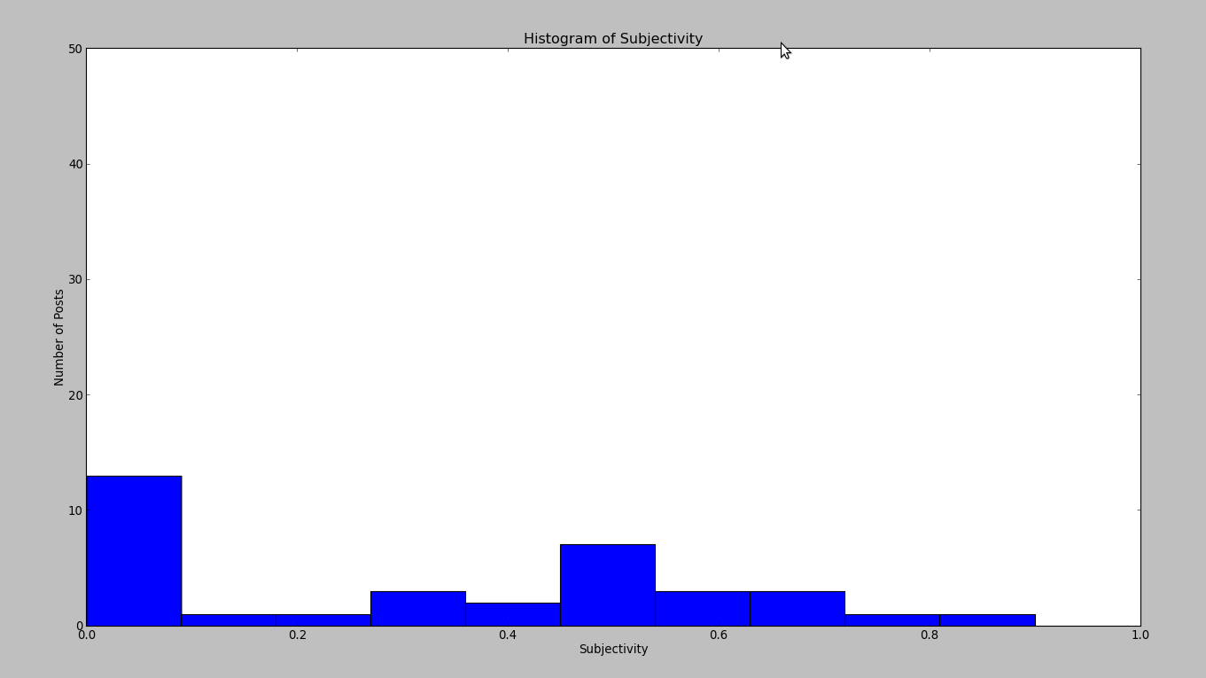Illustration 2: Objectivity of posts analyzed on Sochi Winter Olympics 204

- Reflection: from a process point of view, what went well? what could you improve? For instance, were there specific strategies for better coordinating on a software project with a partner? Was your project appropriately scoped? Did you have a good plan for unit testing?

Planning to do work on our own before meetings saved us a lot of time. We also both code in a similar fashion. We can also explain our code to each other in a way that we understand and we communicated when we did not understand. We were also comfortable watching the other person code and comfortable coding in front of each other. We could improve our communication through GitHub, one of us was less experienced with GitHub and it made transferring code between us more difficult. The project was appropriately scoped. We did not feel overwhelmed, but we did learn new things. We know that we could improve and refine our first search function if we had more time, but we do feel the project is a true reflection of how much time we spent on it. We had two unit tests. The first, get_feelings_unit_test, calls facebook_search to gather a list of tuples of the sentiment and it compares it to the output of get_feelings. The second unit test, get_subjectivity_unit_test, also calls facebook_search and calls get_subjectivity function that align with the facebook_search results. We should also have a unit test for plot_histogram, but we could not make this happen. The data was not always consistent for every facebook search and it could not be easily transmitted between unit tests. Instead of a unit test, we looked at the array that shows the number of posts (the array x in plot_histogram) and compared it to our histogram values.

