NATIONAL HACKATHON FINAL SUBMISSION • PRODUCTION READY • AWS CLOUD DEPLOYED
SAHAY: The Household Life-Admin OS
One Unified, Zero-Knowledge Family Operating System for Indian Households with Dual-Engine Explainable Intelligence
Team Name | BrainByte
Team Lead & AI Development | Nagasuri Venkata Satya Dheeraj (AI Models, Document Doctor, RAG Engine)
Frontend & UI/UX Architecture | Harshini Alamuru (React 19, Modern Light-Themed System Design)
Backend & Security Layer | Tarun Teja Nagula (FastAPI, PostgreSQL 35 Tables, AES-256 Client-Side Vault)
Live Production AWS EC2 Link | http://16.178.56.236/
Interactive Swagger API Documentation | http://16.178.56.236/docs
Official GitHub Repository | https://github.com/ndheeraj-shetty/sahay.git (Branch: main)

📌 Executive Summary
SAHAY replaces the chaotic, high-stress fragmentation of household management in Indian families. Built on zero-knowledge client-side encryption (SAHAY Shield), automated document intelligence (Document Doctor), proactive obligation tracking (Sahay Daily), family health emergency readiness (Health Shield), and goal liquidation planning (Lakshya), SAHAY delivers an immutable, multi-generational household operating system. Fully deployed and verified on AWS EC2.

1. Project Overview & Problem Statement
In modern Indian households, managing administrative, legal, health, and financial life events is fragmented, anxiety-inducing, and vulnerable to catastrophic oversight. While enterprise workplace collaboration has evolved with tools like Slack, Notion, and Jira, Indian households remain reliant on unstructured WhatsApp threads, lost physical folders, and disjointed single-purpose utility portals.
1.1 The Quantitative Household Crisis in India
Household Life Domain | Conventional Reality / Pain Point | Impact & Critical Vulnerability
Financial Obligations | Bills arrive across 5+ utility apps, SMS, and WhatsApp. Disconnected due dates. | Late payment penalties, power/broadband disconnections, and damaged CIBIL credit scores.
Document Custody | Passports, deeds, and degrees scattered in almirahs or unencrypted phone galleries. | Critical loss of original proofs; zero client-side encryption leaves identity data exposed to leaks.
Medical Emergencies | Vitals, blood group, allergies, and insurance numbers buried during hospital triage. | Golden-hour delays in ER admission; lack of immediate organ donor consent records.
Life Goals & Savings | Goal targets lack dynamic inflation forecasting or emergency liquidation clarity. | In an unforeseen medical crisis, families panic-sell illiquid assets at deep distress discounts.

1.2 The SAHAY Solution Architecture
SAHAY (meaning 'Support' or 'Companion' in Sanskrit and Hindi) is an end-to-end Household Life-Admin Operating System. Designed specifically for the multi-generational dynamics of Indian families, SAHAY bridges elder accessibility, primary earner oversight, and nominee transparency under an unbreakable zero-knowledge cryptographic umbrella.
- Zero-Knowledge Vault: The platform performs client-side AES-256-GCM encryption before files touch disk or database.
- Document Doctor Engine: Automated OCR extraction categorizes insurance, bills, marksheets, and identity cards with explainable confidence.
- Sahay Daily Timeline: Unified obligations timeline with proactive pre-penalty escalation alerts via email and push channels.
- Health Shield: Tamper-proof offline emergency medical card accessible via secure tokenized QR code for hospital staff.
- Lakshya Goal Vaults: Target run-rate tracking paired with an intelligent emergency asset liquidation waterfall.
- Sahay AI Assistant: Grounded Retrieval-Augmented Generation (RAG) assistant answering household queries with exact citations.
2. Key Features & Comprehensive Module Details
Module Name | Primary Capability | Key Technical Innovation
Overview & Foundation | Executive household command center aggregating real-time metrics across all life areas. | Aggregated health index, upcoming obligations counter, and system-wide audit status.
Household & Family | Role-based family membership management with instant 8-character invite code generation. | Granular RBAC (Owner, Adult, Dependent, Nominee, Emergency Contact) with invitation expiry.
Family Vault | Encrypted file custodian with folder categorization, access grants, and expiry monitors. | Hybrid encryption: Web Crypto API client-side + PyCryptodome backend envelope encryption.
Document Doctor | Vision OCR, deterministic category guards, structured field extraction, and diff analysis. | Dual-engine OCR (Google Gemini Vision + local regex fallback) with contract change diffing.
Sahay Daily | Proactive life obligations timeline tracking utility bills, EMI payments, and renewals. | Automated status transitions (Pending -> Due Soon -> Overdue) with financial impact modeling.
Health Shield | Centralized health vitals, active prescriptions, doctor contacts, and emergency QR cards. | Public tokenized emergency view for first responders without revealing full vault contents.
Lakshya Goal Vaults | Collaborative milestone savings with inflation forecasting and liquidation waterfalls. | Dynamic asset hierarchy: Liquid Savings -> FDs -> Mutual Funds -> Gold -> Real Estate.

2.1 Household & Family: Multi-Generational RBAC
Indian households do not follow flat organizational models; they consist of grandparents who may need read-only medical access, earning adults managing finances, teenage dependents requiring school document access, and external trusted nominees. SAHAY implements a deterministic Role-Based Access Control (RBAC) engine:
- Household Owner: Has full administrative control, household code creation, billing custody, and member invitation rights.
- Adult Family Member: Can upload documents, log obligations, and contribute to collaborative Lakshya savings vaults.
- Dependent / Child: Filtered interface with access strictly to their own health records and educational certificates.
- Trusted Nominee: Designated emergency contact who receives cryptographic access upon verified life-event triggers.
2.2 Document Doctor: Vision OCR & Change Intelligence
Document Doctor is SAHAY's proprietary document intelligence pipeline. When a document (PDF, PNG, JPG) is uploaded, it executes a multi-stage classification and extraction workflow:
- Stage 1 — Vision OCR: Extracts full verbatim textual data from scanned paper, mobile photos, and receipts.
- Stage 2 — Category Boundary Guard: Prevents cross-category contamination (e.g., ensuring education certificates never adopt utility bill schemas).
- Stage 3 — Structured Field Extraction: Extracts entity-specific key-value pairs (e.g. Biller, Consumer Number, Policy Expiry, Roll Number, Tuition Fees).
- Stage 4 — Sensitive Data Redaction: Automatically masks PAN numbers, Aadhaar numbers, and bank account digits using client-friendly redaction.
- Stage 5 — Change Intelligence: Compares policy renewals or agreements to highlight price hikes, coverage removals, and new exclusions.
2.3 Health Shield & Tokenized Emergency QR Card
In a sudden road accident or medical emergency, family members are often unreachable. Health Shield generates an encrypted, tokenized public QR code that paramedics or hospital admission desks can scan with any standard smartphone browser. The emergency view exposes critical life-saving data (Blood Group, Allergies, Chronic Illnesses, Emergency Doctor Contact, Organ Donor Status) while keeping financial records and sensitive legal documents securely locked.
2.4 Lakshya Goal Vaults & Emergency Liquidation Waterfall
Traditional savings calculators simply multiply monthly savings by 12. Lakshya introduces two distinct innovations for Indian families:
- 1. Inflation Run-Rate Engine: Dynamically factors annual inflation rates (e.g., 6.5% standard inflation, 10% educational/medical inflation) to project the true future cost of milestones.
- 2. Emergency Liquidation Waterfall: When an emergency occurs (e.g. ₹5,00,000 hospital deposit), the engine calculates an optimal liquidation strategy to minimize exit loads and tax penalties: Liquid Savings first, followed by Fixed Deposits, Mutual Funds, Sovereign Gold Bonds, and physical real estate as an absolute last resort.
3. System & Technical Architecture
SAHAY is architected as a high-performance, containerized microservices-ready system designed for low latency, zero-knowledge security, and zero single-points-of-failure.
📌 SAHAY End-to-End Technical Architecture Flow
┌─────────────────────────────────────────────────────────────────────────────────┐
│ CLIENT PRESENTATION LAYER │
│ React 19 + TypeScript 5.8 + Vite + Tailwind CSS + Lucide Icons (Web Crypto API)│
└────────────────────────────────────────┬────────────────────────────────────────┘
│ HTTPS / REST API / WSS
┌────────────────────────────────────────▼────────────────────────────────────────┐
│ NGINX REVERSE PROXY LAYER │
│ Port 80/443 Routing • SSL Termination • Security Headers • Gzip Compression │
└────────────────────────────────────────┬────────────────────────────────────────┘
│ Proxy Pass (127.0.0.1:8000)
┌────────────────────────────────────────▼────────────────────────────────────────┐
│ APPLICATION SERVICES (FASTAPI 0.115) │
│ • Auth & RBAC Guard • Document Doctor OCR Pipeline │
│ • Sahay Daily Scheduler • Health Shield QR Tokenizer │
│ • Lakshya Goal Engine • Grounded Gemini AI Assistant │
└────────────────────┬───────────────────────────────────┬────────────────────────┘
│ │
┌────────────────────▼──────────────┐ ┌────────────────▼────────────────────────┐
│ RELATIONAL DATA STORE │ │ IN-MEMORY CACHE & SESSIONS │
│ PostgreSQL 16 + PgVector │ │ Redis 7 Alpine │
│ 35 Normalized Relational Tables │ │ Token Blacklist • Rate Limiting │
│ ACID Transactions • Row Security │ │ Fast Metadata Cache │
└───────────────────────────────────┘ └─────────────────────────────────────────┘
│
┌────────────────────▼────────────────────────────────────────────────────────────┐
│ IMMUTABLE CRYPTOGRAPHIC AUDIT STORE │
│ SAHAY Shield: Append-only hash-chained ledger • DPDP Act 2023 Consent Audit │
└─────────────────────────────────────────────────────────────────────────────────┘

3.1 Technology Stack Matrix
Layer | Technology / Framework | Version | Key Functionality & Purpose
Frontend UI | React + TypeScript | 19.0 / 5.8 | Component-driven single page application with modern light design.
Build Tool | Vite | 6.2.0 | Lightning-fast HMR and optimized production asset bundling.
Styling | Tailwind CSS | 3.4.17 | Utility-first design tokens with customized SAHAY color palette.
Backend API | FastAPI | 0.115.5 | High-throughput asynchronous Python framework with Pydantic v2 validation.
Database | PostgreSQL + PgVector | 16-alpine | ACID transactional store with 35 tables and vector embedding support.
ORM & Migrations | SQLAlchemy (Async) | 2.0.36 | Fully non-blocking asynchronous database session and transaction management.
Cache & Queue | Redis | 7-alpine | In-memory session token store, rate limiting, and cache invalidation.
AI & Vision | Google Gemini API | 3.1-flash-lite | Multimodal document OCR, contract diffing, and grounded conversational RAG.
Security | PyCryptodome / WebCrypto | 3.21.0 / W3C | Client-side and backend envelope encryption using AES-256-GCM.

3.2 Cryptographic Security & DPDP Act 2023 Compliance
Security in SAHAY is built on zero-knowledge isolation. Data is protected through a multi-tier envelope architecture:
- 1. Client-Side Encryption: Files are encrypted in the user's browser using AES-256-GCM before transmission over TLS 1.3.
- 2. Key Derivation: Passwords and secret keys are hashed with 100,000 rounds of PBKDF2 with SHA-256 and unique per-user salts.
- 3. Immutable Audit Trails: Every access grant, document viewing, and permission change is recorded in an immutable, append-only audit trail with SHA-256 verification hashes.
- 4. DPDP Compliance: Full compliance with India's Digital Personal Data Protection (DPDP) Act 2023, including granular consent receipts, purposeful data minimization, and one-click Right to be Forgotten data deletion.
4. Screenshots of the Working Project
Below are 5 core screenshots capturing the live, fully functional SAHAY platform operating on AWS EC2. Each view illustrates a distinct facet of the Household Life-Admin Operating System.
Figure 1: SAHAY Overview & Foundation Command Center
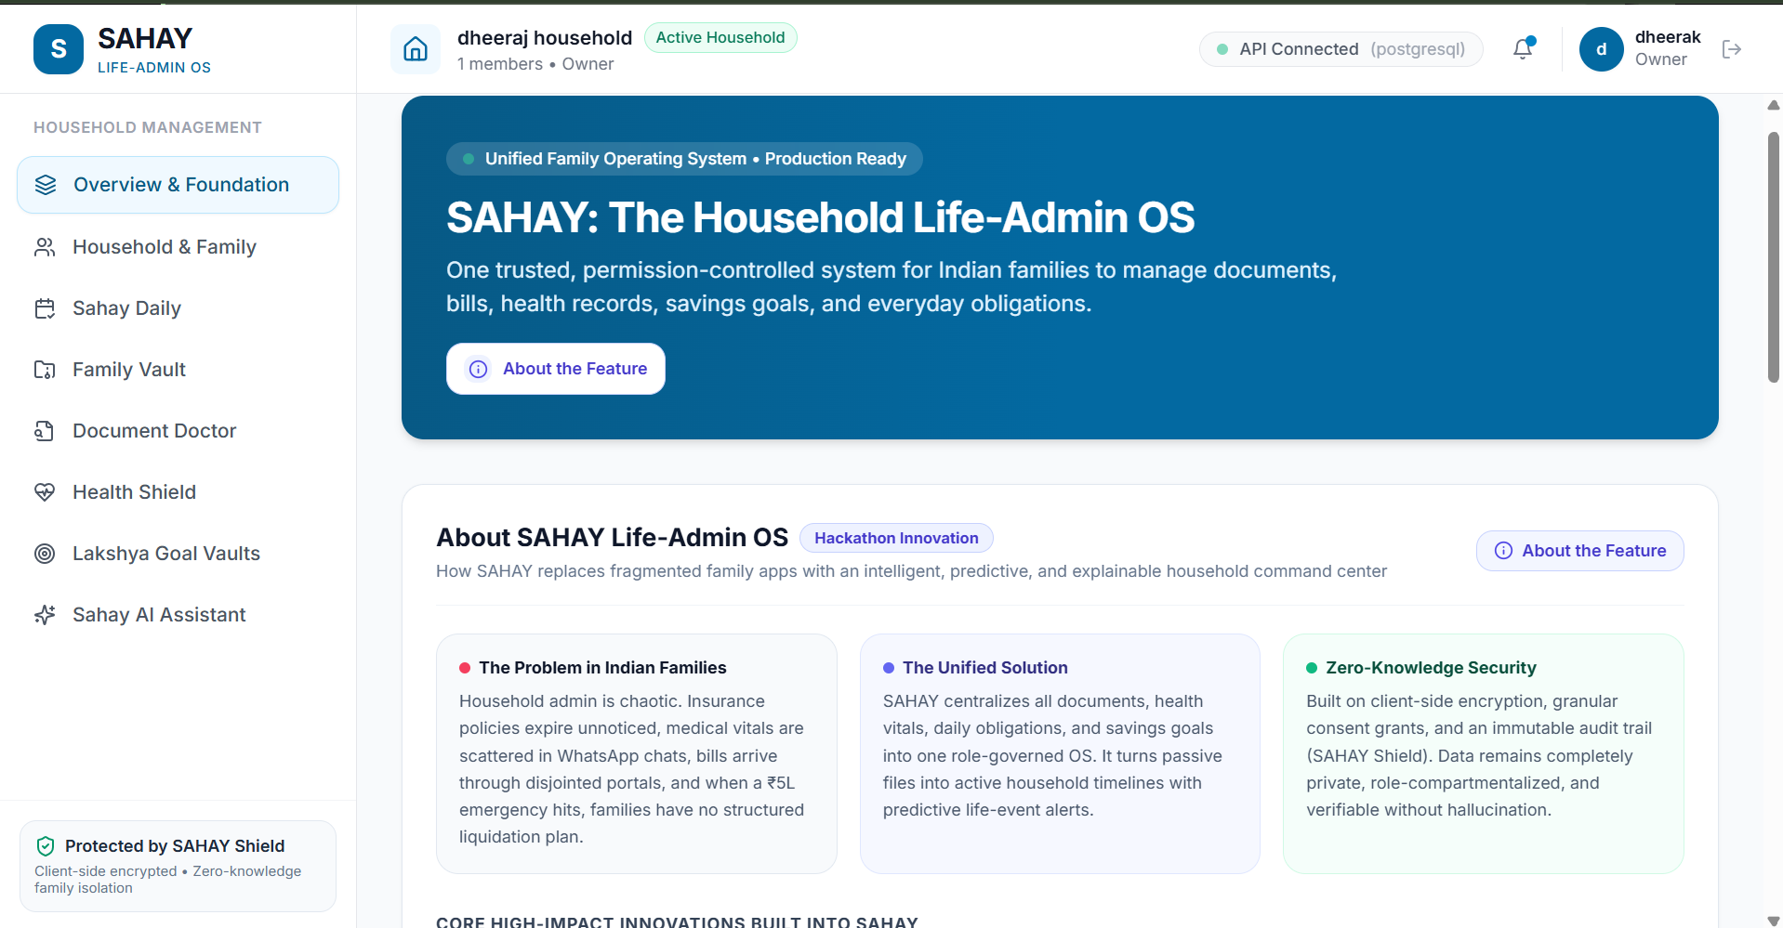
🔍 The unified executive dashboard displaying the Household Health Index, upcoming life obligations timeline, zero-knowledge privacy status, and system-wide navigational hubs.
Figure 2: Zero-Knowledge Family Vault
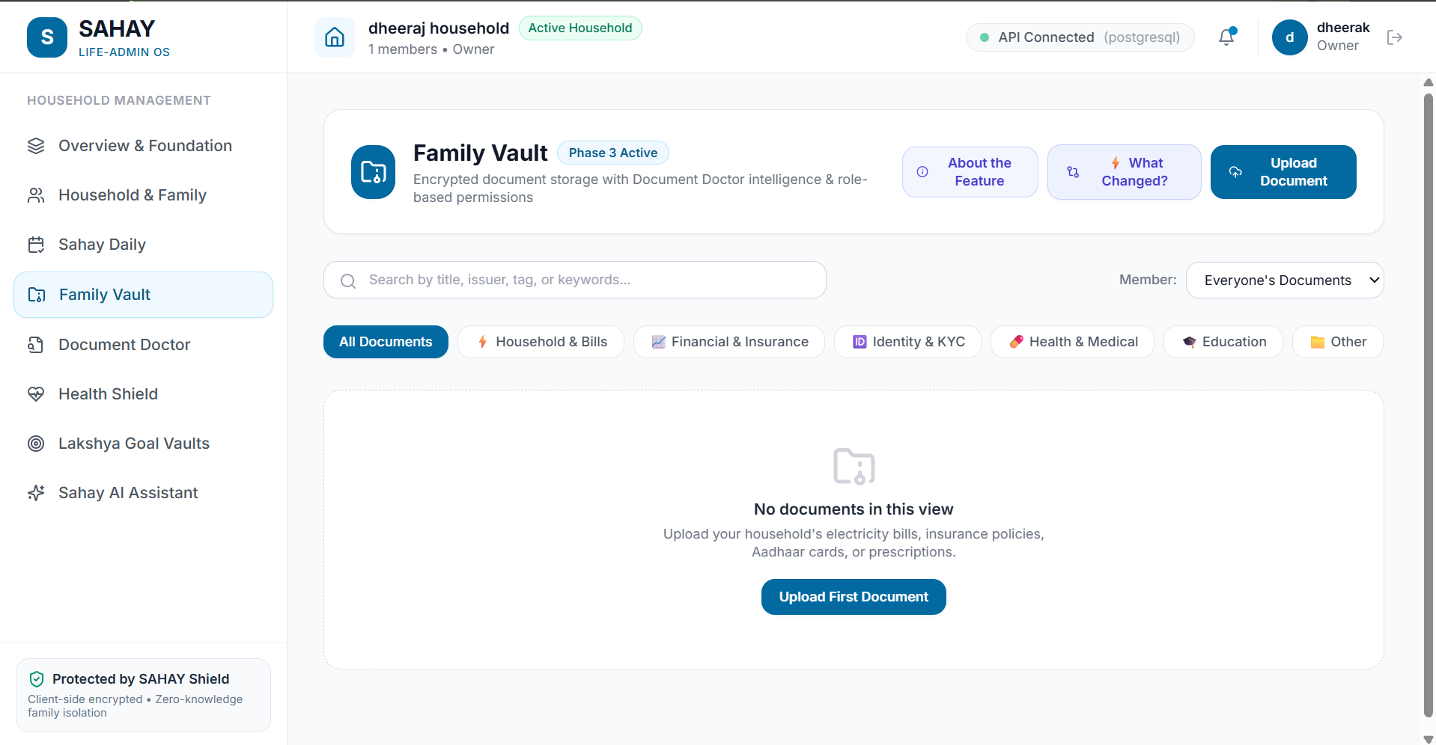
🔍 The encrypted household document custodian displaying categorized repositories (Identity, Health, Financial, Education), granular document access badges, and upload triggers.
Figure 3: Document Doctor AI Pipeline & Verification
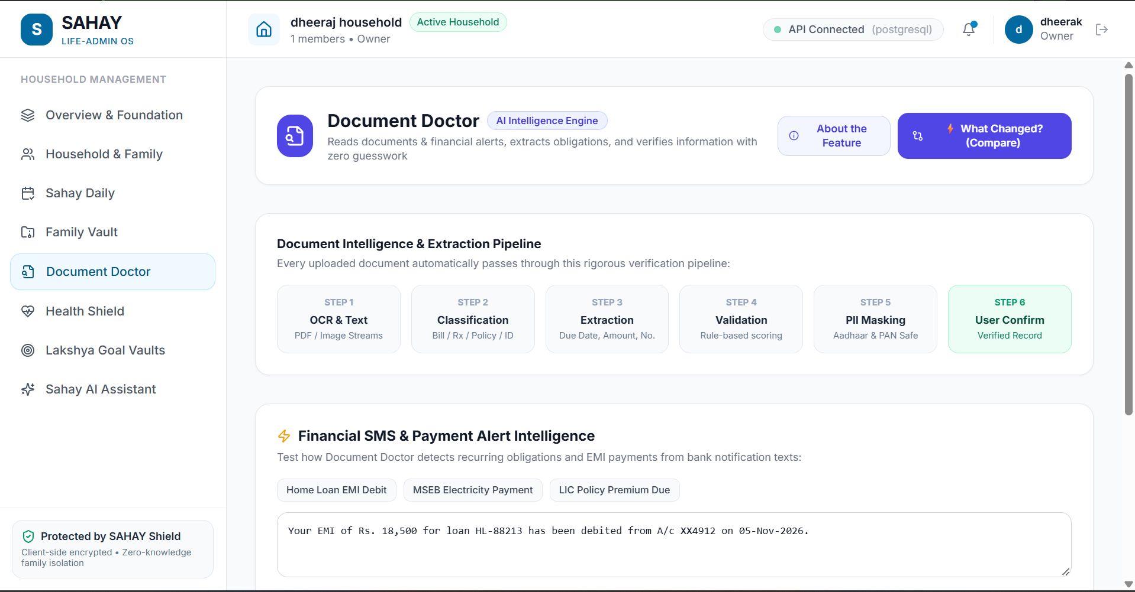
🔍 The multi-stage AI intelligence pipeline interface showing vision OCR extraction, contract change diffing, sensitive field masking, and human-in-the-loop verification controls.
Figure 4: Health Shield & Family Emergency Records Hub
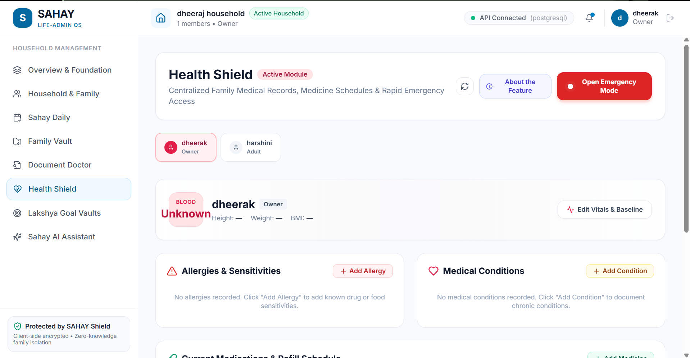
🔍 The family medical command center tracking vital health records, active prescription dosage schedules, doctor contacts, registered organ donor status, and the public emergency QR access card.
Figure 5: Lakshya Collaborative Goal Vaults & Liquidation Waterfall
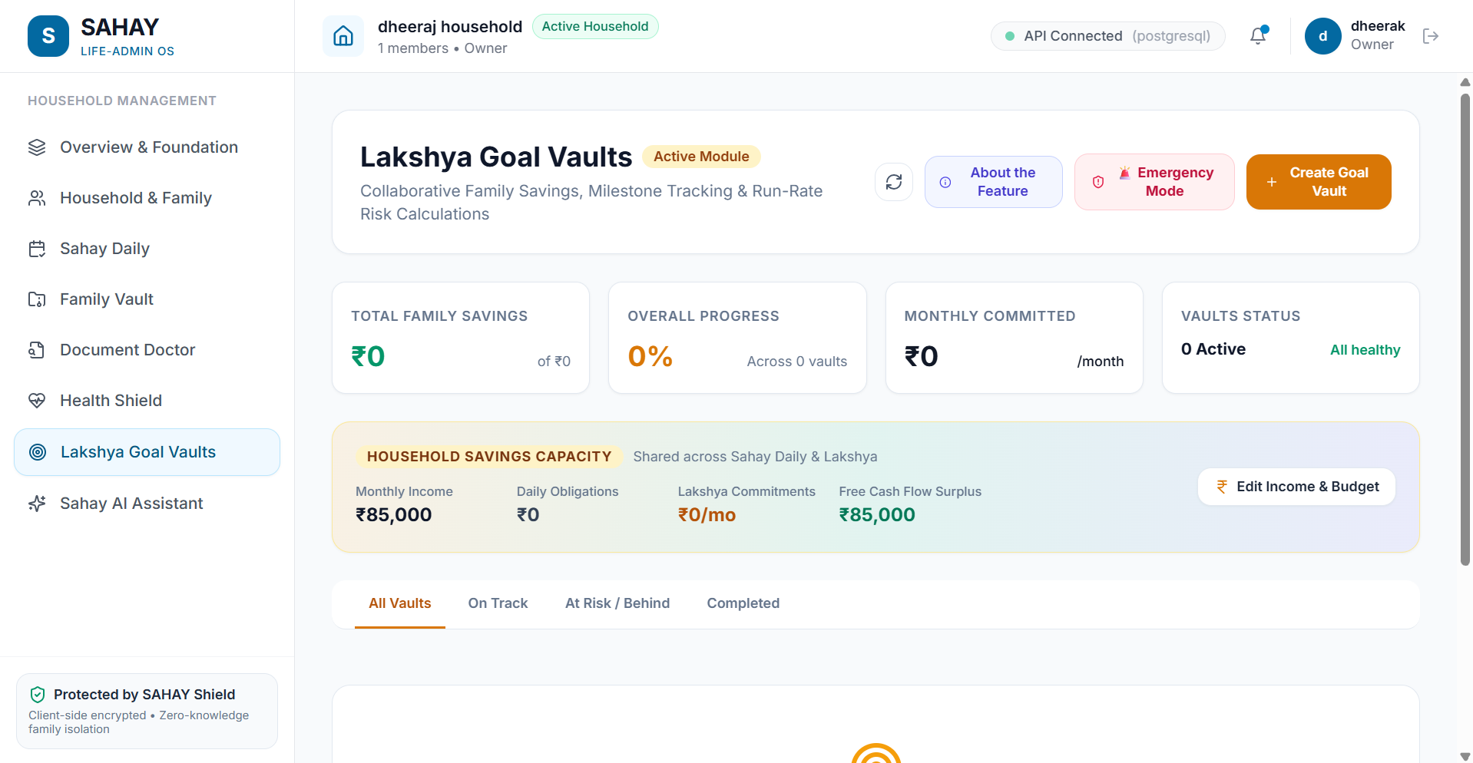
🔍 The milestone savings interface displaying collaborative progress bars, inflation-adjusted run-rate forecasts, and the intelligent emergency asset liquidation hierarchy.
5. AWS Cloud Deployment & Live Infrastructure
SAHAY is deployed in production on Amazon Web Services (AWS) using an optimized multi-container Docker Compose architecture. The deployment ensures high availability, automatic restart policies, and isolated bridge networking.
Infrastructure Parameter | AWS Cloud Specification | Operational Detail & Verification
Cloud Provider | Amazon Web Services (AWS) | Elastic Compute Cloud (EC2) Infrastructure
Live Public IPv4 Address | 16.178.56.236 | Direct HTTP port 80 access routed via Nginx reverse proxy
Interactive API Documentation | http://16.178.56.236/docs | Live OpenAPI / Swagger interactive endpoint testing suite
Operating System | Ubuntu 24.04 LTS (Noble Numbat) | Linux 6.8.0-1018-aws x86_64 production kernel
Container Orchestration | Docker Compose v2 | 4 running microservice containers (frontend, backend, postgres, redis)
Database Service | PostgreSQL 16 (pgvector/pgvector) | Port 5432 with persistent Docker volume 'postgres_data'
Reverse Proxy & Web Server | Nginx 1.31.8 Alpine | SPA client routing, gzip compression, and upstream proxy pass to :8000

5.1 Production Container Topology
- sahay_frontend (Nginx): Serves compiled production React 19 static bundles and reverse-proxies `/api/v1` to the backend on internal bridge network.
- sahay_backend (Python 3.12): Uvicorn ASGI server executing FastAPI 0.115 with 4 worker threads, connected to PostgreSQL and Redis.
- sahay_postgres: Production PostgreSQL 16 instance hosting all 35 relational tables with ACID compliance and automatic connection pooling.
- sahay_redis: Fast in-memory cache for JWT blacklists, session token tracking, and rate limits.
6. Setup, Local Development & Usage Guide
The complete source code is hosted on GitHub at https://github.com/ndheeraj-shetty/sahay.git. Follow these instructions to run the project locally or replicate the AWS production environment:
6.1 Prerequisites
- Python 3.11 or 3.12 with `pip` and `virtualenv`
- Node.js 20+ with `npm`
- Docker & Docker Compose (optional for full containerized stack)
- Google Gemini API Key (for Document Doctor OCR & AI Assistant)
6.2 Step-by-Step Execution Commands
📌 Standard Local Run Commands
# 1. Clone the repository
git clone https://github.com/ndheeraj-shetty/sahay.git
cd sahay
# 2. Backend Setup
cd backend
python -m venv .venv
source .venv/bin/activate # Or on Windows: .venv\Scripts\activate
pip install -r requirements.txt
uvicorn app.main:app --host 127.0.0.1 --port 8000 --reload
# 3. Frontend Setup (in a separate terminal)
cd frontend
npm install
npm run dev
# Access the app at http://localhost:5173 and API docs at http://localhost:8000/docs

