1. After running the command successfully, I list out all pods that are running on k8s:

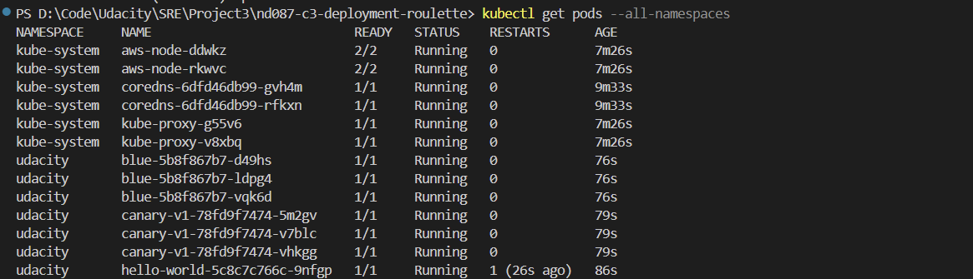

1. I run logs on hello-world application

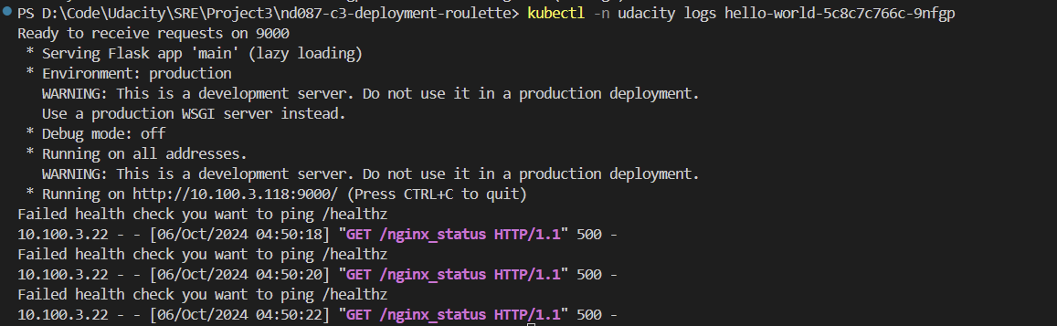

1. So, I go to the hello.yml file on hello-world folder. And, I find out that we ping the wrong endpoint. Then, I replace the /nginx_status with the right one, /healthz

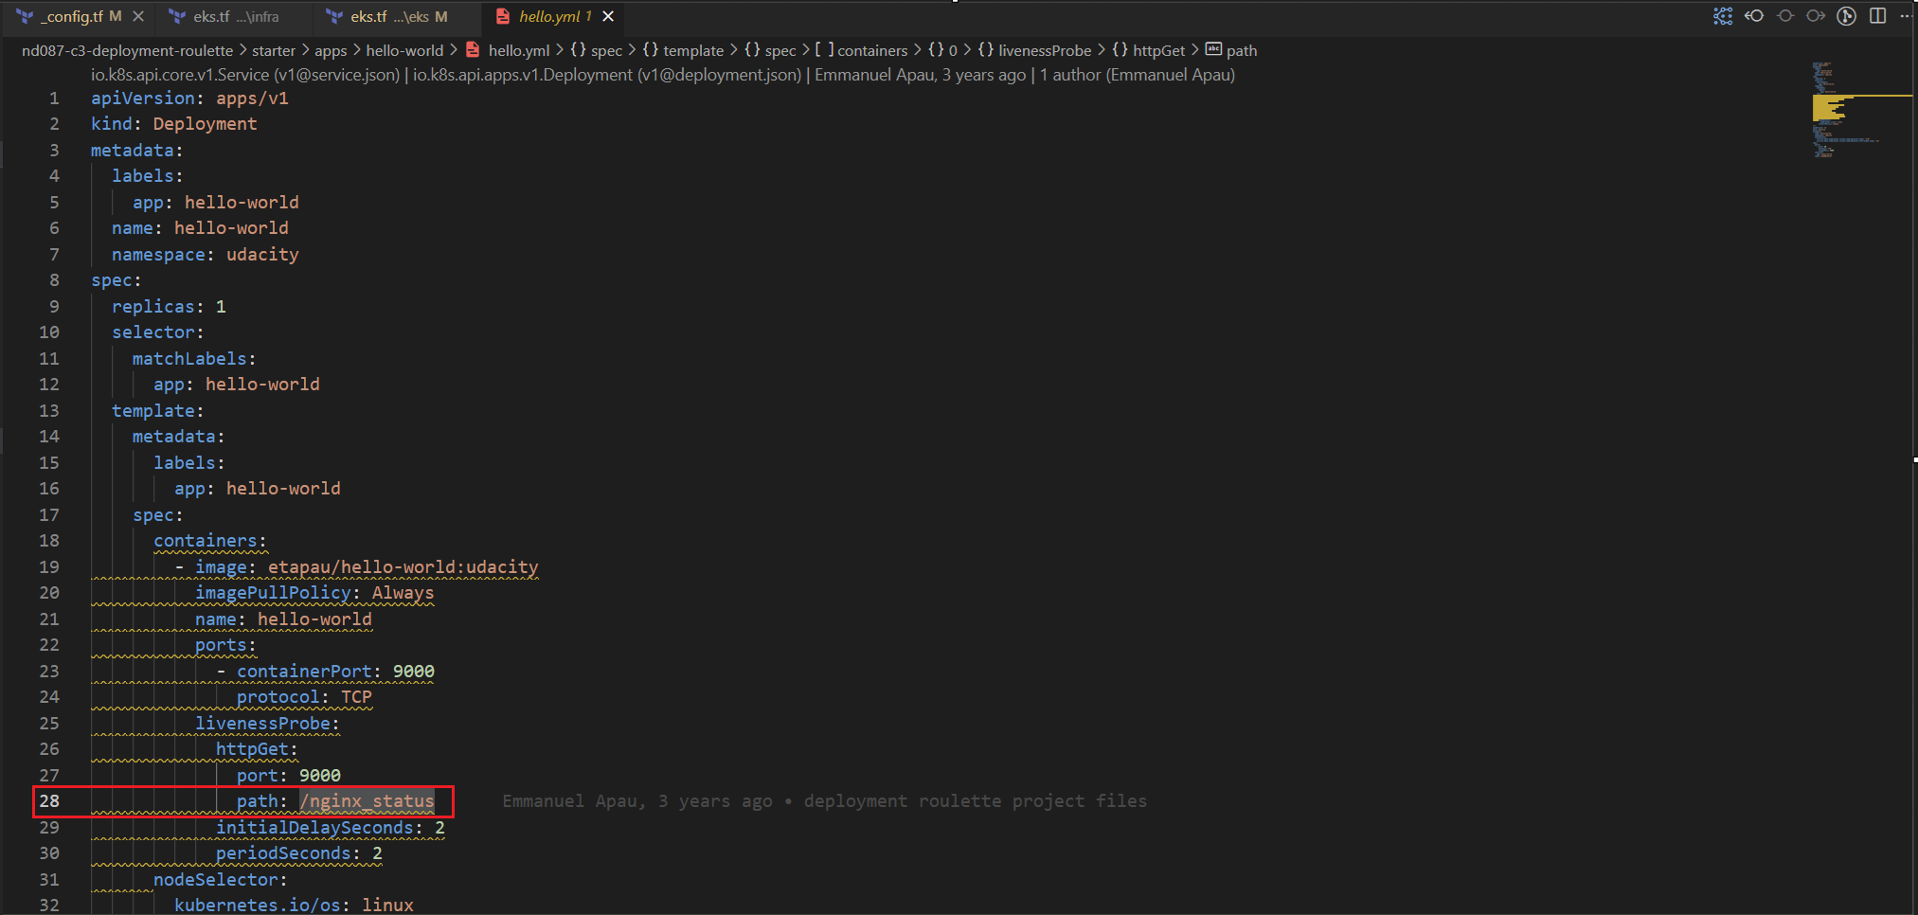

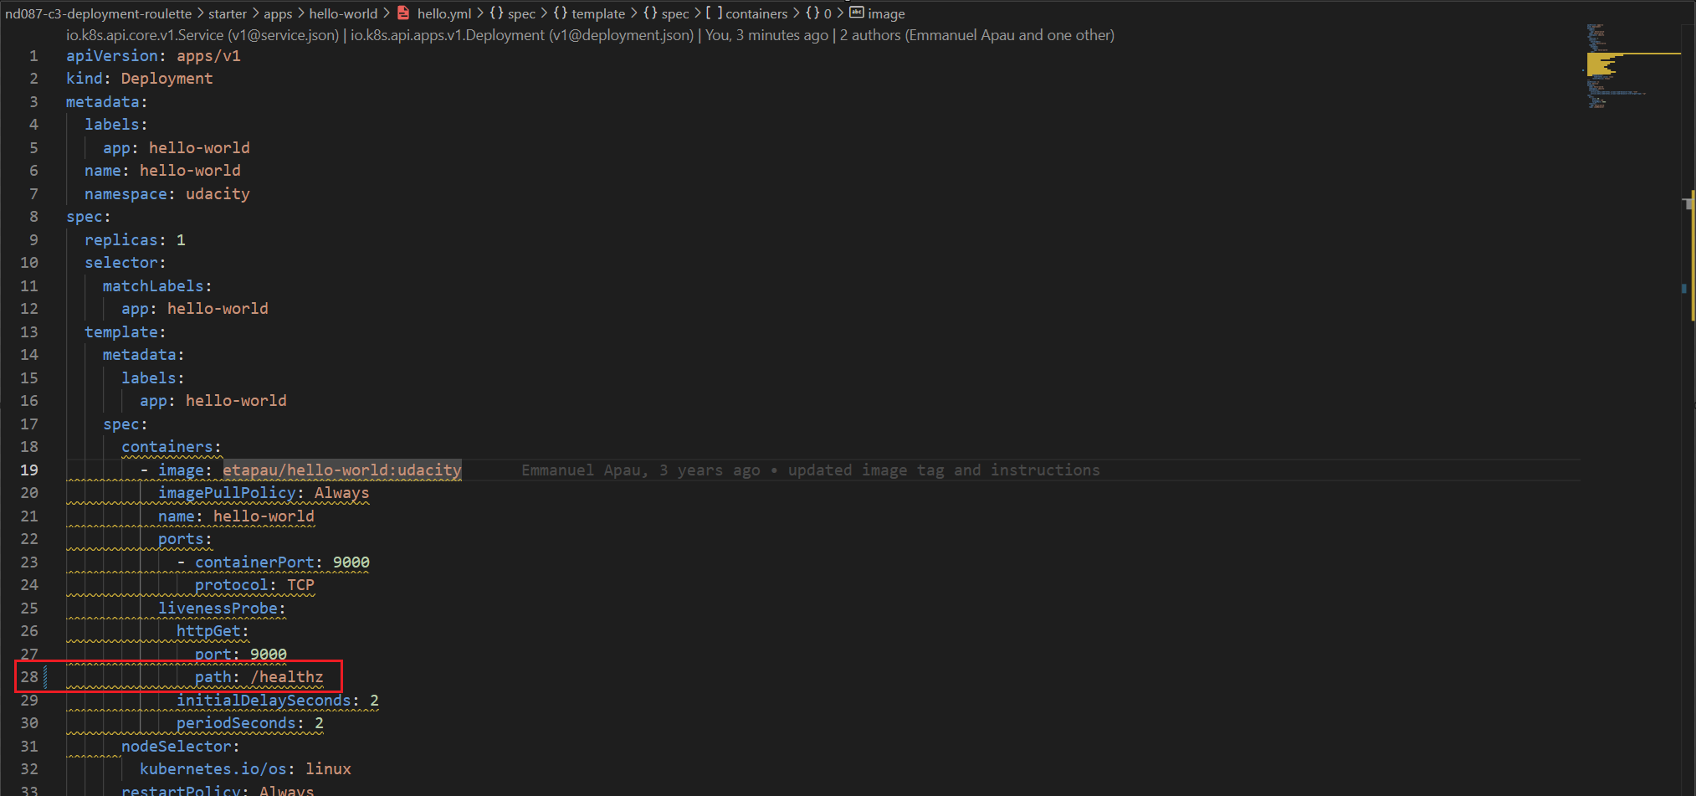

1. Then, I redeploy with the changed ones on hello.yml and list out all pods which are running active again



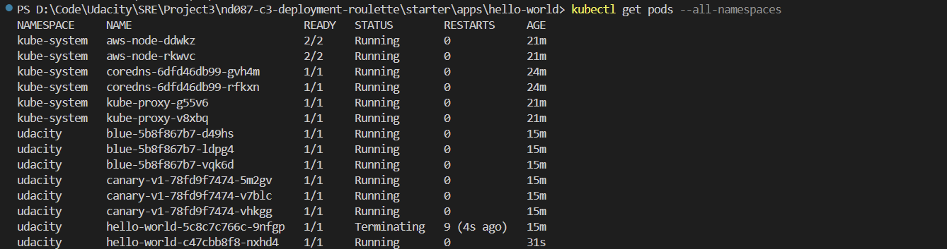

1. Running the logs to make sure it is on the healthy status

