**REPUBLIC OF CAMEROON**

*Peace – work – Fatherland*

**

REPUBLIQUE DU CAMEROUN

*Paix – Travail - Patrie*

**THE UNIVERSITY OF BAMENDA**

UNIVERSITE DE BAMENDA

P.O. Box 39, Bambili, Mezam Division, NW Region, Cameroon

**Tel**.: (237) 683 79 86 43 - **Fax** (237) 233 366 030, **Website**: www.uniba.cm

**THE COLLEGE OF TECHNOLOGY (COLTECH) *ECOLE DE TECHNOLOGIE***

**Building Capacities in Innovative Technology for sustainable Development**

**DEPARTMENT OF COMPUTER ENGINEERING**

**OPTION: COMPUTER NETWORK AND SYSTEM MAINTENANCE**

**SCHOOL MANAGEMENT SYSTEM**

**PRESENTED BY:**

**NDIAMBIE IRIS ZENKEANG**

**MATRICULE: UBA20P0179**

**FIELD SUPERVISOR:**

**ACADEMIC YEAR: 2021/2022**

**ACKNOWLEDGEMENT**

I would like to thank;

* God Almighty for strengthening me all through my hard work and research.
* My parents, guardians and friends for supporting both financially, spiritually.
* Thanking ***NEXINCH***for what they thought me.
* And most especially to my brother Engr Ndiambie Fabrice for always providing and helping me.

# **DEDICATION**

Dedicated to the almighty GOD and the founders of ***NEXINCH***. I hope that this achievement will complete the dream that you had for me all those many years ago when you chose to give me the best education you could.

I also dedicate this to my older brother **Egnr. Ndiambei Fabrice** for also encouraging me to work hard and trying his possible best to provide what I need to achieve m and trying his possible best to provide what I need to achieve m goals.

# **TABLE OF CONTENTS**

**COVER PAGE i**

**ACKNOWLEDGEMENT ii**

**DEDICATION iii**

**TABLE OF CONTENT iv**

**CHAPTER ONE 1**

**1.** **PRESENTATION OF HOST INSTITUTION AND WHY I CHOSE IT 1**

1.1 Location of Host Company 1

1.2 History of institution 2

1.3 Objectives.…………………………………………………………………….....…….2

**CHAPTER TWO………………………………………………………………………………...3**

**2. ACTIVITIES CARRIED OUT DURING INDUSTRIAL TRAINING……………………3**

**2.1 Summary of work done during the industrial training……………………………….3**

**2.2 summary schedule for internship activities……………………………………………4**

**2.3 Details on work done properly……………………………………………………….....5**

**CHAPTER THREE…………………………………………………………………………….13**

3. OUTCOME OF INDUSTRIAL TRAINING……………………………………………13

3.1 Difficulties encountered………………………………………………………………….13

3.2 Solutions/Recommendations…………………………………………………………….13

3.3 General conclusion………………………………………………………………………13

**BIBLIOGRAPHY………………………………………………………………………………14**

# INTRODUCTION TO SCHOOL MANAGEMENT SYSTEM

A school management system(SMS) is an information management system for educational institutions to manage all student’s data. It provides abilities such as registration of students in classes, documenting of grades and analytical marks of each student and other evaluation elements.

Managing a high school and bringing together departments and campuses to achieve the mission is always a big challenge for school management.

Transforming schools system with high technology-enabled automation tools to support the academic and administrative processes will make it easy to achieve their goals.

To succeed in everyday tasks of schools, there is an emerging demand to modernize public education system with cloud, mobile and digital technologies to improve operational efficiency and manage the institution effectively

Here are some commonly observed school management issues, and how technological solutions can be employed to do things right:

### **1. Paper-based processes**

Educational institutions are burdened by cumbersome paperwork and manual processes, and they find it difficult to maintain records on [attendance](https://www.creatrixcampus.com/timetable-management-system), fees, [admissions](https://www.creatrixcampus.com/student-admission-system), transport, etc., and track the information they need. Using School Management System, automate academic processes to save time and reduce staff workload.

### **2. Online Registration**

Students no more have to stand for hours in the queue to pay fees. Simplify registration and fee collections with online forms, with the ability to send automatic notifications, alerts and reminders via email,  SMS alerts and push notifications from mobile devices.

### **3. Admission & Enrollment**

Colleges and Universities are finding hard to achieve [admission and enrollment](https://www.creatrixcampus.com/student-admission-system) targets. Aligning people, processes and technology with simple & user-friendly cloud-based education solution will help institutions to manage information from inquiry and application to admission and enrollment.

### **4. Course Management**

Designing a course curriculum that can adapt to the changing needs of the institution is crucial. With a Course Management System institutions can accomplish a lot with limited resources. Create and track course-work, assignments, and exam papers in a conducive classroom environment to support the goal of graduating students.

### **5. Teacher Evaluation**

Tracking the progress of teachers and evaluating the effectiveness of teachers' work is significant. [Teacher evaluation system](https://www.creatrixcampus.com/faculty-management-software) improves communication and collaboration between evaluators and teachers. Student’s feedback will measure teacher’s performance in the classroom and the automated evaluation process improves student learning skills, achievement and success.

### **6. Communication & Collaboration**

There is apparently no platform to provide seamless communication between students, administrators, staff and teachers. Moreover, increasing student discipline incidents happen as a result of big communication gap between students and teachers. Web and mobile-based education management system improves communication through instant notifications and alerts via email, SMS and push messages to keep the constituents informed at every step of the journey to build relationship and improve student retention.

### **7. Classroom Management Strategy**

Schools are finding it difficult to handle tardy students, and solve indiscipline and behavior issues. Improve classroom environment with discipline tracking and [behavior management system](https://www.creatrixcampus.com/behavior-management-system) to easily handle tardy students and uninformed absences.

### **8. Student Monitoring**

Teachers are struggling to monitor student’s activities including attendance, leave, discipline, assignments, etc.   School administrators are lacking in result-based monitoring tools to track student progress. Automate and streamline student attendance and absenteeism using [student information system](https://www.creatrixcampus.com/student-information-system) which delivers real-time status updates of student activities to support learning needs.

### **9. Revenue Management**

It is difficult for institutions to cope with their finances and track their fee collections and contributions. Seamlessly connect and engage with students, parents and alumni to strengthen relationship and drive greater success.

### **10. Forecasting the academic achievement**

Institutions are unable to manage information and there are endless delays in taking decisions based on complete analysis. Dashboard reports and intelligent analytics are useful indicators for educators to examine attendance, assignments, grades, etc. and predict [student outcomes](https://www.creatrixcampus.com/outcome-based-education-software). Using data analytics will help institutions to identify students at-risk and deploy resources to improve achievement and success.

Now the database to be created helps to specify the departments in which students belongs to and their different options if any. Also, it helps the student to know:

- The course instructor

- Course registered

- Onsite course

- Online course

- Semester

- Office assignment

- Student grade

These problems can be solved using MySQL, PostgreSQL, Microsoft Access, SQL Server, Oracle,Clipper, Papyrus.

The software chosen was Papyrus and PostgreSQL

**UML STATEMENT**

A student fills a form, pay fees and enrolls courses in a department which has one or many options. For example; computer engineering in COLTECH has two options namely;

* Computer Network and System Maintenance
* Software Engineering

The courses chosen by the students has to be in a particular semester. Either;

* First semester.
* Second semester.

The course instructor teaches the courses enrolled by the students, add lectures, marks attendance.

The courses are taught either online or onsite.

The course instructor gives assignments to be done and surmitted in a particular place at a given time.

The course instructor also gives exams to be written by the students.

At the end, the course instructor checks exam paper and declares result which are converted into grades and sent to the student.

UML Class diagram for School Management System is shown below. The various Classes involved in the system are:

Classes

* Student
* Course
* Course instructor
* Admin
* Department
* Option
* Online class
* Onsite class
* Semester
* Student grade
* Office assignment
* Test paper

The various attribute and operation are shown below;

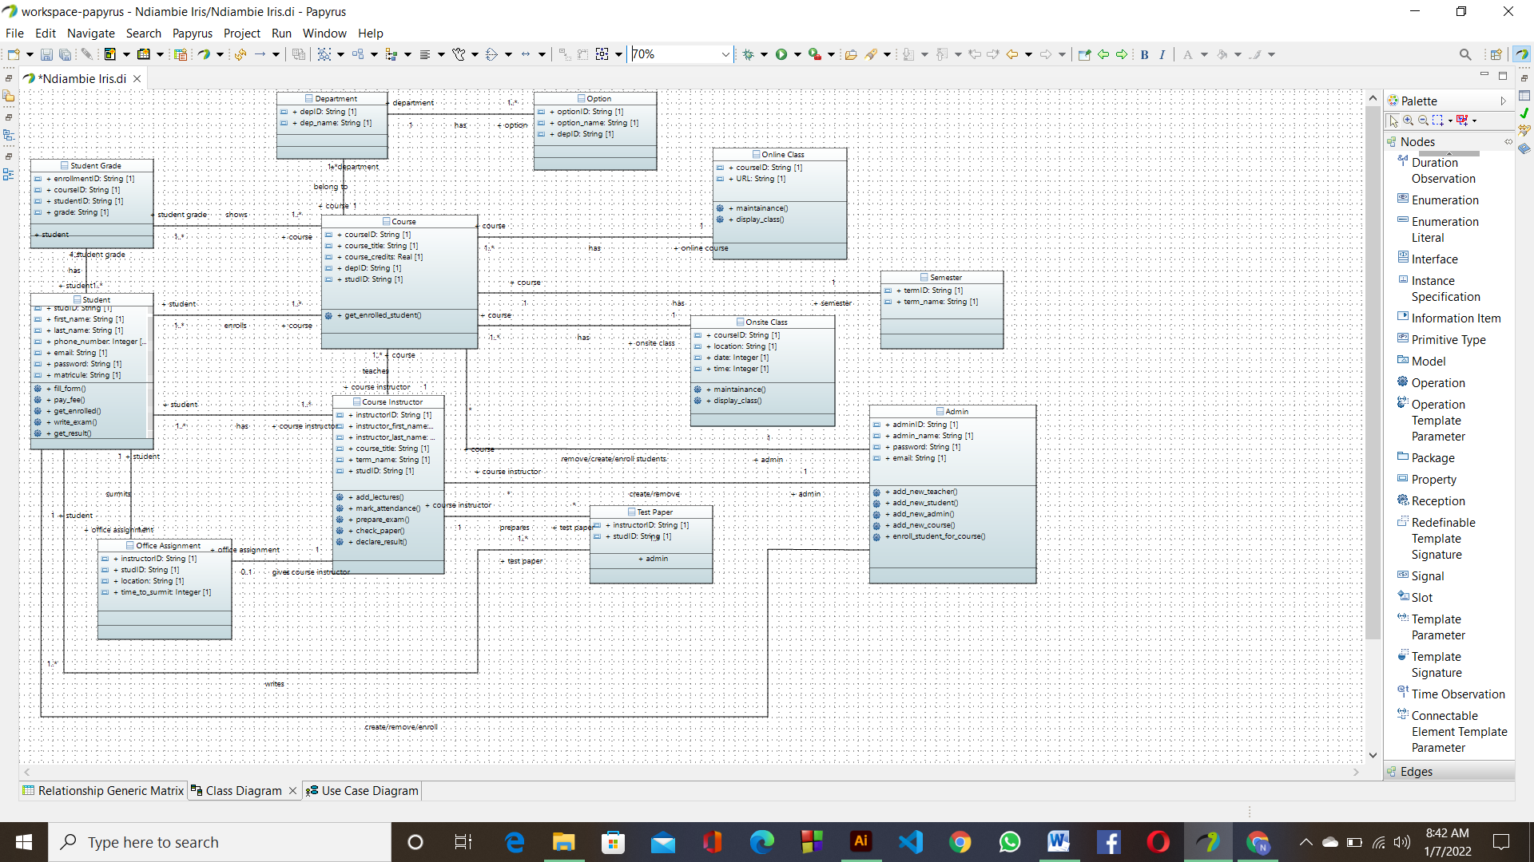

Fig i: Class diagram for school management system.

UML Use Case diagram for School Management System is shown below. The various participants of the same are detailed below:-

Actors

* Admin
* Course instructor
* Student

Corresponding use cases for these actors are:-

 Admin:

* Add new course instructor
* Add new Students
* Add new admin
* Add new course
* Enroll student for course

 Course instructor:

* Add lectures
* Mark attendance
* Prepare exam
* Check paper
* Declare result

Student:

* Fill form
* Pay fee
* Get enrolled
* Write exam
* Get result

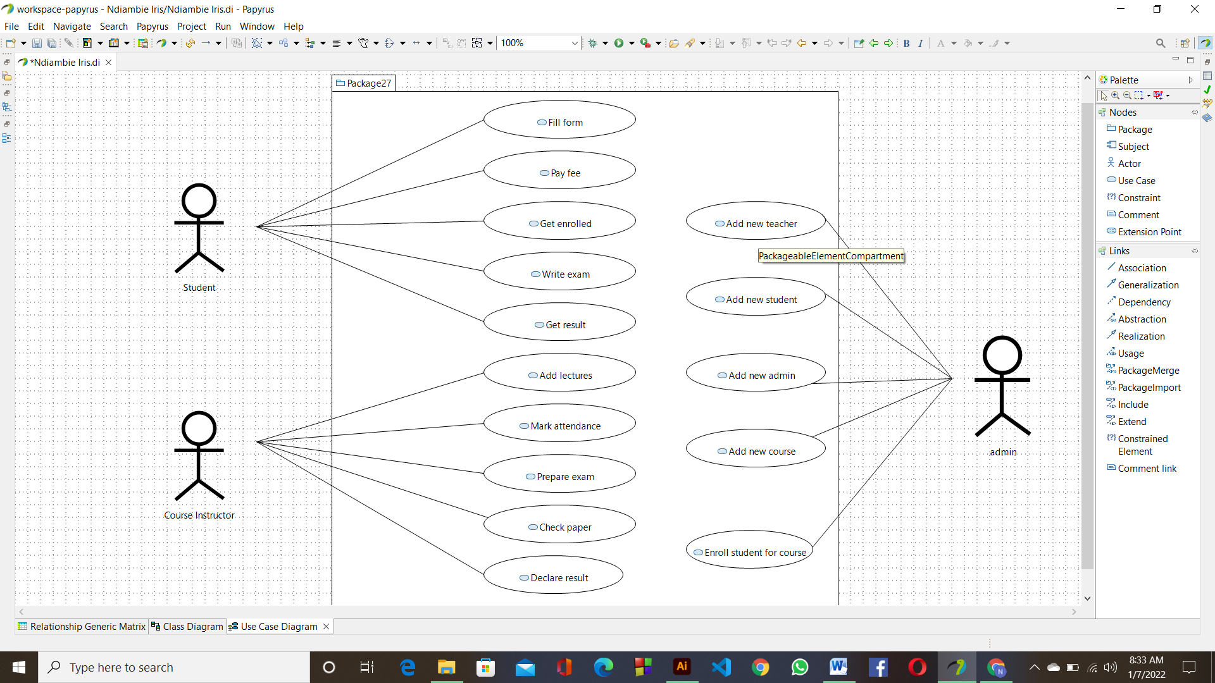

Fig ii: Use Case diagram for school management system.