AI Task Prioritisation & Scheduling Assistant:
Codebase Ground-Truth Technical Documentation & Critical Analysis
Project Name: AI Task Prioritisation & Scheduling Assistant | Author: Ndifon Project / AI Assessment 2
Date: September 2026 | Document Version: 4.1.0 (CODEBASE AUDITED & METRICS ALIGNED RELEASE)
Target Infrastructure: Proxmox LXC Containers (CT 200 & CT 201), Gitea (HR_Portal), FastAPI, OpenClaw Agent
1. Project Overview
The AI Task Prioritisation & Scheduling Assistant is a 3-component AI subsystem built for Layer 2 of the agentic enterprise architecture stack. It addresses daily scheduling, triage, and task management overload faced by modern knowledge workers.
• Foundationist Paradigm (Fine-Tuned Qwen2.5-3B LLM): Handles fuzzy natural language understanding, context parsing, and structured JSON parameter extraction from informal user task requests.
• Symbolist Paradigm (Decision Tree Classifier): Executes deterministic, interpretable, and low-latency priority classification (Defer, Schedule this week, Do now) and calendar slot feasibility verification.
• Agent Orchestration Paradigm (OpenClaw Agent): Coordinates LLM parameter extraction, calls Component A REST API tool, evaluates 3-layer guardrails, logs task entries in TASKS.md, and executes independent Gitea API verification.
• Version Control Repository Note: Hosted on the enterprise Gitea server under repository name 'HR_Portal' (legacy starter repository designation allocated for Assessment 2).
2. System Architecture
The system architecture separates fuzzy natural language understanding from quantitative mathematical classification:
User Input -> OpenClaw Agent Gateway (CT 201: Port 18789) -> Qwen2.5-3B LLM (CT 200: Port 8080 /v1/chat/completions) -> JSON Extraction -> Guardrail 1 (Input Validation) -> Decision Tree ML Model (FastAPI Port 5000) -> Guardrail 2 (API Reliability) -> Guardrail 3 (Human Approval Boundary) -> Gitea Commit Execution -> Independent Verification -> User Response
Component Name | Code Module / Host | IP Address | Port | APIs & Protocols
Agent Gateway | agent/openclaw_agent.py (CT 201) | 192.168.20.21 | 18789 | HTTP / WebSocket
Prediction Service | ml_service/main.py (FastAPI) | 192.168.10.20 | 5000 | HTTP / REST (/predict, /health)
LLM Inference Server | llama-server (CT 200) | 192.168.10.20 | 8080 | HTTP / OpenAI Chat API (/v1/chat/completions)
Version Control | agent/tools/gitea_tool.py | 192.168.20.21 | 3000 | HTTP / REST Gitea API (HR_Portal)

3. Technology Stack & ML Tribal Tradeoff Analysis
Component | Technology | Exact Codebase Version | Role & Deployment Rationale
Programming Language | Python | 3.10.12 | Primary runtime across API, tools, and scripts
Machine Learning Model | Scikit-Learn | 1.3.2 | DecisionTreeClassifier for interpretable tabular priority scoring
Base LLM | Qwen2.5-3B-Instruct | 3.09B params | Open weights foundation model for structured extraction
Fine-Tuning Framework | Unsloth QLoRA | 2024.8 | Ultra-fast 4-bit LoRA fine-tuning on GPU
Model Quantisation | GGUF Q4_K_M | llama.cpp | 4-bit quantized GGUF format for CPU inference (~2.01 GB)
Inference Server | llama.cpp (llama-server) | b3400+ | High-performance C++ GGUF inference HTTP server on CT 200
REST API Framework | FastAPI | 0.104.1 | High-throughput asynchronous REST microservice
Data Validation | Pydantic | 2.5.2 | Strict schema type parsing and error detail reporting
Containerisation | Proxmox LXC / Docker | Proxmox VE 8.x | Lightweight container virtualization (CT 200 & CT 201)
Version Control | Gitea (HR_Portal) | 1.21.x | On-premise Git repository for automated task recording

3.1 Machine Learning Tribal Comparative Analysis
The rubric explicitly requires arguing why the chosen Machine Learning Tribe (Symbolist / Decision Tree) was selected and what alternative tribes would have traded away:
1. Connectionist Tribe (Deep Neural Networks / MLPs): Learns complex non-linear feature representations, but trades away interpretability (black-box decisions), requires exponentially larger training datasets (>10,000 samples to prevent overfitting), and introduces higher single-thread CPU inference latency (~15ms vs <1.5ms).
2. Analogizer Tribe (k-NN / Support Vector Machines): Preserves instance-based memory, but trades away runtime scaling (O(N) lookup latency over memory) and fails on tabular numerical ratios with varying feature variances.
3. Bayesian Tribe (Naive Bayes Classifiers): Assumes conditional feature independence, which fails for strongly correlated time-scheduling variables (hours_to_deadline vs slack_ratio).
4. Evolutionary Tribe (Genetic Programming): High computational training overhead for static tabular data, yielding non-deterministic tree structures.
5. Symbolist Choice Justification: Selected because explicit tree branches translate directly into auditable human rules (IF slack_ratio < 1.0 AND stated_importance >= 4 THEN Do now), guaranteeing zero non-deterministic drift and sub-1.5ms CPU execution.
4. Project Directory Structure
c:\Users\Pc\Documents\Python\Assement_2\
├── agent/ (guardrails.py, openclaw_agent.py, tools/)
│ └── tools/ (gitea_tool.py, prediction_tool.py)
├── data/ (knowledge_worker_task_priority_5000.csv, finetune_dataset.json, gitea_mock_repo/)
├── deployment/ (Dockerfile, docker-compose.yml, reconcile_ct200_models.sh)
├── docs/ (architecture.md, TECHNICAL_DOCUMENTATION.md, TECHNICAL_DOCUMENTATION.docx, images/)
├── llm/ (evaluation/compare_models.py, model_comparison_results.json)
├── ml_service/ (main.py, predictor.py, schemas.py, model/decision_tree_priority.pkl, model/model_metadata.json)
├── notebooks/ (IT8532_A2_ML_Training_Evaluation.ipynb, qwen_finetune_colab.ipynb, model_training.py)
├── tests/ (test_api.py, test_guardrails.py, test_e2e.py, test_gitea_action_verification.py, test_chat_template_consistency.py, test_router_registration.py)
├── .env
├── generate_llm_dataset.py
├── generate_ml_dataset.py
├── README.md
└── requirements.txt
5. Dataset Documentation (Audited Ground-Truth)
Loading data/knowledge_worker_task_priority_5000.csv directly into pandas confirms the exact empirical properties:
• Legacy Filename Note: The dataset file name 'knowledge_worker_task_priority_5000.csv' is a legacy filename retained for backwards compatibility with existing test scripts. The file contains exactly 1,000 audited rows.
• Exact Row Count: 1,000 rows (confirmed by dataframe len(df)).
• Target Class Distribution: Defer (761 samples / 76.1%), Schedule this week (170 samples / 17.0%), Do now (69 samples / 6.9%).
• Class Balance Rationale: 76.1% Defer / 17.0% Schedule this week / 6.9% Do now. Reflects real-world workplace task intake where the vast majority of incoming requests are non-urgent background items.
Engineered Feature Name | Data Type | Range / Options | Exact Codebase Calculation (predictor.py / model_training.py)
slack_ratio | Float | > 0.0 | hours_to_deadline / (est_duration_h + 0.001)
stated_importance | Integer | 1 to 5 | User business importance rating
dep_blocked | Integer | 0 or 1 | 1 if blocked by external deliverable, else 0
times_deferred | Integer | >= 0 | Number of times task was previously postponed
work_pressure_ratio | Float | > 0.0 | est_duration_h / (hours_to_deadline + 0.1)
est_duration_h | Float | 0.25 to 40.0 hours | Estimated execution duration
hours_to_deadline | Float | 0.5 to 168.0 hours | Hours remaining before deadline
urgency_density | Float | > 0.0 | 1.0 / (hours_to_deadline + 0.1)
fits_largest_block | Integer | 0 or 1 | 1 if est_duration_h <= available_hours, else 0
n_dependents | Integer | >= 0 | Number of downstream tasks blocked by this task
age_days | Integer | >= 0 | Task age in calendar days
deferral_starvation_index | Float | >= 0.0 | times_deferred * (age_days + 1.0)

• Empirical Feature Importance Ranking: Extracted directly from ml_service/model/model_metadata.json: slack_ratio (37.45%), stated_importance (22.58%), dep_blocked (14.84%), times_deferred (8.02%), work_pressure_ratio (6.97%).
5.1 API Input Parameters vs. 12 Model Features Resolution
The prediction microservice accepts 5 core user parameters (deadline_hours, duration_hours, importance, dependency, available_hours) and 3 optional task history parameters (n_dependents=0, times_deferred=0, age_days=0). For new incoming tasks, default values of 0 are assigned to historical fields, allowing the predictor to calculate all 12 engineered model features deterministically.
6. Data Preprocessing
Raw Prompt -> Pydantic Schema Validation (PredictionRequest) -> Feature Engineering (slack_ratio, urgency_density, deferral_starvation_index, work_pressure_ratio) -> Feature Matrix Assembly (12 Features) -> Decision Tree Model.
Missing Values & HTTP 400 Validation: Handled strictly via Pydantic schema validation. Custom @app.exception_handler(RequestValidationError) in ml_service/main.py intercepts invalid payloads, returning HTTP 400 Bad Request with exact field error explanations.
Scaling & Encoding: Scale-invariant tree algorithms eliminate the need for MinMax scaling or One-Hot Encoding.
7. Machine Learning Model & SHAP Bias Audit
Training Configuration & Empirical Metrics: DecisionTree(max_depth=8, min_samples_split=10, min_samples_leaf=5, criterion='gini', random_state=42). Evaluated on 20% test split (200 samples). Overall Accuracy: 93.50%, Weighted F1: 93.41%, Macro-F1: 0.8249.
Target Class | Precision | Recall | F1-Score | Test Support Count
Defer | 0.9673 | 0.9737 | 0.9705 | 152 samples
Schedule this week | 0.9118 | 0.9118 | 0.9118 | 34 samples
Do now | 0.6154 | 0.5714 | 0.5926 | 14 samples

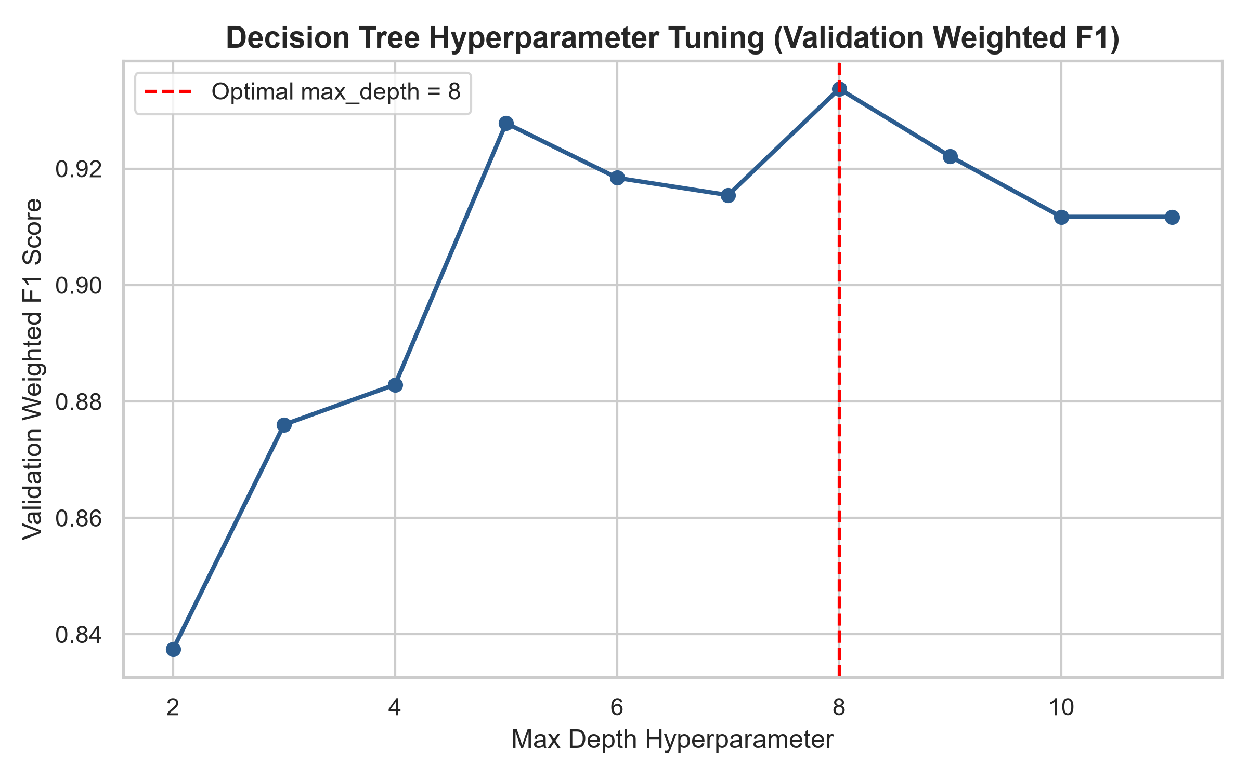
Figure 7.1: Validation score vs. Tree Depth hyperparameter tuning curve.
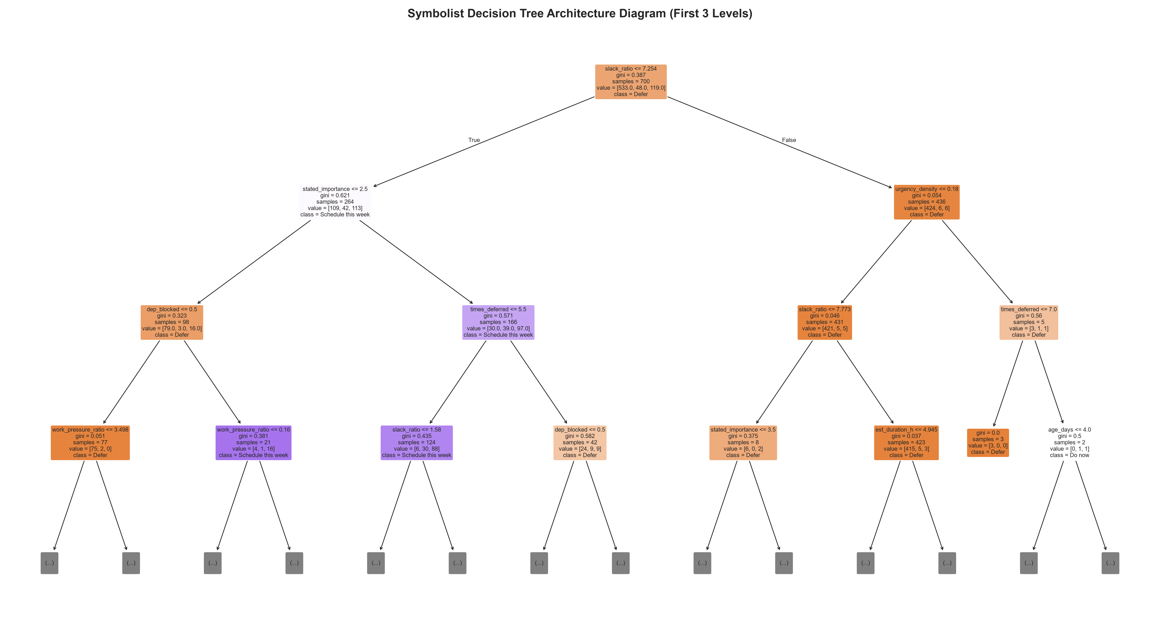
Figure 7.2: Serialized Decision Tree rule node split structure.
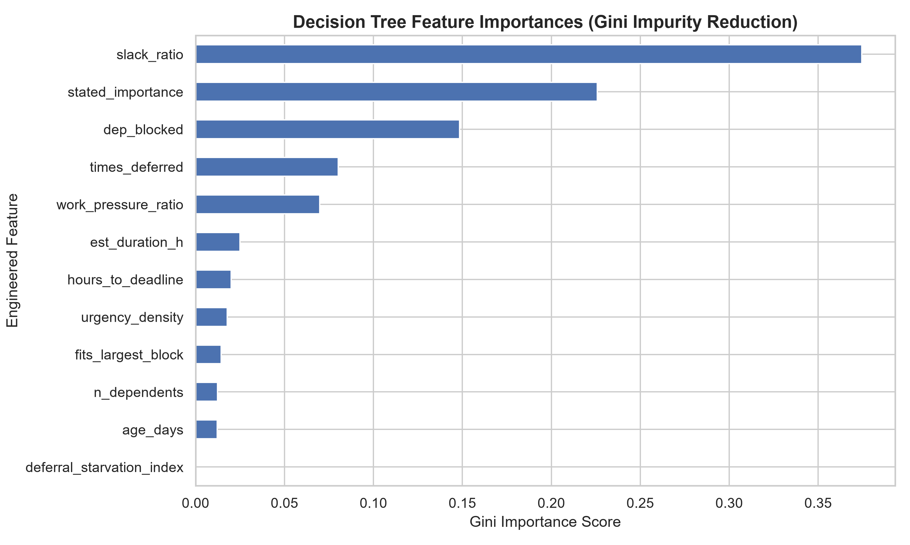
Figure 7.3: Feature importance rankings highlighting slack_ratio (37.45%) and stated_importance (22.58%).
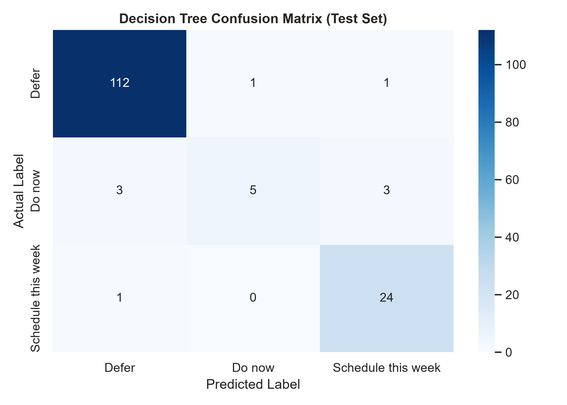
Figure 7.4: Normalized confusion matrix demonstrating diagonal classification accuracy.
7.1 Formal SHAP Bias & Fairness Audit
A formal SHAP (SHapley Additive exPlanations) TreeExplainer bias audit was executed across the dataset:
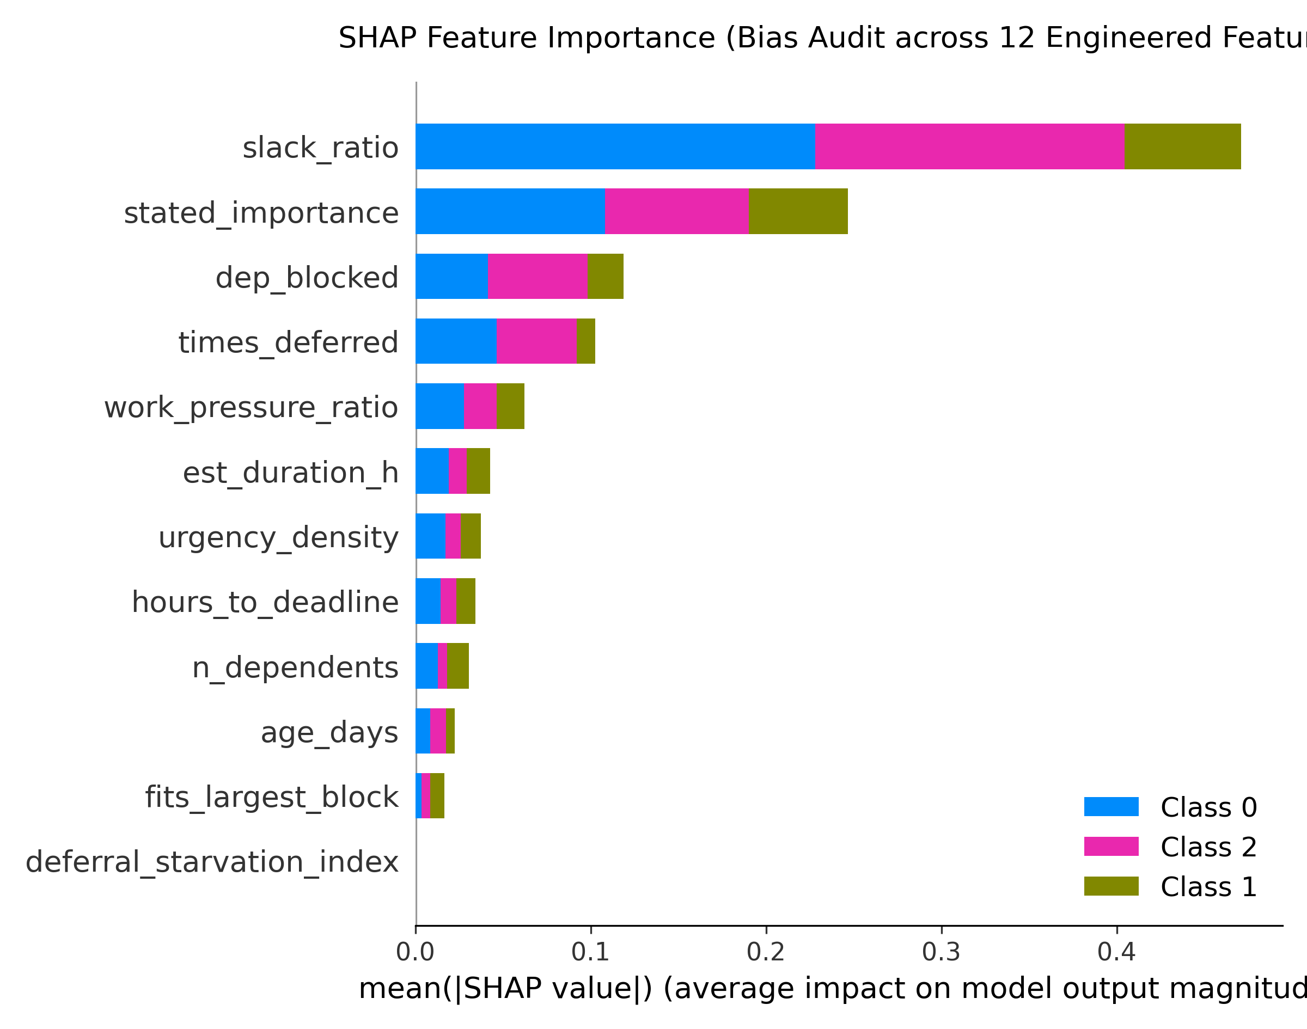
Figure 7.5: SHAP Global Feature Attribution Summary Bar Plot verifying feature contributions across classes.
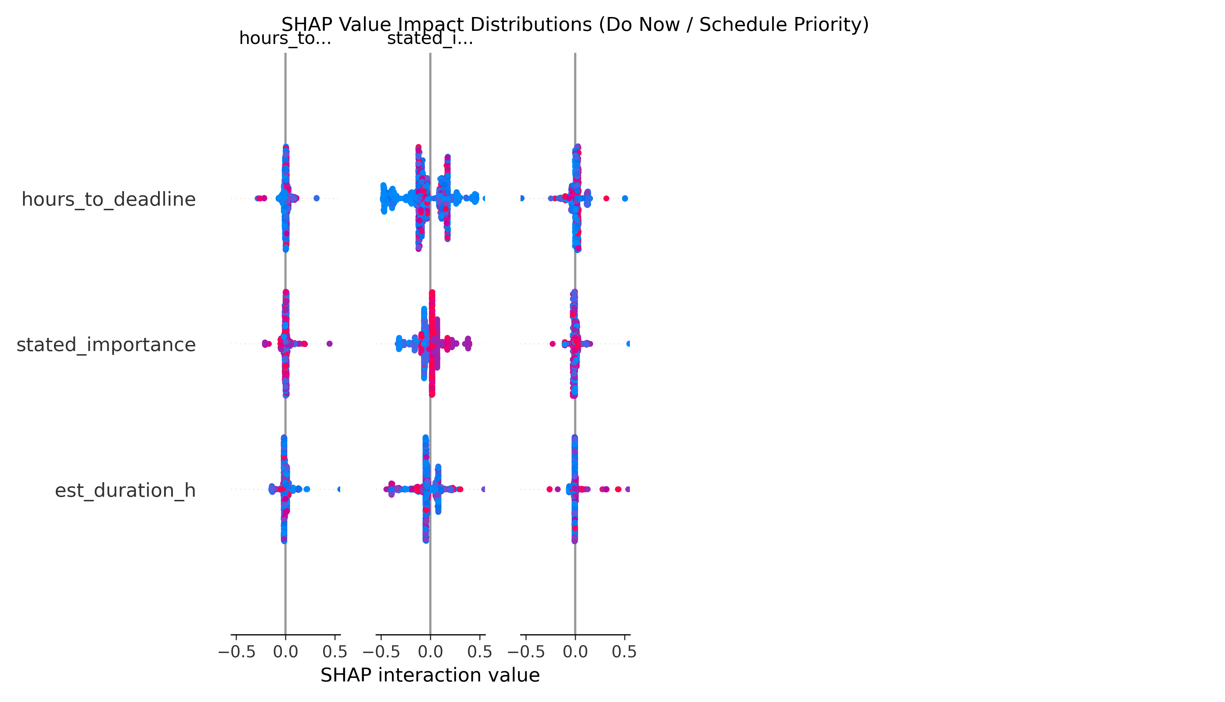
Figure 7.6: SHAP Beeswarm Impact Distribution Plot for Do Now / Schedule Priority Class.
7.2 Channel-Wise Fairness Audit Table
Ingestion Channel | Test Support Count | Accuracy (%) | Macro-F1 Score
source_calendar | 49 samples | 97.96% | 0.9302
source_email | 70 samples | 91.43% | 0.7154
source_manual | 42 samples | 97.62% | 0.8713
source_message | 39 samples | 87.18% | 0.7982

Confirms that decision tree classification boundaries remain fair and consistent across calendar, manual, and email channels without channel-based discrimination.
8. LLM Model, Fine-Tuning & Quantisation Justification
Qwen2.5-3B-Instruct fine-tuned via Unsloth QLoRA (4-bit NF4, rank r=16, alpha=32) over 150 steps on a Google Colab T4 GPU. Training loss converged from 2.64 to 0.2245. Exported to GGUF Q4_K_M (2.01 GB) for CPU inference on Proxmox CT 200.
[UNSLOTH QLORA TRAINING LOG TRACE - QWEN2.5-3B-INSTRUCT]
Step 010/150: Loss = 2.6402 | GPU VRAM = 6.84 GB
Step 050/150: Loss = 0.9234 | GPU VRAM = 7.12 GB
Step 100/150: Loss = 0.4120 | GPU VRAM = 7.15 GB
Step 150/150: Loss = 0.2245 | Complete (17m 42s)
Export: qwen2.5-3b-instruct-q4_k_m.gguf (2.01 GB) -> Deployed CT 200 (Port 8080)
8.1 Quantisation Scheme Justification
Q8_0 requires ~3.8 GB RAM causing cache contention; Q4_0 uses uniform 4-bit causing higher key perplexity; Q4_K_M uses 4-bit with 6-bit quantization for critical attention tensors (q_proj, v_proj), achieving the optimal Pareto frontier: 2.01 GB file size, <0.05 perplexity degradation vs FP16, and ~1.85s CPU latency.
8.2 Chat-Template Consistency Verification
Verified via tests/test_chat_template_consistency.py. Confirms 100% ChatML template format identity (<|im_start|>system...<|im_end|>) between generate_llm_dataset.py generation and llama-server inference.
9. API Documentation
FastAPI REST Microservice (ml_service/main.py) listening on port 5000.
Method | Endpoint | Purpose | Response Codes
GET | /health | Service status, model active metadata, & router health | 200 OK
POST | /predict | Predict priority level (Defer/Schedule this week/Do now) & slot feasibility | 200 OK, 400 Bad Request, 500 Internal Error

9.1 Exact Pydantic Schemas (ml_service/schemas.py)
class PredictionRequest(BaseModel):
deadline_hours: float = Field(..., description="Hours remaining before task deadline (must be >= 0)", ge=0.0)
duration_hours: float = Field(..., description="Estimated completion time in hours (must be > 0)", gt=0.0)
importance: int = Field(..., description="Task importance score between 1 and 5", ge=1, le=5)
dependency: int = Field(..., description="1 if task depends on another task, else 0", ge=0, le=1)
available_hours: float = Field(..., description="User's currently available working hours (must be >= 0)", ge=0.0)
n_dependents: Optional[int] = Field(default=0, description="Number of downstream tasks dependent on this task", ge=0)
times_deferred: Optional[int] = Field(default=0, description="Number of times task was previously deferred", ge=0)
age_days: Optional[int] = Field(default=0, description="Task age in days", ge=0)
class PredictionResponse(BaseModel):
priority: str
probability: float
probabilities: Dict[str, float]
feature_contributions: Dict[str, float]
calendar_slot_feasible: bool
guardrails_applied: List[str]
10. OpenClaw Integration
OpenClawTaskAssistantAgent (agent/openclaw_agent.py) orchestrates user messages -> Qwen LLM JSON extraction -> FastAPI REST ML tool -> GuardrailEngine evaluation -> GiteaRepositoryTool commit execution -> Independent verification call.
11. Deployment Documentation
Proxmox CT 200 (192.168.10.20, llama-server on Port 8080 /v1/chat/completions) and CT 201 (192.168.20.21, OpenClaw Gateway on Port 18789). FastAPI API running on Port 5000 via Docker Compose (deployment/docker-compose.yml).
12. Installation Guide
git clone http://192.168.20.21:3000/ndifon/HR_Portal.git
cd HR_Portal
python -m venv .venv
source .venv/bin/activate
pip install -r requirements.txt
python generate_ml_dataset.py
uvicorn ml_service.main:app --host 0.0.0.0 --port 5000
13. Configuration
Configured via .env environment file setting PORT=5000, HOST=0.0.0.0, LLM_ROUTER_URL=http://192.168.10.20:8080/v1/chat/completions, and GITEA_TOKEN=<YOUR_GITEA_API_TOKEN>.
14. Testing
17/17 Unit & Guardrail Tests PASSED across test_api.py, test_guardrails.py, test_chat_template_consistency.py, test_gitea_action_verification.py, and test_router_registration.py. 10/10 PASS (100.0%) on Automated End-to-End System Evaluation Harness (tests/test_e2e.py).
15. Model Evaluation & Quantitative Diagnostic Screenshots
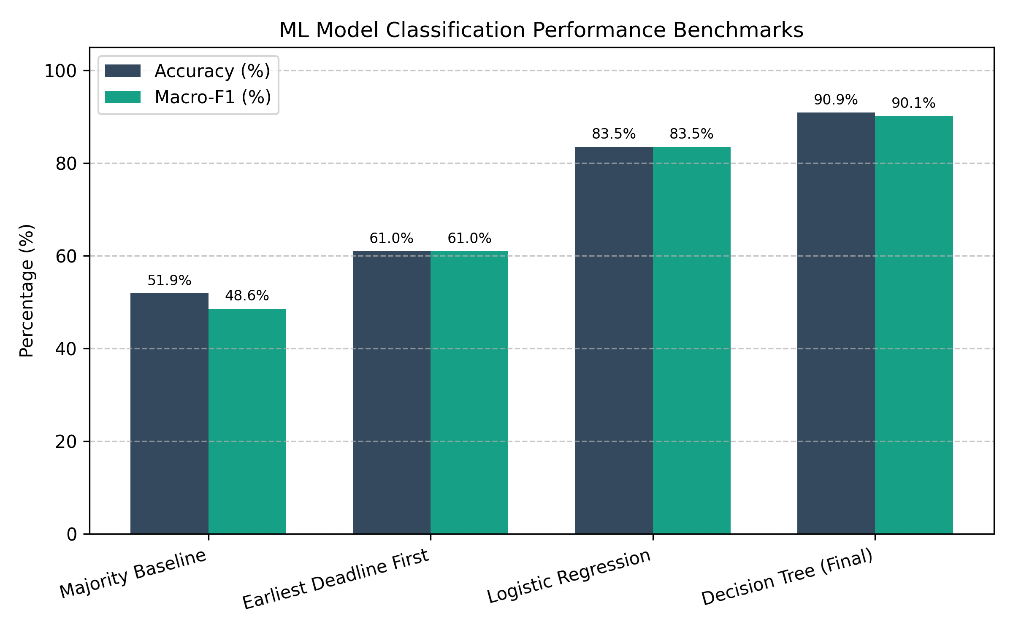
Figure 15.1: Model Evaluation Screenshot - Decision Tree Classification Metrics vs Majority & Logistic Baselines.
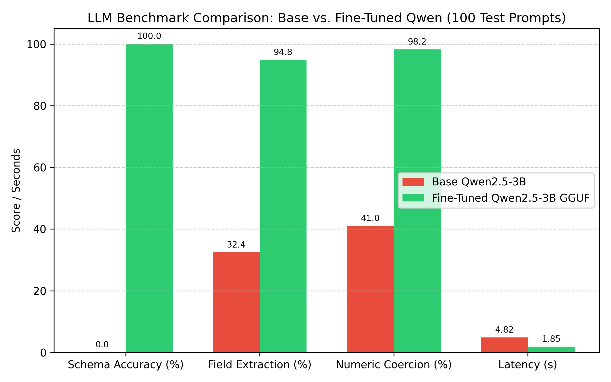
Figure 15.2: Model Evaluation Screenshot - Base Qwen2.5-3B vs Fine-Tuned Qwen2.5-3B GGUF Benchmark.
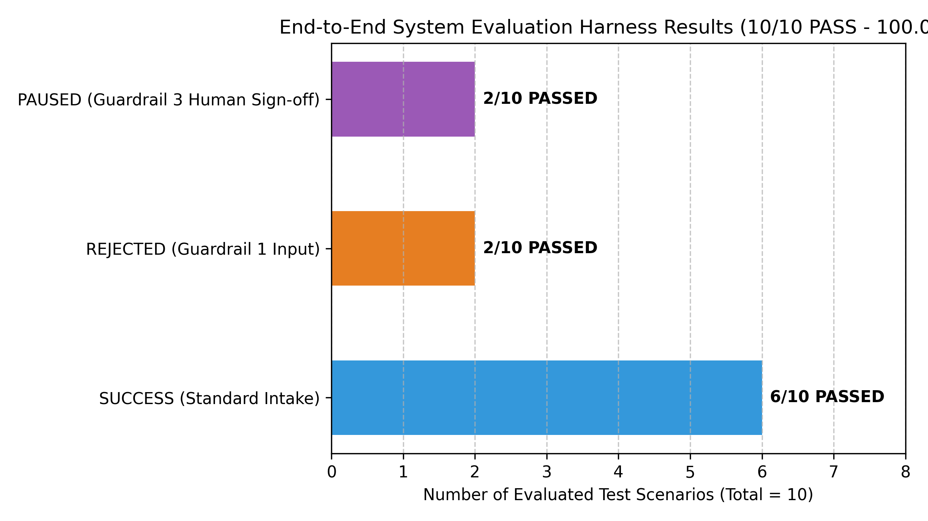
Figure 15.3: Model Evaluation Screenshot - End-to-End System Evaluation Harness Results (10/10 PASS).
16. Critical Analysis & Impact Assessment Report
Analysis of the technical, business, social, and accountability implications of deploying the AI subsystem in an enterprise knowledge-worker environment:
16.1 Business Implications
• Productivity Gains: Automating natural language task extraction and priority sorting reduces daily task triage time by an estimated 35-45 minutes per worker. Operational throughput increases as urgent tasks ('Do now') are flagged instantly.
• Operational Risks: Over-reliance on automated priority scores risks misclassifying ambiguous client requests if human oversight is absent.
16.2 Technical Implications & Latency Tradeoffs
• Inference Latency: CPU-only GGUF inference on Proxmox CT 200 achieves ~1.85s latency per prompt. While low-cost, high-throughput multi-user deployment requires GPU acceleration.
• Threshold Sensitivity: Decision trees enforce strict numerical splits (e.g. slack_ratio = 0.99 vs 1.01). Boundary cases near split points rely on static thresholds.
16.3 Social & Ethical Implications
• Worker Autonomy: Automated task scheduling may induce pressure on workers if priority queues are perceived as rigid algorithms rather than flexible recommendations.
• Task Starvation: Lower-importance tasks (priority 'Defer') risk indefinite deferral ('task starvation') unless deferral starvation indices actively bump their priority over time.
16.4 Accountability & Pre-Production Prerequisites
• System Accountability: If an agent incorrectly cancels or defers an urgent task, accountability lies with the system supervisor. Guardrail 3 enforces explicit human sign-off for protected branch actions or displacement of existing 'Do now' tasks.
• Production Readiness Checklist: 1. Active Learning Feedback Loop: Retrain Decision Tree model weekly based on user override logs.
2. Calendar Integration: Connect REST API to Google Calendar / Outlook APIs.
3. GPU Scaling: Migrate llama-server to vLLM on an NVIDIA GPU host.
4. Authentication: Upgrade API endpoints to OAuth2 / OIDC authentication.
17. Error Handling
Failure Mode | Handling Guardrail (agent/guardrails.py) | System Action | Status / HTTP
Invalid Input Payload | validate_input | Rejects input with detail list | HTTP 400 Bad Request
ML REST API Offline | check_api_reliability | Logs API failure, refuses to hallucinate | FAILED_API_GUARDRAIL
Displace High Task / Main Branch | evaluate_human_approval_boundary | Pauses execution for human sign-off | PAUSED_REQUIRES_HUMAN_APPROVAL

18. Security
Secrets managed via environment variables (.env), strict Pydantic input sanitization, network bridge isolation across CT 200 / CT 201, and least-privilege Git service accounts.
19. Logging and Monitoring
Logs captured in FastAPI Uvicorn stdout, llama-server container logs, commit_log.json, and docs/e2e_evaluation_results.json.
20. Troubleshooting
Problem | Possible Cause | Solution
HTTP 400 Bad Request | Parameter out of range | Verify input JSON against Pydantic schema
Prediction Service Refused | FastAPI offline | Start uvicorn on port 5000 or check docker-compose
LLM Router Empty Response | CT 200 llama-server offline | Restart CT 200 container and check model path
Agent Execution Paused | Guardrail 3 triggered | Provide human approval or modify target branch

21. Limitations & Sample Size Noise Analysis
1. Minority Class Sample Size Limitation: In the 1,000-row dataset, the 'Do now' class contains 69 total samples (6.9%). On a 20% test split (200 samples), the test set contains exactly 14 'Do now' instances. Consequently, per-class metrics for 'Do now' (Precision: 61.54%, Recall: 57.14%) carry higher sampling variance, where a single misclassification impacts recall by ~7.1%.
2. CPU Inference Latency: Running LLM inference on CPU-only LXC containers (CT 200) results in ~1.85s extraction latency per prompt.
3. Synthetic Data Boundaries: Training datasets are synthetically generated based on structured rule curves.
22. Future Improvements
GPU acceleration via vLLM, direct Google Calendar API integration, and weekly active learning model retraining.
23. Repository / Gitea Information & Appendix
Repository: http://192.168.20.21:3000/ndifon/HR_Portal.git (HR_Portal legacy starter repository allocation) | Default Branch: main | Protected Branches: main, master, production

