How to edit the questionnaires

The 3 questionnaires templates:
- Questionnaire 1
- Questionnaire 2
- Questionnaire 3

How to edit

In all the above links click on the “pencil” button

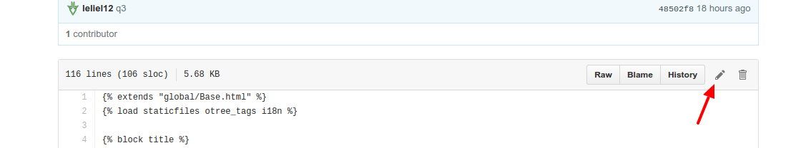

All the text to modify are inside a “trans” function with the form

{% trans “text” %}

For example

{% trans "Did other members follow the recommendations of action?" %}

change only inside the quotes “”

