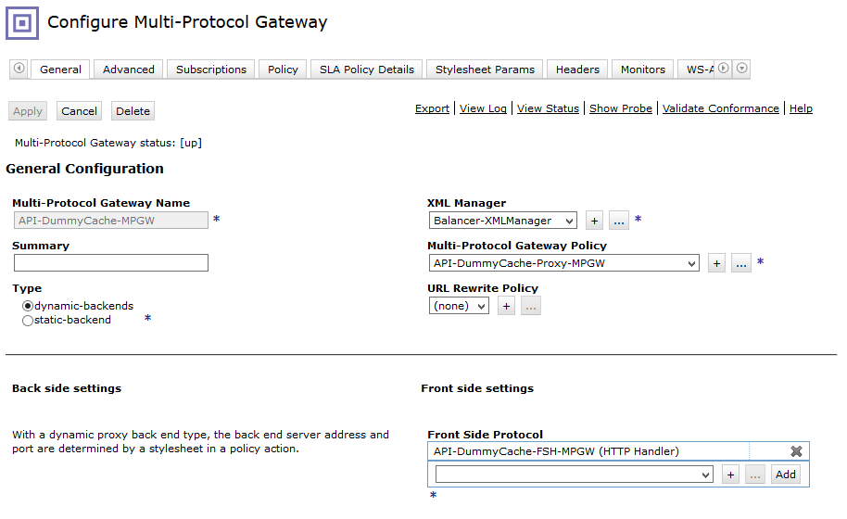

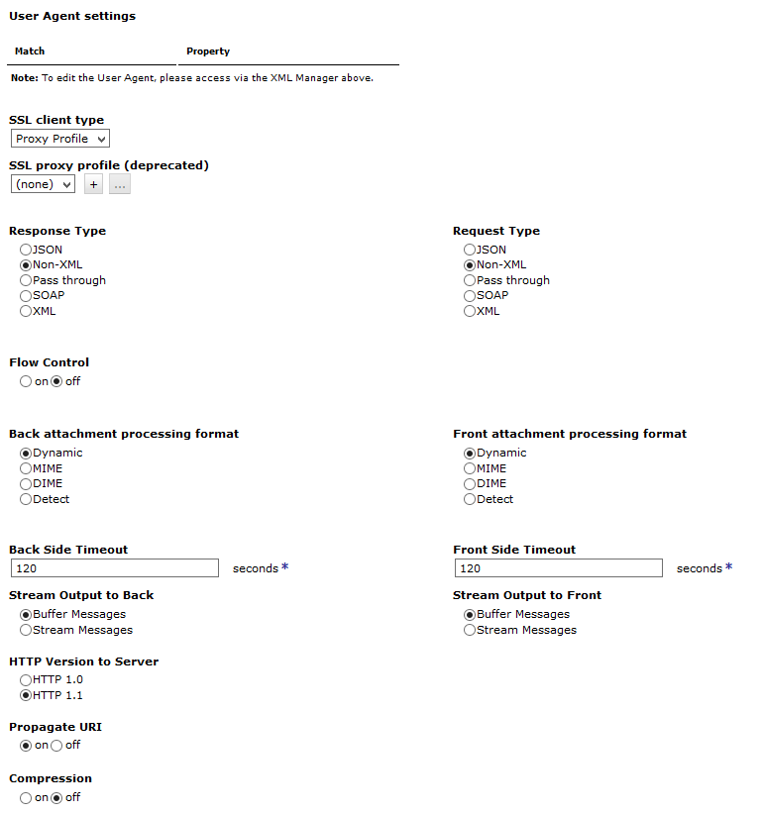

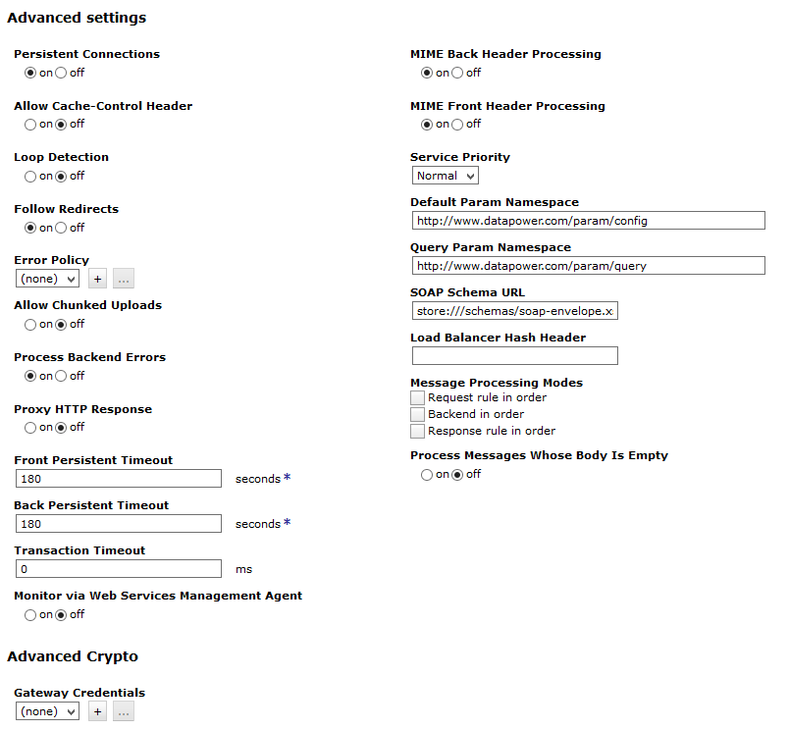

disable

<https://localhost:44318/MultiProtocolGatewayService/DisableProbe?id=API-Proxy-MPGW&Environment=Desarrollo&Host=dpconsoledesa.telecom.com.ar&Domain=DESARROLLO_WEB_PUB>

enable

<https://localhost:44318/MultiProtocolGatewayService/EnableProbe?id=API-GTW-GenerarClaveDF-MPGW&Environment=Testing&Host=dpconsoletest.telecom.com.ar&Domain=TESTING_WEB_PUB>

Web Service:

