**Business Requirements Document for Unlock Pincode Application**

**Features**

1. Homepage
   1. Display of a background image
   2. There’s a welcome image top of the page.
   3. There’s a link to the account page.
   4. There’s a link to the Feedback page.
   5. There’s a drop-down list to turn on/off the sound.
   6. There’s a drop-down list to select a game board of your choose.
   7. There’s a start button.
   8. There’s an exit button.
   9. There’s an image with digit from 1-9.

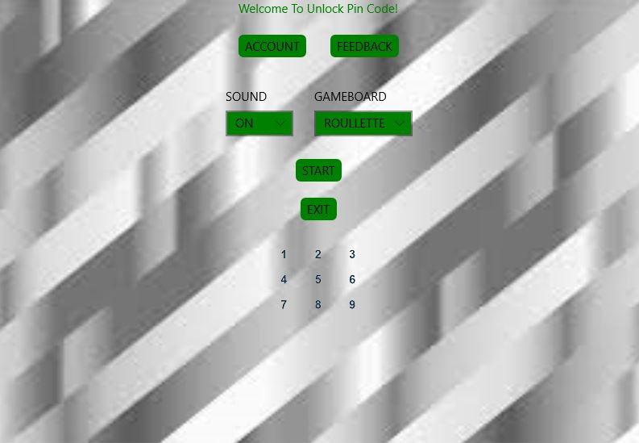

1. Account Page
   1. There’s a username label.
   2. There’s an entry username entry field with a place holder “username”.
   3. There’s a password label.
   4. There’s a password entry field with a placeholder “password”.
   5. There’s a sign in button.
   6. There’s a sign-up button.
   7. There’s a home button.
   8. Warning or alert are displayed if field are empty.
   9. Warning is displayed if username already exist.
   10. There’s a background image.

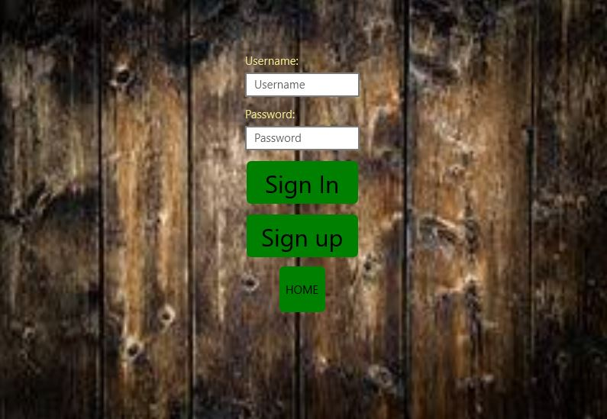

1. MyAccount Page
   1. There’s a home button at the top left.
   2. User’s details are displayed on the left.
   3. User name is displayed on the top right.
   4. User highest scores ever are displayed on the top right.
   5. There’s an edit button on the bottom left.
   6. There’s a log out button at the middle of the bottom row.
   7. There’s a delete button at the right of the bottom row.
   8. There’s a background image.

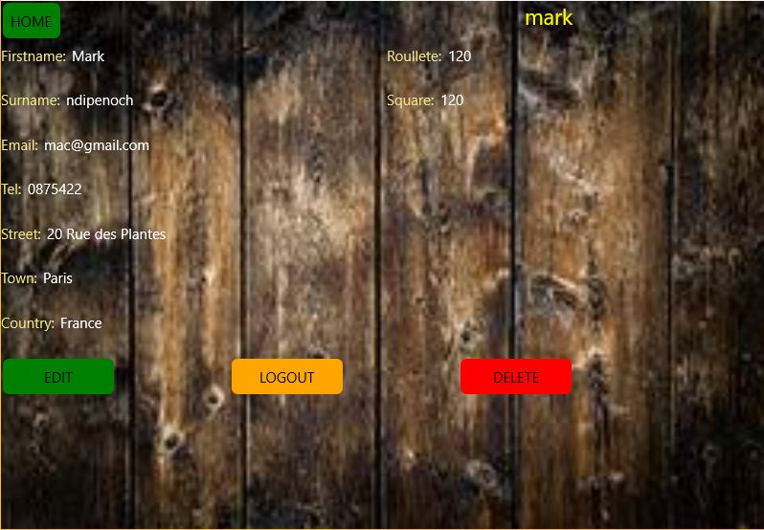

1. Edit MyAccount Page
   1. There’s a home button at the top left.
   2. Labe with user’s details are displayed on the left.
   3. Entry fields with user’s details are displayed on the left with placeholders.
   4. User name is displayed on the top right.
   5. User highest scores ever are displayed on the top right.
   6. There’s a Save button at the middle of the bottom row.
   7. There’s a background image.

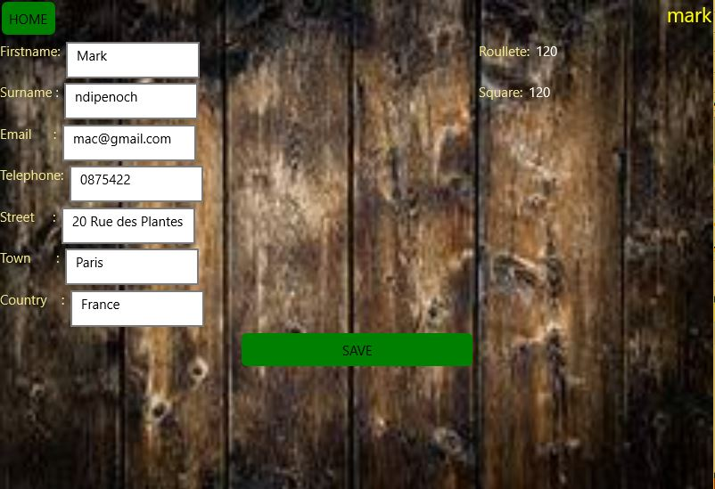

1. Feedback Page
   1. There’s a home button at the top left.
   2. There’s a name entry field with a place holder “Name”.
   3. There’s an email entry field with a place holder “Email”.
   4. There’s a telephone entry field with a place holder “Telephone”.
   5. There’s a text area with a place holder “Comments...”.
   6. There’s a send button at the middle of the bottom row.
   7. There’s a background image.

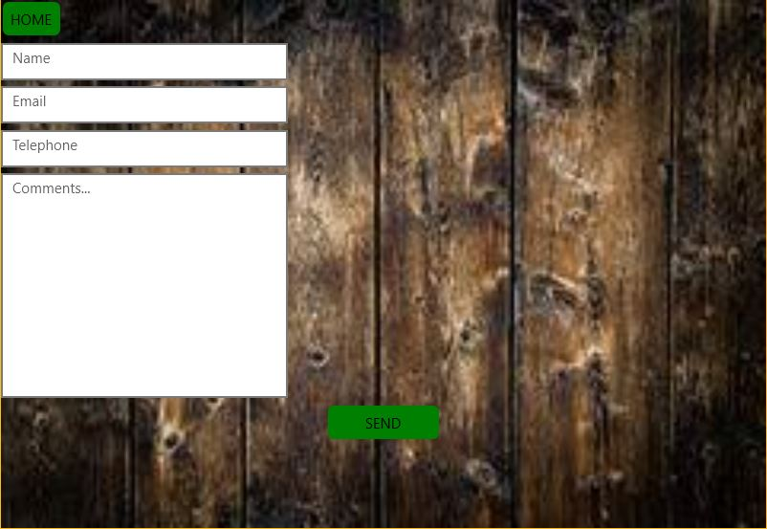

1. Roulette Page.
   1. There’s a Home button at the left.
   2. The highest score ever is displayed at the top right, if user is log in.
   3. At the middle of the second row is a level label.
   4. Next to the level label is the current level.
   5. There’s a hi five greeting.
   6. Next to the hi-5 greetings are 4 randomly generated numbers.
   7. If a user gets it right a green tick appears on the number.
   8. If the user gets it wrong red “X” appears on the number.
   9. Below the random numbers is a circle or numbers from 1-9.
   10. At the middle of the circle is a moving arm/stroke in green.
   11. Below the circle is a welcome message with username if the user is log in.
   12. At the right of the bottom row is a press button.
   13. The background colour is silver.

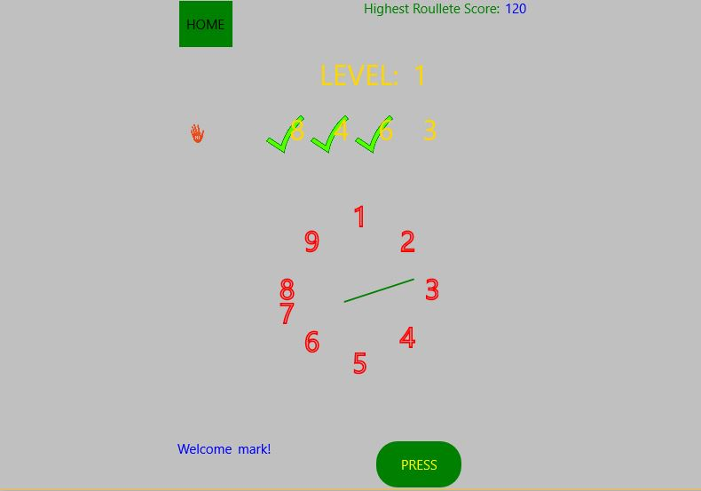

1. Square Page
   1. There’s a Home button at the left.
   2. The highest score ever is displayed at the top right, if user is log in.
   3. At the middle of the second row is a level label.
   4. Next to the level label is the current level.
   5. Below the level label are 4 randomly generated numbers.
   6. If a user gets it right a green tick appears on the number.
   7. If the user gets it wrong red “X” appears on the number.
   8. Below the 4 random numbers are 3X3 9 green square buttons.
   9. At the middle of the bottom row is a welcome message with username if the user is log in.
   10. There’s background image.

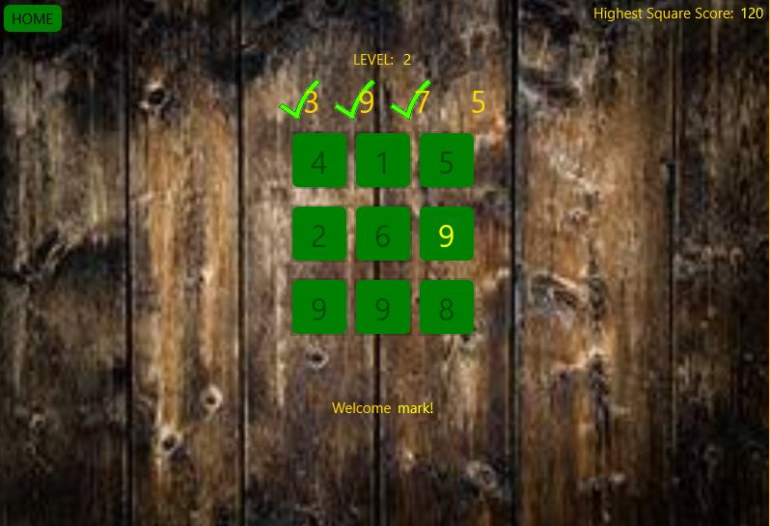

# **Tests Conducted**

**Features**

* Sound is either turn on/off when the user navigates to either the Roulette or square page depending on which sound mode, they selected on the home page.

* On the account page the username and password field must be field if not a warning alert is shown to the user. This bug was only discover when the first version of the app was released to Play store and it was fix in the second release. Thanks to the multiple user’s experience, feedback and reviews.

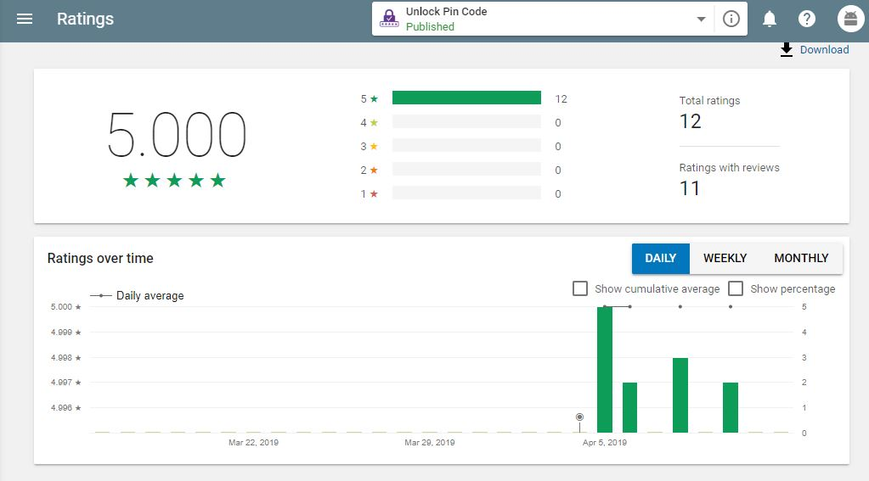

* On both the Roulette and square pages, if you sign in your highest score ever and a welcome message will be displayed on the screen.

* The highest score changes instantly on screen and on the servers if a user gets a higher score.

*Different users can sign in on the same device and each user will see only their own scores and details. Any update or changes made will only be implemented to the user’s account.

*Users can sign in and retrieve their details and scores anywhere, any time and on any device that meets the application requirements.

* Username and password fields must be filed upon clicking the sign in or sign up button or else an alert message will be shown to the user.

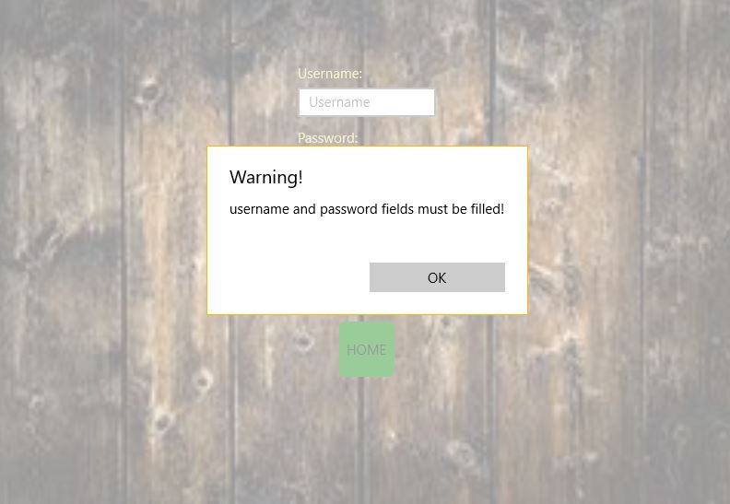

* Username is unique for the application, if a user already exists with the username, a warning or alert is shown to the user.

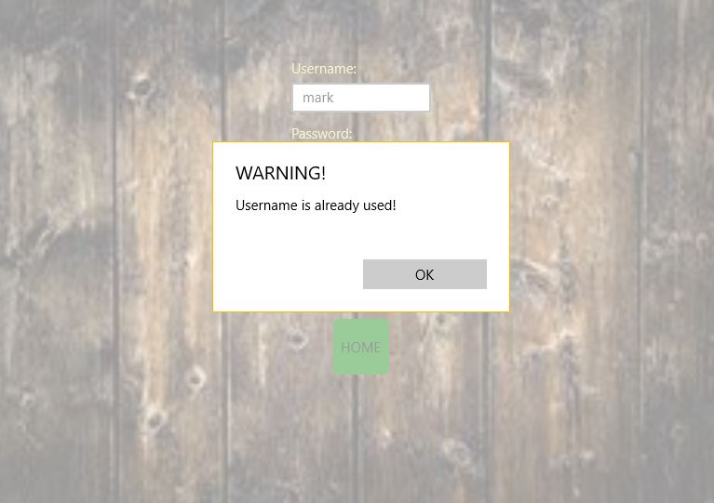

* If you Edit your details and click the save button, the changes are reflected immediately in your account page upon refreshing the page.

* If you click the delete button, your details are deleted on the server and on your device if it is UWP.

* On the Feedback page, the name and comment fields must be filed upon clicking the send button or else you will get an alert or waring message.

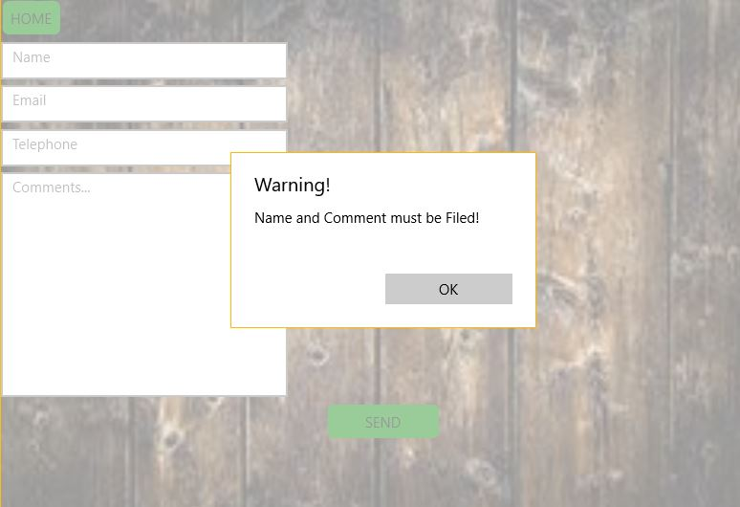

* If you don’t have internet and try to sign in/ sign up an alert will be shown to you.

