**Các bước tạo project Spring MVC**

B1 tạo mới project

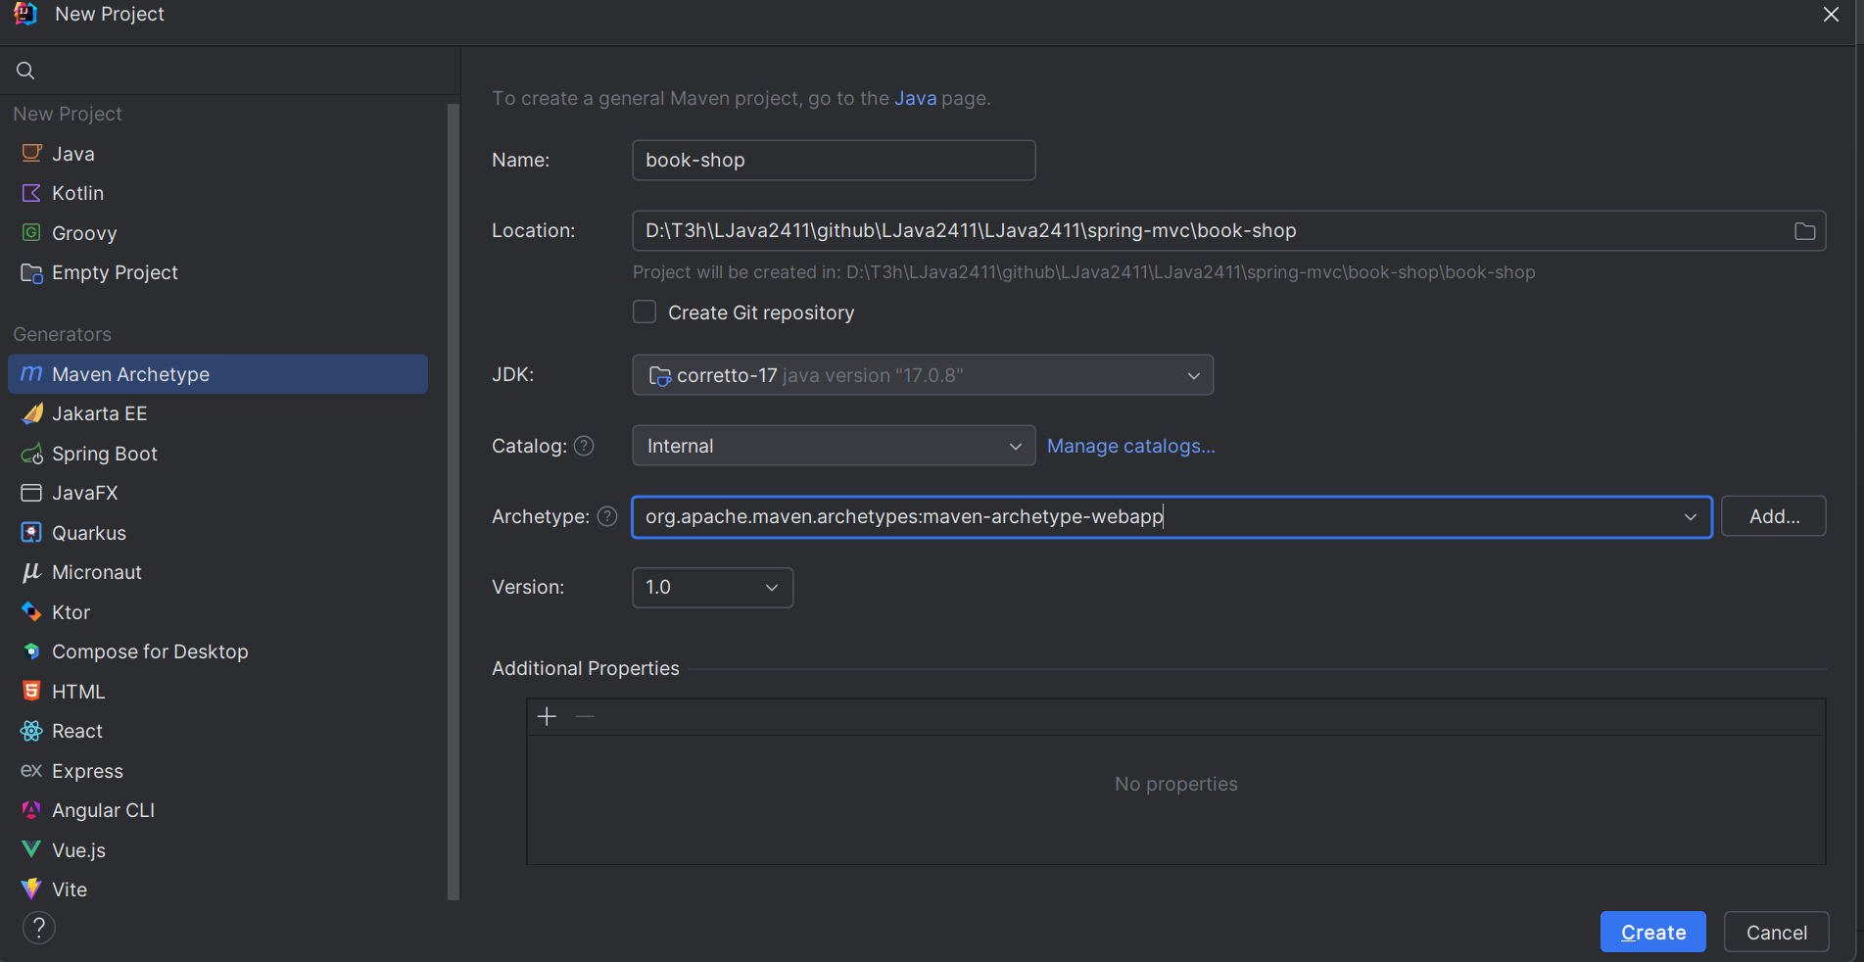

Project sau khi tạo xong

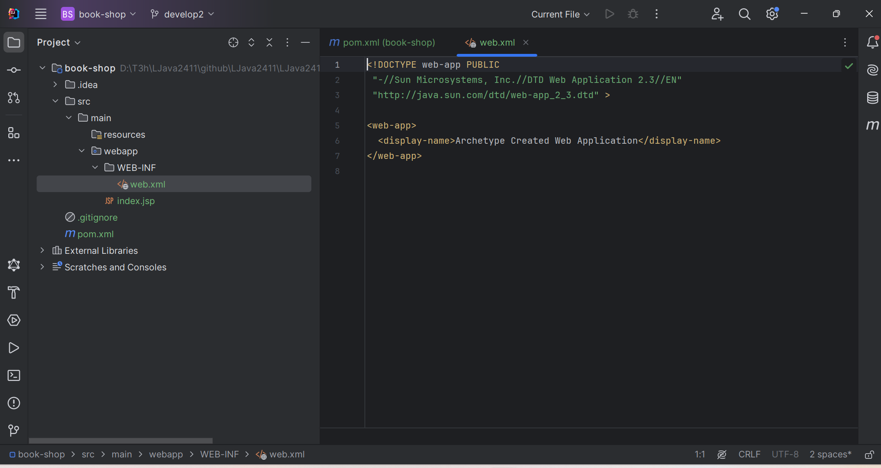

B2) Thêm các thư viện này trong file pom.xml

<!-- https://mvnrepository.com/artifact/org.springframework/spring-webmvc -->  
<dependency>  
 <groupId>org.springframework</groupId>  
 <artifactId>spring-webmvc</artifactId>  
 <version>6.2.2</version>  
</dependency>  
<!-- https://mvnrepository.com/artifact/org.springframework/spring-context -->  
<dependency>  
 <groupId>org.springframework</groupId>  
 <artifactId>spring-context</artifactId>  
 <version>6.2.1</version>  
</dependency>  
<!-- https://mvnrepository.com/artifact/org.springframework/spring-web -->  
<dependency>  
 <groupId>org.springframework</groupId>  
 <artifactId>spring-web</artifactId>  
 <version>6.2.1</version>  
</dependency>

B3) Config file web.xml, xóa mặc định đi và thay bằng code config mới

<web-app xmlns="http://java.sun.com/xml/ns/javaee"  
 xmlns:xsi="http://www.w3.org/2001/XMLSchema-instance"  
 xsi:schemaLocation="http://java.sun.com/xml/ns/javaee  
 http://java.sun.com/xml/ns/javaee/web-app_3_0.xsd"  
 version="3.0">  
  
 <servlet>  
 <servlet-name>dispatcher</servlet-name>  
 <servlet-class>org.springframework.web.servlet.DispatcherServlet</servlet-class>  
 <init-param>  
 <param-name>contextConfigLocation</param-name>  
 <param-value>/WEB-INF/dispatcher-servlet.xml</param-value>  
 </init-param>  
 <load-on-startup>1</load-on-startup>  
 </servlet>  
  
 <servlet-mapping>  
 <servlet-name>dispatcher</servlet-name>  
 <url-pattern>/</url-pattern>  
 </servlet-mapping>  
  
</web-app>

B4) Trong folder main tạo folder java và tạo package vn.com.t3h.controller trong folder java

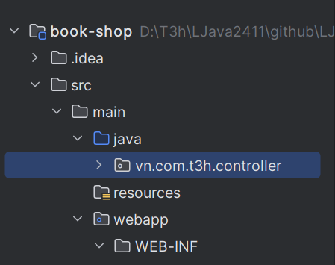

B5) Tạo file dispatcher-servlet.xml trong webapp/WEB-INF/dispatcher-servlet.xml

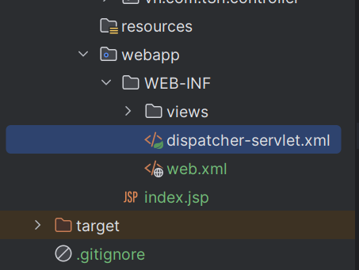

B6) Config trong file dispatcher-servlet.xml

<beans xmlns="http://www.springframework.org/schema/beans"  
 xmlns:xsi="http://www.w3.org/2001/XMLSchema-instance"  
 xmlns:context="http://www.springframework.org/schema/context"  
 xsi:schemaLocation="http://www.springframework.org/schema/beans  
 http://www.springframework.org/schema/beans/spring-beans-4.3.xsd  
 http://www.springframework.org/schema/context  
 https://www.springframework.org/schema/context/spring-context.xsd">  
  
 <!-- Cấu hình component-scan để Spring tìm kiếm các controller -->  
 <context:component-scan base-package="vn.com.t3h.controller" />  
  
 <!-- Cấu hình view resolver để hiển thị JSP -->  
 <bean class="org.springframework.web.servlet.view.InternalResourceViewResolver">  
 <property name="prefix" value="/WEB-INF/views/" />  
 <property name="suffix" value=".jsp" />  
 </bean>  
</beans>

B7) Tạo file HelloController trong package controller

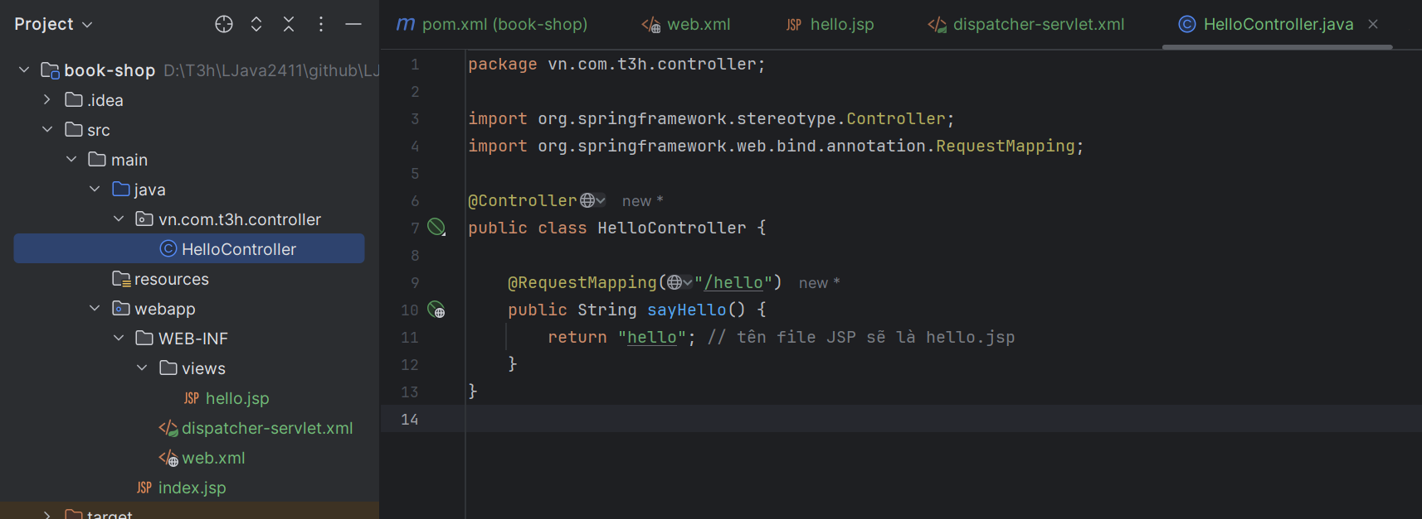

B8) Tạo file hello.jsp

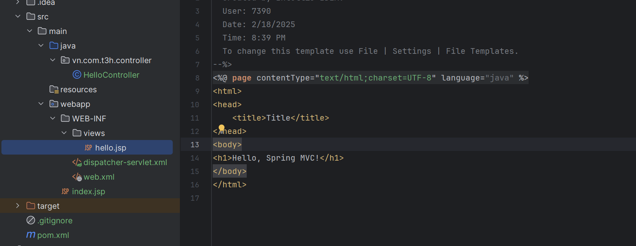

B9) Config tomcat server

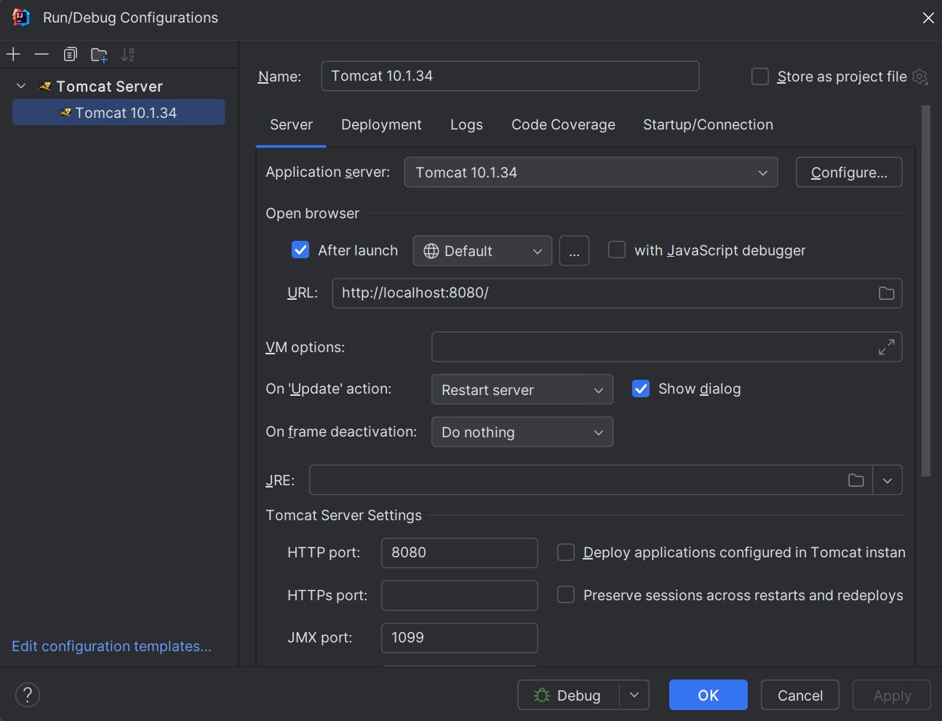

B10) Chuyển sang tab Deployment config Artifact

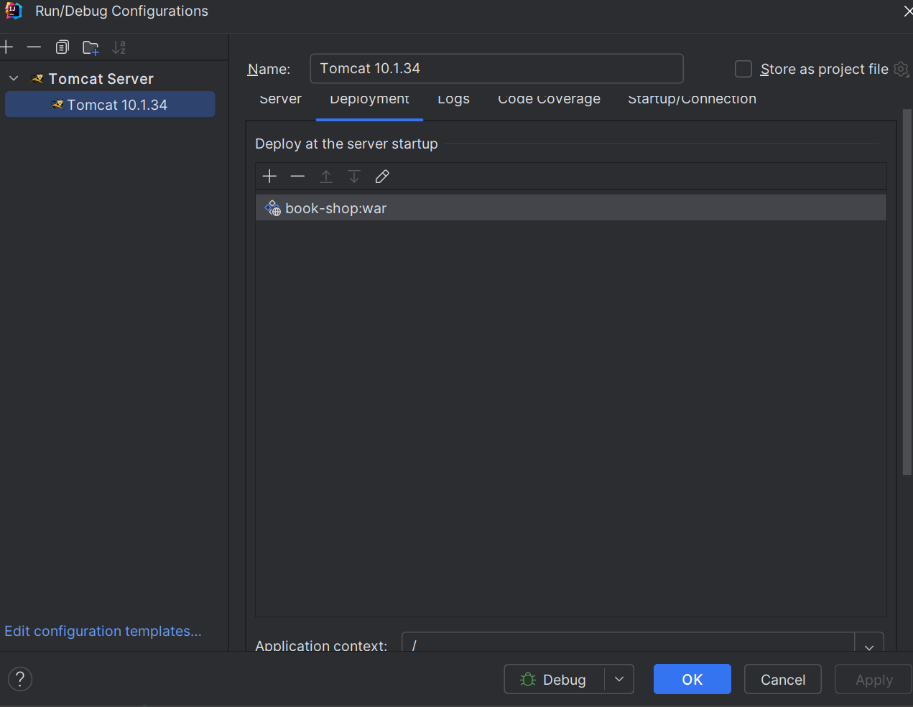

Run project như servlet

Truy cập <http://localhost:8080/hello>