Dynamo OS
Project Management Definitions & Processes
Version 1.0 | March 2026
Classification: Dynamo Confidential

1. Purpose
This document defines the core terminology, workflow states, and processes used in Dynamo OS. These definitions govern how work is tracked, reviewed, escalated, and communicated across all Dynamo projects. All team members are expected to apply these definitions consistently so that Jira remains a reliable system of record and project signals are accurate.

2. Jira Workflow States
The following definitions apply to all work items in Jira.
Consistent application of these states is critical for accurate reporting and early escalation.

2.1 Stalled
A work item is stalled when progress has slowed or paused, but the delay does not yet impact the sprint commitment, outcome, or delivery timeline.

Key characteristics:
- The item is not moving forward, but the sprint target is not yet at risk.
- A resolution is expected within the current sprint.
- No immediate escalation is required.
- Stalled items should be monitored closely and escalated to Blocked if not resolved before the sprint target is threatened.

How to apply: Add the label 'Stalled' to the work item and add a comment explaining the reason and expected resolution path. Move the Work Item into the ‘Stalled’ column.

2.2 Blocked
A work item is blocked when an unresolved dependency, decision, or external factor prevents forward progress and directly threatens the sprint outcome and/or delivery timeline.

Key characteristics:
- The item cannot move forward without external action.
- The delay will impact the project commitment, outcome delivery, invoicing, or milestone timelines.
- Blocked status is reserved for critical situations only.
- Blocked items require immediate escalation to a named resolution owner, with a due date.
- Block status should apply only to items outside the team's direct control.

How to apply: Add the label 'Blocked' to the work item, add a comment identifying the specific blocker, the resolution owner, and the [Due Date] by which it must be resolved to avoid project impact. Create a corresponding Action Item (Risk) in Jira linked to the blocked work item. Move the work Item into the ‘Blocked’ column.

Important distinction: Stalled is a warning state. Blocked is a 911 state. The goal is to prevent items from ever reaching Blocked by proactively managing Stalled items.

2.3 Quality Review
A work item enters Quality Review when the assignee considers it complete and is pending validation that it meets the defined acceptance criteria and outcome definition of done.

Key characteristics:
- The assignee has completed the work to the best of their knowledge.
- The item has not yet been accepted as Done.
- A named reviewer must be assigned before the item enters this state.
- The reviewer validates against the acceptance criteria defined at sprint planning.
- The reviewer may be Brent Atkinson or another qualified team member, depending on the nature of the work.

How to apply: Transition the work item to the Review column and assign the appropriate reviewer. The reviewer either approves the item and moves it to Done or returns it with documented feedback.

2.4 Done
A work item is Done when it has passed Quality Review, and the output has been confirmed to meet the acceptance criteria defined at the start of the sprint.

Key characteristics:
- Quality Review has been completed, and the reviewer has approved the item.
- The output matches the definition of done agreed at sprint planning.
- The item is reflected as complete in Jira before the sprint close.
- No further action is required on the item unless a new issue is discovered.

How to apply: The reviewer transitions the item to Done. If the item has a corresponding document, the document should be promoted to the main branch in GitHub before marking it as Done.

3. Action Item Definitions
Action Items are a custom Jira issue type used to track Risks, Decisions, and Questions. They are distinct from work items or tickets and represent information or commitments that require tracking, ownership, and resolution. All Action Items must have a named owner and a target Due Date.

3.1 Risk Log
A Risk is an identified condition or event that could negatively impact the project's timeline, outcomes, or client relationship if not addressed.

Field | Definition
Label | Risk
Assignee | Named individual responsible for monitoring and resolving the risk
Priority | Type 1 (irreversible, resolve before acting) or Type 2 (reversible, resolve quickly)
Status | Open, Stalled, Blocked, or Done
Due Date | The date by which the risk must be resolved to avoid project impact
Resolution | How the risk was resolved. Required before closing

Escalation path: If a risk is not resolved by its due date, it must be escalated to the Project Manager immediately. A stalled risk should be communicated to the team before being escalated to Blocked status.

3.2 Decision Log
A Decision is a choice that has been made or needs to be made that affects the direction, scope, or approach of the project. Decisions are classified as Type 1 or Type 2.

Field | Definition
Label | Decision
Type 1 | Irreversible or high-cost-to-reverse decisions. Must be answered before acting. Examples: platform selection, architecture choices, vendor contracts.
Type 2 | Reversible decisions. Answer quickly, correct if wrong. Examples: naming conventions, configuration choices, process preferences.
Owner | Named individual or group responsible for making the decision
Due Date | The date by which the decision must be made to avoid blocking downstream work
Status | Open, Advancing, or Done
Resolution | The decision that was made and the rationale — required before closing

3.3 Questions
A Question is an open item that requires an answer from an internal or external stakeholder before work can proceed or a decision can be made. Questions that remain unanswered beyond their due date should be escalated as Risks.

Field | Definition
Label | question
Assignee | Named individual responsible for obtaining the answer
Due Date | The date by which the answer is needed
Status | Advancing or Done
Resolution | The answer received — required before closing

4. Telemetry
Telemetry refers to the structured signals and metrics that Dynamo OS collects from Jira, GitHub Projects, meeting transcripts, and other sources to provide real-time visibility into project health. Telemetry powers the Signals layer.

Telemetry sources:
- Jira workflow state changes: how long items stay in each state when they move between states.
- Label changes: when stalled or blocked labels are applied or removed
- Action Item activity: new risks, decisions, and questions created, overdue items, and resolution rates
- GitHub Projects sync: items added, updated, or mismatched between Jira and GP
- Meeting transcripts via Fireflies: extracted decisions, risks, and questions compared against Jira
- Teams messages: (NICE TO HAVE) extracted action items and commitments compared against Jira

Telemetry is used to generate signals and proactive alerts that surface potential issues before they become blockers. The goal is to reduce decision latency and eliminate surprises for the project team, leadership, and clients.

TBD: Method of alert (Teams, Email, other)

Key metrics tracked:
- Number of items in Stalled state by age
- Number of items in the Blocked state
- Number of overdue Action Items by type
- Time in Quality Review by item
- Sprint completion rate against commitment
- GP to Jira sync lag and mismatch count

5. GitHub Document Approval Process
All project documentation is stored in the Dynamo GitHub repository and follows a branch-based approval process. This process ensures that all published documents have been reviewed, approved, and are traceable to a specific Jira ticket.

5.1 Branch Strategy
Field | Definition
Main branch | The approved, current version of all documentation. Anything on main is considered reviewed and ready to share.
Feature branch | Documents in progress. Named after the corresponding Jira ticket (e.g. WSA-120-visibility-infrastructure). Work in progress stays on the feature branch until approved.

5.2 Approval Process
The following steps apply to all document changes:
- Step 1: Create a feature branch named after the Jira ticket the document relates to.
- Step 2: Make changes or create the new document on the feature branch.
- Step 3: Open a Pull Request (PR) targeting the main branch.
- Step 4: Assign at least one reviewer. The reviewer provides comments or approves the PR.
- Step 5: Once approved, merge to main. The document is now the current approved version.
- Step 6: Add the GitHub main branch URL to the doc_link field on the corresponding Jira ticket.

Key principles:
- No document is considered approved until it is on the main branch.
- All changes are attributed to the person who committed them, providing a full audit trail.
- Documents generated by Cursor from Jira data follow the same process before being shared externally.
- Once a document is on the main, it can be written to SharePoint for client or leadership distribution without a separate review step.

6. Architecture Overview
Dynamo OS is an AI-first project management system built on top of Dynamo’s existing toolstack. It is designed to reduce decision latency, surface project risks early, and provide leadership and clients with real-time visibility into project health without requiring manual reporting.

6.1 Layers
Inputs: Data flows into the system from Fireflies (meeting transcripts), Microsoft Teams (messages and decisions), uploaded documents, and meeting notes. The AI layer processes these sources to extract actionable items.
AI Processing Layer: Built on Cursor, AWS Lambda, and Claude. This layer extracts decisions, risks, questions, and task updates from inputs, compares them against the system of record in Jira, and creates or flags items accordingly. It also powers the sync process between Jira and GitHub Projects.
Sync and Review Layer: AWS Lambda and API Gateway manage the hourly sync between Jira and GitHub Projects. Proposed changes are staged in DynamoDB and presented in a review UI before being applied. Approved changes are written back to the appropriate system and logged as Jira comments for audit trail purposes.
Systems of Record: Jira is the system of record for all work items, risks, decisions, and questions. GitHub is the system of record for all project documentation, using a branch-based approval process (see Section 5). GitHub Projects serves as the development team’s workspace and stays in sync with Jira via the Jira Key field.
Generated Outputs: All reports, project plans, and status documents are generated on demand from Jira data by Cursor and written to SharePoint for client and leadership distribution. Confluence is used for embedded leadership views. Signals are proactive alerts generated from telemetry data to surface risks before they become blockers.

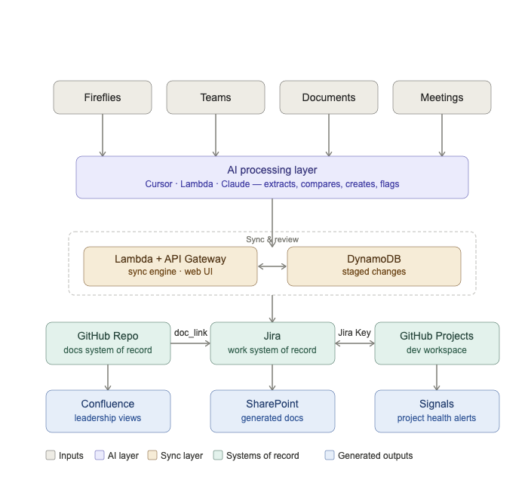

6.2 Technology Stack
Tool | Layer | Role
Jira | System of record | Work items, risks, decisions, questions
GitHub Repo | System of record | All project documentation, branch-based approval
GitHub Projects | Dev workspace | Developer task tracking, synced to Jira via Jira Key
Cursor + Claude | AI layer | AI development IDE and reasoning engine
AWS Lambda + API Gateway | Sync layer | Hourly sync engine, review web UI backend
DynamoDB | Sync layer | Staged changes pending review and approval
Confluence | Output | Leadership and client-facing views, generated from Jira
FUTURE STATE:  SharePoint | Output | Generated documents distributed to client and leadership

7. Version History
Version | Date | Author | Notes
1.0 | March 2026 | Nick Kramer / Dynamo | Initial release

