Tepastry5 2
MultiZoneUpdate 2

Tepastry5

MultiZoneUpdate

Assets
Assets are any kind of file that may be downloaded to a client web browser in addition to the dynamically generated HTML.
Assets are most often images, stylesheets, and JavaScript libraries.
Normal assets are stored in the web application's context folder ... stored inside the web application WAR file in the ordinary way.
Assets are exposed to your code as instances of the Asset interface

Component Rendering

Rendering Phases
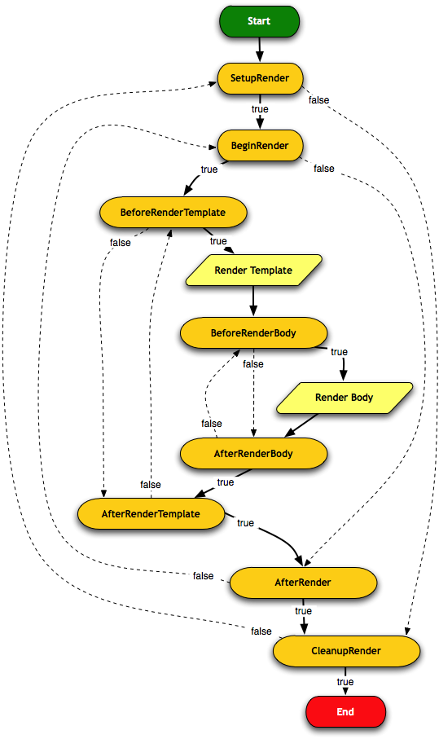

SetupRender
This is where you can perform any one-time per-render setup for your component. This is a good place to read component parameters and use them to set temporary instance variables.

BeginRender
For components that render a tag, the start tag is should be rendered here (the close tag should be rendered inside the AfterRender phase). The component can also prevent the template and/or body from being rendered by returning false.

BeforeRenderTemplate
This phase exists to allow a component to decorate its template (creating markup around the template generated markup), or to allow a component to skip its template.

BeforeRenderBody
Phase associated with a component's body (the portion of its container's template that the component occupies). The BeforeRenderBody phase allows the component the ability to skip the body, while still rendering the rest of the component's template (if any).

If no methods are annotated with BeforeRenderBody, then the body will be rendered by default. Again, this occurs when the <body> element of the component's template is reached, or automatically if the component has no template (but the component does have a body).

AfterRenderBody
Phase that is executed after the body is rendered; this only occurs for components with a body.

AfterRender
This phase complements BeginRender, and is often used to render the close tag that matches the start tag rendered in the BeginRender phase. In any case, the AfterRender phase can continue on to CleanupRender, or revert back to BeginRender (as in our Count component example, above).

If no methods are annotated with AfterRender, then no special output occurs, and the CleanupRender phase is triggered.

CleanupRender
The counterpart to SetupRender, this allows final cleanups to occur

Component Templates
Under Tapestry, component templates are files associated with page or component classes that contain the markup for the component

Template Localization
Templates are localized in much the same way as individual files of a component's message catalog: the effective locale is inserted into the name of the file. Thus a German users will see the content generated from MyPage_de.tml and French users will see content generated from MyPage_fr.tml. When no specific localization is available, the default location (MyPage.tml) is used.

Template Inheritance
If a component does not have a template, but extends from a component class that does have a template, then the parent class' template will be used by the child component.
This allows a component to extend from a base class but not have to duplicate the base class' template.
Parent template can mark replaceable sections as <t:extension-point>s, and sub-components can extend the parent template and <t:replace> those sections.
This can work across multiple levels of inheritance

<t:extension-point id="title">
<h1>${defaultTitle}</h1>
</t:extension-point>

<t:extend xmlns:t="http://tapestry.apache.org/schema/tapestry_5_1_0.xsd">
<t:replace id="title">
<h1><img src="${context:images/icon.jpg}"/>
Customer Service</h1>
</t:replace>
</t:extend>

Tapestry Elements

<body>

<container>
A container element contains markup without being considered part of the template. This is useful for components that render several top level tags, for example, a component that renders several columns within a table row:
<t:container xmlns:t="http://tapestry.apache.org/schema/tapestry_5_1_0.xsd">
<td>${label}</td>
<td>${value}</td>
</t:container>

<block>
A block is a container of a portion of the component template. A block does not normally render; any component or contents you put inside a block will not ordinarily be rendered. However, by injecting the block you have precise control over when and if the content renders.
A block may be anonymous, or it may have an id (specified with the id attribute). Non-anonymous blocks may be injected into the component.
Ids must be valid Java identifiers: start with a letter, and contain only letters, numbers and underscores

Expansions
Welcome, ${userId}!

Ignored Paths
Ex:
public static void contributeIgnoredPathsFilter(Configuration<String> configuration)
{
configuration.add("/dwr/.*");
}

Environmental Services

Injection with Components

InjectionProvider

Page Lifecycle

