Evaporation-driven solute redistribution in a macroscopically heterogeneous porous media with a vertical textural interface: MRI observations and numerical analysis

M.A. Chaudhry², Z. Chen², A. Pohlmeier¹, R. Helmig², and J.A. Huisman¹

1 Agrosphere Institute (IBG 3), Forschungszentrum Jülich GmbH, 52428 Jülich, Germany.
2 Institute for Modeling Hydraulic and Environmental Systems (IWS), University of Stuttgart, 70569 Stuttgart, Germany.

Corresponding author: Dr. Zhixin Chen (zhixin.chen@iws.uni-stuttgart.de)

Key Points:
-
-
-

Abstract
Evaporation of saline water from saturated porous media produces near-surface solute enrichment, however the resulting concentration distribution also depends on transport within the pore space and across material interfaces. Previous three-dimensional sodium magnetic resonance imaging (²³Na-MRI) demonstrated that dense saline solution can move downward through a sufficiently permeable sand, whereas a less permeable material retains much of the accumulated salt near the evaporating surface. In the current work, spatial and temporal redistribution of dissolved NaCl was investigated in a hydraulically connected, continuously supplied packing consisting of coarse F36 and fine W3 sand separated by a sharp vertical interface using time resolved ²³Na-MRI in combination with ¹H-MRI. The F36 domain developed descending high-concentration structures within the first hours, followed by substantial enrichment at depth, while the W3 domain exhibited pronounced near-surface accumulation. The dissolved NaCl concentration near the W3 surface approached the solubility limit between 96 and 108 h. Spatial concentration differences across the interface changed direction with depth; first-order Fickian calculations indicate diffusion from W3 into F36 near the surface and from F36 into W3 deeper in the packing. The mean measured evaporation rate was approximately 3.8 mm d⁻¹, with little change in near-surface water content. ¹H-MRI revealed initial signs of crust over the W3 half towards the end of the experiment. These observations establish a spatially coupled redistribution pattern that cannot be explained solely by the behavior of either domain in isolation. Additionally, numerical simulations were performed on an identical system using DuMuX along with further permeability contrasts and targeted salt transport process comparisons. Details of simulations to be added.

1 Introduction
Evaporation from porous media such as soil supplied by shallow saline groundwater can sustain upward liquid transport toward the atmosphere while leaving dissolved salts behind in the pore solution (Nachshon et al., 2011a; Shokri-Kuehni et al., 2020). As the water is removed, the concentration of NaCl increases near the evaporating surface, lowering the water activity of the remaining solution and potentially leading to salt precipitation. This salinization process is known to cause significant soil degradation and reductions in crop yield within arid and semi-arid regions (Rodriguez et al., 1997; Chaves et al., 2009) The resulting distribution of salt depends on water supply, surface saturation, the transport properties of the porous medium and the location of the evaporation front (Shimojimaa et al., 1996; Nachshon et al., 2011b; Shokri-Kuehni et al., 2020). Under conditions where the pore network remains hydraulically connected to a reservoir, salt accumulation is not restricted to a drying front moving into the medium. Instead, the near-surface concentration develops while liquid replenishment continues, making internal transport mechanisms particularly important for predicting the subsequent evolution of surface salinity.
The accumulation of salt increases the density of the pore solution and can create a gravitationally unstable concentration boundary layer. The onset and evolution of this instability have been investigated through analytical and numerical studies of saline groundwater evaporation (Wooding et al., 1997a, 1997b; Bringedal et al., 2022). Where intrinsic permeability is sufficiently high, downward buoyant transport can compete with the upward solute transport associated with evaporative supply and with diffusion or dispersion. Direct experimental confirmation was provided by Chaudhry et al. (2026), who used three-dimensional ²³Na-MRI to compare homogeneous F36 and W3 sands. In the higher-permeability F36 sand, descending saline plumes redistributed NaCl toward the bottom of the sample, thereby limiting surface enrichment. The lower-permeability W3 sand showed no corresponding instability and developed strong concentration gradients confined largely to the near-surface region. These findings establish the role of permeability-dependent downward transport in homogeneous, saturated porous media, but do not establish how it interacts with an adjacent material of contrasting texture.
A sharp textural interface introduces an additional pathway for solute redistribution. When coarse and fine domains remain hydraulically connected, differences in pore pressure, water supply, and evolving salt concentration can produce lateral fluxes of liquid and dissolved solute (Lehmann and Or, 2009; Shahraeeni and Or, 2010). Previous investigations of evaporation from heterogeneous porous media have demonstrated that material configuration influences surface wetness, evaporative fluxes and precipitation patterns (Nachshon et al., 2011b; Shokri-Kuehni et al., 2020). However, an unresolved question for continuously saturated systems is whether downward redistribution in a highly permeable domain can alter salt storage and surface enrichment in a neighboring, low-permeability domain. In particular, local concentration gradients may drive diffusion in opposite directions at different depths, while changes in hydraulic flow may contribute additional interdomain transport. Observing a concentration contrast across the interface, on its own, does not determine the net transport budget or separate advective and diffusive contributions.
While the previously mentioned experimental studies establish the importance of hydraulic coupling and heterogeneity, the individual contributions of advective and diffusive transport to net dissolved-salt exchange across an interface remain insufficiently quantified. Extending current numerical investigations (Wooding et al., 1997a, 1997b; Bringedal et al., 2022; Lasser et al., 2023; Chen et al., 2026) to hydraulically connected porous media with contrasting permeabilities, while systematically varying permeability contrasts and evaporative conditions, could therefore provide a more detailed understanding of interfacial solute transport. In particular, quantifying the spatially and temporally varying advective and diffusive contributions, together with their combined net flux across the interface is essential for establishing the extent to which interdomain solute exchange modifies near-surface enrichment and the overall redistribution of salt during evaporation.
This study investigates evaporation-driven NaCl redistribution in a heterogeneous packing of relatively coarser F36 and fine W3 sand coupled across a vertical interface. The objectives are to (i) characterize the three-dimensional evolution of dissolved-salt concentrations within each domain; (ii) identify the observed interfacial concentration gradients and determine the processes responsible for interdomain exchange; and (iii) assess how hydraulic connection modifies surface enrichment compared with the corresponding disconnected configurations. The experimental analysis combines time-resolved ²³Na-MRI, ¹H-MRI and evaporation measurements. The accompanying numerical investigation is designed to quantify conservative interfacial fluxes and evaluate the contribution of density-driven flow through matched process comparisons. The experimental measurements and the numerical analysis will thus be used together to distinguish directly observed redistribution from modeled transport mechanisms.

2 Materials and methods
2.1 Porous materials and experimental configuration
Two quartz sands with contrasting texture and intrinsic permeability were selected: F36 and W3, both supplied by Quarzwerke Frechen GmbH (Frechen, Germany). Their hydraulic properties were determined in accordance with methods elaborated in Chaudhry et al., (2026) by fitting the Brooks–Corey model to measured water-retention data and calculating intrinsic permeability from saturated falling-head conductivity measurements. The resulting intrinsic permeabilities were 7.83 × 10⁻¹² m² for F36 and 3.2 × 10⁻¹⁴ m² for W3. The material properties relevant to the present experiments are summarized in Table 1.

Table 1. Properties of the two materials used for the evaporation experiments. Particle size ranges were provided by the supplier (Quarzwerke Frechen). The parameters of the Brooks-Corey model were obtained by fitting to measured water retention data.
Sand Type | F36 | W3
Average particle size (μm) | 160 | 90
Particle size range (μm) | 90 – 355 | 2 – 400
Type (USDA) | medium sand | very fine sand
Intrinsic permeability (m²) | 7.83 × 10⁻¹² | 3.2 × 10⁻¹⁴
Brooks-Corey saturated water content (θ_{sat} in cm³ cm⁻³) | 0.39 | 0.31
Brooks-Corey residual water content (θ_{res} in cm³ cm⁻³) | 0.02 | 0.08
entry pressure (p_{b} in Pa) | 4.69 ∙ 10³ | 1.12 ∙ 10⁴
Brooks-Corey parameter (λ_{BC}) | 5.04 | 0.384

The heterogeneous sample was prepared in a non-metallic polymethylmethacrylate (PMMA) holder with an inner diameter of 5 cm and a packing height of 4 cm (Figure 1). A 0.45-cm-thick porous filter plate (P3, Robu, Hattert, Germany) was installed at the bottom. A temporary 5 × 5 × 0.6 cm PMMA partition divided the sample cavity into two equal semicircular domains, which were filled separately with dry F36 and W3 sand. The central partition was then removed slowly while the holder was gently tapped to maintain a sharp vertical material interface. Dry packing was selected because removing the partition after wet packing caused deformation of the interface and introduced air or water pockets. The prepared sample was saturated from below with 1 mol L⁻¹ NaCl (Sigma-Aldrich Chemie GmbH, Taufkirchen, Germany) solution while evaporation from its upper surface was prevented with a Parafilm covering.
An external reservoir containing the same 1 mol L⁻¹ NaCl solution was connected to the bottom inlet. Its water level was adjusted to 2 cm below the sample surface, and the system was allowed to equilibrate for 2 h. The initial volumetric water content of the packed sample, obtained from the solution mass retained after saturation was calculated to be 0.38. With m_{sol} denoting the retained solution mass, ρ_{sol} its density and V_{pa} the bulk packing volume, the volumetric content was obtained as θ = m_{sol}/(ρ_{sol}V_{pa}). Continuous hydraulic contact with the reservoir was maintained throughout evaporation (wicking). The 1 mol L⁻¹ NaCl concentration was used as it was found to be suitable for providing a high enough concentration range for downwards density-driven flow.
The sample holder featured a wider internal diameter that fit into the 23Na/1H 66 mm wide probe head (Bruker Mini SWB 90 imaging probe DR) of the MRI scanner (Bruker super wide bore scanner at B0 = 4.7 T). The bottom inlet was opened and the dry-gas diffuser was switched on to generate a turbulent stream of N2 gas at 60 dm³ h⁻¹, thus initiating evaporation. Ambient laboratory conditions were monitored using a multi-purpose probe (FHAD 46-C2, ALMEMO® D06,
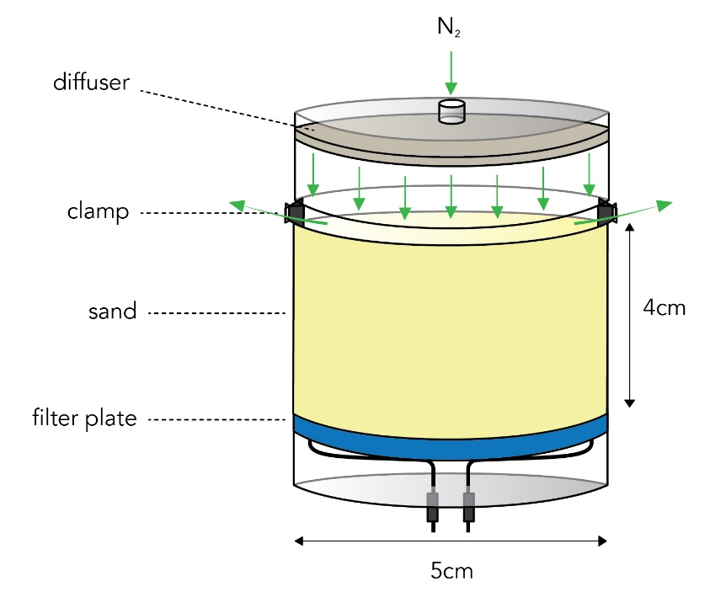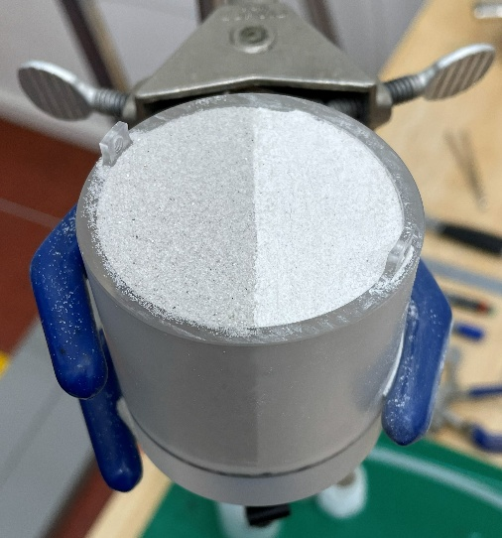
(a) (b)
Figure 1 (a) Adapted sample holder design used for performing evaporation experiments on heterogeneous porous media within the MRI. (b) Sample with vertical interface of the packed sand in the sample holder with the gas distributor removed.
Ahlborn, Holzkirchen, Germany). The mean temperature and ambient humidity were relatively stable at 20 ± 2°C and 40% ± 2.5%. The evaporation rate E_{rate} was determined from the mass change of the reservoir recorded hourly with a balance (accuracy ±0.01 g, EX2202, Ohaus Corporation, Parsippany, USA) using:
$E_{rate}= \frac{∆m}{ρ_{sol}A_{evap.}t_{diff}}$ , (1)
where ∆m = m₁ – m₂ is the mass difference during the time interval t_{diff} = t₁ – t₂, and A_{evap} is the evaporative area.
2.2 MRI acquisition and calibration
The experiment was conducted using a Bruker super wide bore scanner with a B_{o} field strength of 4.7 T. The 3D orthogonal gradient/shimming system was capable of delivering a maximum gradient strength of 700 mT m⁻¹. The scanner was run using an Avance III console and controlled by Paravision software (version 6, Bruker Microimaging, Ettlingen, Germany). Due to the faster T₂ relaxation of brine in the W3 sample (Chaudhry et al., 2026), the acquisition parameters were shifted to accommodate this (Table 2). Due to the early development of instabilities in F36, it was essential to keep the scan time for ²³Na imaging short. The experiment started with an initial ²³Na scan before the N₂ gas stream was turned on.

Table 2. Key parameters of the imaging protocols adopted for ¹H and ²³Na MRI during evaporation from the heterogeneous F36 and W3 sample. The native Bruker protocols to which adjustments were made are 3D single echo (3DSE) sequence and multi-slice multi-echo (MSME).
 | ²³Na Imaging | ¹H Imaging
Pulse Sequence | 3DSE | MSME
t_{R} (ms) | 300 | 3000
t_{E} (ms) | 4.6 | 4
Slices | 1 | 40
Slice thickness (mm) | 55 | 1
Number of averages | 4 | 4
Scan time (min) | 32 | 51
Matrix size | 64×40×40 | 256×256×1
Resolution (mm) | 1×1.375×1.375 | 0.25×0.25×0.25
Bandwidth (KHz) | 50 | 150

The scan intervals for the heterogeneous sample were kept shorter in the initial stages of the experiment. After the initial scan, imaging was performed in the following sequence: 8 × 30 min, 2 × 60 min, 3 × 120 min, and 27 × 360 min. The total duration of the experiment was 174 hours.
¹H scans were periodically performed to ensure that the sample remained fully saturated throughout the evaporation experiment. The sample holder dimensions did not allow the use of a marker tube for calibration. Therefore, the known initial volumetric water content θ of the sample (0.38) was used for calibration instead. The subsequent scans were then normalized against this scan to identify any changes in volumetric water content.
Na concentration profiles were determined using a calibration approach where F36 and W3 packings in the sample holder were saturated with known concentrations of 0, 1, 2, 3, 4 and 5 mol L⁻¹ solution and scanned using the imaging protocols shown in Table 4.1. The average voxel intensity of the calibration samples was plotted against the Na volume concentration using the relationship (Perelman et al., 2020):
$c_{(Na.vol)}= \frac{n_{Na}}{V_{pa}}= c_{(Na.sol)}.θ_{vol}$ , (2)
where n_{Na} is the number of moles of Na, V_{bulk} is the bulk volume, c_{Na.sol} is the solution concentration and θ_{vol} is the volumetric water content. It was then fitted with a linear function for F36 and a polynomial function for W3.
Data processing of the raw MRI data involved several steps. First, the acquired k-space data was reconstructed into spatial domain images through inverse Fourier transformation using the Paravision software package (version 6, Bruker Microimaging, Ettlingen, Germany). The resulting images were then further processed with ImageJ (version 1.53t, National Institutes of Health (NIH), Bethesda, USA). All scans were equally scaled using the brightness/contrast function and then set to a standardized brightness range within the used color table for enhanced visualization. To reduce noise, a 1.5 pixel median filter was applied. Additionally, transparent 3D illustrations were generated using the volume viewer plugin to highlight internal features of the samples. During data acquisition, a spike artifact was detected in the sample space, which was removed to the extent possible in the 3D visualization by filtering out high voxel values in this region.
2.3 Numerical model and boundary conditions
2.4 Quantities used for model comparison
2.6 Process comparisons and numerical verification
2.7 Dimensionless parameters and regime classification

3 Results and discussion
3.1 Evaporation dynamics of the heterogeneous porous media
The cumulative water loss over time for the heterogeneous sand packing containing F36 and W3 is presented in Figure X. The evaporation rate as a function of time is presented in Figure Xb along with the observed volumetric water content for the top 2 mm of the sample at three distinct times. The water content in the top 2 mm remained constant despite ongoing evaporation, thus ensuring saturation throughout the duration of the experiment. The flow rate for dry nitrogen gas was the same as in Chaudhry et al., 2026 but the surface area of the sample significantly increased from 7.0 cm² to 19.6 cm². Therefore, the mean evaporation rate was lower. The initial evaporation rate was approximately 6 mm d⁻¹ and reducing to 3.8 mm d⁻¹ in the first 24 hours. The average evaporation rate for the experimental duration of 174 hours was 3.8 mm d⁻¹. A sharp decrease in evaporation rate is seen for the heterogeneous packing in the first 4 hours which then becomes more gradual with time. This is attributed to a thin water film and minor settling during installation of the sample in the MRI, as well as stronger near-surface solute enrichment for W3. Beyond this sharp initial decrease, the evaporation rate decreased from 4.0 mm d⁻¹ to 3.2 mm d⁻¹ after the first four hours. This decrease is much smaller than the decrease observed for pure W3, but higher than the near constant rate observed for pure F36 (Chaudhry et al., 2026). As expected, the evaporation dynamics of the heterogeneous medium falls between the behavior of the individual materials.

(a) (b)
Figure X (a) Cumulative mass loss of water during the evaporation experiment for the heterogeneous F36 and W3 packing with a vertical interface under wicking conditions. (b) Evaporation rate for the heterogeneous F36 and W3 packing and the volumetric water content θ in the top 2 mm of the sample at 0 h, 24 h and 174 h from the start of the experiment (right ordinate).
3.2 Calibration of ²³Na-MRI for heterogeneous sand packing
To determine Na concentration profiles, calibration relationships were developed for the sample holder and acquisition protocol used in this investigation. As predicted, a linear calibration relationship was obtained for F36, which reflects the bulk-like relaxation behavior of Na in F36. A slightly non-linear relation was obtained for W3, which could be well described by a polynomial fit. The shape of this new calibration relationship deviates from the earlier calibration reported by Chaudhry et al., 2026, which was obtained using a slightly longer echo time t_{E} of 5.1 ms. By adopting an imaging protocol for a shorter total scan time and a long enough t_{E} to capture bulk relaxation in F36, the slope of the signal response S(r) apparently decreased for higher solute concentrations in W3. For Chaudhry et al., 2026 the slope of S(r) increased with increasing concentration, which was attributed to stronger shielding of the surface charge at increased ionic strengths (Rijniers et al., 2004). However, this effect was much lower for the current acquisition protocol. Further investigation is required to fully understand the dependence of the measured signal on ionic strength and material properties. Consequently, the present calibration approach should be regarded as an empirical and practical method for obtaining quantitative estimates of Na concentration in porous media.
The relatively low SNR for ²³Na-MRI led to variations in voxel signal intensity for the heterogeneous sample. The obtained calibration relationships can be used to re-calculate the known Na concentrations of the calibration samples. Assuming that all observed variation within the calibration samples is due to the low SNR, the standard deviation of the concentration in the total voxel area of each sample (after filtering) can be used as an estimate of uncertainty in estimated concentration (Figure X). The obtained standard deviations for the solution concentrations in the F36 calibration series (i.e. 0, 1, 2, 3, 4 and 5 mol L⁻¹) were 0.11, 0.26, 0.35, 0.42, 0.51 and 0.63, respectively. Thus, the mean relative error in the concentration estimates is ~14%, and is higher for the lowest concentrations. The standard deviations of the concentration estimates obtained for W3 were 0.13, 0.28, 0.29, 0.54, 0.67 and 0.63 concerning the calibration samples. This indicates a similar relative error for higher concentrations (~15%) and higher relative errors for the lower concentrations. The slight increase in relative error compared to the results in Chaudhry et al., 2026 can be attributed to the more challenging sample preparation when the sample is larger. The change in packing method to dry packing with subsequent water saturation may also have led to minor air entrapment. It is important to mention that this approach to error characterization is a worst-case scenario since all actual heterogeneity in packing density is considered within the error estimation.

Figure X. Calibration results for F36 and W3 using an identical imaging protocol where average voxel signal intensity (S_{r}) is related to the volume concentration of sodium c_{Na.vol} obtained with Equation 2. The dotted lines are a linear and a 2nd order polynomial fit with the parameters shown in the plot. Error bars represent 1 standard deviation of voxel intensity after the use of a 1.5 pixel median filter.

3.3 Na enrichment and redistribution during evaporation
Figure X shows the spatial and temporal development of the Na concentration for the heterogeneous F36/W3 sand packing during the first 8 hours. The time gap between acquisitions was kept short here to capture instability formation and downward ddensity-driven flow. During this initial stage of evaporation, a minor enrichment of sodium concentration was observed near the surface of W3 and F36. This enrichment was more patchy for the F36 surface, whereas a more uniform enrichment was observed for W3. Although a sharp and distinct finger could not be observed initially in F36, a high concentration instability patch was observed near the top right of the F36 surface (Figure X, red arrow at T = 2 h). Between 3 h and 4 h, a gradual descent of this region with higher concentration was observed. Another high concentration zone in the center of the F36 packing also highlights a site for potential finger formation (Figure Xb, red arrow at T = 8 h). In contrast to F36, W3 showed only localized near surface enrichment. This behavior was anticipated due to the two orders of magnitude difference in intrinsic permeability between the two porous media, thus promoting divergent enrichment dynamics from the onset of evaporation.

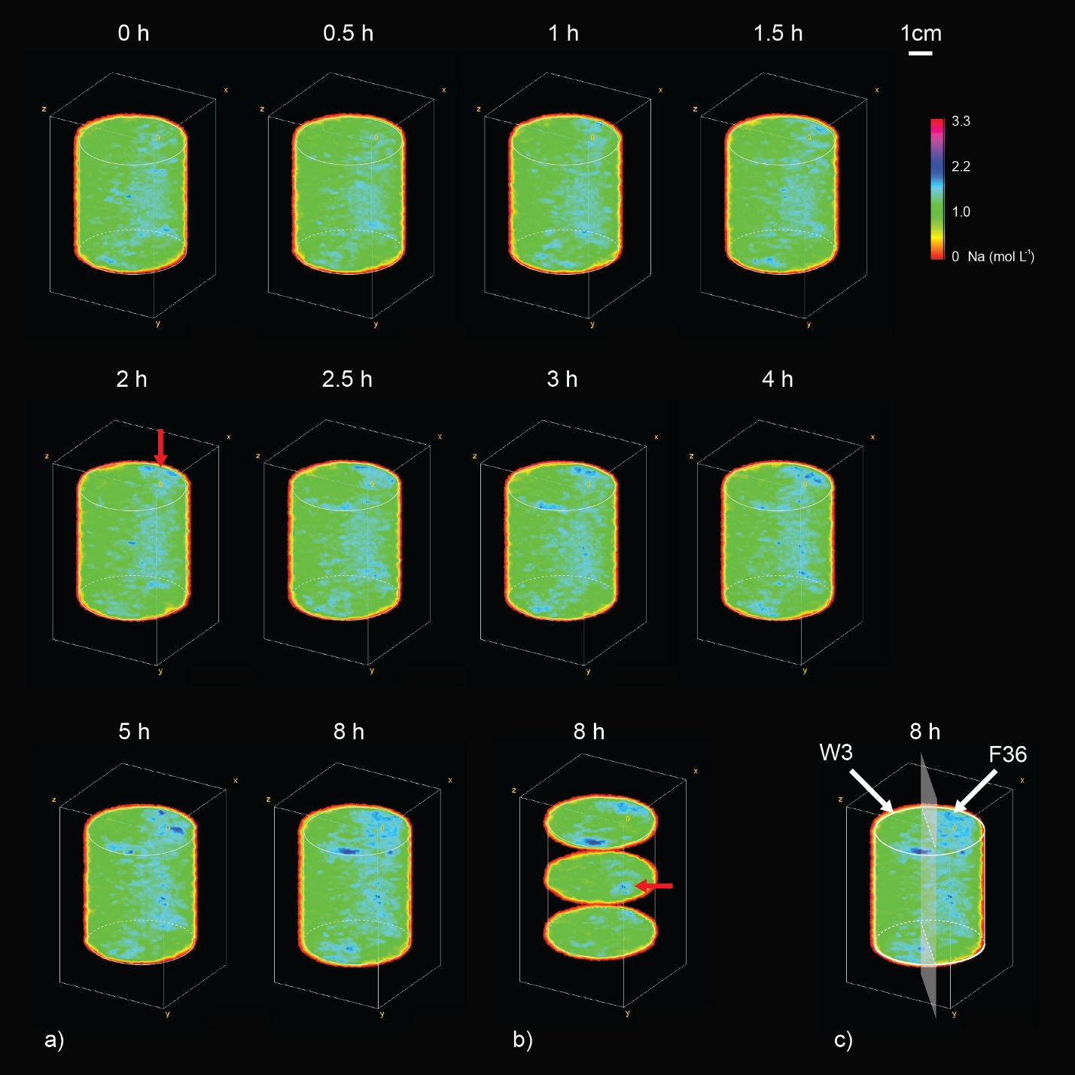
Figure X. (a) 3D voxel view of ²³Na-MRI imaging results as Na concentration for the first 8 hours of evaporation. (b) Top, center and bottom slabs (3.9 mm thickness) at 8 h that indicate instabilities. (c) 3D view of an ²³Na-MRI imaging result highlighting W3 and F36 halves connected at a vertical interface. Red arrows mark regions of interest, white arrows and the plane mark the W3 and F36 halves and vertical interface respectively.
Figure Xa shows the spatial and temporal development of the Na concentration for the heterogeneous F36/W3 sand packing during the entire length of the experiment. As expected, there is a strong surface enrichment of Na in the W3 half of the sample. The Na concentration value reaches the solubility limit between 96 and 108 hours, and enrichment is mostly confined to the upper half of the W3 material. In contrast, F36 shows a relatively even enrichment throughout the sample depth due to downward density-driven flow. The cross-sectional images provided in Figure Xb indicate the positions of the fingers that redistributed Na to the bottom of the packing. The minor fingers initially visible in Figure Xa have evolved into mature convective plume structures. The fingers are primarily located near the sample holder wall. The concentration within a cross-sectional slice in the center of the sample ranges between 1 mol L⁻¹ to upwards of 4 mol L⁻¹ (Figure Xb). This range is considerably higher than the estimated relative error of approximately 15% in concentration for the new imaging protocol. This further strengthens confidence in the use of ²³Na MRI for imaging unstable flows.
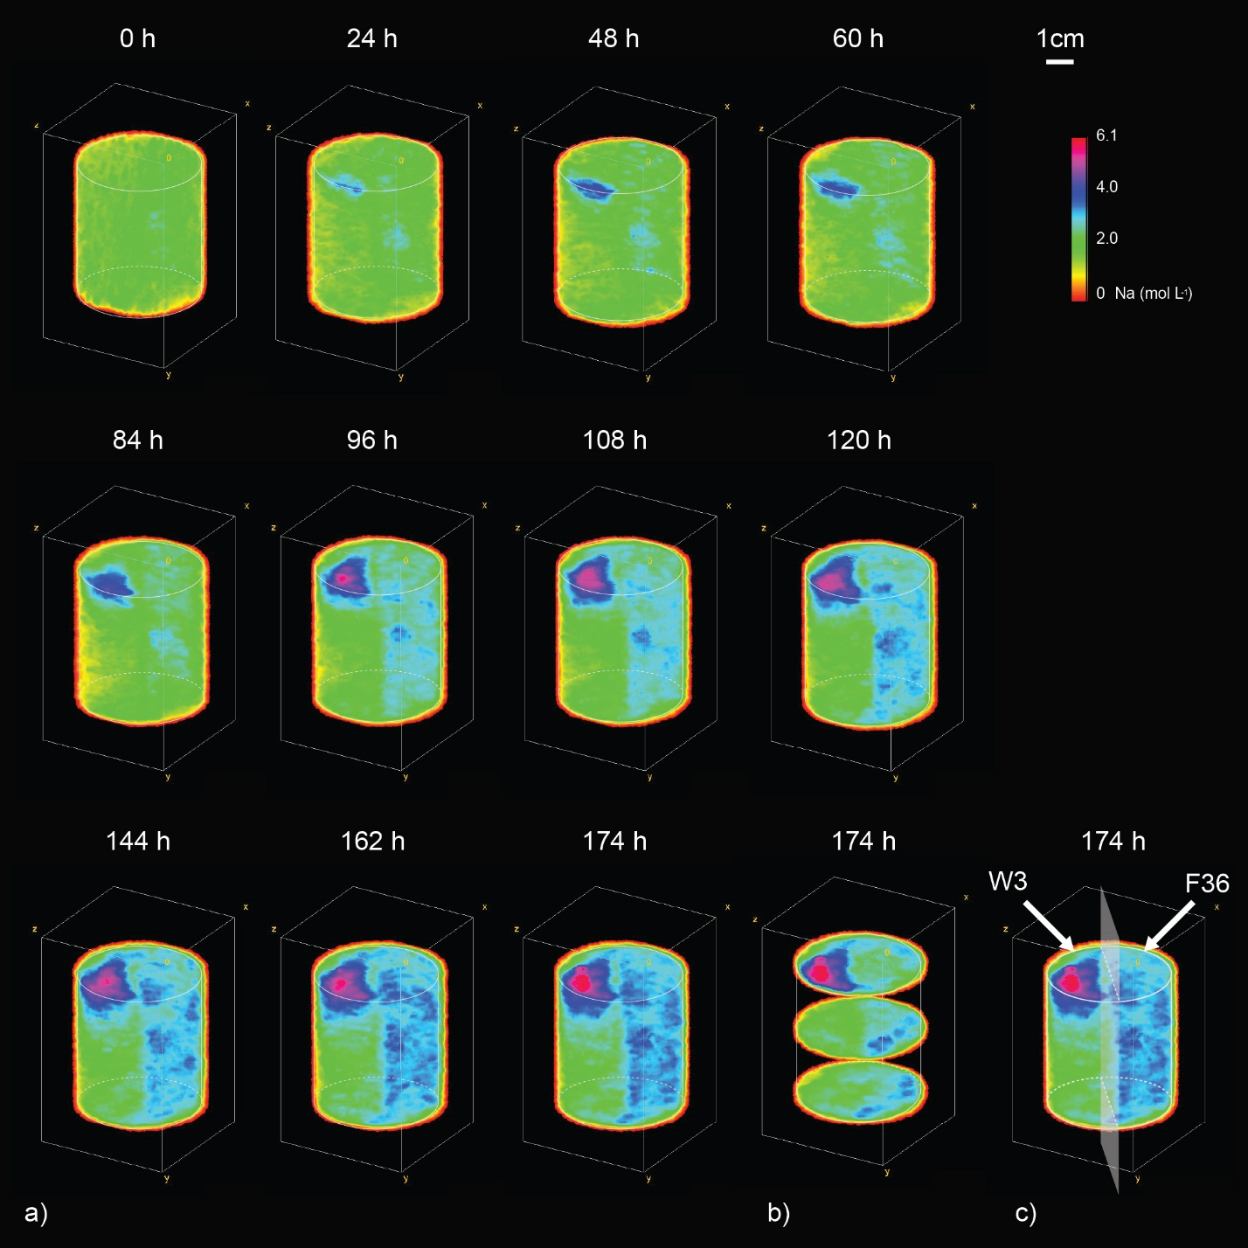
Figure X. (a) 3D view of ²³Na MRI imaging results as Na concentration for the entire duration of the evaporation experiment. (b) Top, center and bottom slabs (3.9 mm thickness) at 174 h that indicate instabilities. (c) 3D view of an ²³Na-MRI imaging result highlighting W3 and F36 halves connected at a vertical interface.
Strong downward density-driven flow was observed in the F36 half. The lack of a central or sharply defined density instability may be attributed to the new packing geometry where each material only takes up 50% of the sample volume. The larger ratio of sand volume to wall contact area of the F36 half in the current experiment may have caused instability formation near the sample wall, further strengthening with time. The finger observed by Chaudhry et al., (2026) in homogeneous F36 packing and in the numerical simulation for the identical system also advanced towards the sample holder wall with time. The diameter of the current sand packing is constrained by the probe head diameter of the used MRI system. Future research could use a wider bore MRI to image unstable flows in larger samples that are less affected by wall effects to capture instabilities in heterogeneous sand packings with more detail.
The duration of this experiment was kept long enough to generate indications of salt crust on the W3 half of the sample. Figure X shows the 1 mm thick top slice of the sand packing using Na imaging alongside the corresponding cross sectional ¹H imaging results that provide the volumetric water content in the top 10 mm of the packing. Due to evaporation, a strong enrichment of Na at the sample surface is seen on the W3 half. Although ²³Na-MRI cannot capture precipitated NaCl, the associated ¹H imaging results indicate the presence of moisture inside an evolving NaCl crust that creates a new porous media on top of the original sample surface (Wieboldt et al., 2023). No salt crusts and water inside potential salt crusts are observed for the F36 half. The position of the developing salt crust deduced from ¹H imaging matches the position where Na concentration is highest in the Na imaging.
These results highlight the importance of distinguishing evaporation from fully saturated and partially saturated samples. In fully saturated conditions, air entry does not occur and both coarse and fine domains remain hydraulically connected to the evaporating surface. The observation that salt precipitation may initiate in the fine textured domain under such conditions therefore provides an important first indication that precipitation patterns can differ from those observed in partially saturated systems. For example, Shokri-Kuehni et al. (2020) showed that evaporation from a partially saturated heterogeneous system leads to earlier salt crust formation on the partially saturated coarse sand. This is not consistent with the results seen in Figure X, where the opposite is observed for the fully saturated sample in this experiment. This apparent contradiction is due to the larger mass and solute fluxes from the fewer active pores at the surface of a partially saturated system. These higher fluxes eventually lead to fast solute enrichment and strong crust production (Norouzi Rad et al., 2013; Shokri, 2014; Shokri-Kuehni et al., 2020).
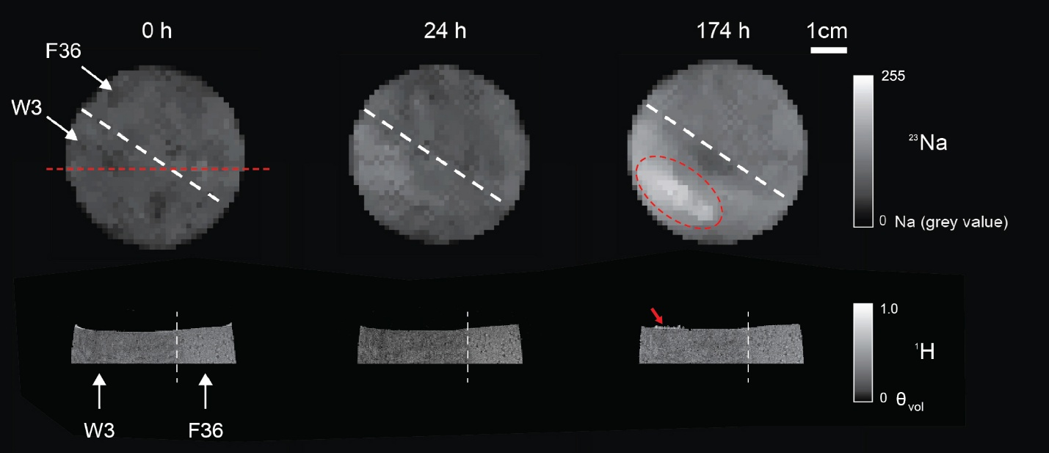
Figure 4.6. Cross-sectional view of the top 10 mm captured by ¹H-MRI at time 0 h, 24 h and 174 h (bottom) alongside the corresponding top view of the heterogeneous sand packing using ²³Na-MRI (top). Brightness of the voxels correspond to volume concentration of the target nuclei. The dashed white line in the imaging indicates the interface between the two media. The dashed straight red line indicates the position of the cross-sectional view extracted from ¹H-MRI. The red arrow and the oval-shaped red line indicate regions of interest for salt precipitation.

3.4 Salt concentration profiles and implications for evaporation
A comparison of the amount of Na recovered with ²³Na-MRI and the amount of Na present in the column based on the initial concentration and the mass loss data of the external reservoir is presented in Figure Xa. Initially, the difference in mass is low. However, the deviations in mass rise and reach up to 23% with time after the start of the evaporation due to underestimation of the Na concentration by ²³Na-MRI. With time, the difference in mass reduced again to an underestimation of 10-15% in the final stages of the evaporation experiment. This increased error in ²³Na MRI compared to that observed in Chaudhry et al., 2026 may be due to the following reasons. Firstly, the new imaging protocol used a coarser resolution and less averaging to achieve shorter acquisition time in an attempt to capture the development of instabilities in the heterogeneous packing. The reduced spatial resolution resulted in larger partial volume effects and the reduced averaging decreased the signal to noise ratio (SNR) (i.e. SNR improves with the square root of the number of averages). Secondly, the results presented in Figure X indicate the presence of a solid NaCl crust at the sample surface that remains undetected by ²³Na-MRI, which also adds to the underestimation of the total Na content within the column since precipitated salt is not detected. Finally, the higher error may also be related to supersaturation due to delayed nucleation, since such high concentration values were not considered during calibration. Nevertheless, recovery of the mass with ²³Na-MRI is considered to be adequate for investigating solute enrichment and redistribution in heterogeneous samples.
Depth profiles of Na concentration throughout the total cross-section, W3 half, and F36 half are presented in Figure Xb-d, respectively. The average Na concentration profiles for the entire sample (Figure Xb) visually seem to correspond with the average of the homogeneous F36 and W3 reported by Chaudhry et al.,

(a) (b)

(c) (d)
Figure 4.7. (a) The calculated amount of Na from ²³Na-MRI against the total amount of Na in the column calculated from the initial concentration and the mass loss data registered by the balance. The green line represents the 1:1 relation. Depth profiles of Na solution concentrations for b) the total sample, c) the W3 half, and (d) the F36 half during evaporation as a function of time.

2026. The enrichment is strongest with large gradients near the surface, but redistribution is also evident throughout the entire sample. The solute distribution in the W3 half of the sample (Figure Xc) shows the expected near-surface enrichment for this material. The low permeability of the W3 sand hampers the formation of instabilities and downward solute transport. As strong enrichment takes place in W3, nucleation is hypothesized to have initiated between 96 and 108 hours, and the ensuing crystal growth process acts as a sink, drawing ions from its surroundings (Scherer, 2004). It is interesting to note the increase in concentration near the bottom of the W3 sample, which is attributed to lateral transport from the adjacent F36 material.
The concentration profiles for the F36 half (Xd) clearly show that solute is convectively transported downwards due to its higher permeability during evaporation. This density-driven downward distribution leads to concentration profiles that show a uniform increase in concentration, even in the lowest most depths. Differences in solute concentration between the W3 and F36 half lead to local concentration gradients across the interface, and Na transport through solute diffusion should thus be anticipated along the length of the sample.
The following text in italic can be removed but some remarks of the second paragraph may be useful
To obtain a rough indication of the extent of diffusive transport across the vertical interface, a 1D analytical solution of Fick’s second law for a step change in concentration was used. As salt enrichment patterns varied significantly between the F36 and W3 halves, estimates of diffusive transport were obtained at different sample depths from the surface (i.e. 0 mm, 25 mm and 40 mm). To account for tortuosity and porosity effects on diffusion in porous media, an effective diffusion coefficient was calculated using the Millington-Quirk approach (Millington and Quirk, 1961) using the porosity of F36 and W3 and a representative diffusion coefficient for NaCl in concentrated solutions (i.e. 1.2 × 10⁻⁹ m² s⁻¹; Rard and Miller, 1979). This yielded an effective diffusion coefficients of 3.54 × 10⁻¹⁰ m² s⁻¹ for F36 and 3.07 × 10⁻¹⁰ m² s⁻¹ for W3. At the depth of 0 mm, the mean concentration in W3 is 5.9 mol L⁻¹ and the mean concentration in F36 is 2.35 mol L⁻¹. This will result in a diffusive flux from W3 to F36. For a point 5 mm away from the interface, the 1D analytical solution predicts an increase in concentration at the F36 side by 0.65 mol L⁻¹ after 12 hours. At a depth of 25 mm, the mean concentrations are 1.94 mol L⁻¹ and 2.44 mol L⁻¹ in W3 and F36. This leads to a concentration increase by 0.083 mol L⁻¹ in W3 for a point 5 mm away from the interface after 12 hours. For the final point at 40 mm depth, a mean concentration of 1 mol L⁻¹ and 2.3 mol L⁻¹ is taken for W3 and F36, respectively. Here, the concentration for W3 is assumed to be 1 mol L⁻¹ given the results for the homogeneous W3 sample results, where no enrichment at depth was observed. This leads to a concentration increase by 0.22 mol L⁻¹ in W3 at a position 5 mm away from the interface after 12 h.
These approximate model calculations show that significant exchange of NaCl is expected to occurs across the interface. Near the sample surface, ion transport due to diffusion is significant. For the lower depths of 25 mm and 40 mm, a lower net movement from F36 to W3 is anticipated, but this exchange occurs over a larger length of the interface and can therefore potentially also lead to a significant mass flux. Although the analytical solution is only a rough approximation due to the assumption of 1D diffusion, it nonetheless highlights the effect of an enhanced salt enrichment at the upper F36 and lower W3 depths in comparison to the enrichment dynamics of similar homogeneous samples. In combination with the ²³Na-MRI results, the calculations demonstrate that a heterogeneous system leads to a coupled circulation pathway in which density-driven convection transports NaCl downward through the coarse medium, lateral diffusion redistributes solute across the interface, and capillary flow in the fine medium returns the redistributed salt toward the evaporation surface. This recirculation mechanism continuously enriches the fine medium, and provides a physical explanation for accelerated solute accumulation also at depths away from the surface (Figure Xc).
An approximate stability analysis to numerically assess and validate the potential of instability formation in the evaporating porous medium may be extended to the heterogeneous system. Instability formation in F36 is again seen at an estimated concentration of ~2 mol L⁻¹, and no instabilities are observed for W3 even near the maximum concentration of ~6 mol L⁻¹. The boundary layer Rayleigh number i.e. R_{δ} can be used to assess the stability of the system (Wooding et al., 1997a). The kinematic viscosity v_{r} may be assumed as 1.05 × 10⁻⁶ m² s⁻¹ and 1.4 × 10⁻⁶ m² s⁻¹ for 2 and 6 mol L⁻¹ NaCl solutions, respectively. Unfortunately, the local evaporation rates for the F36 and W3 surfaces are not known and expected to vary from the observed average values due to the differences in solute enrichment. Nonetheless, a first approximation can be obtained using the average evaporation rate at the time when 2 mol L⁻¹ is first reached at the surface (i.e. t = 3 h, 5.3 mm d⁻¹) for F36. Similarly, a mean evaporation rate of 3.88 mm d⁻¹ can be used for W3, which is the rate when a concentration of 6 mol L⁻¹ is reached at the surface. This results in R_{δ} values (Wooding et al., 1997a) equal to 38 and 0.79 for F36 and W3, respectively. Since R_{δ} ≥ 10 is often taken as an indication for instability formation, F36 is expected to form density-driven instabilities and W3 is expected to be stable. Thus, the observed behavior is in good agreement with the stability analysis of Wooding et al. (1997a).
Bridging paragraph to numerical simulations
The observed concentrations at depth in the W3 half of the coupled system as seen in Figure X suggest that transport from the neighboring coarse domain may influence the spatial distribution of salt in the finer medium. In the preceding homogeneous W3 measurements performed by Chaudhry et al., 2026, the principal enrichment remained confined to the near-surface region, whereas the current heterogeneous W3 half developed additional deep enrichment. This qualitative comparison motivates a direct test of the effect of interdomain exchange. Nevertheless, the homogeneous and heterogeneous experiments differed in sample geometry and evaporating area, and the heterogeneous experiment provides only the net response of the coupled packing. Consequently, the present observations alone do not establish the magnitude, or even the sign at all times, of the effect of hydraulic connection on W3 surface accumulation. A paired connected-versus-isolated numerical comparison under equivalent conditions is therefore needed before such a causal difference can be quantified.
3.4 Numerical simulation of the observed redistribution within the coupled F36 and W3 system
3.5 Regime map of convective redistribution and interdomain coupling
3.6 Joint implications for salt accumulation and limits of interpretation
3.7 Conceptual model for evaporation in heterogeneous porous media with wicking
The results observed for the fully saturated heterogeneous packing with F36 and W3 undergoing evaporation can be summarized using the conceptual model presented in Figure X. A similar conceptual model was presented by Nachshon et al. (2011a), but for a drying heterogeneous porous media with a vertical interface. As highlighted in Figure Xa-f, a fully saturated heterogeneous porous matrix with a sharp vertical interface is subjected to saline water evaporation with wicking. As the permeability of the coarser grained medium permits density-driven downwards flow, an instability is formed that starts to transport Na downwards. For the fine-grained material, the concentration of solute increases sharply near the surface as conditions for instability formation are not fulfilled. This sharp increase in surface concentration leads to a decrease in the evaporation rate for the fine-grained material. The instability formation in the coarse-grained material reduces the increase in surface concentration, which results in less reduction in evaporation. The resulting lateral concentration gradients may lead to diffusive transport across the interface. Numerical simulations show strong diffusive potential at the surface from the fine to the coarse media, and vice versa where concentration gradients from the coarse to the fine media will develop. After a sufficient amount of time, a salt crust is bound to form on the fine side as the saturation limit for the salt solution is reached. Due to diffusion from the coarse to the fine media at depths away from the surface enrichment, a stronger and faster enrichment may be expected at the surface of the fine side, which may also result in a shorter time to crust formation in comparison to a homogenous sample. This demonstrates that textural heterogeneity not only governs the spatial redistribution of solutes during evaporation, but also influences the location and timing of salt crust formation. Since the development of a surface salt crust further modifies the evaporative boundary conditions and influences subsequent mass and heat transfer across the solid air interface (Jannesarahmadi et al., 2025), understanding the mechanisms controlling crust initiation is essential for predicting the evolution of saline evaporation systems.
4 Conclusions
Text in italics can be removed once modelling data is developed
The effects of a sharp vertical interface on solute transport between evaporating porous media contrasting in permeability and with constant full saturation were studied. For this, two porous media (F36 and W3) with permeabilities of 7.8 × 10⁻¹² m² and 3.2 × 10⁻¹⁴ m² were hydraulically coupled to create a heterogeneous sand packing. Available ²³Na/¹H MRI strategies were adapted to capture the 3D in-situ transport of Na. The presented results highlighted the importance of downwards density-driven flow for F36, and additionally suggested significant diffusion across the interface through concentration gradients. First-order approximations of diffusion using an analytical solution of Fick’s second law showed that the strong concentration gradient at the surface results in significant diffusion into F36, which is subsequently transported away from the surface due to density-driven downward flow. At depths away from the surface, accumulated Na due to downward transport leads to lateral diffusion into the finer W3 media, which is consistent with higher concentrations observed at depth in the W3 half of the heterogeneous packing compared to the homogeneous packing. These higher concentrations at depth in W3 will in turn lead to faster solute enrichment at the W3 surface, and a reduced time to crust may also be expected relative to a homogeneous sample. The experimental duration was selected to capture salt crust formation on the fine media. Although ²³Na-MRI cannot image precipitated salt, water contained in the precipitates was imaged using ¹H-MRI, thus highlighting the significance of complete surface saturation in producing crust on finer media for a heterogeneous system where downwards density-driven flow is occurring. Mention results of numerical simulations.
The findings of this investigation further extend the theoretical understanding of saline water evaporation and shed light on the intricate nature of solute distribution for such systems. A conceptual model distilling the solute transport mechanisms observed for these evaporation conditions was presented where the primary solute transport mechanisms of advective surface enrichment and downwards density-driven flow were pointed out along with the secondary mechanism of diffusive transport across the interface due to the developing concentration gradients. Through a more complete understanding of saline water evaporation and the particular phenomena involved i.e. density-driven solute redistribution and solute diffusion, further insight may be gained into the complex hydrology of many natural features, such as salt pans, playas, and waterlogged soils. These sites are relevant since they are considered as potential wastewater disposal locations (Wooding et al., 1997b), sources of dust emission (Gill, 1996) and are constantly growing in size due to the drying of salt lakes e.g. Dead Sea, Great Salt Lake (Wurtsbaugh et. al., 2017).
Future work should expand on the observations presented here. It may be interesting to use high resolution imaging (e.g. synchrotron XRCT) to understand the crystallization of ions using subflorescent salts (e.g. Na₂SO₄ and MgSO₄) with a focus on primary nucleation of seed crystals while the porous media remains fully saturated. Further work using MRI could consider the use of different salt types (e.g. Na₂SO₄) and larger samples sizes to avoid boundary wall effects. The time to crust formation is another important aspect to investigate for sands with contrasting permeabilities in order to quantify how density-driven solute redistribution and its auxiliary transport processes control the onset and spatial location of salt precipitation.

References
Bringedal, C., Schollenberger, T., Pieters, G. J. M., van Duijn, C. J., & Helmig, R. (2022). Evaporation-driven density instabilities in saturated porous media. Transport in Porous Media, 143(2), 297–341.
Chaudhry, M. A., Kiemle, S., Pohlmeier, A., Helmig, R., & Huisman, J. A. (2026). Non-invasive imaging of solute redistribution below evaporating surfaces using ²³Na-MRI. Water Resources Research, 62, e2025WR041207.
Chaves, M. M., Flexas, J., & Pinheiro, C. (2009). Photosynthesis under drought and salt stress: regulation mechanisms from whole plant to cell. Annals of Botany, 103(4), 551–560.
Chen, Z., Guo, B., Kelm, M., Schollenberger, T., & Helmig, R. (2026). Quasi-static pore-network modeling for evaporation-driven salt transport and precipitation in porous media. Water Resources Research, 62, e2026WR043446.
Gill, T. E. (1996). Eolian sediments generated by anthropogenic disturbance of playas: human impacts on the geomorphic system and geomorphic impacts on the human system. Geomorphology, 17(1–3), 207–228.
Jannesarahmadi, S., Aminzadeh, M., Helmig, R., Or, D., Oesterle, B., & Shokri, N. (2025). The role of wind velocity in saline water evaporation from porous media and surface salt crystallization dynamics. ACS Earth and Space Chemistry, 9(7), 1938–1945.
Lasser, J., Nield, J. M., Ernst, M., Karius, V., Wiggs, G. F., Threadgold, M. R., … & Goehring, L. (2023). Salt polygons and porous media convection. Physical Review X, 13(1), 011025.
Lehmann, P., & Or, D. (2009). Evaporation and capillary coupling across vertical textural contrasts in porous media. Physical Review E—Statistical, Nonlinear, & Soft Matter Physics, 80(4), 046318.
Millington, R. J., & Quirk, J. P. (1961). Permeability of porous solids. Transactions of the Faraday Society, 57(8), 1200–1207.
Nachshon, U., Weisbrod, N., Dragila, M. I., & Grader, A. (2011a). Combined evaporation and salt precipitation in homogeneous and heterogeneous porous media. Water Resources Research, 47(3), W03513.
Nachshon, U., Shahraeeni, E., Or, D., Dragila, M., & Weisbrod, N. (2011b). Infrared thermography of evaporative fluxes and dynamics of salt deposition on heterogeneous porous surfaces. Water Resources Research, 47(12), W12519.
Norouzi Rad, M., Shokri, N., & Sahimi, M. (2013). Pore-scale dynamics of salt precipitation in drying porous media. Physical Review E, 88(3), 032404.
Perelman, A., Lazarovitch, N., Vanderborght, J., & Pohlmeier, A. (2020). Quantitative imaging of sodium concentrations in soil-root systems using magnetic resonance imaging (MRI). Plant and Soil, 454, 171–185.
Rard, J. A., & Miller, D. G. (1979). The mutual diffusion coefficients of NaCl–H₂O and CaCl₂–H₂O at 25°C from Rayleigh interferometry. Journal of Solution Chemistry, 8(10), 701–716.
Rodriguez, P., Dell’amico, J., Morales, D., & Sánchez Blanco, M. J. (1997). Effects of salinity on growth, shoot water relations and root hydraulic conductivity in tomato plants. Journal of Agricultural Sciences, 128(4), 439–444.
Rijniers, L.A., Magusin, P.C.M.M., Huinink, H.P., Pel, L., & Kopinga, K., (2004). Sodium NMR relaxation in porous materials. Journal of Magnetic Resonance, 167(1), 25-30.
Scherer, G. W. (2004). Stress from crystallization of salt. Cement and Concrete Research, 34(9), 1613–1624.
Shahraeeni, E., & Or, D. (2010). Thermo-evaporative fluxes from heterogeneous porous surfaces resolved by infrared thermography. Water Resources Research, 46(9), W09511.
Shimojimaa, E., Yoshioka, R., & Tamagawa, I. (1996). Salinization owing to evaporation from bare-soil surfaces and its influences on the evaporation. Journal of Hydrology, 178(1–4), 109–136.
Shokri, N. (2014). Pore-scale dynamics of salt transport and distribution in drying porous media. Physics of Fluids, 26(1), 012106.
Shokri-Kuehni, S. M., Raaijmakers, B., Kurz, T., Or, D., Helmig, R., & Shokri, N. (2020). Water table depth and soil salinization: from pore-scale processes to field-scale responses. Water Resources Research, 56(2), e2019WR026707.
Wieboldt, R., Lindt, K., Pohlmeier, A., Mattea, C., Stapf, S., & Haber-Pohlmeier, S. (2023). Effects of salt precipitation in the topmost soil layer investigated by NMR. Applied Magnetic Resonance, 54(11), 1607–1631.
Wooding, R. A., Tyler, S. W., & White, I. (1997a). Convection in groundwater below an evaporating salt lake: 1. Onset of instability. Water Resources Research, 33(6), 1199–1217.
Wooding, R. A., Tyler, S. W., White, I., & Anderson, P. A. (1997b). Convection in groundwater below an evaporating salt lake: 2. Evolution of fingers or plumes. Water Resources Research, 33(6), 1219–1228.
Wurtsbaugh, W. A., Miller, C., Null, S. E., DeRose, R. J., Wilcock, P., Hahnenberger, M., Howe, F., & Moore, J. (2017). Decline of the world's saline lakes. Nature Geoscience, 10, 816–821.

