1. Create White paper Download Page ( Study Whitepaperdownload file)

* 1. We have some White paper (pdfs) : See sample attached for your reference.



* 1. The Page will list all White paper as below:

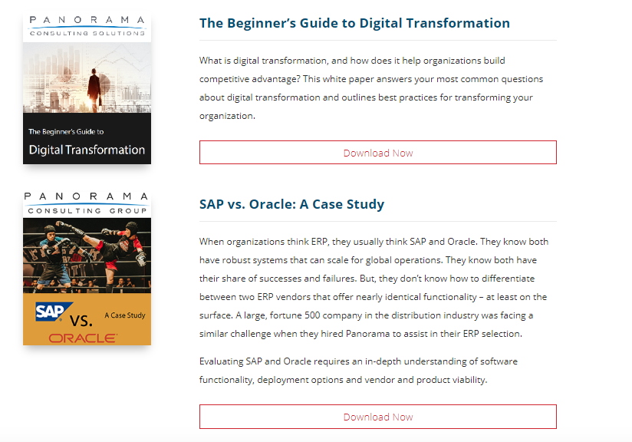

* 1. When Click on “Download now” : “Provide USER Detail” page will open. See details:

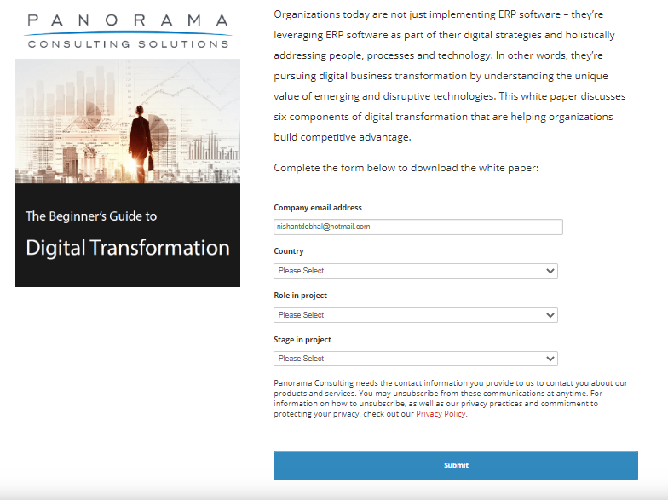

Where USER is supposed to provide this details and click Submit button.

Submit button will check the fields and then

* 1. Next Page would allow user to down the pdf file.

User can download the file by clicking ‘Download Now!’ button:

