Q3:Consider the ER diagram shown in Figure 1 for part of a BANK database. Each

bank can have multiple branches, and each branch can have multiple accounts and

loans.

(a) List the (nonweak) entity types in the ER diagram.

(b) Is there a weak entity type? If so, give its name, its partial key, and its

identifying relationship.

(c) What constraints do the partial key and the identifying relationship of the

weak entity type specify in this diagram?

(d) List the names of all relationship types, and specify the (min,max) constraint

on each participation of an entity type in a relationship type. Justify your

choices.

(e) List concisely the user requirements that led to this ER schema design.

(f) Suppose that every customer must have at least one account but is restricted

to at most two loans at a time, and that a bank branch cannot have more than

1000 loans. How does this show up on the (min,max) constraints?

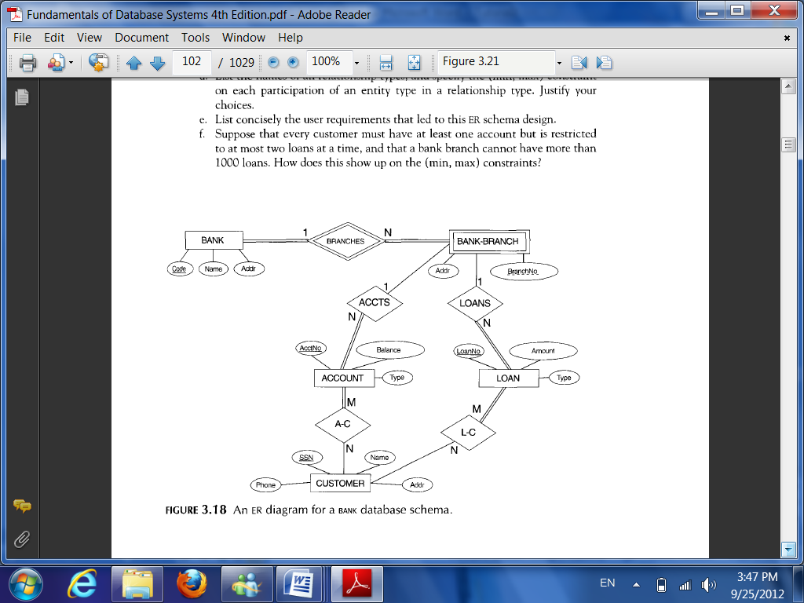

Figure 1: An ER diagram for a BANK database schema.

Answer:

(a) Entity types: BANK, ACCOUNT, CUSTOMER, LOAN

(b) Weak entity type: BANK-BRANCH. Partial key: BranchNo. Identifying relationship: BRANCHES.

(c) The partial key BranchNo in BANK-BRANCH specifies that the same BranchNo value may occur under different BANKs. The identifying relationship BRANCHES specifies that BranchNo values are uniquely assigned for those BANK-BRANCH entities that are related to the same BANK entity. Hence, the combination of BANK Code and BranchNo together constitute a full identifier for a BANK-BRANCH.

(d) Relationship Types: BRANCHES, ACCTS, LOANS, A-C, L-C. The (min, max) constraints

are shown below.

(e) The requirements may be stated as follows: Each BANK has a unique Code, as well as a Name and Address. Each BANK is related to one or more BANK-BRANCHes, and the BranhNo is unique among each set of BANK-BRANCHes that are related to the same BANK. Each BANK-BRANCH has an Address. Each BANK-BRANCH has zero or more LOANS and zero or more ACCTS. Each ACCOUNT has an AcctNo (unique), Balance, and Type and is related to exactly one BANK-BRANCH and to at least one CUSTOMER. Each LOAN has a LoanNo (unique), Amount, and Type and is related to exactly one BANK-BRANCH and to at least one CUSTOMER. Each CUSTOMER has an SSN (unique), Name, Phone, and Address, and is related to zero or more ACCOUNTs and to zero or more LOANs.

(f) The (min, max) constraints would be changed as follows:

