**EXCEL -PIVOT TABLE AND CHARTS:**

**Average Rating for Fudgemart and Fudgeflix:**

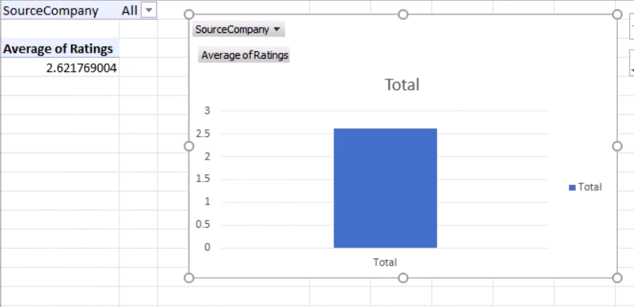

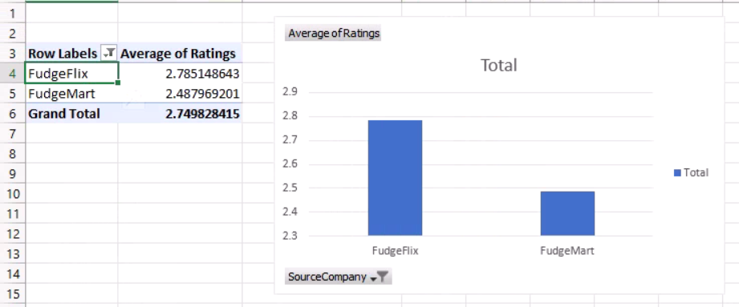

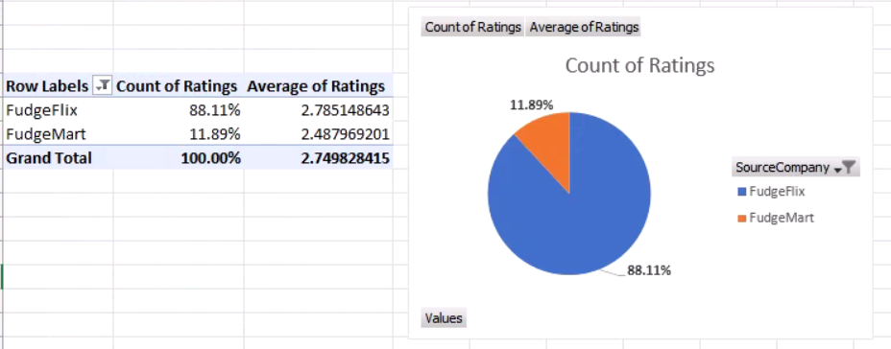

**Average Rating by Department for Fudgemart:**

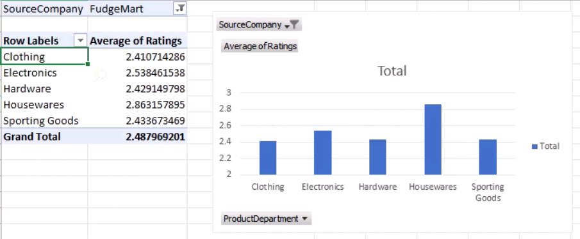

**Analysis of effect of price on rating:**

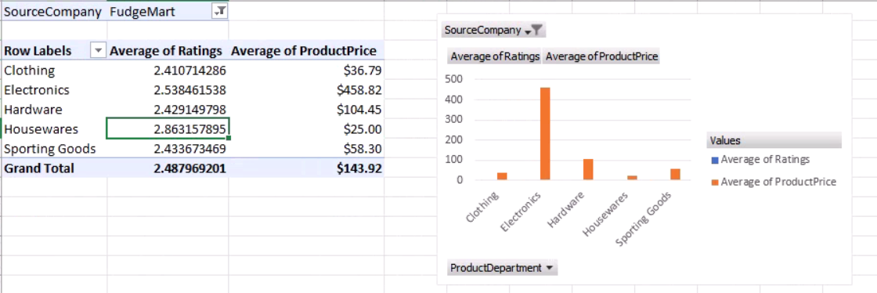

**Average Rating by Genre for Fudgeflix:**

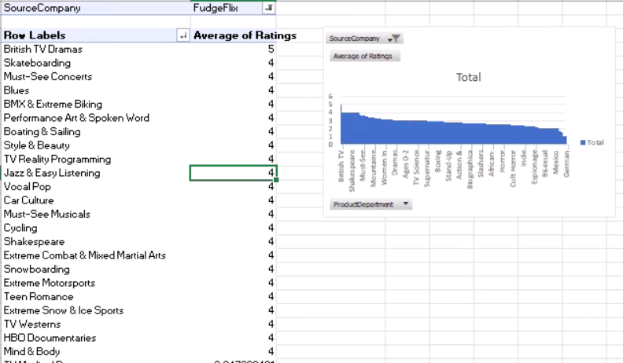

**Worst Performing Genres in FudgeFlix:**

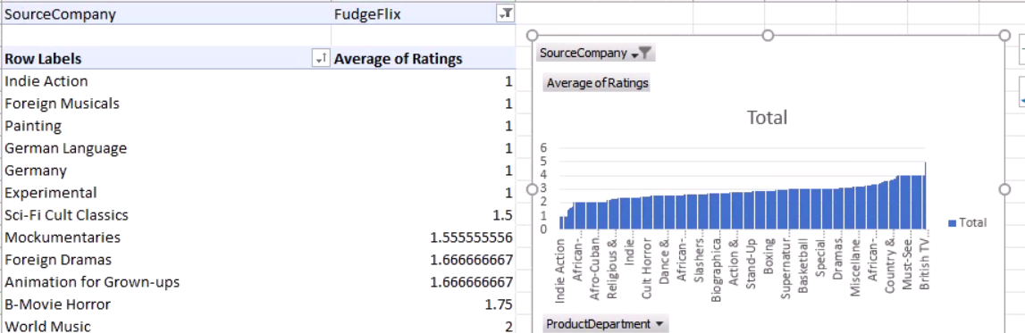

**Top Performing Genres in FudgeFlix:**

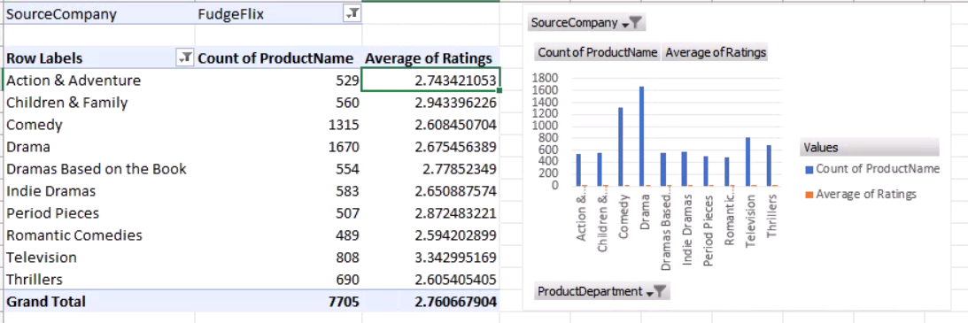

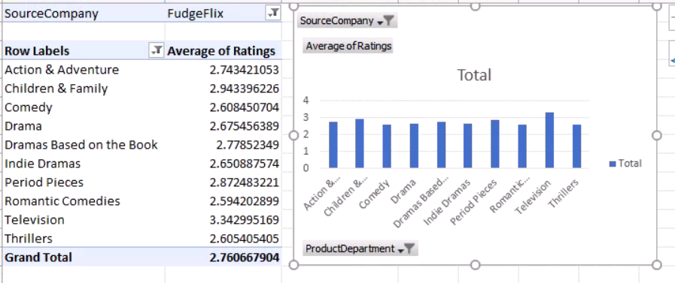

**Average Rating by Location:**

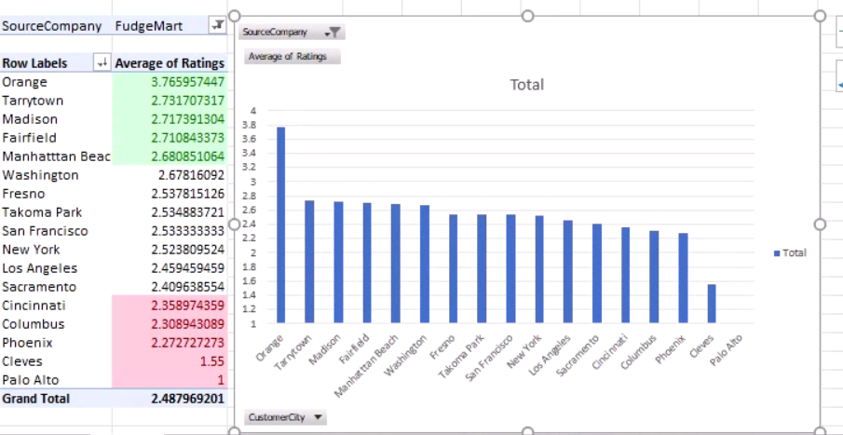

**Average Rating (Year over Year Analysis):**

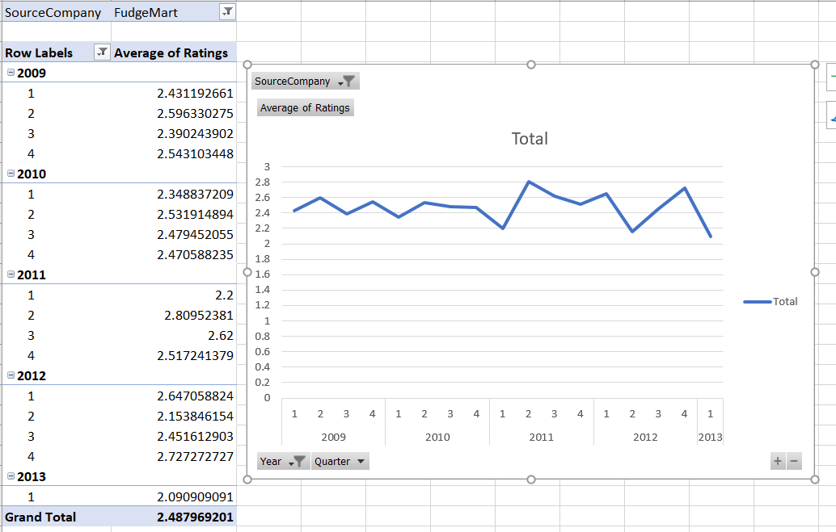

**Average rating by product department (Year over year analysis):**

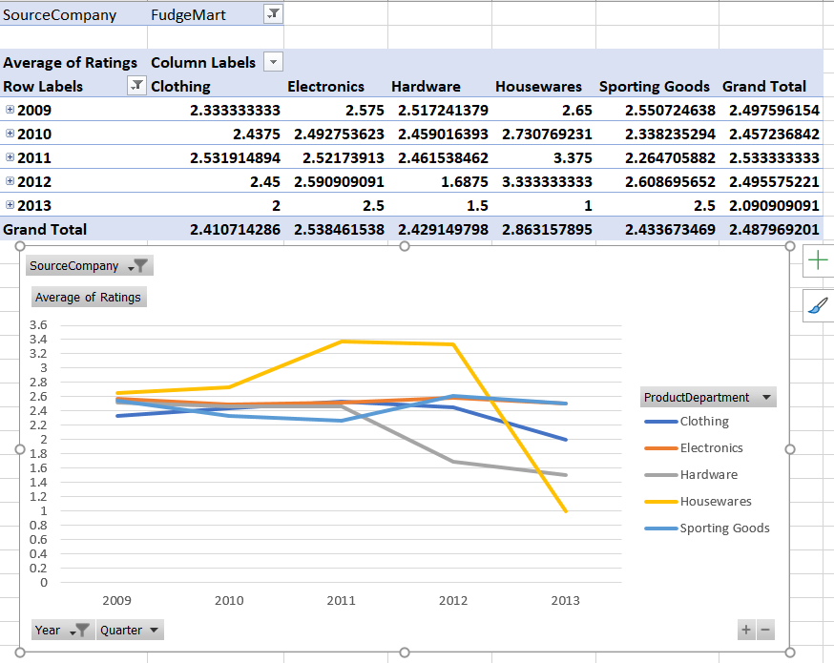

**Average rating by product vendor (Year over year analysis):**

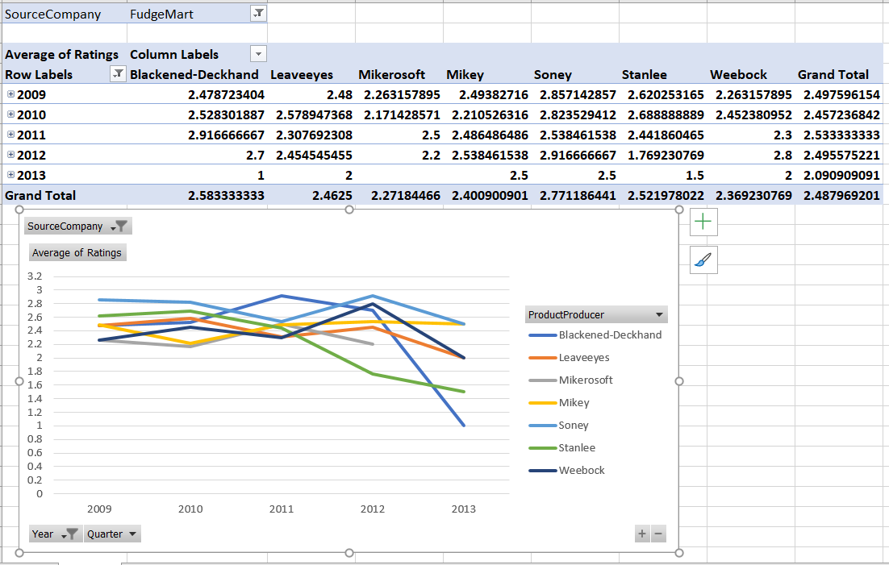

**Average Rating for Title type (Movie/Season) for FudgeFlix:**

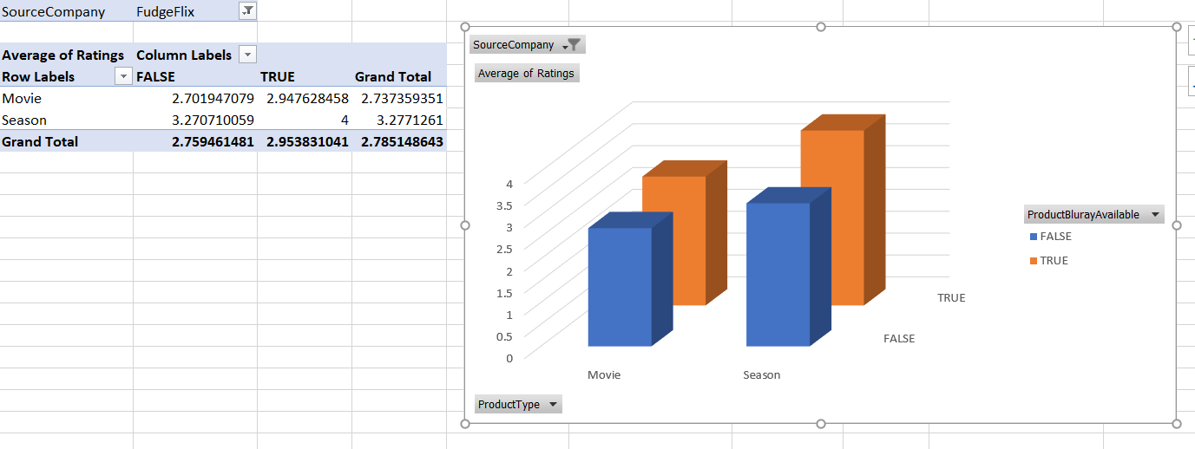

**Average Rating for Title type (G, NR, R rated movies,etc) and Bluray Availability for FudgeFlix:**

