**ETL using SSIS**

**Source to Datawarehouse (Date):**

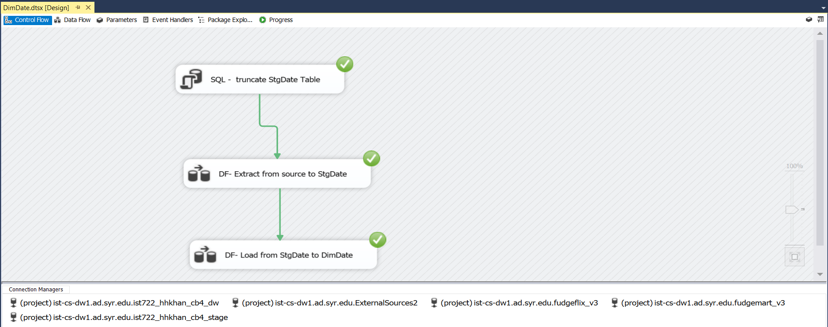

**Source to Stage (Customers, Products, Tweet Dictionary, Customer Satisfaction):**

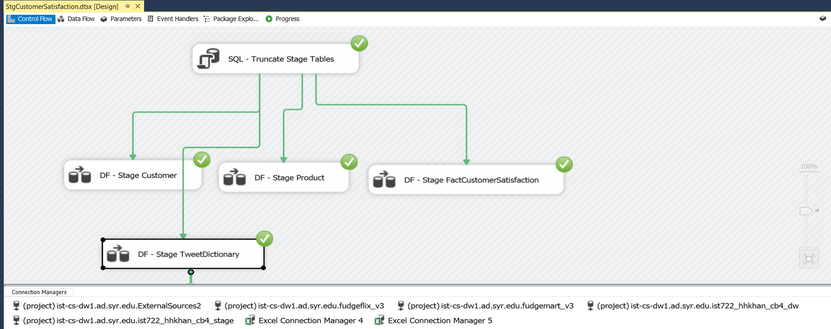

**Stage to Datawarehouse (Customers, Products, Tweet Dictionary, Customer Satisfaction):**

