Ethernet LAN Switching
Lesson Notes — Part 2: ARP, MAC Tables & Ping

1. Ethernet Frame Review
This section recaps the Ethernet frame structure from the previous lesson, focusing on size rules.

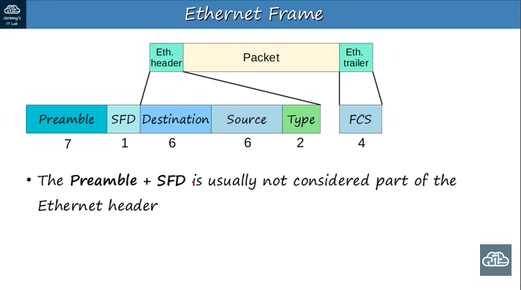

1.1 Ethernet Header Fields
- Destination MAC address — 6 bytes
- Source MAC address — 6 bytes
- Type (Ethernet Type) field — 2 bytes
- FCS (Frame Check Sequence) trailer — 4 bytes
- Total header + trailer = 18 bytes

💡 The Preamble (7 bytes) and SFD (1 byte) are usually NOT counted as part of the Ethernet header. 🧾

Why they’re Not Part of the Header

📡 Purpose of Preamble & SFD
- Preamble (7 bytes) → A repeating 10101010 pattern.
  - Used for synchronization: it helps the receiving NIC (Network Interface Card) lock onto the signal and know when a frame is about to start.
- SFD (Start Frame Delimiter, 1 byte) → 10101011.
  - Marks the end of the preamble and the start of the actual frame.

- Physical Layer Function
  - Preamble and SFD belong more to the Physical Layer than the Data Link Layer.
  - They are used to prepare the medium and synchronize clocks, not to carry addressing or protocol information.
2) No Addressing or Control Info
- The Ethernet header (MAC addresses, type/length field) contains logical addressing and control information.
- Preamble/SFD don’t carry such information — they’re just “timing signals.”
3) Stripped Before Processing
- When a frame is received, the NIC uses the preamble and SFD to align itself, then discards them.
- The higher layers (Data Link, Network, and Transport) never see them.
Think of the preamble + SFD like the “beep beep” before someone talks on a walkie-talkie.
- The beep helps you know a message is coming.
- But the beep itself is not part of the message — you ignore it once the real words start.
- The Ethernet header starts after the SFD because the preamble and SFD are only used for synchronization at the Physical Layer. They don’t carry addressing or protocol data, so they’re not considered part of the logical Ethernet frame header.

3. Ethernet LAN Switching — Network Topology
The demo network used throughout this lesson:

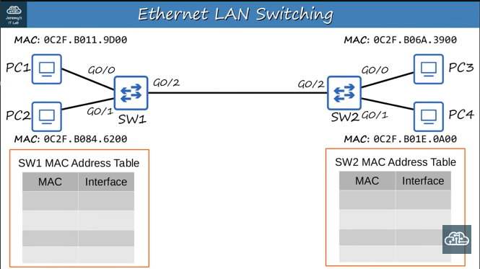

3.1 Devices & MAC Addresses
- PC1 — MAC: 0C2F.B011.9D00 (connects to SW1 via G0/0)
- PC2 — MAC: 0C2F.B084.6200 (connects to SW1 via G0/1)
- PC3 — MAC: 0C2F.B06A.3900 (connects to SW2 via G0/0)
- PC4 — MAC: 0C2F.B01E.0A00 (connects to SW2 via G0/1)
- SW1 ↔ SW2 connected via G0/2

- Network: 192.168.1.0/24 (all PCs on the same subnet)
- OUI (first 3 bytes) is the same for all — they come from the same manufacturer
- Last 3 bytes are unique per device

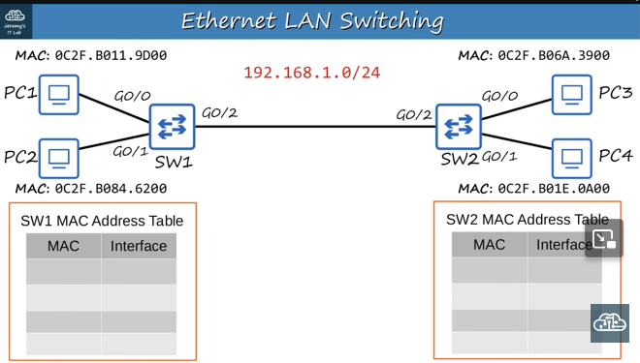

4. How Devices Send Data — IP + MAC Encapsulation
When a device sends data, it does NOT just use MAC addresses. It encapsulates the data in an IP packet first:

- The IP packet contains: Source IP + Destination IP
- The Ethernet frame wraps the IP packet with: Source MAC + Destination MAC

Key point: You type an IP address when sending data — NOT a MAC address. The MAC is resolved automatically.

Example — PC1 wants to send data to PC3:
- Source IP: 192.168.1.1 | Destination IP: 192.168.1.3
- Source MAC: 0C2F.B011.9D00
- Problem: PC1 does NOT know PC3's MAC address yet!

5. ARP — Address Resolution Protocol
ARP is used to discover the MAC address of a device when only its IP address is known.

5.1 ARP Request (Broadcast)
PC1 sends an ARP Request to find PC3's MAC address:

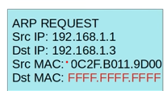

- Source IP: 192.168.1.1
- Destination IP: 192.168.1.3 (who has this IP? Tell me your MAC)
- Source MAC: 0C2F.B011.9D00
- Destination MAC: FFFF.FFFF.FFFF ← BROADCAST (sent to everyone on the LAN)

5.2 ARP Request — Propagation Through Switches
The ARP Request travels through the network as follows:

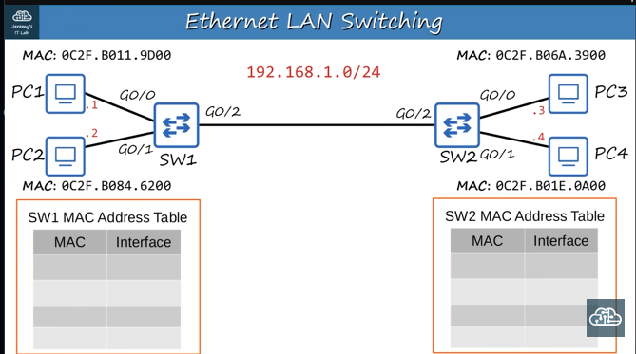

- PC1 sends ARP Request → SW1
- SW1 floods the frame out ALL ports EXCEPT the one it arrived on (broadcast flooding)
- SW1 learns PC1's MAC (0C2F.B011.9D00) on port G0/0 → stores in MAC address table
- SW1 forwards to SW2 via G0/2
- SW2 also floods the broadcast to PC3 and PC4
- SW2 learns .9D00 is reachable via G0/2

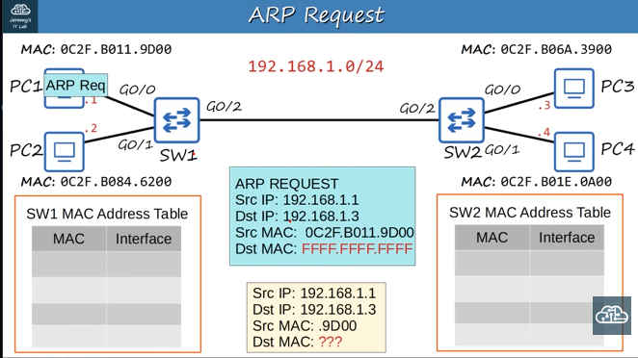

5.3 ARP Reply (Unicast)
PC3 recognizes its own IP in the request and replies:

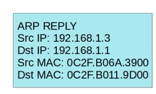

- Source IP: 192.168.1.3 | Destination IP: 192.168.1.1
- Source MAC: 0C2F.B06A.3900 | Destination MAC: 0C2F.B011.9D00
💡 ARP Reply is UNICAST — it goes directly back to PC1, not broadcast.

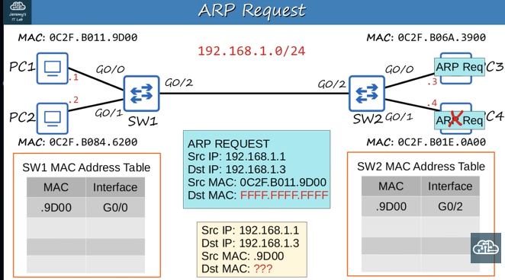

The ARP Reply travels back: PC3 → SW2 → SW1 → PC1
- Each switch learns MAC entries along the way
- After the reply, PC1 knows PC3's MAC and can send data directly

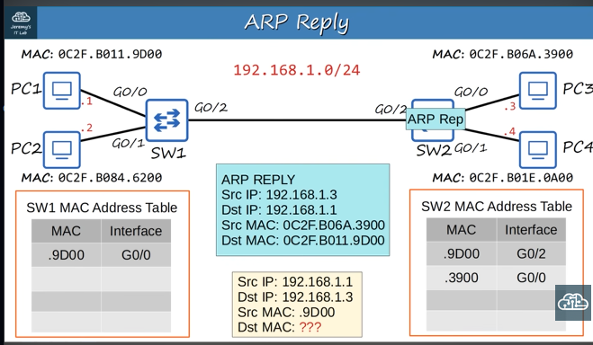

6. Ping
After ARP resolves the MAC, normal data transfer (like Ping) can occur.

- Ping is a network utility used to test reachability between devices
- It measures round-trip time (RTT)
- Uses two ICMP messages:
  - ICMP Echo Request — sent from source
  - ICMP Echo Reply — returned by destination

7. MAC Address Table — Aging & Clearing

7.1 Aging
MAC address table entries are not permanent. Each entry has an aging timer.
- If a MAC address is not seen on a port for a period of time, the entry is removed
- Default aging time on Cisco switches: 300 seconds (5 minutes)

7.2 Clearing the MAC Address Table Manually
You can view and clear the MAC address table using the CLI:

View the table:
SW1# show mac address-table

Clear ALL dynamic entries:
SW1# clear mac address-table dynamic

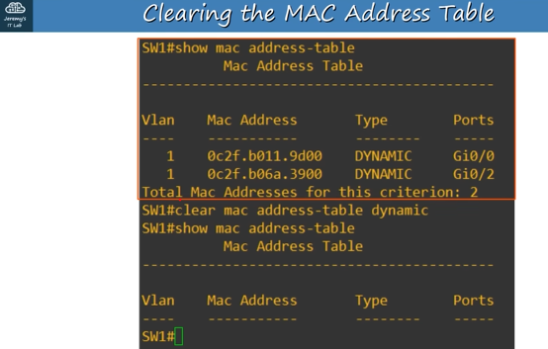

Clear a specific MAC address:
SW1# clear mac address-table dynamic address 0c2f.b011.9d00

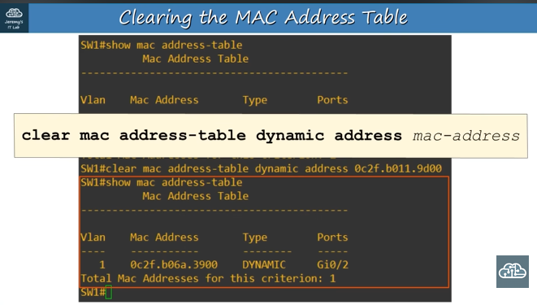

Clear all entries on a specific interface:
SW1# clear mac address-table dynamic interface Gi0/0

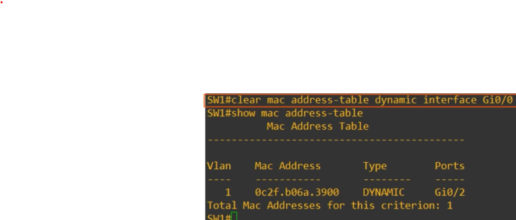

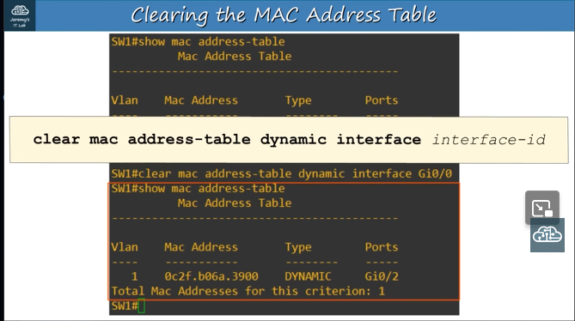

8. Key Takeaways
- The minimum Ethernet frame size is 64 bytes; padding is added if the payload is under 46 bytes.
- Devices communicate using IP addresses; MAC addresses are resolved by ARP.
- ARP Request is a BROADCAST (Dst MAC = FFFF.FFFF.FFFF).
- ARP Reply is a UNICAST sent directly back to the requester.
- Switches learn MAC addresses dynamically and store them in a MAC address table.
- Switches flood unknown/broadcast frames and forward known unicast frames.
- Ping uses ICMP Echo Request and Reply to verify connectivity.
- MAC address table entries expire after 300 seconds by default and can be cleared manually.

