Ethernet Switching
Study Notes — Data Link Layer & LAN Switching
Layer 2 • OSI Model • MAC Addresses • Frame Encapsulation

1. Course Overview
This course focuses on Ethernet switching — specifically how data travels through a network at Layer 2 of the OSI model. We build on TCP/IP concepts and concentrate on the Data Link Layer.

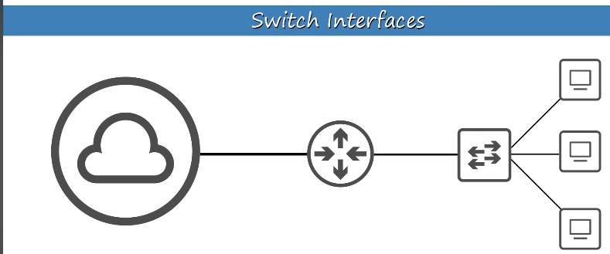
Figure 1 – Network topology used in this course

2
- Detects and helps retransmit errors
- Uses Layer 2 addressing (MAC addresses)
- In this course, we focus on Ethernet LAN switching at Layer 2

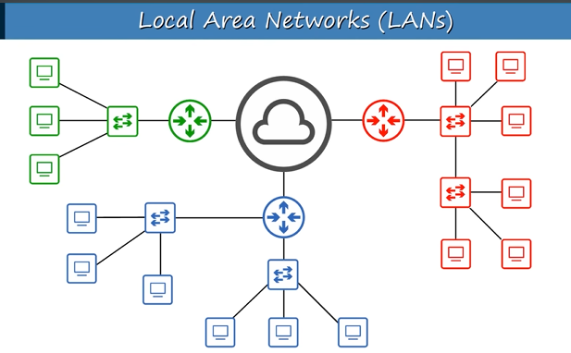
Figure 2 – Data Link Layer in the OSI model

What Is a LAN?
A Local Area Network (LAN) is a network that covers a relatively small geographic area, such as an office floor or a building.
⚠️ Two switches connected to each other form ONE LAN. Two switches separated by a router form TWO different LANs.

3. Data Encapsulation (PDU Review)
As data moves down the OSI model, each layer adds its own header (and sometimes a trailer). This process is called encapsulation and produces a Protocol Data Unit (PDU).

OSI Layer | PDU Name | What Is Added
Layer 7 — Application | Data | Raw data generated by the application (e.g. HTTP request, DNS query)
Layer 6 — Presentation | Data | Encoding, encryption, and compression applied (e.g. SSL/TLS, JPEG, ASCII)
Layer 5 — Session | Data | Session management: establishes, maintains, and terminates communication sessions
Layer 4 — Transport | Segment | Layer 4 header added: source/dest ports, sequence numbers, error checking (TCP/UDP)
Layer 3 — Network | Packet | Layer 3 header added: source/dest IP addresses, TTL, and routing info
Layer 2 — Data Link | Frame | Layer 2 header AND trailer added: MAC addresses (header) + CRC/FCS error check (trailer)
Layer 1 — Physical | Bits | Frame converted into electrical signals, light pulses, or radio waves for transmission

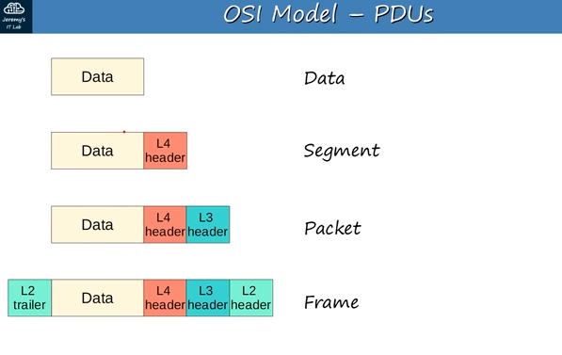
Figure 3 – Ethernet frame encapsulation diagram

4. The Ethernet Frame

Header vs. Trailer
HEADER | Information added at the BEGINNING of a message — identifies where the frame is going and coming from.

TRAILER | Information added at the END of a message — verifies whether the frame was received correctly.

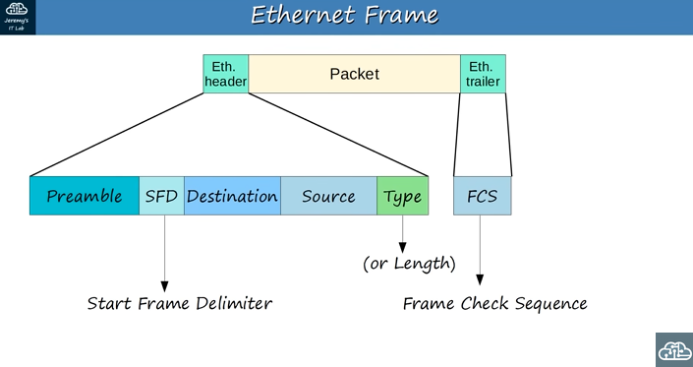
Figure 4 – Ethernet frame structure with all fields

Preamble (7 bytes)
A pattern of alternating 1s and 0s (10101010...) sent before the actual frame. It allows receiving devices to synchronize their receiver clocks so they are ready to receive the rest of the frame.

Analogy | Like the ringing of a phone before a conversation. The ring alerts the other person to get ready — but it is not the conversation itself.

SFD — Start Frame Delimiter (1 byte)
Marks the end of the preamble and signals that the actual Ethernet frame content is beginning.

Destination & Source MAC Address (6 bytes each)
The Destination MAC address identifies the intended recipient device. The Source MAC address identifies the sender. The switch uses both to build and query its MAC address table.

Type / Length Field (2 bytes)
Indicates the Layer 3 protocol encapsulated in the frame (for example: 0x0800 = IPv4, 0x86DD = IPv6). In older Ethernet versions this field indicates data length instead.

FCS — Frame Check Sequence (4 bytes)
Detects corrupted data using the CRC (Cyclic Redundancy Check) algorithm. The sender calculates a value from the frame data and stores it here. The receiver re-calculates and compares — if they differ, the frame is discarded.

5. MAC Addresses
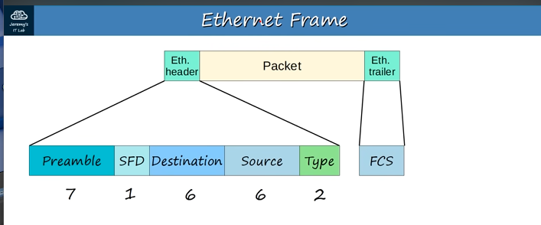
Figure 5 – MAC address structure (OUI + device-specific)

- 6 bytes (48 bits) long, written as 12 hexadecimal characters
- Also called a BIA (Burned-In Address) — permanently assigned at the factory
- First 3 bytes: OUI (Organizationally Unique Identifier) — identifies the manufacturer
- Last 3 bytes: unique to the specific network interface card (NIC)

Types of Frames
- Unicast: a frame addressed to one specific device using its MAC address
- Unknown Unicast: when the switch does not have the destination MAC in its table, it floods the frame to all ports except the one it arrived on

6. How Switches Learn & Forward Frames
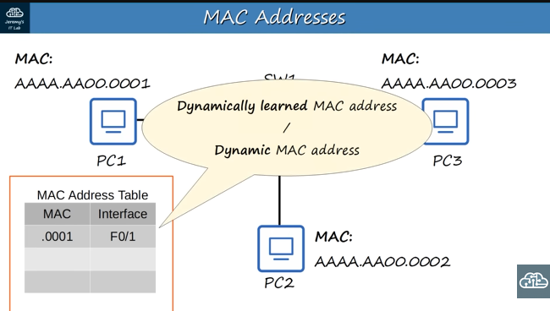
Figure 6 – Switch MAC address table and forwarding process

Switches dynamically build their MAC address table by reading the SOURCE address of every incoming frame and recording which port it arrived on.

Step-by-Step Learning Process
- Step 1: A frame arrives on a switch port.
  - Step 2: The switch reads the SOURCE MAC address and saves it in the MAC table with the incoming port number.
  - Step 3: The switch looks up the DESTINATION MAC address in its table.
  - Found → forward: Send the frame only to the correct port. This is called a Known Unicast.
  - Not found → Flood: Send the frame to ALL ports except the one it arrived on. This is called an Unknown Unicast / Flooding.
- Step 4: When the destination replies, the switch learns its MAC address too and stores it.
- Step 5: MAC address table entries expire after 5 minutes of inactivity.

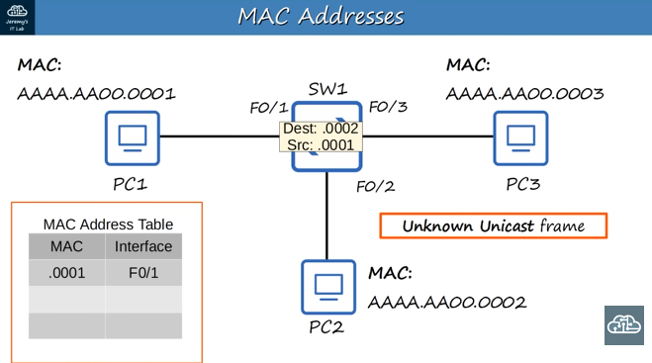
Figure 7 – Unknown unicast flooding and reply learning

⚠️ Flooding is NOT broadcasting. Flooding happens only when the destination MAC is unknown. Once learned, traffic goes directly to the correct port only (unicast — more efficient).

7. Self-Check: How Many LANs?
Study the network topology in Figure 1 carefully, then try to answer the question below. You have 3 attempts — try your best before checking the answer!

❓ How many LANs are shown in the topology above?

Attempt | Your Answer | Hint
⭐ Attempt 1 | My answer: ___________ | Excellent if right!
👍 Attempt 2 | My answer: ___________ | Good try — look again!
✅ Attempt 3 | My answer: ___________ | Check answer below!

Answer | Count every group of devices separated by a router. Each router interface creates a LAN boundary. Remember: two switches connected together = still ONE LAN.

8. Key Takeaways
- Layer 2 (Data Link Layer) handles node-to-node delivery using MAC addresses.
- An Ethernet frame has a Header (preamble, SFD, destination MAC, source MAC, type/length) and a Trailer (FCS).
- The Preamble synchronizes receiver clocks; the FCS detects corrupted frames using CRC.
- MAC addresses are 6 bytes: first 3 bytes = manufacturer (OUI), last 3 bytes = unique to the device.
- Switches learn MAC addresses dynamically by reading the source address of every incoming frame.
- Unknown destination MAC → the switch floods the frame to all ports (except the incoming port).
- Known destination MAC → the switch forwards the frame only to the correct port (unicast).
- MAC address table entries expire after 5 minutes of inactivity.
- Two switches connected = one LAN. A router separating switches = two separate LANs.

