Configuration Management Tools: Ansible, Puppet, Chef
CCNA Study Notes: Network Automation and Programmability

1. Overview
Topics covered in these notes:
- Introduction to configuration management tools
- Ansible
- Puppet
- Chef

- Configuration management tools like these three can be useful in any network, but especially in medium to large networks with hundreds or even thousands of devices.
- To understand why they are useful, it helps to understand the concept of configuration drift.

2. Configuration Drift
- Configuration drift is when changes made by individuals over time cause a device's configuration to deviate from the standard (correct) configuration defined by the company.
- Each device has some unique parts in its configuration (IP addresses, hostname, etc.).
- Most of a device's configuration is usually defined in standard templates designed by the company's network architects and engineers.
- When engineers make changes to devices (for example to troubleshoot and fix issues, or to test configurations), the device can drift away from the standard.

KEY RULE: Avoid configuration drift
Configuration drift is a bad thing and should be avoided as much as possible, because it can lead to future issues.

3. Configuration Management Without Automation
Even without automation tools, it is best to have standard configuration management practices:
- When a change is made, save the config as a text file and place it in a shared folder.
- This helps keep track of changes and shows where each change was made.

3.1 Flaws of this system
- An engineer might forget to place the new config in the folder after making a change.
- It is then unclear which config should be considered the correct one.
- Even if configs are saved properly, it does not guarantee they match the standard. It only helps track different versions of the config.

4. Configuration Provisioning
- Configuration provisioning refers to how configuration changes are applied to devices. This includes configuring new devices too.
- Traditionally, it is done by connecting to devices one by one via SSH, which is not practical in a large network.
- Tools like Ansible, Puppet, and Chef let us make changes to devices on a mass scale in a fraction of the time and effort.

KEY RULE: Two essential components
Templates and variables are found in all of these tools.
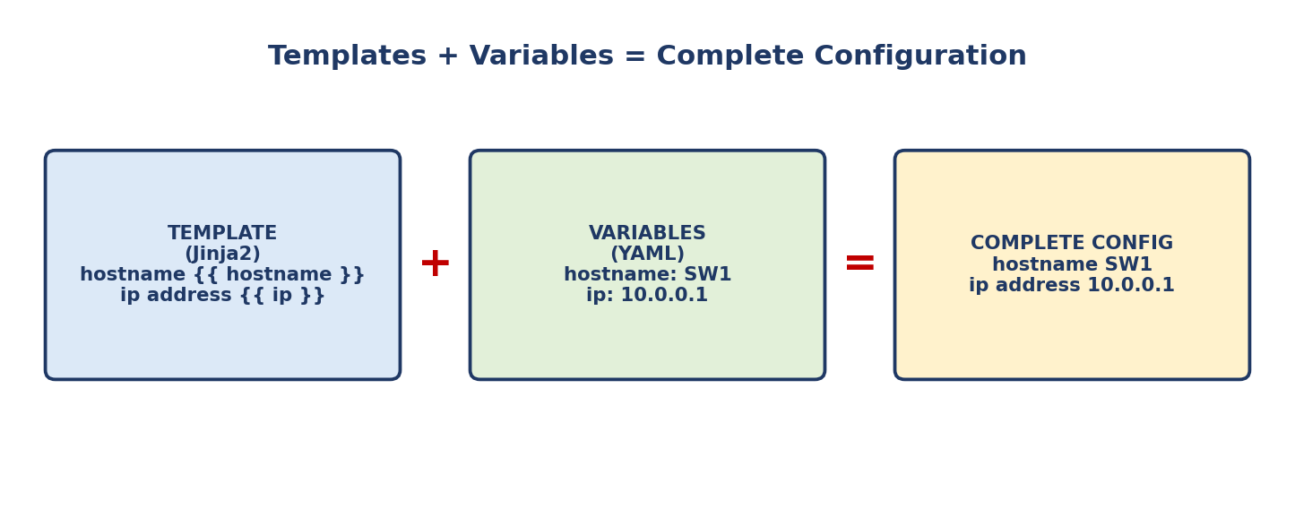

5. Configuration Management Tools
- They are network automation tools that facilitate centralized control of a large number of network devices.
- They are useful in a network of any size, but are mostly used in large networks.
- The options to know for the CCNA are Ansible, Puppet, and Chef.
- They were originally developed after the rise of VMs, to let server system admins automate creating, configuring, and removing VMs.
- They are also widely used to manage network devices.

5.1 Tasks they can perform
- Generate configurations for new devices on a large scale.
- Perform configuration changes on devices (all devices in the network or a certain subset).
- Compare configurations between devices, and between different versions of the configuration on the same device.

6. Ansible

6.1 Key facts
- A configuration management tool owned by Red Hat.
- Written in Python.
- Agentless: no special software needs to run on the managed devices.
- Uses SSH to connect to devices, make configuration changes, extract information, etc.
- Push model: the Ansible server (control node) uses SSH to connect to the managed devices and push configuration changes to them.
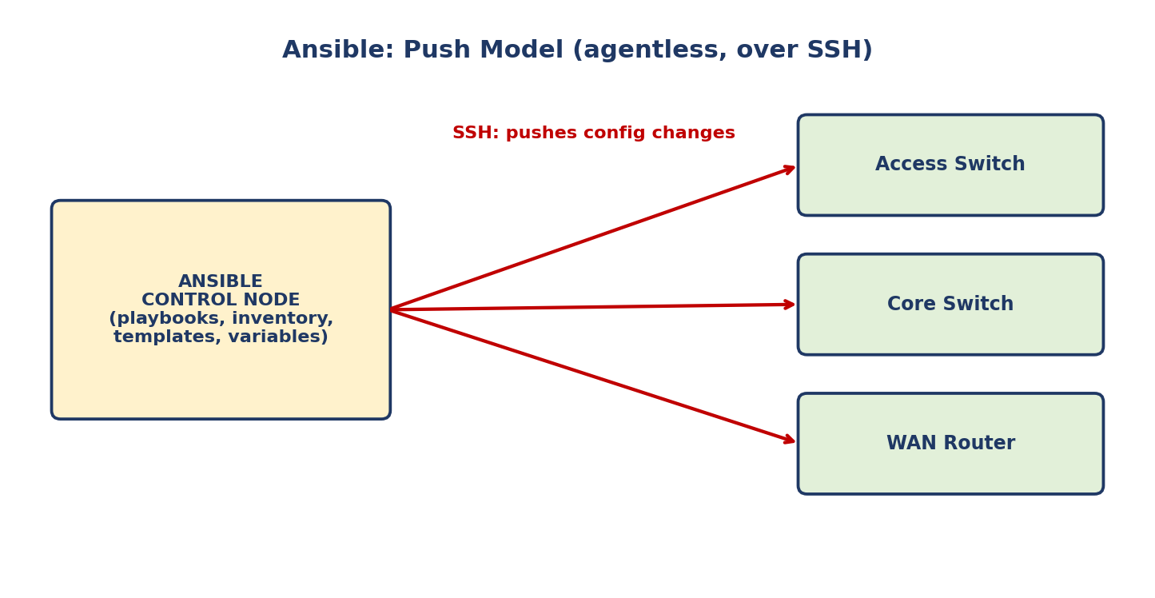

6.2 Files you must create
After installing Ansible, you must create several text files:
- Playbooks: the blueprint of automation tasks. They outline the logic and actions Ansible should perform. Written in YAML.
- Inventory file: lists the devices managed by Ansible and the characteristics of each (for example device role: access switch, core switch, WAN router, firewall). Written in INI, YAML, or other formats.
- Templates: represent a device's configuration file, but specific values for variables are not provided. Written in Jinja2 format.
- Variables: list the variables and their values. These values are substituted into the templates to create complete configuration files. Written in YAML.

KEY RULE: Ansible
Agentless + push model + SSH + Python. Playbooks and variables use YAML; templates use Jinja2.

7. Puppet

7.1 Key facts
- A configuration management tool written in Ruby.
- Agent-based: specific software must be installed on the managed devices. Not all Cisco devices support Puppet agents.
- It can run agentless: a proxy agent runs on an external host and uses SSH to connect to and communicate with the managed devices.
- The Puppet server is called the Puppet master.
- Pull model: clients pull configurations from the Puppet master.
- Clients use TCP port 8140 to communicate with the Puppet master.
- Instead of YAML, it uses a proprietary language for its files.
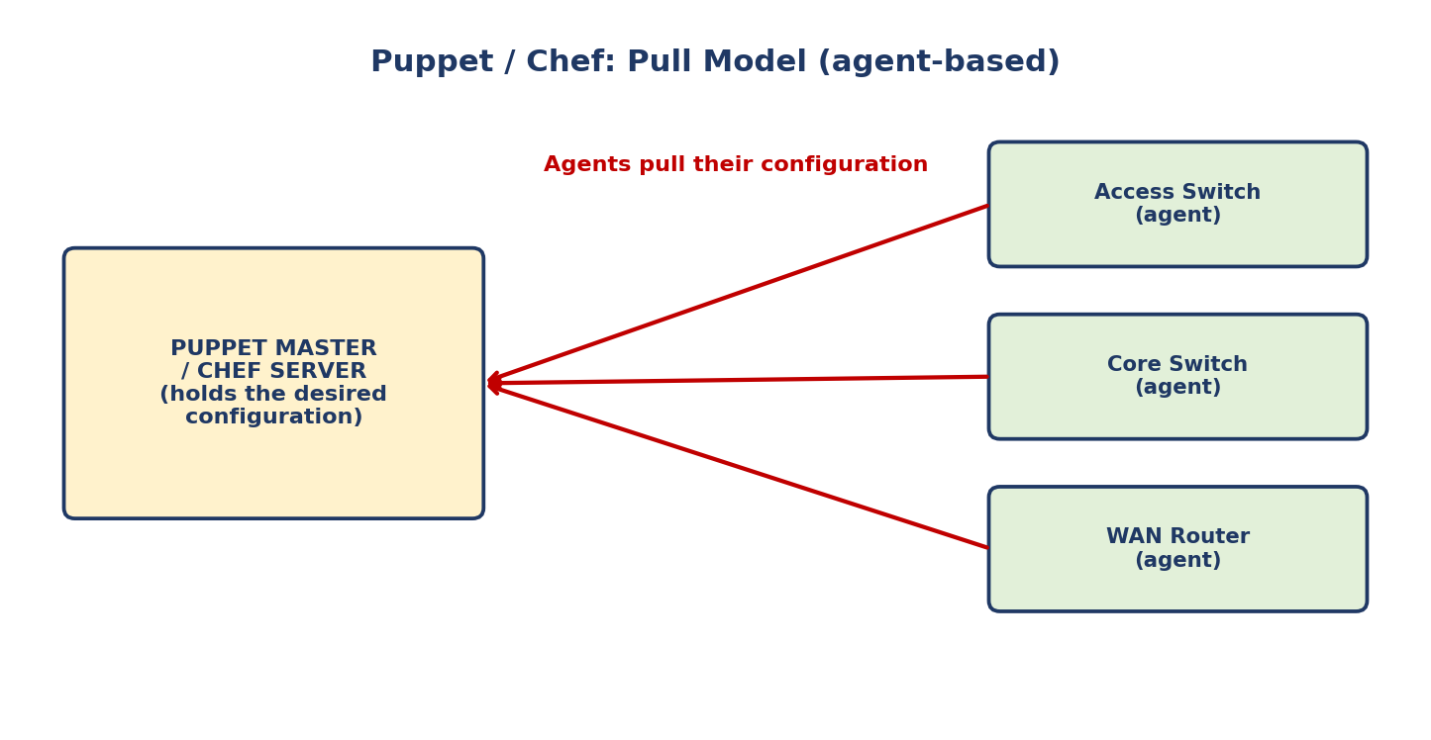

7.2 Files required on the Puppet master
- Manifest: defines the desired configuration state of a network device.
- Template: similar to an Ansible template. Used to generate manifests for the devices.

KEY RULE: Puppet
Agent-based + pull model + TCP 8140 + Ruby. The server is the Puppet master.

8. Chef

8.1 Key facts
- A configuration management tool written in Ruby.
- Agent-based: specific software must be installed on the managed device. Not all Cisco devices support Chef agents.
- The least popular of the three choices.
- Pull model as well.
- The server uses TCP port 10002 to send configurations to clients.
- Files use a DSL (domain-specific language) based on Ruby.

8.2 Text files used by Chef
- Resources: the "ingredients" in a recipe. These are the configuration objects managed by Chef.
- Recipes: the "recipes" in a cookbook. They outline the logic and actions of the task performed on the resources.
- Cookbooks: a set of related recipes grouped together.
- Run list: an ordered list of recipes that are run to bring a device to the desired configuration state.

KEY RULE: Chef
Agent-based + pull model + TCP 10002 + Ruby-based DSL. Resources go into recipes, recipes are grouped into cookbooks, and a run list sets the order.

9. Quick Comparison
Feature | Ansible | Puppet | Chef
Written in | Python | Ruby | Ruby
Agent | Agentless | Agent-based (agentless via proxy possible) | Agent-based
Model | Push | Pull | Pull
Communication | SSH | TCP 8140 (to the Puppet master) | TCP 10002 (server to clients)
File language | YAML (playbooks, variables); Jinja2 (templates) | Proprietary language | DSL based on Ruby
Key files | Playbook, Inventory, Template, Variables | Manifest, Template | Resource, Recipe, Cookbook, Run list
Popularity note | Owned by Red Hat | Server is the Puppet master | Least popular of the three

KEY RULE: Push vs pull
Ansible pushes configuration to devices. Puppet and Chef have agents that pull configuration from the server.

10. Summary
- Configuration drift happens when individual changes make a device deviate from the company standard.
- Configuration management tools apply changes at scale and keep configurations consistent.
- All three tools use templates and variables.
- Ansible: agentless, push, SSH, Python, YAML.
- Puppet: agent-based, pull, TCP 8140, Ruby, proprietary language.
- Chef: agent-based, pull, TCP 10002, Ruby-based DSL, least popular.

