REST APIs
CCNA Study Notes — Network Automation & Programmability

1. Introduction to APIs
- An API (Application Programming Interface) is a software interface that allows two applications to communicate and exchange information with each other.
- APIs are important for network automation because they allow our programs to easily interact with network devices and controllers.
- REST APIs are commonly used for the northbound interface (NBI) in an SDN architecture.

Topics covered in this note:
- CRUD operations and HTTP verbs
- REST APIs

KEY RULE — What an API does
An API lets software talk to software. In SDN, APIs are used to communicate between applications and the SDN controller (via the NBI), and between the controller and network devices (via the SBI).

2. APIs in SDN Architecture
Both the application and the SDN controller are software, but they have different jobs:
- SDN controller: special network software whose job is to control and manage network devices. Example: Cisco Catalyst Center. It knows about the network and can communicate with routers and switches.
- Application: software that uses the controller's services. Example: a network-monitoring application asks the controller, "Which switches are down?" The controller gets the information from the network and gives the application the answer.
- REST API: one possible way the application communicates with the controller.
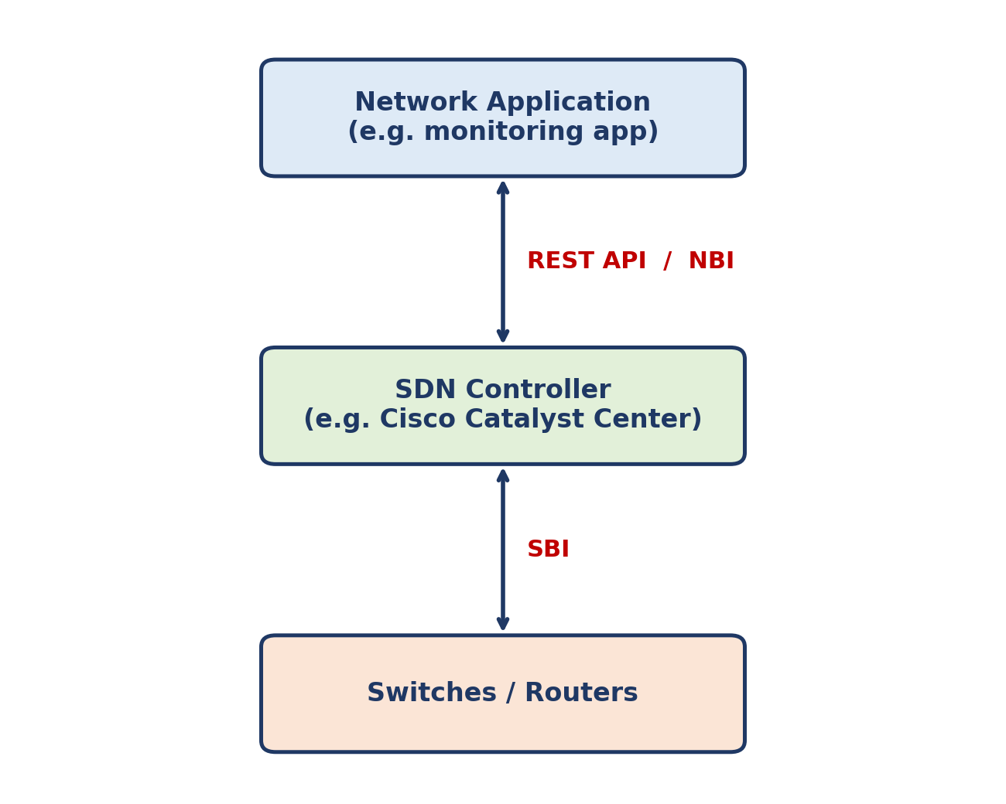
Figure 1: Application → REST API (NBI) → SDN Controller → SBI → Network devices
KEY RULE — NBI and SBI
Application → REST API → SDN Controller → SBI → Network devices.
The NBI (northbound interface) typically uses a REST API.
Other APIs used to configure network devices via the southbound interface include NETCONF and RESTCONF (not covered in this note).

3. CRUD Operations
CRUD stands for Create, Read, Update, Delete. These are the operations we perform using REST APIs.
- Create: create new variables and set their initial value (e.g. create variable IP address and set it to 10.1.1.1).
- Read: retrieve the value of a variable (e.g. what is the value of the variable?).
- Update: change the value of a variable (e.g. change IP address to 10.2.3.4).
- Delete: delete a variable (e.g. delete the IP address variable).

KEY RULE — CRUD ↔ HTTP verbs
HTTP uses verbs (methods) that map to the CRUD operations, matching the actions we typically want to perform with an application.
Create = POST | Read = GET | Update = PUT | Delete = DELETE

CRUD operation | HTTP verb | Meaning / example
Create | POST | Create a new variable and set its initial value, e.g. create variable IP address = 10.1.1.1
Read | GET | Retrieve the value of a variable, e.g. "What is the value of the IP address variable?"
Update | PUT | Change the value of a variable, e.g. change IP address to 10.2.3.4
Delete | DELETE | Delete a variable, e.g. delete the IP address variable

4. HTTP and REST
Although this topic is about REST, HTTP matters because REST APIs commonly use HTTP as the communication protocol.
- When an HTTP client sends a request to an HTTP server, it includes a verb that indicates what the client wants to do.
- Example: to access a web page on a server, the client uses the GET verb to retrieve that page.
- HTTP does not mean a web browser must be involved. A network application can send an HTTP request directly to the SDN controller.
- The controller receives the request, processes it, and sends an HTTP response back to the application.

Common verbs used by an application toward an SDN controller:
- GET — ask for information
- POST — create something
- PUT — update something
- DELETE — remove something

KEY RULE — Application → HTTP/REST API → SDN Controller → Response
The application sends an HTTP request to the SDN controller, and the controller sends an HTTP response back to the application.

5. HTTP Verb vs Request vs Response
- HTTP verb: tells the SDN controller what action the application wants to perform (e.g. GET = retrieve information).
- HTTP request: the whole message sent by the application to the controller. It contains the verb and the details of what is being asked for.
- HTTP response: the answer or result the server sends back after receiving a request.

Example:
- GET = the action → "I want to retrieve information."
- "Give me the status of SW1" = the specific thing being requested.
- The whole thing together = the HTTP request.
- The controller replies with the HTTP response: "SW1 is UP".
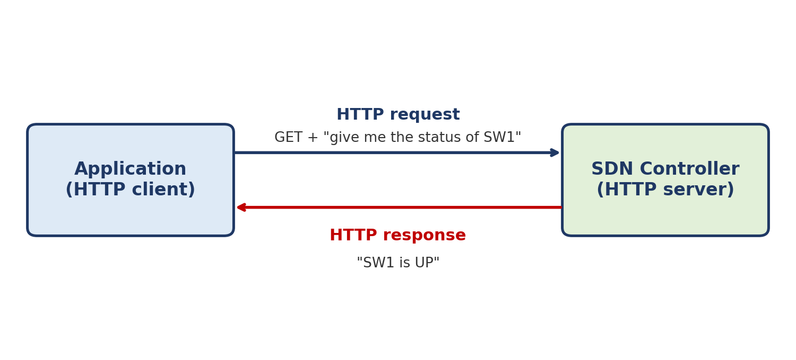
Figure 2: HTTP request and response between application and SDN controller
KEY RULE — Remember
HTTP verb = what action?
HTTP request = the complete message asking for that action.
HTTP response = the answer / result.

6. REST API
- REST stands for Representational State Transfer.

NOTE — Section to complete
The original notes end at the definition of REST. Add the rest of your REST API notes here (e.g. REST characteristics, data formats) when you have them.

