TCP/IP Model
CCNA study notes · Network fundamentals

1. Protocols and standards
- A protocol is a set of rules defining how data should be communicated between devices over a network.
- Protocols are the language devices use to communicate.
- Since the early days of networking, there have been several attempts to define the functions computers need in order to communicate.

Functions a protocol defines
- How to send data (rules for transmission)
- How to receive data (rules for reception)
- How to check for errors
- How to make sure the message arrives in the right place

From proprietary to standard
- At first: vendors had their own functions and protocols, which were not compatible. Communication between different vendors' products was difficult.
- Now: we use standard protocols (TCP/IP, HTTP, Wi-Fi, Bluetooth), which are universal and work across all vendors.
- Most networking standards are developed by independent standards organizations, not by a single vendor, with engineers from many companies taking part.

Key definition
A standard is an agreed specification that different manufacturers follow so their devices can work together.

2. Why use a layered model?
A network does many different jobs to move data from one computer to another:
- Physical transmission of signals
- Local delivery on a LAN
- Routing traffic between networks
- End-to-end conversations between applications

- A model lets us group related jobs into layers.
- Each layer has its own specific role, uses the services of the layer below, and provides services to the layer above.
- The layers work together to deliver the message, but each focuses on its own task.
- What happens inside one layer does not change the job of another layer. For example, changing the content of a letter does not change how it is delivered.

3. Building a model: the post office analogy
You are in your house. Bob and his wife are in theirs. Two post offices sit between you, connected by roads.
- You write a letter addressed to Bob and put it in an envelope addressed to Bob's house.
- Bob's house is far away, so you drive the envelope to Post Office A. Notice the three different destinations: your car is going to Post Office A, the envelope is going to Bob's house, and the letter is going to Bob.
- Post Office A puts the envelope on a truck to Post Office B. The truck's destination is Post Office B, but the envelope and letter keep their original destinations.
- Post Office B puts the envelope on another truck to Bob's house. This truck has yet another destination.
- The envelope is delivered, opened, and Bob reads the letter.
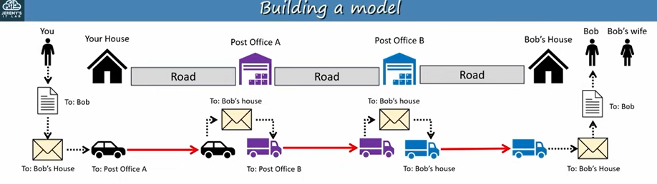
Figure 1: the post office analogy
Analogy layer | What it means | Network equivalent
Content | The text of the letter: what you actually want to say | The data (application layer)
Recipient | Bob vs Bob's wife: the intended person inside the house | Port number (transport layer)
Address | The destination address of the house | IP address (internet layer)
Local delivery | Delivery to the next stop by car or truck: Post Office A, Post Office B, Bob's house | MAC address, hop to hop (local network layer)

Remember
The car and trucks change at every stop, but the envelope and letter keep their original destinations all the way. In a network, the Layer 2 address changes at each hop while the IP address and port stay the same.

4. The TCP/IP layers
In the example, PC1 runs a web client (a browser such as Chrome). Server 1 runs a couple of processes: a web server and a file server. The user on PC1 wants a web page hosted on Server 1.
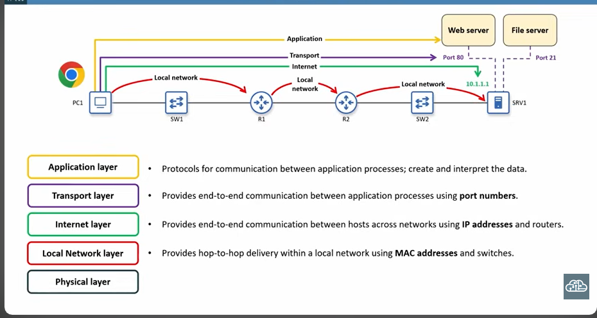
Figure 2: the five layers in action between PC1 and SRV1
Layer | Role
Application | Protocols for communication between application processes. Creates and interprets the data.
Transport | End-to-end communication between application processes using port numbers.
Internet | End-to-end communication between hosts across networks using IP addresses and routers.
Local network | Hop-to-hop delivery within a local network using MAC addresses and switches.
Physical | Sends and receives bits as electrical, optical, or radio signals over the medium.

Application layer
- The layer where applications (browsers, email clients, file transfer tools) interact with the network using specific protocols.
- It is where network communication meets applications.
- PC1's web client needs to send a request to the web server on Server 1. The application layer includes the protocols for this and is responsible for creating and interpreting the data.

Transport layer (Layer 4)
- Provides end-to-end communication between applications on different devices, also called process-to-process or service-to-service communication.
- It makes sure data sent by one computer's application arrives correctly at the right application on the other computer.
- It uses port numbers to do this.
- Protocols: TCP and UDP.
- It runs mainly on the communicating hosts (PC1 and Server 1). Routers normally operate at Layer 3, not at the transport layer.

What is a port?
A port is a number used to identify a process running on a host. It tells a computer which program or service should handle incoming data.
Server 1 has more than one process, so PC1 needs a way to reach the right one: port 80 for the web server and port 21 for the file server. To reach the web server, PC1 addresses its message to port 80.

Post office worker analogy. Think of the transport layer as the post office worker who:
- Puts your letter in the right envelope, with the correct room number (port).
- Cuts a letter that is too big into smaller pieces and sends them one by one.
- Has the pieces put back together in the right order at the other end.
- Asks you to resend a piece if it gets lost.

Gmail example: you open Gmail and your browser talks to Gmail's server. The transport layer says the data is for the email program, not the music player, uses ports (like door numbers) to deliver it to the right place, and checks that every piece arrives safely.

Internet layer (Layer 3)
- Responsible for addressing and routing. It tells a packet where to go and how to get there across multiple networks.
- Provides end-to-end delivery between hosts across multiple networks. It is called end to end because it focuses on getting the message from the source host all the way to the final destination.
- Uses IP addresses to identify hosts. When PC1 sends a message to Server 1, it addresses the message to Server 1's IP address.
- Routers operate mainly at this layer, using the destination IP address to forward the message toward its final destination.
- Protocols: IP (versions 4 and 6) and ICMP (Internet Control Message Protocol).

Local network layer (Layer 2)
- Also called the data link layer in some models.
- Provides hop-to-hop delivery within a local network using MAC addresses and switches.
- Each device sends the message to the next device on the path: PC1 to R1 (via SW1), R1 to R2, then R2 to Server 1 (via SW2).
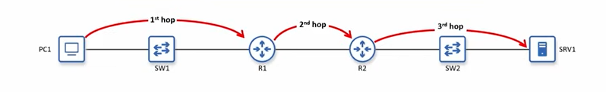
Figure 3: each red arrow is one hop
What is a hop?
A hop is one step along the path between two devices, from a router or host to the next router or host in the path.
Switches do not count as hops. A switch just extends the local network so multiple devices can connect.

Physical layer (Layer 1)
- Sends and receives bits as electrical or optical signals over the medium.
- Defines things like cables, connectors, signal levels and link speeds.
- Examples: copper UTP and fiber optic cables, Wi-Fi and antennas, and the network interface card (NIC).
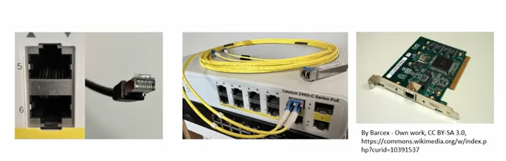
Figure 4: a UTP port and cable, fiber optic cables on a switch, and a network interface card

5. Layer interaction

Adjacent-layer interaction
- Each layer provides a service to the layer above it and is serviced by the layer below it.
- Layer 4 serves Layer 5 by delivering data to the correct application using port numbers.
- Layer 3 serves Layer 4 by delivering segments/datagrams to the correct destination host using IP addresses.
- Layer 2 serves Layer 3 by delivering packets to the next hop using MAC addresses.
- Layer 1 serves Layer 2 by sending and receiving frames as electrical, optical, or radio signals.
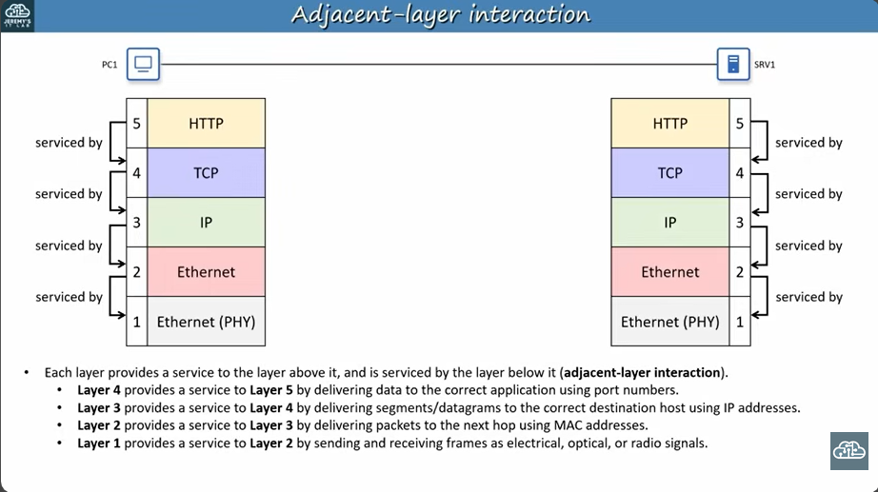
Figure 5: adjacent-layer interaction

Same-layer interaction
- Each layer also communicates with the same layer on the other device.
- The application layer on one host sends data to the application layer on the other.
- A segment/datagram is addressed to the Layer 4 port number of the correct application on the destination host.
- A packet is addressed to the Layer 3 IP address of the destination host.
- A frame is addressed to the Layer 2 MAC address of the next hop.
- Signals sent out of a physical port are received by a physical port on the connected device.
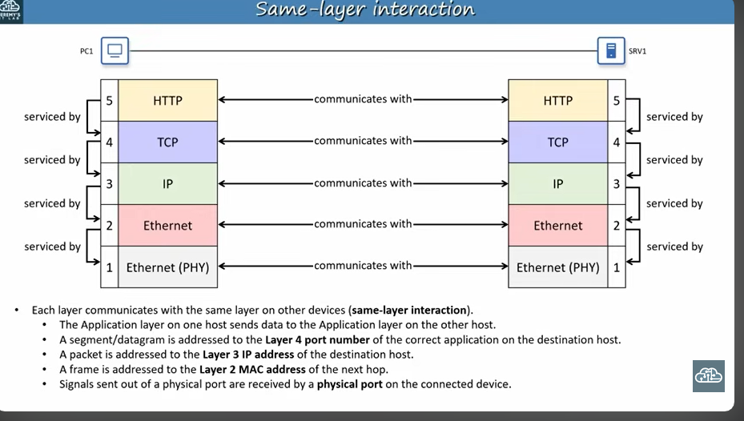
Figure 6: same-layer interaction

6. Encapsulation
To keep it simple, picture a direct connection between PC1 and Server 1. The application layer prepares the data, for example an HTTP request from Chrome on PC1 to the web server on Server 1. As the message moves down the stack, each layer encapsulates the data with a header holding the information that layer needs (source and destination addresses, Layer 4 port numbers, Layer 3 IP addresses, Layer 2 MAC addresses).
Step | Layer | What happens
1 | Application | Prepares the data (for example, the HTTP request).
2 | Transport (L4) | Adds the Layer 4 header with source and destination port numbers and other information.
3 | Internet (L3) | Adds the Layer 3 header with the source and destination IP addresses.
4 | Local network (L2) | Adds a Layer 2 header and a trailer. The trailer lets the receiving device check for transmission errors.
5 | Physical (L1) | Transmits the bits as signals over the physical medium (here, Ethernet cables).
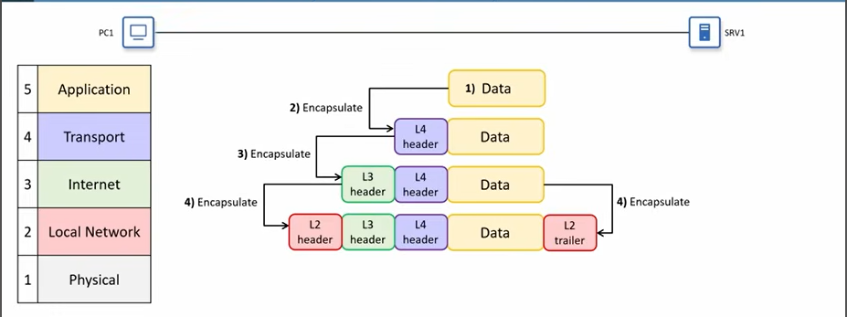
Figure 7: encapsulation from application data down to the Layer 2 trailer

7. Decapsulation
Decapsulation is the encapsulation process in reverse.
- The receiving device gets the message as a stream of bits at Layer 1, which simply passes the bits up. It is up to the higher layers to interpret them.
- The device examines the Layer 2 header and trailer, then removes them. This is called decapsulation.
- The process continues up the stack: Layer 3 removes the Layer 3 header, then Layer 4 removes the Layer 4 header.
- The data is delivered to the application layer, which processes it and, if needed, generates a response. The response goes back down the stack and is transmitted to PC1.
Key rule
Encapsulation goes down the stack, adding a header at each layer (plus a trailer at Layer 2). Decapsulation goes up the stack, removing them.

