OSPF

1. Introduction
In the CCNA, OSPF is topic 3.4 of the exam, which states that you should be able to configure and verify a single-area OSPFv2 network, covering:
- 3.4a — Neighbor adjacencies
- 3.4b — Point-to-point
- 3.4c — Broadcast (DR/BDR selections)
- 3.4d — Router ID
In this document we will cover:
- Basic OSPF operations (introduction)
- OSPF areas
- Basic OSPF configuration
OSPF is a link-state dyna .mic routing protocol. Compared to a distance-vector protocol — which routes “by rumor,” where each router shares information about the routes it knows and their metric cost to reach each destination — OSPF routers don't have a complete map of the network either; they use the information their neighboring routers tell them to determine the best routes to each destination.

2. Basic OSPF Operation
OSPF stands for: Open Shortest Path First
- Uses the Shortest Path First algorithm of Dutch computer scientist Edsger Dijkstra (Dijkstra's algorithm).
- There are three versions of OSPF:
  - OSPFv1 — no longer used
  - OSPFv2 — used in IPv4
  - OSPFv3 — developed for IPv6, but can also be used with IPv4
- Link-state = routers share maps, then calculate the best routes using those maps.

In simple words
- Each router says: "Here are my neighbors and the cost of my links."
- That message = the LSA (Link-State Advertisement).
- All routers send these LSAs to each other.
- Together, they store them in the Link-State Database (LSDB).
- Since every router has the same database, they can all build the same map of the network and calculate the best paths.

LSAs, flooding and the LSDB
- Routers store information about the network in LSAs (Link-State Advertisements), which are organized in a structure called the LSDB (Link-State Database).
- Routers will flood LSAs until all the routers in an OSPF area develop the same map of the network (the LSDB).
- Two important concepts here are flood and area.
- Flooding, in OSPF, means routers send the LSAs to all of their OSPF neighbors.
- Routers will keep flooding LSAs until all routers in the OSPF area have built the same LSDB.

Link and cost
- Link = the physical or logical connection between routers.
- Cost = the value (number) that tells how efficient that link is.
- Routers share this info in LSAs → stored in the LSDB → used to calculate the shortest path.
- The LSDB contains the LSAs for all the different links in the network. Remember: the LSDB is identical on every router within the same OSPF area.
- An OSPF area = a group of routers that share the same database. It helps OSPF scale by dividing a big network into smaller, manageable zones.

Aging timer
- Aging timer = the expiration date of an LSA. It ensures routers always use fresh information.
- Each LSA has an aging timer (30 minutes by default). The LSA will be flooded again after the timer expires.

The three steps of OSPF operation
In OSPF, there are three main steps in the process of sharing LSAs and determining the best routes to each destination in the network:
- Step one: form adjacencies with other routers connected to the same segment.
- Step two: exchange LSAs with neighbor routers.
- Step three: calculate the best routes to each destination and insert them into the routing table.

3. OSPF Areas
OSPF uses areas to divide a network.
- A small network can run as a single area without any negative effect on performance.
- In a large network, a single-area design can have a negative effect. For example, if an OSPF network had 500 routers with over 1000 subnets — instead of just four routers and a few subnets — using a single OSPF area would be a bad idea. You should divide that network into several smaller areas.

Negative effects of using only one area in a larger network
- The SPF algorithm takes more time to calculate the routes.
- SPF requires exponentially more processing power on routers.
- A larger LSDB takes up more memory on routers.
- Any small change on the network causes every router to flood LSAs and run the SPF algorithm again.
By dividing a large OSPF network into several smaller areas, you can avoid the negative effects above.
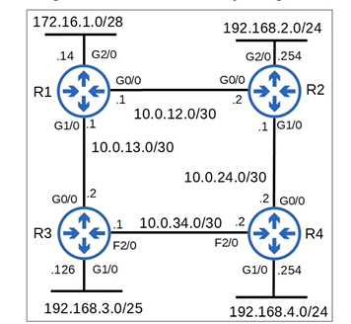

Areas and the backbone (Area 0)
- All interfaces on all routers are assigned to an area. Area 0 is also known as the backbone area.
- An area is a group of routers that share the same Link-State Database (LSDB).
- Area 0 is the backbone area — the central zone that connects all other areas.
- Routers inside one area know the full details of their own area, but only summaries of other areas.
- To communicate between different areas, traffic must pass through Area 0.
- If an area is not connected to Area 0, routers inside that area can talk to each other, but they cannot talk to routers in other areas.
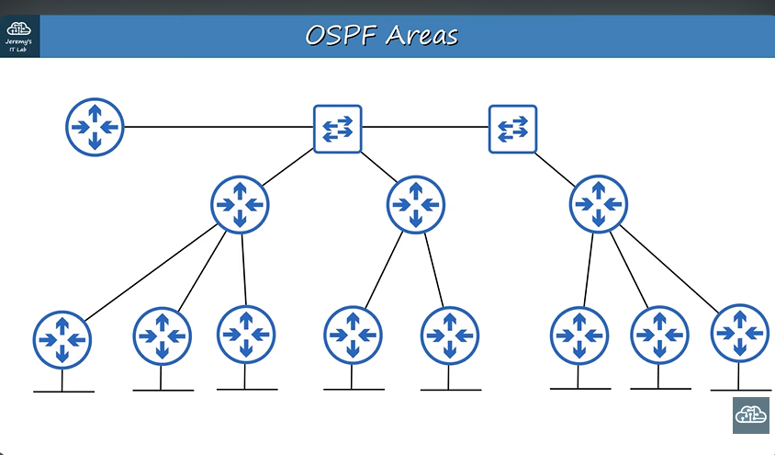
Instead of one large area, a network can be divided into several areas:
- An area is a set of routers and links that share the same LSDB.
- In the diagram below, there are three areas plus one Area 0 (backbone).
- However, that kind of design is not allowed in OSPF, because Area 1 is not connected to Area 0.

Internal routers and Area Border Routers (ABRs)
- Routers with all their interfaces in the same area are called internal routers.
- Routers with interfaces in multiple areas are called Area Border Routers (ABRs).
- An ABR is any router that has one interface in Area 0 (the backbone) and another interface in a different area (like Area 1, Area 2, etc.).
- Because it touches multiple areas, it becomes the border between them.
- It keeps a separate LSDB (map) for each area it belongs to.
- It then summarizes and shares routes between those areas, always through Area 0.

Example
- R2 has one interface in Area 0 and another in Area 1 → R2 is an ABR.
- R3 has one interface in Area 0 and another in Area 2 → R3 is also an ABR.
- Thanks to R2 and R3, routers in Area 1 can reach Area 2, because the ABRs connect them through Area 0.
In short: ABRs are routers that connect Area 0 to another area. They act as bridges, allowing communication between areas.
- ABRs maintain a separate LSDB for each area they are connected to. It is recommended to connect an ABR to a maximum of two areas — connecting an ABR to more than two areas can overburden the router.
- A router connected to the backbone (Area 0) is called a backbone router.
- An intra-area route is a route to a destination inside the same OSPF area, e.g. from a router in Area 1 to a destination that is also in Area 1.
- An inter-area route is a route to a destination in a different OSPF area.
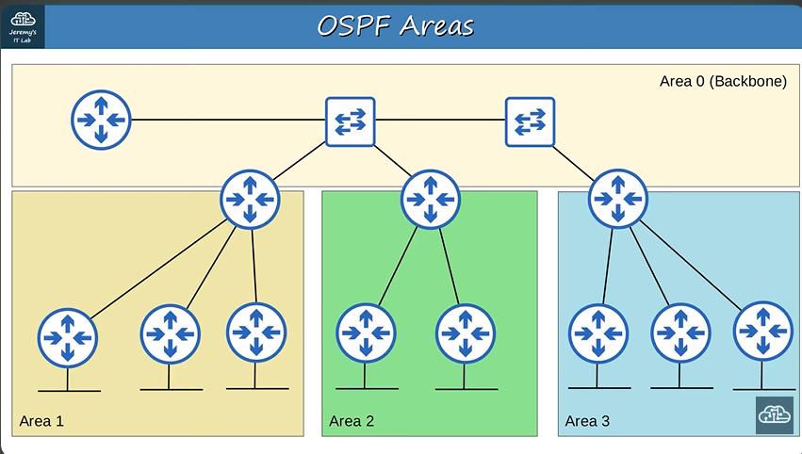

Contiguous vs. non-contiguous areas
OSPF areas should be contiguous. Below is a diagram of a non-contiguous design:
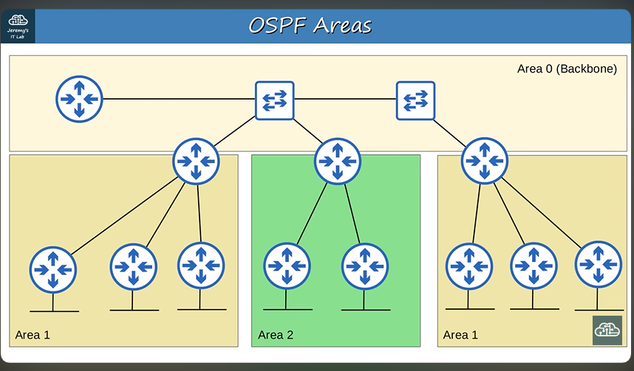
And this is a diagram of a correctly contiguous design:

- Every OSPF area must have at least one ABR connected to Area 0, as shown above: Area 1 has an ABR connected to both Area 1 and Area 0, and Area 0 has ABRs connected to Area 2 and Area 3 as well.
- The earlier (non-contiguous) diagram is not a correct OSPF design and will cause problems, because Area 1 does not have an ABR connected to the backbone area (Area 0).

Same subnet, same area
- OSPF interfaces in the same subnet must be in the same area. If they are not in the same area, they will not become OSPF neighbors and will not exchange information about the network they know.
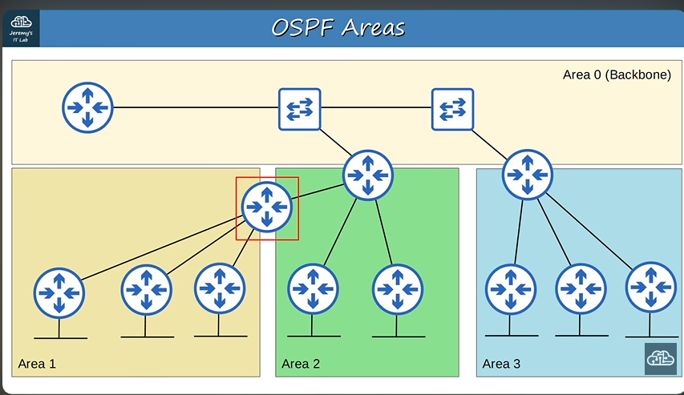
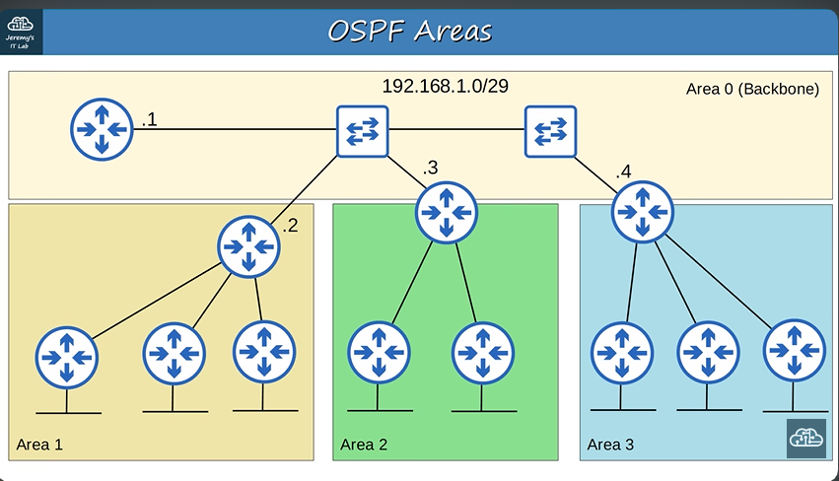
- In this example, three routers all have an interface in Area 0, in the 192.168.1.0/29 subnet. Another router also has an interface in that same 192.168.1.0/29 subnet, but its interface is configured in Area 1, not Area 0.
- Even though all four interfaces are in the same subnet and OSPF is enabled on all of them, the Area 1 router will not become an OSPF neighbor with the others — see the diagram below.
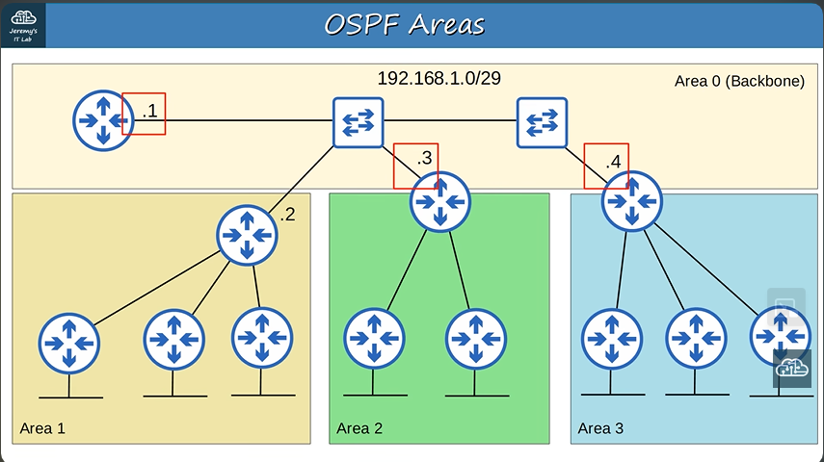
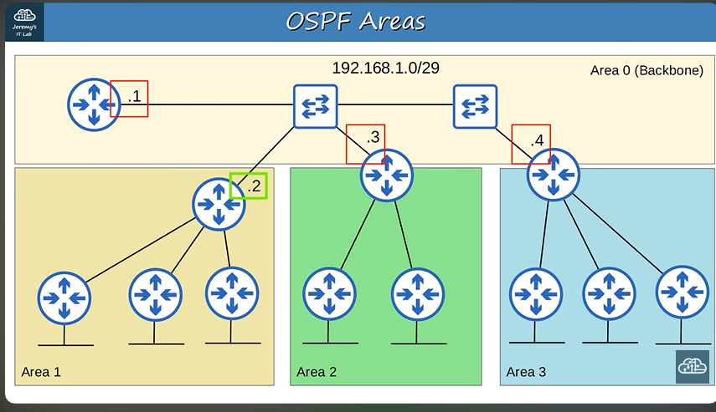
- So the Area 1 router is not considered a neighbor, because the interface connected in the 192.168.1.0/29 subnet is configured inside Area 1 instead of Area 0 — the interface should be in Area 0.
- Below, the Area 1 ABR's interface in the 192.168.1.0 subnet is correctly configured in Area 0.
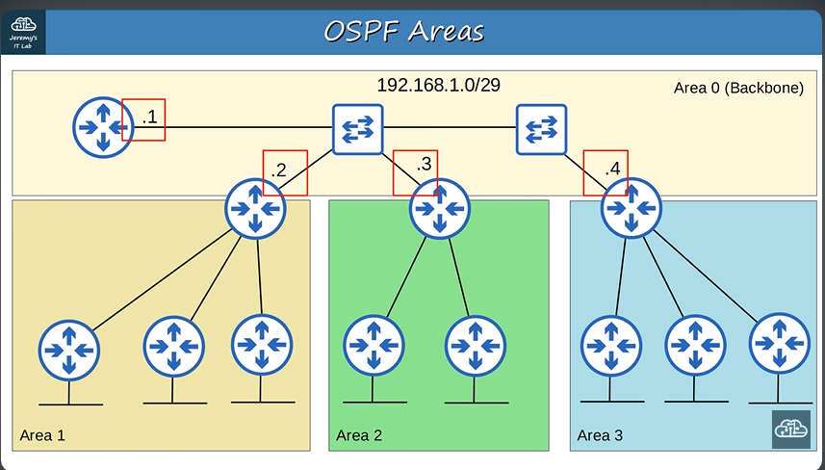
Important:
• All OSPF areas must have at least one ABR connected to the backbone area (Area 0).
• OSPF interfaces in the same subnet must be in the same area.

4. OSPF Configuration
Basic OSPF configuration
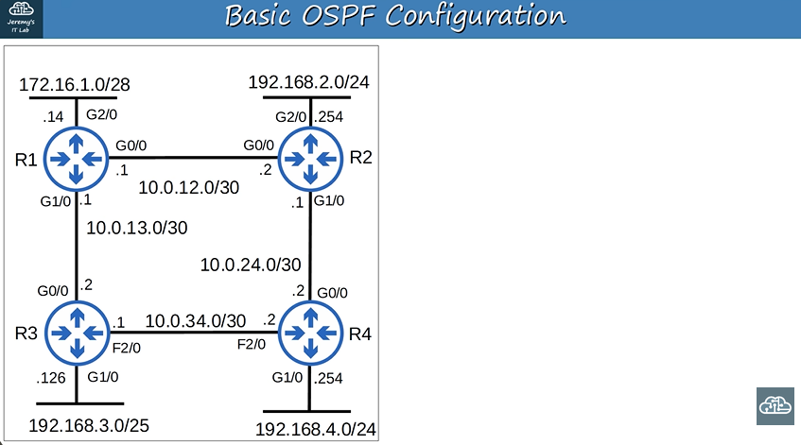
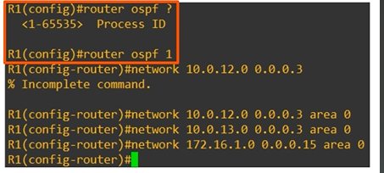
- To enter OSPF configuration mode, use the command: router ospf <process-id>.
- A router can run multiple OSPF processes at once; the process ID is used on the router to identify each one.
The command router ospf <process-id> starts an OSPF process. The process ID is just a local number used to identify it — a router can run multiple OSPF processes, each separate from the others.
Important (CCNA scope):
• For the CCNA, you only need to configure single-area OSPF, and you will usually use Area 0.

