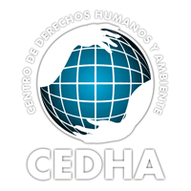

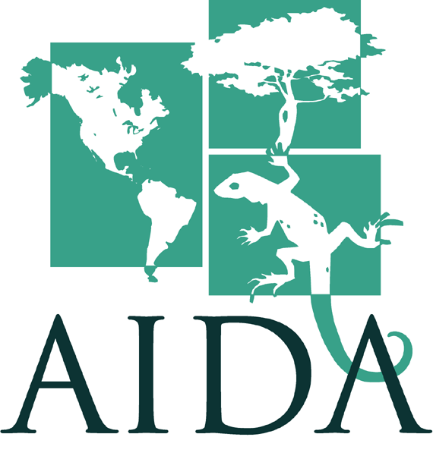

For immediate release 4/24/07

CONTACTS:

Astrid Puentes, AIDA (+5255) 52120141 Martin Wagner, Earthjustice (510) 550-6700
apuentes@aida-americas.org mwagner@earthjustice.org

Carlos Chirinos (+511) 422-2720
cchirinos@spda.org.pe

U.S. SMELTER’S POLLUTION NOW HUMAN RIGHTS ISSUE FOR PERU

IACHR to Examine Peru’s Responsibility for Contamination from Doe Run Corp. Facility

April 24, 2007, WASHINGTON DC, LIMA – The Inter-American Commission on Human Rights (a division of the Organization of American States) forwarded a petition alleging human rights violations to the Government of Peru, giving them two months to respond. The petition asserts that severe contamination from a smelter owned by U.S.-based Doe Run Corporation, and lack of effective pollution and human health controls by the government, gravely threaten the rights of the residents of La Oroya, Peru, including their rights to life, health, and integrity.

“This first step by the IACHR is good news,” assured Carlos Chirinos, an attorney with the Peruvian Society for Environmental Defense (SPDA), an organization that has been associated with the case since its inception, and one of the lawyers representing the community. “It shows the strength of our petition, and is a positive step in the process to identify the government’s responsibilities.”

The IACHR determined that the petition, prepared by Earthjustice, the Interamerican Association for Environmental Defense (AIDA), the Center for Human Rights and Environment (CEDHA), and Peruvian lawyer, Carlos Chirinos, met the Commission’s procedural requirements and forwarded it to the Peruvian government last week. According to the Commission’s rules, after this two-month period the IACHR will take into account Peru’s comments in evaluating the admissibility of the case, determining whether the contamination violates human rights, and the resulting responsibilities of the Peruvian government.

The Commission is simultaneously evaluating a request by these groups for precautionary measures to address the urgent health threats to the citizens in La Oroya. “We are now waiting for the government’s comments on the petition, as well as a decision by the Commission on the request for precautionary measures. These measures could help considerably to provide effective protection for the people’s human rights in La Oroya,” added Astrid Puentes of AIDA.

The precautionary measures requested include: adequate diagnosis and medical treatment for the persons represented, education programs and efficient access to information, effective emissions and contamination controls, an evaluation of contamination in key areas of the city, and implementation of adequate clean-up measures. According to Martin Wagner of Earthjustice, the goal of the precautionary measures is “to improve human rights conditions for the people we represent in La Oroya, and ensure that those responsible take definitive action to control the contamination.”

For more information visit our website: www.aida-americas.org

