**Tools:**

* VS2013
* .NET 4, MVC5
* IoC with Autofac
* VisualStudio Test & Moq
* Swashbuckle (<https://www.nuget.org/packages/Swashbuckle> )
* Log4Net

**Solution Structure:**

* Movies.Core : this project contains the MoviesService that can be consume directly from a web controller.
* Movies.Data
* Movies.Entities
* Movies.IntegrationTests
* Movies.Utility
* Movies.WebApi: not necessary for the requirement of this test but this is just a showcase of how we can expose the movie service via a WebApi with Autofac IoC and Swagger. Swagger allows you to explore the Api documentation and test it out right on the browser..

**Highlights:**

* Logging: logging is a essential for production code.

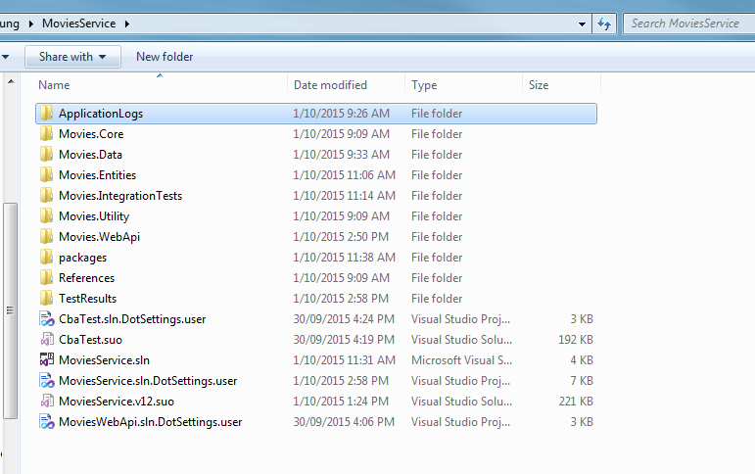

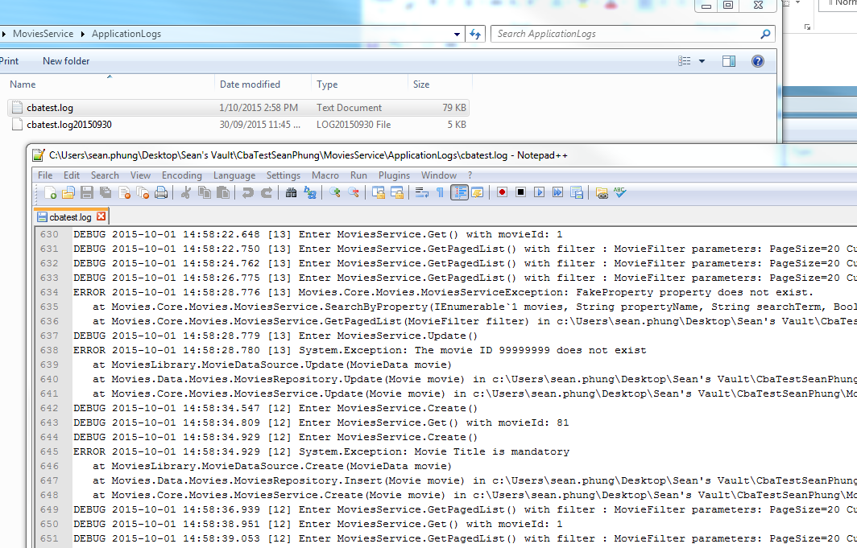

* Code coverage:
* Integration/unit tests & code coverage

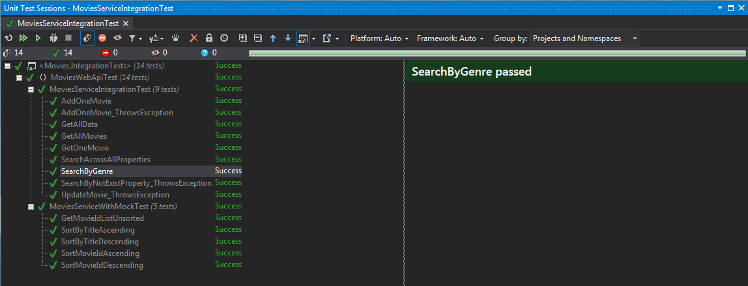

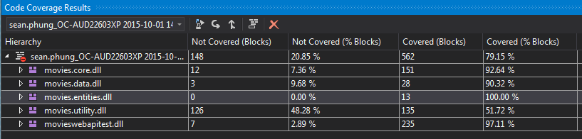

* Web API :

