Distributions of (Simplified) Answer Types at T1 and T2
Thomas Miller
2026-03-26

Distribution of simplified response types at T1, by Condition.
Note: All midpoint types collapsed to value 3
## Filter 1:
## Filter 2:
##
## Rows: Condition | Columns: pre_simple
## # A tibble: 4 × 7
## Condition `1` `2` `3` `4` `5` Sum
## <chr> <int> <int> <int> <int> <int> <dbl>
## 1 1 75 165 113 309 304 966
## 2 2 66 164 112 337 315 994
## 3 3 45 123 90 348 248 854
## 4 Sum 186 452 315 994 867 2814
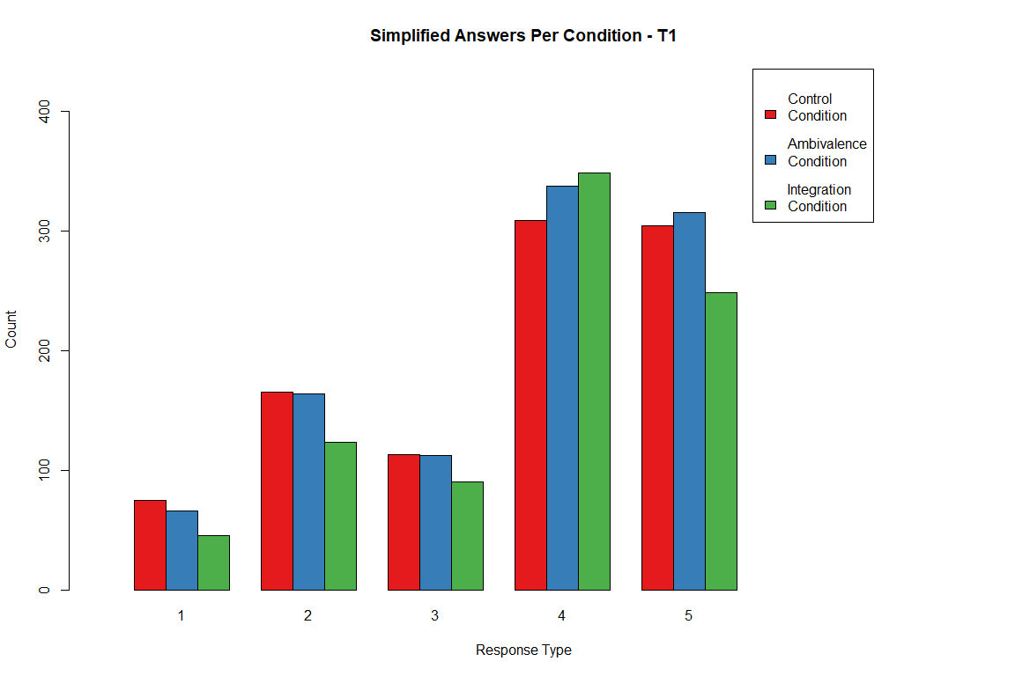
Given that there is imbalance in the number of participants per condition, look at proportions as well.
Note: in the table, proportions sum to 1.00 row-wise.
## Filter 1:
## Filter 2:
##
## Rows: Condition | Columns: pre_simple
## # A tibble: 3 × 6
## # Groups: Condition [3]
## Condition `1` `2` `3` `4` `5`
## <chr> <dbl> <dbl> <dbl> <dbl> <dbl>
## 1 1 0.08 0.17 0.12 0.32 0.31
## 2 2 0.07 0.16 0.11 0.34 0.32
## 3 3 0.05 0.14 0.11 0.41 0.29
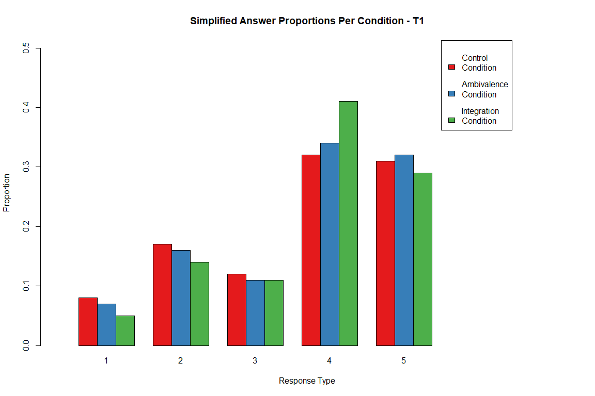

Distribution of simplified response types at T2, by Condition.
Note: All midpoint types collapsed to value 3
## Filter 1:
## Filter 2:
##
## Rows: Condition | Columns: post_simple
## # A tibble: 4 × 7
## Condition `1` `2` `3` `4` `5` Sum
## <chr> <int> <int> <int> <int> <int> <dbl>
## 1 1 58 177 101 346 284 966
## 2 2 60 158 97 336 343 994
## 3 3 41 119 88 351 255 854
## 4 Sum 159 454 286 1033 882 2814
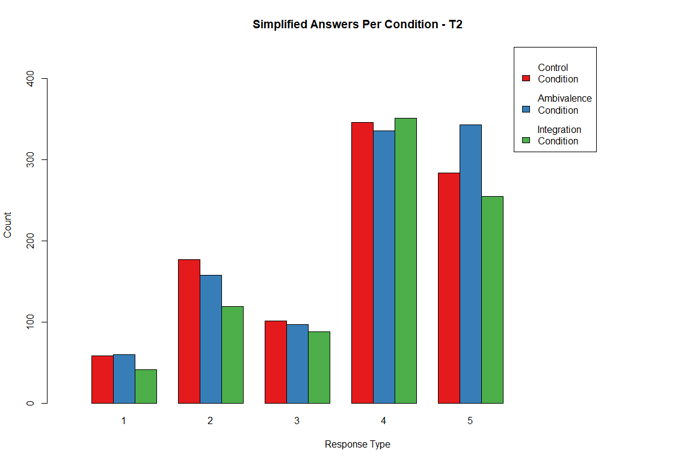
Given that there is imbalance in the number of participants per condition,look at proportions as well.
Note: in the table, proportions sum to 1.00 row-wise.
## Filter 1:
## Filter 2:
##
## Rows: Condition | Columns: post_simple
## # A tibble: 3 × 6
## # Groups: Condition [3]
## Condition `1` `2` `3` `4` `5`
## <chr> <dbl> <dbl> <dbl> <dbl> <dbl>
## 1 1 0.06 0.18 0.1 0.36 0.29
## 2 2 0.06 0.16 0.1 0.34 0.35
## 3 3 0.05 0.14 0.1 0.41 0.3
