Completed tasks and working time:

* ER diagram (completed by Sofia Altusar-Anderson, working time: 40 min)
* Relational schemas (completed by Sofia Altusar-Anderson, working time: 10 min)
* BCNF validation (completed by Sofia Altusar-Anderson, working time: 10 min)
* Repository (completed by Sofia Altusar-Anderson, working time: 40 min)

**ER DIAGRAM**

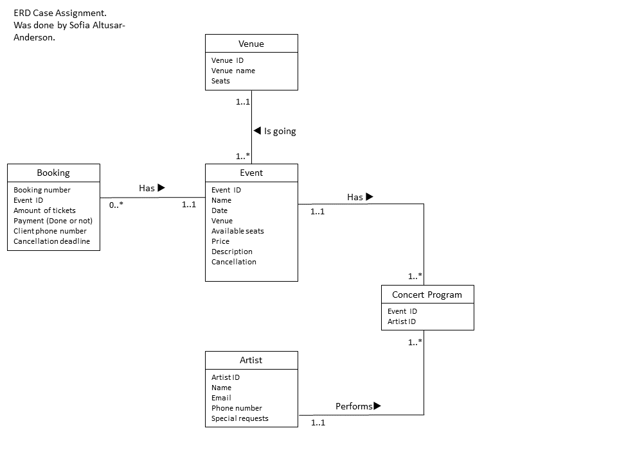

**RELATIONAL SCHEMAS**

Venue (venueID, venueName, seats)

Event (eventID, eventName, date, venue, availableSeats, price, description, cancellation)

FK venue REF Venue(venueID)

Artist(artistID, artistName, artistPhone, artistEmail, preferences)

ConcertProgram(eventID, artistID)

FK eventID REF Event(eventID)

FK artistID REF Artist (artistID)

Booking (bookingNumber, eventID, tickets, completedPayment, cancellationDeadline)

FK eventID REF Event(eventID)

*All schemas are BCNF.*

**REPOSITORY**

ENTITY TYPE DESCRIPTIONS

| ENTITY TYPE | Description | Synonyms, aliases | Occurence |
| --- | --- | --- | --- |
| Venue | A venue for events that belongs to Cardiff festival association. | Concert hall, auditorium. | Currently there are 2 venues but probably in future other venues will be available. |
| Event | An event that is organized by Cardiff festival association. | Concert, performance. | Events are organized all year round. |
| Artist | An artist who is performing in events that are organized by Cardiff festival association. | Singer, actor, dancer, showman, celebrity. | There is at least one artist performing in each event. |
| Concert Program | Program of an event. Contents an information about artists who are performing. | Performance, agenda. | There is a concert program for each event. |
| Booking | A record of booking for the event. | Reservaation. | Amount of booking records is limited by number of events per year and by number of places in venue for the event. |

ATTRIBUTE TYPE DESCRIPTIONS

1. Venue

| Attribute type | Description | Data type | Value required | Indentity attribute or part of it | Special domain |
| --- | --- | --- | --- | --- | --- |
| Venue Name | The name of a venue | Text | Yes | Yes | - |
| Seats | Total amount of seats in the venue | Integer | Yes | - | - |

2. Event

| Attribute type | Description | Data type | Value required | Identity attribute or part of it | Special domain |
| --- | --- | --- | --- | --- | --- |
| Name | Name of the event | Text | Yes | - | - |
| Date | Date when the event organized | Date | Yes | - | - |
| Venue | The place where concert is | Name | Yes | - | - |
| Available seats | Amount of available seats |  | Yes | - | >0 |
| Price | Price for the event | Float | Yes | - | >0 |
| Description | Description of the event, what kind of performance will be there | Text | Yes | - | - |
| Cancellation | A status that let us know whether event cancelled or not. | Boolean | Yes | - | True or false |

3. Artist

| Attribute type | Description | Data type | Value required | Identity attribute or part of it | Special domain |
| --- | --- | --- | --- | --- | --- |
| Name | Name of an artist | Text | Yes | - | - |
| Email | Email of an artist | Text | Yes | - | Valid email format |
| Phone number | Contant phone number of an artist | Integer | Yes | - | - |
| Special requests | Special recuest of an artist for catering and refreshments | Text | No | - | - |

4. Concert Program.

| Attribute type | Description | Data type | Value required | Identity attribute or part of it | Special domain |
| --- | --- | --- | --- | --- | --- |
| Event ID | ID of an event | Integer | Yes | Yes | - |
| Artist ID | Id of an artist who is performing on an event | Integer | Yes | Yes | - |

5. Booking

| Attribute type | Description | Data type | Value required | Identity attribute or part of it | Special domain |
| --- | --- | --- | --- | --- | --- |
| Event ID | ID of an event | Integer | Yes | - | - |
| Amount of tickets | How many tickets are reserved. | Integer | Yes | - | >0 |
| Completed payment | Status of payment. Whether it was done or not. | Boolean | Yes | - | True or false |
| Client’s phone number | Phone number of a person that makes booking. | Integer | Yes | - | - |
| Cancellation deadline | A deadline when a booking will be cancelled if customer did not pay for tickets. | Date | Yes | - | the date of booking + 3 days |

TABLE DESCRIPTIONS

1. Venue

| Attribute type | Description | Data type | Value required | Keys | Special domain |
| --- | --- | --- | --- | --- | --- |
| Venue id | Unique venue identifier | INTEGER | Yes | PRIMARY KEY (surrogate key) | Autonumber column |
| Venue Name | The name of a venue | VARCHAR (50) | Yes | - | - |
| Seats | Total amount of seats in the venue | INNTEGER | Yes | - | - |

2. Event

| Attribute type | Description | Data type | Value required | Keys | Special domain |
| --- | --- | --- | --- | --- | --- |
| Event ID | Unique event identifier | INTEGER | YES | PRIMARY KEY  (surrogate key) | Autonumber column |
| Name | Name of the event | Text | Yes | - | - |
| Date | Date when the event organized | Date | Yes | - | Valid time format: :mm. |
| Venue ID | The place where concert is | INTEGER | Yes | FOREIGN KEY 1 => Venue | - |
| Available seats | Amount of available seats | INTEGER | Yes | - | >0 |
| Price | Price for the event | FLOAT | Yes | - | >0 |
| Description | Description of the event | VARCHAR (150) | - | - | - |
| Cancellation | Whether event is cancelled or not | BOOLEAN | Yes | - | True or False |

3. Artist

| Attribute type | Description | Data type | Value required | Keys | Special domain |
| --- | --- | --- | --- | --- | --- |
| Artists ID | Unique artist identifier | INTEGER | YES | PRIMARY KEY  (surrogate key) | Autonumber column |
| Name | Name of an artist | VARCHAR (50) | Yes | - | - |
| Email | Email of an artist | VARCHAR (50) | Yes | - | - |
| Phone number | Contant phone number of an artist | VARCHAR (15) | Yes | - | - |
| Special requests | Special recuest of an artist for catering and refreshments | VARCHAR (180) | - | - | - |

4. Concert Program.

| Attribute type | Description | Data type | Value required | Keys | Special domain |
| --- | --- | --- | --- | --- | --- |
| Event ID | ID of an event | Integer | Yes | IN PRIMARY KEY  FOREIGN KEY 1  => Event | - |
| Artist ID | Id of an artisr who is performing on an event | Integer | Yes | IN PRIMARY KEY  FOREIGN KEY 2  => Artist | - |

5. Booking

| Attribute type | Description | Data type | Value required | Keys | Special domain |
| --- | --- | --- | --- | --- | --- |
| Booking Number | Unique booking number | INTEGER | Yes | PRIMARY KEY  (surrogate key) | Autonumber column |
| Event ID | ID of an event | INTEGER | Yes | FOREIGN KEY 1 => Event | - |
| Amount of tickets | How many tickets are reserved. | INTEGER | Yes | - | >0 |
| Payment | Status of payment. Whether it was done or not. | BOOLEAN | Yes | - | True or False |
| Client phone number | Phone number of a person that makes booking. | INTEGER | Yes | - | - |
| Cancellation deadline | A deadline when a booking will be cancelled if customer did not pay for tickets. | DATE | Yes | - | Valid time format: dd.mm.yyyy, the date of booking + 3 days |