LAB 8
8.1: UML DEPLOYMENT DIAGRAM
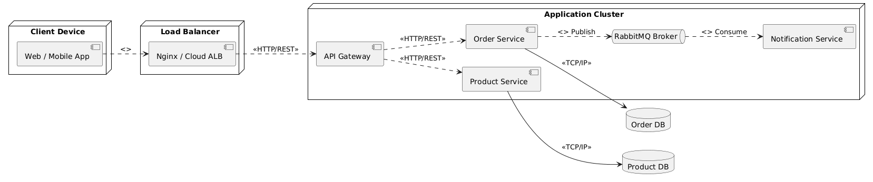
8.2: QUALITY ANALYSIS (SIMPLIFIED ATAM)
Objective:
Evaluate key architectural design decisions against specific quality attribute scenarios to uncover system risks and sensitivity points.
Step 1: Scenario Formulations
- Scenario SS1 (Scalability): Traffic and concurrent order processing volume surge 5x during peak dining hours, while catalog browsing activities remain completely stable.
- Scenario AS1 (Availability): The external third-party Email/SMS gateway API experiences an outage, causing the notification module to crash or hang indefinitely.
Step 2: ATAM Evaluation and Comparison Table
Quality Attribute | Scenario | Monolithic Architecture (Layered) | Microservices Architecture
Scalability | SS1: Peak load on order processing increases by 5x while menu catalog browsing remains stable. | The entire monolithic application must be duplicated across servers (scaled out) even though only the order component is under stress. This causes significant waste of server hardware resources such as RAM and CPU, resulting in high infrastructure costs. | The system can scale up or spin up multiple instances of the Order Service independently. The Product and User services remain at baseline capacity. This achieves precise resource allocation, high cost efficiency, and optimal hardware utilization.
Availability | AS1: The third-party API fails, causing the notification component to crash or freeze. | The thread pool handling notifications can become exhausted or stuck. This blocking behavior quickly propagates through the shared memory, risking a memory leak or a total server crash. The entire system goes down, preventing users from viewing the menu or placing orders. | The Notification Service crashes in isolation, but the API Gateway and Order Service remain fully operational. Customers can still place orders normally. The transaction events are securely buffered in the RabbitMQ queue and processed automatically once the Notification Service recovers.
Step 3: Architectural Trade-off Statement
Microservices Strengths:
The architecture provides exceptional localized scalability, allowing the system to handle sudden traffic spikes on specific features without inflating infrastructure costs. It provides high fault isolation, which guarantees that an edge-case failure in a non-critical module (like notifications) cannot cause a cascading failure across core business workflows (like order placement).
Microservices Weaknesses and Trade-offs:
Adopting this architecture drastically increases operational and deployment complexity, requiring container orchestration, service discovery, and advanced monitoring systems. Network communication across distinct services introduces cross-network latency compared to in-memory function calls. Furthermore, maintaining transactional data consistency across isolated, distributed databases becomes highly complex, requiring asynchronous event-driven synchronization or eventual consistency patterns.

