We highly appreciate all reviewers’ comments.

# How to evaluate results. Compare with native TV GUI (R2Q1, R1Q3)

Better effect is determined by more reasonable GUI layout from experienced developers in user study and more similar to ground truth’s layout in automated evaluation.
In the user study, participants subjectively rate the generated TV GUI based on their own GUI development experience and ground truth (corresponding redesigned TV GUIs).
In the automated evaluation, we compare the objective similarity between the generated GUI and the ground truth.

Figure 1 shows results of one case in our experiment. ‘GUI on the TV’ is the re-designed native TV GUI. ‘Approach B’ is the result of our tool. Compared with approach A, the result of our tool without the black edge is more suitable for TV. Although approach C is adapted to the size of TV, the size of UI component in it is very strange, which affects the user experience. So, the result of our tool is more suitable for TV. In addition, the layout of TV GUI generated by us is closer to that of the ground truth (‘GUI on the TV’), and mIOU is higher. Therefore, our results are considered to have better effects both subjectively and objectively.

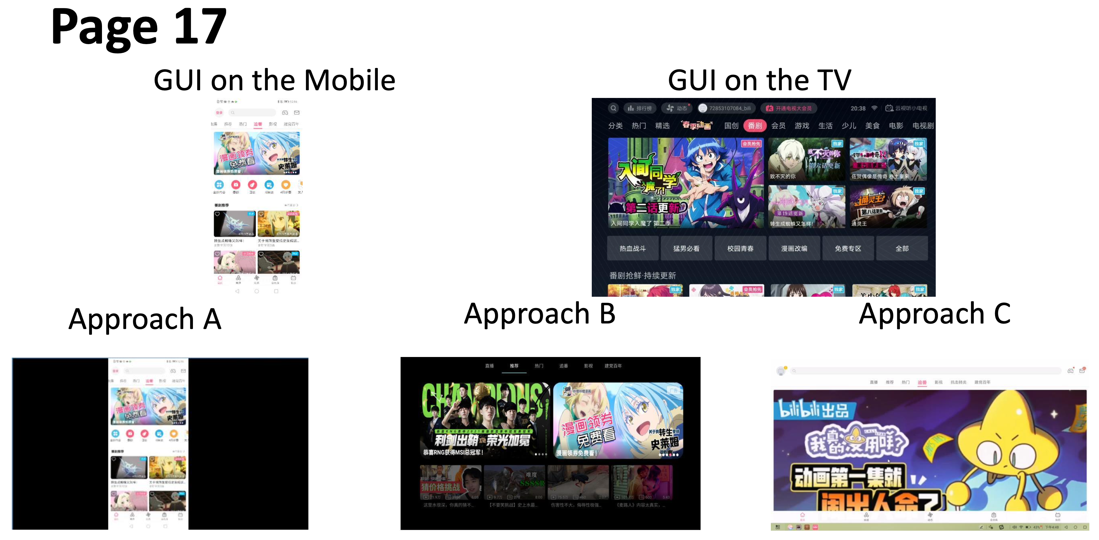
Figure 1

We tried to compare the results generated by us and baselines with the native TV GUI, but we found that the native TV GUI had been re-optimized and redesigned, so each example is better than ours and baselines', making the comparison meaningless. Finally, we take the native and redesigned TV GUI as the ground truth of the experiment.

# Threats of the usefulness evaluation (R2Q2)

We strongly agree with the use of qualitative analysis to explore the usefulness of our tool, which we did in our study.
It is inappropriate to only evaluate the usefulness of the tool quantitatively, so we used both quantitative and qualitative analysis.

Due to the huge efforts of carrying out large scale user study, we just invited 3 participants in the experimental group to evaluate the usefulness of our tool.
The major threat to this user study is the potential bias that experimental and control participants differ in their ability to develop GUI.
To mitigate the threat, all participants invited are GUI development experts.
The GUI tasks we assigned to each group are in areas they are familiar with to ensure each group has comparable development experience.
Another threat is that users may be subjectively biased in their evaluation of the tool. So, we have 3 participants in each group to evaluate the tool quantitatively and qualitatively.
They will not only use our tools to complete the user study task, but also communicate with us about the use of tools and give effective feedback.
Expert feedback on tools is obviously more professional and valuable.
In section 5.2 of our paper, we included one item of feedback from one participant.
Other participants also give positive feedback about our tool: ‘the tool gives us a very good GUI template and eases the work burden’, ‘This tool would be very welcome if it could be built into Android Studio as a plug-in for Android app development’.
Our tool inspires developers and saves them time, so all the developers in the experimental group think our tool is useful.
So, in the study, we proved the usefulness of our tool using both quantitative (the time it took participants to complete the task) and qualitative methods (the subjective satisfaction score and comments of experienced developers on the tool). Although the number of participants in experimental group is not very large, but the results are valuable and effective.

# Main treats to validity (R2Q3)
There are some issues that may influence the validity of our work, including internal and external validity.
The major threat to internal validity is that a potentially small number of GUIs are difficult to classify, and therefore difficult to convert appropriately according to the GUI category.
It's hard to categorize because there are some third-party designed GUIs, some company - and device-specific GUIs. They are different from mainstream GUIs.
In addition, we have already discussed this problem in Section 4.4. Current data collection tools (UI Automator) cannot accurately obtain metadata of some third-party GUI and WebView views, which further makes it difficult to classify.
To mitigate the validity, we use Grid Layout as the default template to map these unrecognized GUI groups, which can be seen in Table 1.
Grid Layout templates are card-like layout, which is widely used in current TV GUI.
It can ensure that the information of mobile phone is not lost after mapping and basically meet the user experience.
The major threat to external validity is fragmentation of Android devices. The screen, OS version, and UI styles of Android devices are markedly different and difficult to unify.
To mitigate this issue, we design language- and platform-free GUI DSL for code synthesis.
The DSL compiler pre-installed on the relevant TV converts the DSL into the TV version of the GUI based on the TV's properties.

# Public tool or dataset (R3Q1)
We will share our tools and core algorithm code when our papers are accepted.

# Tool implementation details (R1Q1, R1Q2)
We explain how we implement the tool in section 3.5.
We pre-install a DSL compiler in the TV devices.
The compiler will generate new TV GUIs according to received DSL.
Our tool is for software developers, so developers can customize mobile input to the TV version of input during development.
Please note that our work is currently only looking at apps, not games.

