

**ALTEK COMPANY PTE. LTD**

**AAS SOLUTION PLC**

**<PROJECT NAME>**

**AUTHENTICATION AUTHORIZATION SYSTEM**

**Project Code: AAS**

**Document Number: v0.1.4**

**<Ho Chi Minh, 06/2022>**

|  |  |
| --- | --- |
|  | **SYSTEM REQUIREMENT SPECIFICATION** |

**REQUIREMENT INFORMATION:**

Requestor: …………………… Deparment: Product Management

Mobile, fax: …………………… Email: ………………………………

Start Time: ………………….. .. Finish Time Proposal: ………………

Type: 🞏 New 🞏 Upgrade

Priority: 🞏 Urgent 🞏 Normal

* + 1. **Project Information**
  1. ***Project Name:*** *…………………*
  2. ***Partner Name:*** *………….*
  3. ***Project Code:*** *………*
     1. **Overview**
  4. ***Current Status***

* 1. ***Proposal:*** 
     1. **Approval Information**

|  |  |  |
| --- | --- | --- |
| **REQUESTOR** | **REVIEWER** | **APPROVER** |

**Link Jira: ……………….**

**REVISE HISTORY**

*A – Create New, M – Edit, D – Delete

|  |  |  |  |  |  |  |
| --- | --- | --- | --- | --- | --- | --- |
| **Date** | **Change** | **A, M, D** | **Original** | **Old Version** | **Description change** | **New Version** |
|  |  |  |  |  |  |  |
|  |  |  |  |  |  |  |
|  |  |  |  |  |  |  |
|  |  |  |  |  |  |  |
|  |  |  |  |  |  |  |
|  |  |  |  |  |  |  |
|  |  |  |  |  |  |  |
|  |  |  |  |  |  |  |
|  |  |  |  |  |  |  |
|  |  |  |  |  |  |  |
|  |  |  |  |  |  |  |
|  |  |  |  |  |  |  |

**Content**

AUTHENTICATION AUTHORIZATION SYSTEM 1

SYSTEM REQUIREMENT SPECIFICATION 3

REVISE HISTORY 4

1. INTRODUCTION 10

**1.1 Purpose 10**

**1.2 Scope 10**

**1.3. Definitions, Acronyms, and Abbreviations 10**

**1.4 Reference 11**

2. SYSTEM OVERVIEW 12

**2.1 Problem Statement 12**

**2.2 Purpose of system 12**

**2.3 Scope of system 12**

**2.3.1 Use case 12**

**2.3.2 Function 14**

**2.3.3 Overall model 16**

**2.3.4 System Authorization Table 16**

3. SPECIFIC REQUIREMENTS 16

**3.1 Login 17**

**3.1.1 Login information 17**

**3.1.2 Login Screen 18**

**3.1.3 Business Flow Chart 19**

**3.1.4 Detail description of the business flow 20**

**3.1.5 Function Affected 20**

**3.2 Manage project 20**

**3.2.1 General description 20**

**3.2.2 Manage Project Screen 21**

**3.2.3 Business Flow Chart 23**

**3.2.4 Detail description of the business flow 25**

**3.2.5 Function Affected 26**

**3.3 Create Account 26**

**3.3.1 General description 26**

**3.3.2 Create Account Screen 27**

**3.3.3 Business Flow Chart 29**

**3.3.4 Detail description of the business flow 29**

**3.3.5 Function Affected 30**

**3.4 Manage permission 30**

**3.4.1 General description 30**

**3.4.2 Manage Permission Screen 31**

**3.4.3 Business Flow Chart 33**

**3.4.4 Detail description of the business flow 35**

**3.4.5 Function Affected 37**

**3.5 Manage Role 37**

**3.5.1 General description 37**

**3.5.2 Manage Role Screen 38**

**3.5.3 Business Flow Chart 41**

**3.5.4 Detail description of the business flow 42**

**3.5.5 Function Affected 44**

**3.6 Manage Component 44**

**3.6.1 General description 44**

**3.6.2 Manage Component Screen 45**

**3.6.3 Business Flow Chart 48**

**3.6.4 Detail description of the business flow 49**

**3.6.5 Function Affected 51**

**3.7 Manage Menu 51**

**3.7.1 General description 51**

**3.7.2 Manage Menu Screen 52**

**3.7.3 Business Flow Chart 55**

**3.7.4 Detail description of the business flow 55**

**3.7.5 Function Affected 58**

**3.8 Manage Profile 58**

**3.8.1 General description 58**

**3.8.2 Manage Profile Screen 59**

**3.8.3 Business Flow Chart 62**

**3.8.4 Detail description of the business flow 63**

**3.8.5 Function Affected 66**

4 Non-Functional Requirements 67

**4.1 Performance Requirements 67**

**4.2 Safety Requirements 67**

**4.3 Privacy Requirements 67**

**4.4 Software Quality Requirements 67**

5 Appendix 67

# INTRODUCTION

## Purpose

The Authentication and Authorization System will:

* Authentication check the identity of an account entering the current system through an authentication system
* Authorization gives you full access to resources like information, files, databases, funds, enclosures, most everything facilitating a common understanding of functional requirements for all stakeholders.
* Authorization is the process to confirm whether authenticated customers have access to specific resources in detail. It commits your rights to grant you access to resources such as information, databases, files, etc. Authorization is usually given after authentication confirms your exclusive rights for deployment.

## Scope

This section covers:

* Identify the module AAS.
* Explain the scope of the module AAS that will meet (and will not meet, if necessary) the same benefits, results and objectives as accurately as possible.
* Recording conditions for acceptance and handling plans when conflicts arise.

## 1.3. Definitions, Acronyms, and Abbreviations

Provide the definitions of all terms, acronyms, and abbreviations required to properly interpret the SRS. This information maybe provided by reference to one or more appendices in the SRS or by reference to documents. This information maybe provided by reference to an Appendix*.*

|  |  |
| --- | --- |
| Abbreviations | Detail |
| SRS | System Requirement Specification |
| AAS | Authentication Authorization System |
| BR | Business Rule |
| N/A | Not Applicable or Not Available |
| …… | ………………… |

## Reference

In this subsection:

(1) Provide a complete list of all documents referenced elsewhere in the SRS

(2) Identify each document by title, report number (if applicable), date, and publishing organization

1. Specify the sources from which the references can be obtained.

This information can be provided by reference to an appendix or to another document.

# SYSTEM OVERVIEW

## Problem Statement

* Briefly state the cause and content of the problem to be done
* Based on the requirements of product owner as well as the actual survey status to come up with all the problems that need to be solved
* The problem stated here often arises from a certain management/business need in reality of the user and the problem is set out to hope that if the software is built, it will solve that problem.

## Purpose of system

## Scope of system

### Use case

Example:

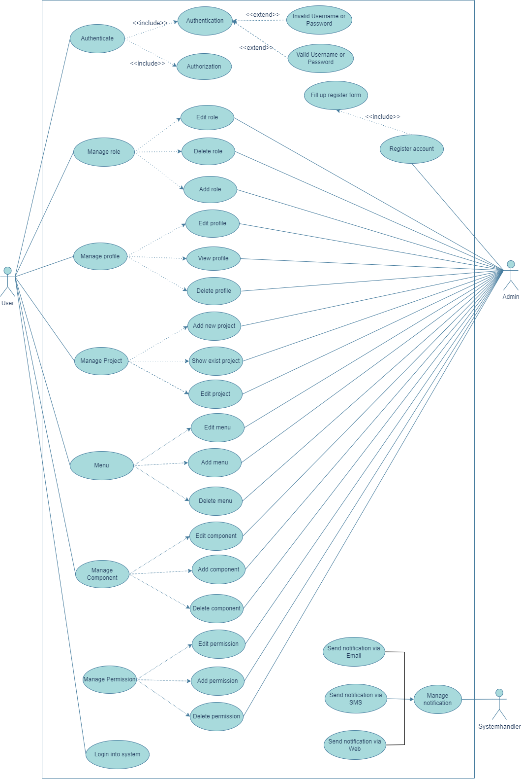

### Function

* + - 1. *Function List*

Example:

| No | Function Name | Fuction Code | Description |
| --- | --- | --- | --- |
|  | Login into system | SRS-01 | Allow login to the system and register account |
|  | Authenticate | SRS-02 | Include authentication and authorization |
|  | Manage Project | SRS-03 | Divided into 2 roles: Admin and User  -Admin: can Add/Edit/Delete project, change status of the project or choose project that has been created before  -User: can only see project that has been created before |
|  | Manage Profile | SRS-04 | Allow to View/Edit/Delete Profile |
|  | Manage Role | SRS-05 | Allow to Delete/Edit/Add Role |
|  | Manage Permission | SRS-06 | Allow to Add/Delete/Edit permission |
|  | Manage Component | SRS-07 | Allow to Add/Edit/Delete component |
|  | Menu | SRS-08 | It has Sub menu (Sub menu also contains components), allow to Add/Edit/Delete menu |

* + - 1. *Functional Hierarchy*

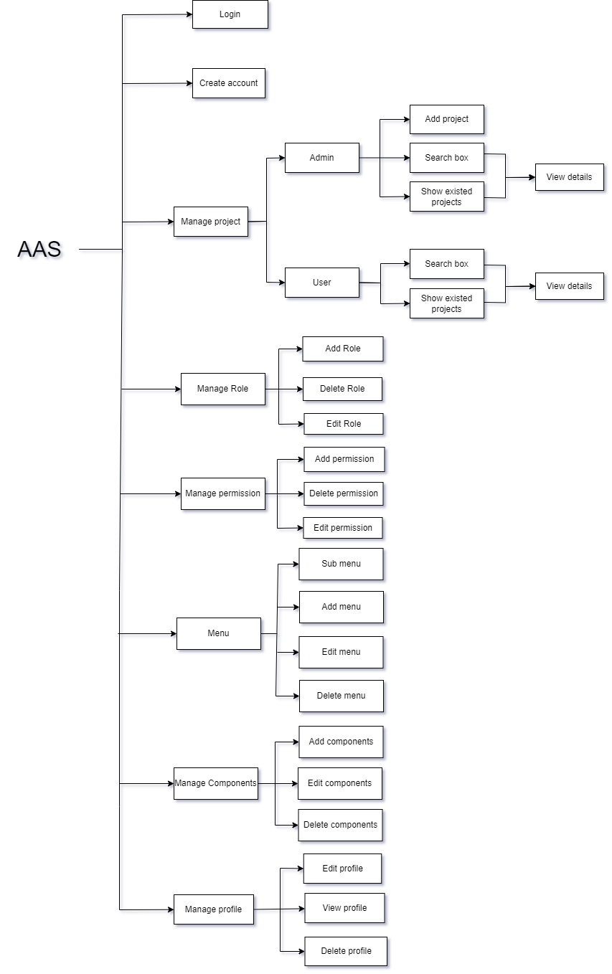

### Overall model

* + - 1. *Business Process Model*

Example:

* + - 1. *Entity Relationship Model (If any)*

Example

* + - 1. *State Transition Model (If any)*

N/A

### System Authorization Table

Example:

|  |  |  |  |
| --- | --- | --- | --- |
| **System** | **Role** | **Description** | **Screen** |
| Document System | Root | Allows access on all system functions | * System configuration * Records management * Report |
| Admin | Allows access on all system functions | * System configuration * Records management * Report |
| User | Allows access on some system functions | * Report |

# SPECIFIC REQUIREMENTS

This section contains all the software requirements at a level of detail sufficient to enable designers to design a system to satisfy those requirements, and testers to test that the system satisfies those requirements. Throughout this section, every stated requirement should be externally perceivable by users, operators, or other external systems. These requirements should include at a minimum a description of every input (stimulus) into the system, every output (response) from the system and all functions performed by the system in response to an input or in support of an output.

## Login

* + 1. Login information

|  |  |
| --- | --- |
| **Purpose** | Allow user to login into website |
| **Users** | User, admin and partner |
| **Users affected** | User, admin and partner |
| **Applicable channel** | AAS |
| **Function path** | AAS/Login |
| **Input Data** | User already have account can login into website |
| **Output Data** | System show website homepage |

### Login Screen

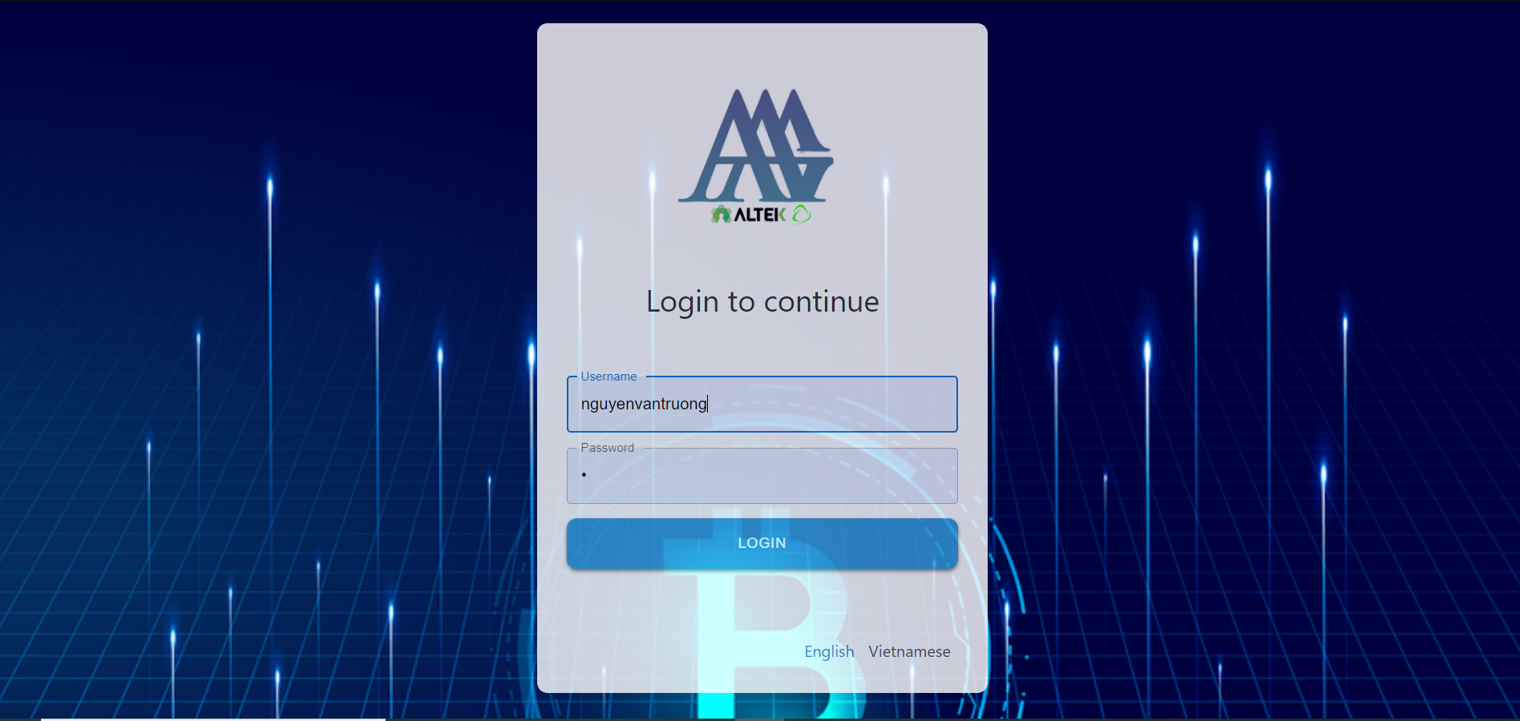

Screen description:

|  |  |  |  |  |  |  |
| --- | --- | --- | --- | --- | --- | --- |
| # | Name | Control Type | Edit | Obligatory | Default Value | Description |
| 1 | Username | Textfield | Yes | Yes | 8-50 characters | Required value between 8-50 characters |
| 2 | Password | Textfield | Yes | Yes | 8-16 characters | Required value between 8-16 characters |
| 3 | Login | Button | No | Yes | N/A | When user press this button, system will navigate to the hompage website if the username and password are correct, otherwise, it will give an error: "Username or Password is invalid" |
| 4 | English | Button | No | Yes | N/A | When user press this button, system will display all content in English |
| 5 | Vietnamese | Button | No | Yes | N/A | When user press this button, system will display all content in Vietnamese |

### Business Flow Chart

Ti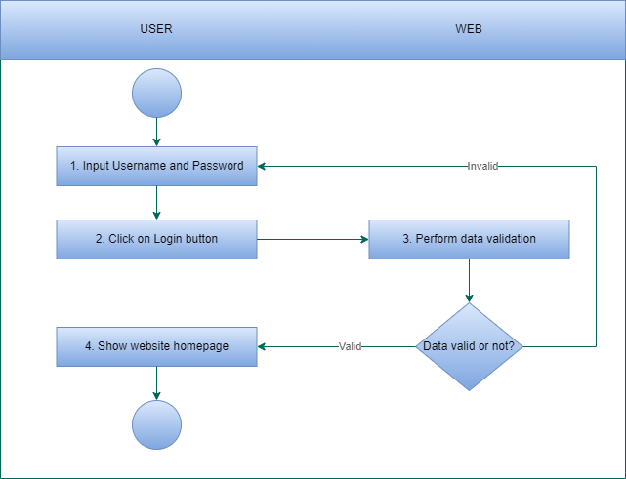

### Detail description of the business flow

Step 1: User login website

* If Username is invalid, system show message:”Username is invalid”
* If Password is invalid, system show message:”Password is invalid”
* If User don’t input Username or Password field, system show message: “User or Password is required”
* If the data is valid, go to the next step.

Step 2: System show website screen

### 3.1.5 Function Affected

|  |  |
| --- | --- |
| Affected function name | Detail description of the affect |
| None |  |

## *Manage project*

### 3.2.1 General description

|  |  |
| --- | --- |
| **Purpose** | Allow admin to create/edit/delete project and change status of the project  User can only see existed project |
| **Users** | User, admin and partner |
| **Users affected** | User, admin and partner |
| **Applicable channel** | AAS |
| **Function path** | AAS/Manage_project |
| **Input Data** | Admin can manage project (Create/Edit/Delete) and change status of project(Inactive/Active) |
| **Output Data** | System show project that admin has create/edit/delete or change status of project |

### Manage Project Screen

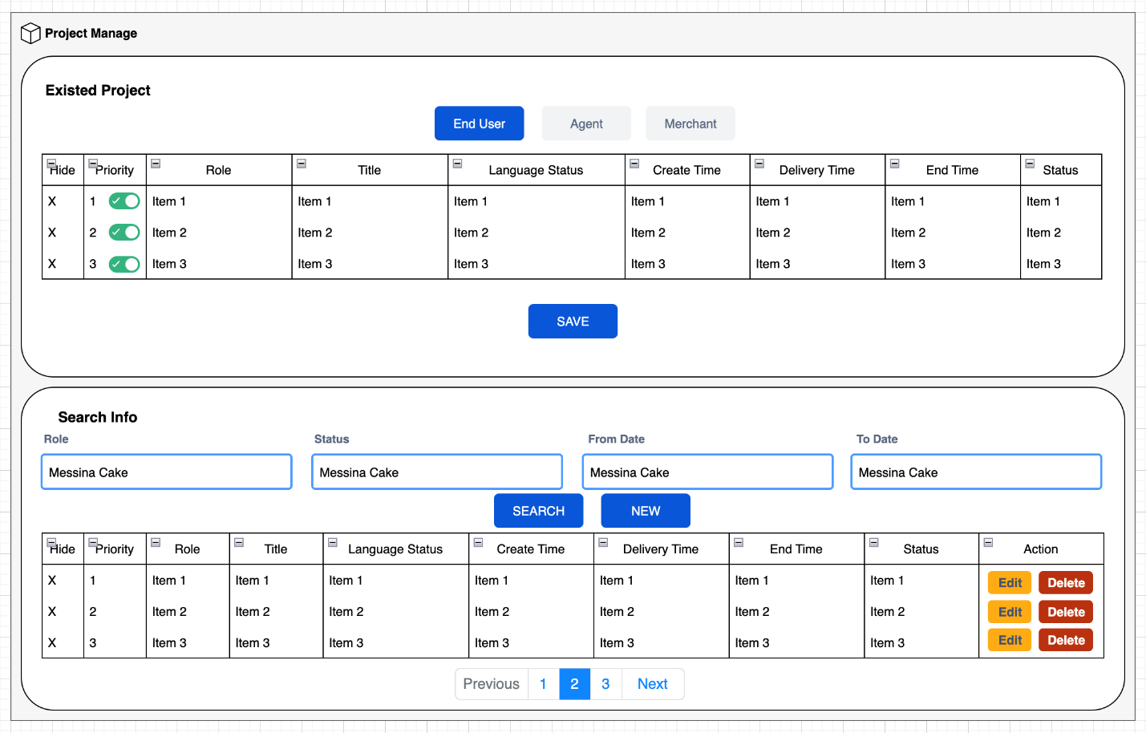

Screen description:

|  |  |  |  |  |  |  |
| --- | --- | --- | --- | --- | --- | --- |
| # | Name | Control Type | Edit | Obligatory | Default Value | Description |
| 1 | Hide | Text | Yes | Yes | N/A | If project has been done, system will hide it from existed project |
| 2 | Priority | Toggle button | Yes | Yes | 1,2,3  1: High  2: Medium  3: Low | Show priority of the project (from high to low) |
| 3 | Role | Text | No | Yes | N/A | Show which role can work on that project |
| 4 | Title | Text | No | Yes | N/A | Show the project name |
| 5 | Language status | Text | No | Yes | English, Vietnamese | Show the language that project is using |
| 6 | Create time | Text | Yes | Yes | DD:MM:YYYY | Show the time creating of the project |
| 7 | Delivery time | Text | Yes | Yes | DD:MM:YYYY | Show the time delivering product |
| 8 | End time | Text | Yes | Yes | DD:MM:YYYY | Show the time ending of the project |
| 9 | Status | Text | Yes | Yes | 0,1 | Inactive/Active |
| 10 | Save | Button | No | Yes | N/A | After user click on this button, system will save all information that user have changed before |
| 11 | Search | Button | No | Yes | N/A | After user input values in those Text and click on this button, system will search for the information user has chose |
| 12 | New | Button | No | Yes | N/A | After user click on this button, system will navigate to Add project page |
| 13 | End User | Button | No | Yes | N/A | After user click on this button, system will show existd project that belong to End user role |
| 14 | Agent | Button | No | Yes | N/A | After user click on this button, system will show existd project that belong to Agent role |
| 15 | Merchant | Button | No | Yes | N/A | After user click on this button, system will show existed project that belong to Merchant role |
| 16 | Previous | Button | No | Yes | N/A | After user click on this button, back to the previous page |
| 17 | Previous | Button | No | Yes | N/A | After user click on this button, go to the next page |

### Business Flow Chart

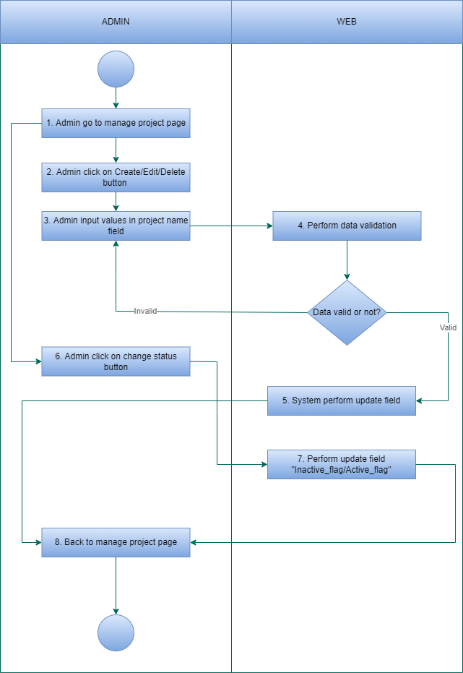

### 3.2.4 Detail description of the business flow

- Index:

Step 1: Admin go to the manage project page

Step 2: System executes a query to get all the projects of that admin and show it on the page

- Create:

Step 1: Admin click on Add button, system will navigate to Add project page

Step 2: Admin input values in project name field

Step 3: System perform data validation, if the data is valid, then move to the next step

Step 4: System perform insert new project

Step 5: System show a message on the screen

Step 6: Back to index page

- Edit:

Step 1: Admin click on Edit button on any project in the project list (Index), system will navigate to edit project page of the project that has been chose

Step 2: Admin input values in project name field

Step 3: System perform data validation, if the data is valid, then move to the next step

Step 4: System perform update new project name

Step 5: System show a message on the screen

Step 6: Back to index page

- Delete:

Step 1: Admin click on Delete button on any project in the project list (Index), system will show popup to confirm delete project or not

Step 2:

* If admin click on Accept, then move to Step 3
* If admin click on Deny , then move to Step 6

Step 3: System perform data validation, if the data is valid, then move to the next step

Step 4: System perform update field “Is deleted”

Step 5: System show a message on the screen:”Project has been deleted”

Step 6: Back to index page

- Inactive/Active

Step 1: Admin click on Change status button on any project in the project list (Index)

Step 2: System perform update field “Active_flag”

Step 3: System show a message on the screen

Step 4: Refresh index page

### 3.2.5 Function Affected

|  |  |
| --- | --- |
| Affected function name | Detail description of the affect |
| None |  |

* 1. ***Create Account***

### 3.3.1 General description

|  |  |
| --- | --- |
| **Purpose** | Admin create account with username and password, after that send account information to user via Web/SMS/Email |
| **Users** | User, admin and partner |
| **Users affected** | User, admin and partner |
| **Applicable channel** | AAS |
| **Function path** | AAS/Create_account |
| **Input Data** | Admin create account for user. User login with username and password that admin has created before |
| **Output Data** | System show website screen after user login |

### Create Account Screen

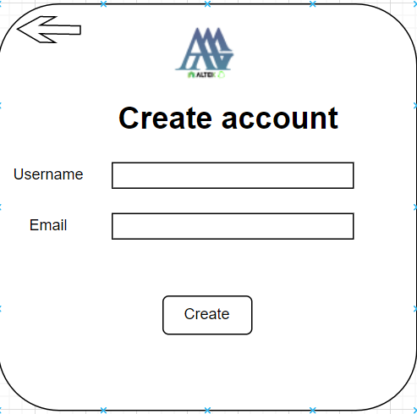

Screen description:

|  |  |  |  |  |  |  |
| --- | --- | --- | --- | --- | --- | --- |
| # | Name | Control Type | Edit | Obligatory | Default Value | Description |
| 1 | Username | Textbox | Yes | Yes | 8-50 characters | Required value between 8-50 characters |
| 2 | Password | Textbox | Yes | Yes | 8-16 characters | Required value between 8-16 characters |
| 3 | Create | Button | No | Yes | N/A | After click on this button, system will show a message that account has been created successfully |
| 4 | Back | Button | No | Yes | N/A | After click on this button, system will navigate back to website screen |

### Business Flow Chart

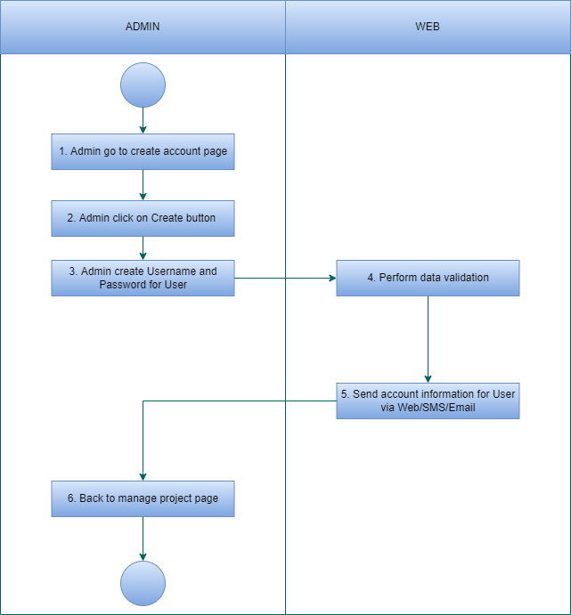

### Detail description of the business flow

- Index:

Step 1: Admin go to create account page

Step 2: Admin create account for user. After create account success, system will show a notification

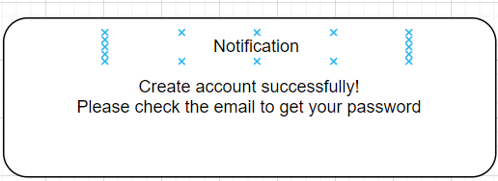

After that, admin send account information via Website/SMS/Email

### 3.3.5 Function Affected

|  |  |
| --- | --- |
| Affected function name | Detail description of the affect |
| None |  |

* 1. ***Manage permission***

### 3.4.1 General description

|  |  |
| --- | --- |
| **Purpose** | Allow admin to Create/Edit/Delete permission of user |
| **Users** | User, admin and partner |
| **Users affected** | User, admin and partner |
| **Applicable channel** | AAS |
| **Function path** | AAS/Manage_permission |
| **Input Data** | Admin can create/edit/delete permission of user |
| **Output Data** | System show permission of user after create/edit/delete |

### Manage Permission Screen

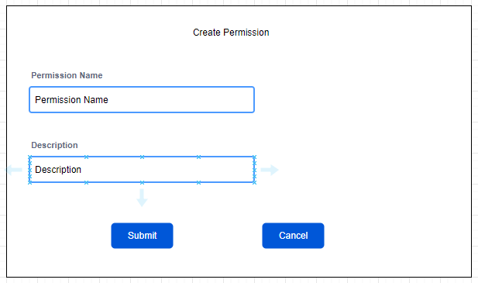

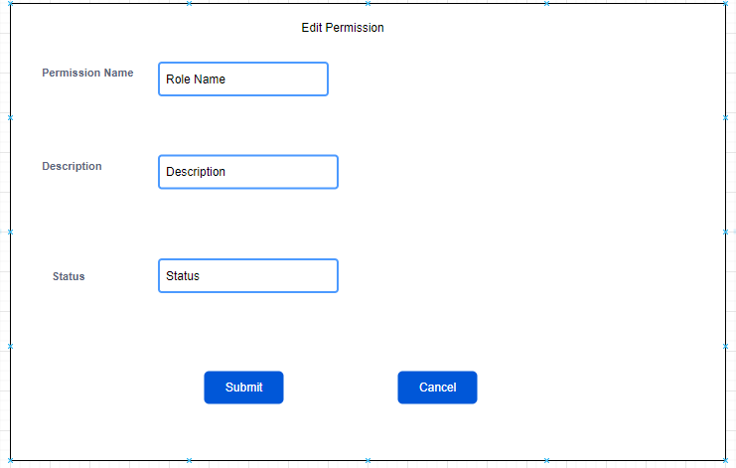

Screen description:

|  |  |  |  |  |  |  |
| --- | --- | --- | --- | --- | --- | --- |
| # | Name | Control Type | Edit | Obligatory | Default Value | Description |
| 1 | Permission name | Textbox | Yes | Yes | 100 characters | Required value must be shorter than 100 characters |
| 2 | Description | Textbox | Yes | Yes | 500 characters | Required value must be shorter than 500 characters |
| 3 | Status | Textbox | Yes | Yes | 100 characters | Required value must be shorter than 100 characters |
| 4 | Submit | Button | No | Yes | N/A | After click on this button, system will navigate to website screen |
| 5 | Cancel | Button | No | Yes | N/A | After click on this button, system will navigate back to Edit/Delete permission screen |

### Business Flow Chart

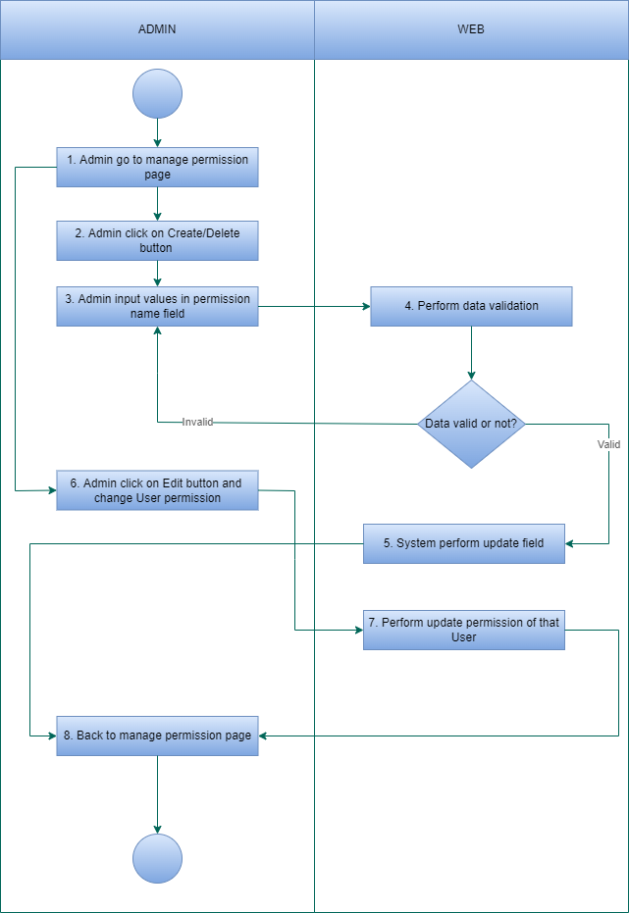

### Detail description of the business flow

* Manage permissions as User

- Index

Step 1: User go to manage permission page

Step 2: System executes a query to get all the permissions of that user and show it on the page

* Manage permissions as Admin

- Index

Step 1: Admin go to manage permission page

Step 2: System executes a query to get all permissions of that admin and show it on the page

- Create

Step 1: Admin click on Add button and go to add permission page

Step 2: Admin input data in the permission name textbox

Step 3: System perform data validation, if the data is valid, then go to the next step

Step 4: System perform insert new permission name

Step 5: System show a message on the screen: "Permission has been created"

Step 6: Back to Index page

-Edit

Step 1: Admin click on the edit button on any user in the permission list (Index), system will navigate to edit permission page

Step 2: Admin input data in the permission name textbox

Step 3: System perform data validation, if the data is valid, then go to next step

Step 4: System perform update new permission name

Step 5: System show a message on the screen: "Permission has been edited"

Step 6: Back to Index page

-Delete

Step 1: Admin click on the edit button on any user in the permission list (Index), system will show popup

Step 2:

* If admin click on Accept, then move to Step 3
* If admin click on Deny , then move to Step 6

Step 3: System perform data validation, if the data is valid, then move to the next step

Step 4: System perform update field “Is deleted”

Step 5: System show a message on the screen:”Project has been deleted”

Step 6: Back to index page

* Manage permissions as Root

- Index

Step 1: Root go to manage permission page

Step 2: System executes a query to get all permissions of that admin and show it on the page

- Create

Step 1: Root click on Add button and go to add permission page

Step 2: Root input data in the permission name textbox

Step 3: System perform data validation, if the data is valid, then go to the next step

Step 4: System perform insert new permission name

Step 5: System show a message on the screen: "Permission has been created"

Step 6: Back to Index page

-Edit

Step 1: Root click on the edit button on any user in the permission list (Index), system will navigate to edit permission page

Step 2: Root input data in the permission name textbox

Step 3: System perform data validation, if the data is valid, then go to next step

Step 4: System perform update new permission name

Step 5: System show a message on the screen: "Permission has been edited"

Step 6: Back to Index page

-Delete

Step 1: Root click on the edit button on any user in the permission list (Index), system will show popup

Step 2:

* If root click on Accept, then move to Step 3
* If root click on Deny , then move to Step 6

Step 3: System perform data validation, if the data is valid, then move to the next step

Step 4: System perform update field “Is deleted”

Step 5: System show a message on the screen:”Project has been deleted”

Step 6: Back to index page

### 3.4.5 Function Affected

|  |  |
| --- | --- |
| Affected function name | Detail description of the affect |
| None |  |

* 1. ***Manage Role***

### 3.5.1 General description

|  |  |
| --- | --- |
| **Purpose** | Allow admin to Create/Edit/Delete role of user |
| **Users** | User, admin and partner |
| **Users affected** | User, admin and partner |
| **Applicable channel** | AAS |
| **Function path** | AAS/Manage_role |
| **Input Data** | Admin can create/edit/delete role of user |
| **Output Data** | System show role of user after create/edit/delete |

### Manage Role Screen

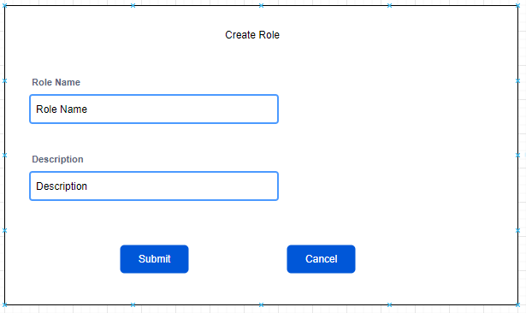

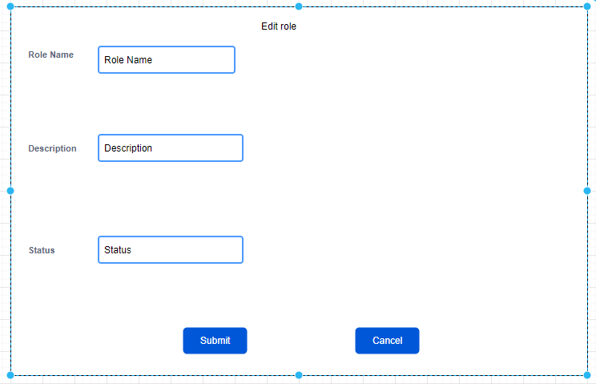

Screen description:

|  |  |  |  |  |  |  |
| --- | --- | --- | --- | --- | --- | --- |
| # | Name | Control Type | Edit | Obligatory | Default Value | Description |
| 1 | Role name | Textbox | Yes | Yes | 100 characters | Required value must be shorter than 100 characters |
| 2 | Description | Textbox | Yes | Yes | 500 characters | Required value must be shorter than 500 characters |
| 3 | Status | Textbox | Yes | Yes | 100 characters | Required value must be shorter than 100 characters |
| 4 | Submit | Button | No | Yes | N/A | After click on this button, system will navigate to website screen |
| 5 | Cancel | Button | No | Yes | N/A | After click on this button, system will navigate back to Edit/Delete role screen |

### Business Flow Chart

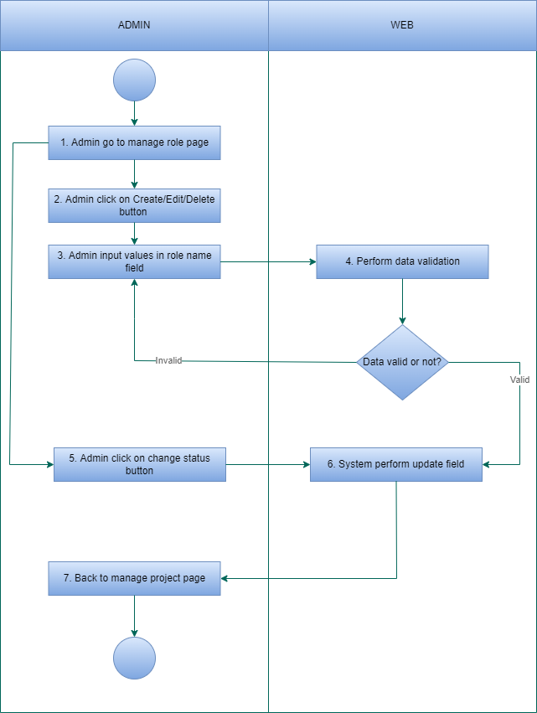

### 3.5.4 Detail description of the business flow

* Manage role as User

- Index

Step 1: User go to manage role page

Step 2: System executes a query to get all the role of that user and show it on the page

* Manage role as Admin

- Index

Step 1: Admin go to manage role page

Step 2: System executes a query to get all role of that admin and show it on the page

- Create

Step 1: Admin click on Add button and go to add role page

Step 2: Admin input data in the role name textbox

Step 3: System perform data validation, if the data is valid, then go to the next step

Step 4: System perform insert new role name

Step 5: System show a message on the screen: "Role has been created"

Step 6: Back to Index page

-Edit

Step 1: Admin click on the edit button on any user in the role list (Index), system will navigate to edit role page

Step 2: Admin input data in the role name textbox

Step 3: System perform data validation, if the data is valid, then go to next step

Step 4: System perform update new role name

Step 5: System show a message on the screen: "Role has been edited"

Step 6: Back to Index page

-Delete

Step 1: Admin click on the edit button on any user in the role list (Index), system will show popup

Step 2:

* If admin click on Accept, then move to Step 3
* If admin click on Deny , then move to Step 6

Step 3: System perform data validation, if the data is valid, then move to the next step

Step 4: System perform update field “Is deleted”

Step 5: System show a message on the screen:”Role has been deleted”

Step 6: Back to index page

* Manage role as Root

- Index

Step 1: Root go to manage role page

Step 2: System executes a query to get all role of that admin and show it on the page

- Create

Step 1: Root click on Add button and go to add role page

Step 2: Root input data in the role name textbox

Step 3: System perform data validation, if the data is valid, then go to the next step

Step 4: System perform insert new role name

Step 5: System show a message on the screen: "Role has been created"

Step 6: Back to Index page

-Edit

Step 1: Root click on the edit button on any admin in the role list (Index), system will navigate to edit rolepage

Step 2: Root input data in the role name textbox

Step 3: System perform data validation, if the data is valid, then go to next step

Step 4: System perform update new role name

Step 5: System show a message on the screen: "Role has been edited"

Step 6: Back to Index page

-Delete

Step 1: Root click on the edit button on any admin in the role list (Index), system will show popup

Step 2:

* If root click on Accept, then move to Step 3
* If root click on Deny , then move to Step 6

Step 3: System perform data validation, if the data is valid, then move to the next step

Step 4: System perform update field “Is deleted”

Step 5: System show a message on the screen:”Role has been deleted”

Step 6: Back to index page

### 3.5.5 Function Affected

|  |  |
| --- | --- |
| Affected function name | Detail description of the affect |
| None |  |

* 1. ***Manage Component***

### 3.6.1 General description

|  |  |
| --- | --- |
| **Purpose** | Allow admin to Create/Edit/Delete component of user |
| **Users** | User, admin and partner |
| **Users affected** | User, admin and partner |
| **Applicable channel** | AAS |
| **Function path** | AAS/Manage_component |
| **Input Data** | Admin can create/edit/delete component of user |
| **Output Data** | System show component of user after create/edit/delete |

### Manage Component Screen

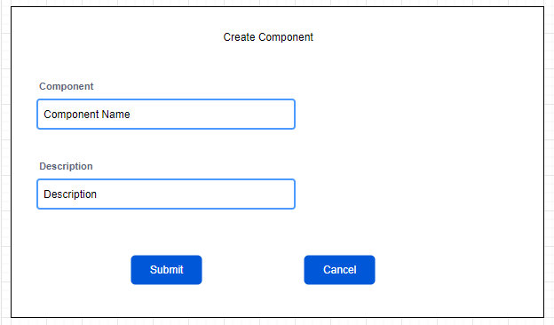

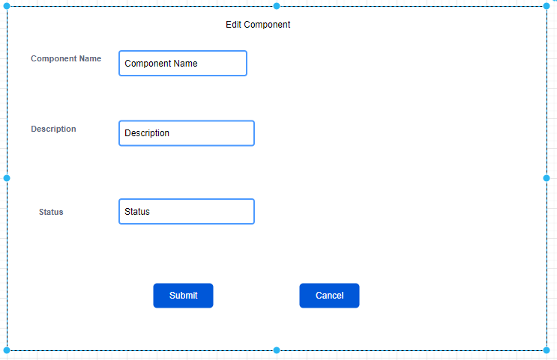

Screen description:

|  |  |  |  |  |  |  |
| --- | --- | --- | --- | --- | --- | --- |
| # | Name | Control Type | Edit | Obligatory | Default Value | Description |
| 1 | Component name | Textbox | Yes | Yes | 100 characters | Required value must be shorter than 100 characters |
| 2 | Description | Textbox | Yes | Yes | 500 characters | Required value must be shorter than 500 characters |
| 3 | Status | Textbox | Yes | Yes | 100 characters | Required value must be shorter than 100 characters |
| 4 | Submit | Button | No | Yes | N/A | After click on this button, system will navigate to website screen |
| 5 | Cancel | Button | No | Yes | N/A | After click on this button, system will navigate back to Add/Edit/Delete component screen |

### Business Flow Chart

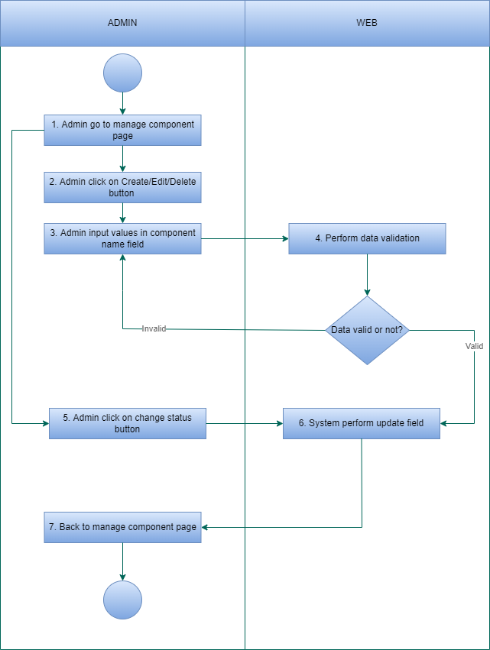

### Detail description of the business flow

* **User can not manage component**
* Manage component as Admin

- Index

Step 1: Admin go to manage component page

Step 2: System executes a query to get all component of that user and show it on the page

- Create

Step 1: Admin click on Add button and go to add component page

Step 2: Admin input data in the component name textbox

Step 3: System perform data validation, if the data is valid, then go to the next step

Step 4: System perform insert new component name

Step 5: System show a message on the screen: "Component has been created"

Step 6: Back to Index page

-Edit

Step 1: Admin click on the edit button on any user in the component list (Index), system will navigate to edit component page

Step 2: Admin input data in the component name textbox

Step 3: System perform data validation, if the data is valid, then go to next step

Step 4: System perform update new component name

Step 5: System show a message on the screen: "Component has been edited"

Step 6: Back to Index page

-Delete

Step 1: Admin click on the edit button on any user in the component list (Index), system will show popup

Step 2:

* If admin click on Accept, then move to Step 3
* If admin click on Deny , then move to Step 6

Step 3: System perform data validation, if the data is valid,then move to the next step

Step 4: System perform update field “Is deleted”

Step 5: System show a message on the screen:”Component has been deleted”

Step 6: Back to index page

* Manage role as Root

- Index

Step 1: Root go to manage component page

Step 2: System executes a query to get all component of that admin and show it on the page

- Create

Step 1: Root click on Add button and go to add component page

Step 2: Root input data in the component name textbox

Step 3: System perform data validation, if the data is valid, then go to the next step

Step 4: System perform insert new component name

Step 5: System show a message on the screen: "Component has been created"

Step 6: Back to Index page

-Edit

Step 1: Root click on the edit button on any admin in the component list (Index), system will navigate to edit component page

Step 2: Root input data in the component name textbox

Step 3: System perform data validation, if the data is valid, then go to next step

Step 4: System perform update new component name

Step 5: System show a message on the screen: "Component has been edited"

Step 6: Back to Index page

-Delete

Step 1: Root click on the edit button on any admin in the component list (Index), system will show popup

Step 2:

* If root click on Accept, then move to Step 3
* If root click on Deny , then move to Step 6

Step 3: System perform data validation, if the data is valid,then move to the next step

Step 4: System perform update field “Is deleted”

Step 5: System show a message on the screen:” Component has been deleted”

Step 6: Back to index page

### 3.6.5 Function Affected

|  |  |
| --- | --- |
| Affected function name | Detail description of the affect |
| None |  |

* 1. ***Manage Menu***

### 3.7.1 General description

|  |  |
| --- | --- |
| **Purpose** | Allow admin to Create/Edit/Delete Menu. It has sub menu (Sub menu also contains component) |
| **Users** | User, admin and partner |
| **Users affected** | User, admin and partner |
| **Applicable channel** | AAS |
| **Function path** | AAS/Manage_Menu |
| **Input Data** | Admin can create/edit/delete menu. Menu has sub menu (Sub menu also contains component) |
| **Output Data** | System show menu after create/edit/delete |

### 3.7.2 Manage Menu Screen

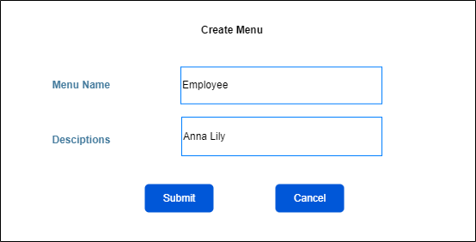

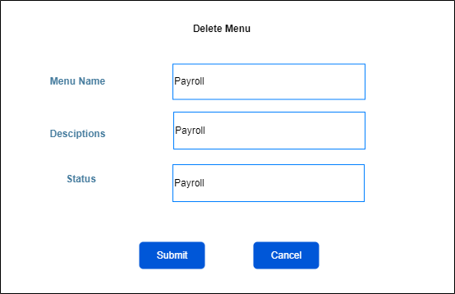

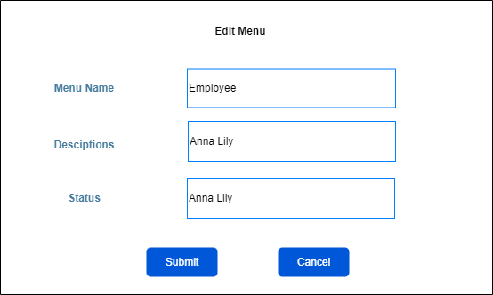

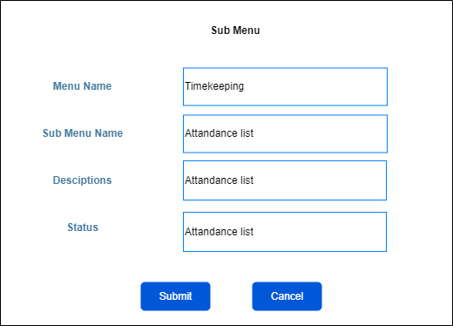

Screen description:

|  |  |  |  |  |  |  |
| --- | --- | --- | --- | --- | --- | --- |
| # | Name | Control Type | Edit | Obligatory | Default Value | Description |
| 1 | Menu name | Textbox | Yes | Yes | 100 characters | Required value must be shorter than 100 characters |
| 2 | Description | Textbox | Yes | Yes | 500 characters | Required value must be shorter than 500 characters |
| 3 | Sub menu name | Textbox | Yes | Yes | 100 characters | Required value must be shorter than 100 characters |
| 4 | Status | Textbox | Yes | Yes | 100 characters | Required value must be shorter than 100 characters |
| 5 | Submit | Button | No | Yes | N/A | After click on this button, system will navigate to website screen |
| 6 | Cancel | Button | No | Yes | N/A | After click on this button, system will navigate back to Add/Edit/Delete menu screen |

### Business Flow Chart

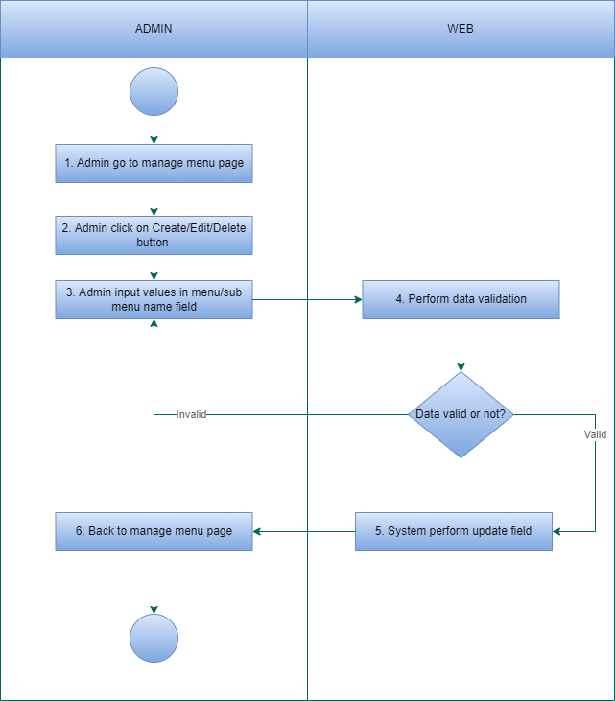

### Detail description of the business flow

* **User can not manage menu**
* Manage menu as Admin

- Index

Step 1: Admin go to manage menu page

Step 2: System executes a query to get all menu of that user and show it on the page

- Create

Step 1: Admin click on Add button and go to add menu page

Step 2: Admin input data in the menu name textbox

Step 3: System perform data validation, if the data is valid,then go to the next step

Step 4: System perform insert new menu name

Step 5: System show a message on the screen: "Menu has been created"

Step 6: Back to Index page

-Edit

Step 1: Admin click on the edit button on any user in the menu list (Index), system will navigate to edit menu page

Step 2: Admin input data in the menu name textbox

Step 3: System perform data validation, if the data is valid, then go to next step

Step 4: System perform update new menu name

Step 5: System show a message on the screen: "Menu has been edited"

Step 6: Back to Index page

-Delete

Step 1: Admin click on the edit button on any user in the menu list (Index), system will show popup

Step 2:

* If admin click on Accept, then move to Step 3
* If admin click on Deny , then move to Step 6

Step 3: System perform data validation, if the data is valid, then move to the next step

Step 4: System perform update field “Is deleted”

Step 5: System show a message on the screen:” Menu has been deleted”

Step 6: Back to index page

* Manage role as Root

- Index

Step 1: Root go to manage menu page

Step 2: System executes a query to get all menu of that admin and show it on the page

- Create

Step 1: Root click on Add button and go to add menu page

Step 2: Root input data in the menu name textbox

Step 3: System perform data validation, if the data is valid, then go to the next step

Step 4: System perform insert new menu name

Step 5: System show a message on the screen: "Menu has been created"

Step 6: Back to Index page

-Edit

Step 1: Root click on the edit button on any admin in the menu list (Index), system will navigate to edit menu page

Step 2: Root input data in the menu name textbox

Step 3: System perform data validation, if the data is valid, then go to next step

Step 4: System perform update new menu name

Step 5: System show a message on the screen: "Menu has been edited"

Step 6: Back to Index page

-Delete

Step 1: Root click on the edit button on any admin in the menu list (Index), system will show popup

Step 2:

* If root click on Accept, then move to Step 3
* If root click on Deny , then move to Step 6

Step 3: System perform data validation, if the data is valid,then move to the next step

Step 4: System perform update field “Is deleted”

Step 5: System show a message on the screen:” Menu has been deleted”

Step 6: Back to index page

### 3.7.5 Function Affected

|  |  |
| --- | --- |
| Affected function name | Detail description of the affect |
| None |  |

* 1. ***Manage Profile***

### 3.8.1 General description

|  |  |
| --- | --- |
| **Purpose** | Allow root,admin to Create/Edit/Delete profile of user |
| **Users** | User, admin and partner |
| **Users affected** | User, admin and partner |
| **Applicable channel** | AAS |
| **Function path** | AAS/Manage_profile |
| **Input Data** | Root,Admin can create/edit/delete profile of user |
| **Output Data** | System show profile of user after create/edit/delete |

### Manage Profile Screen

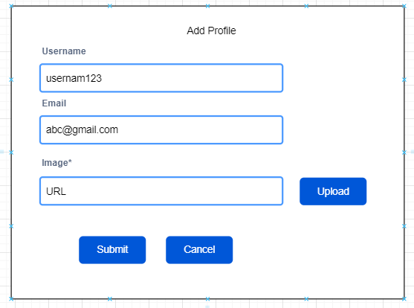

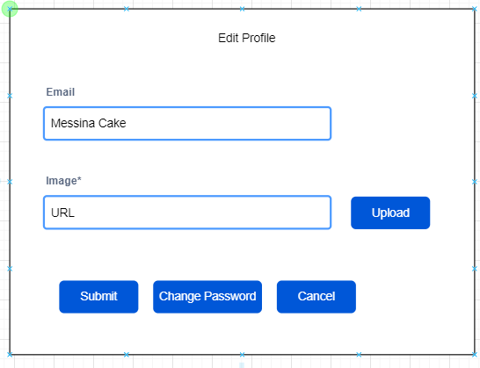

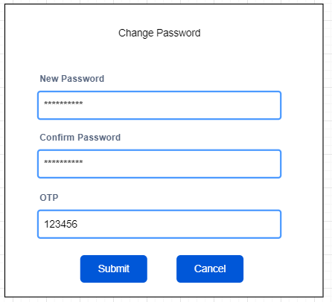

Screen description:

|  |  |  |  |  |  |  |
| --- | --- | --- | --- | --- | --- | --- |
| # | Name | Control Type | Edit | Obligatory | Default Value | Description |
| 1 | Username | Textbox | Yes | Yes | 8-50 characters | Required value must be between 8-50 characters |
| 2 | Email | Textbox | Yes | Yes | 8-50 characters | Required value must be between 8-50 characters |
| 3 | Imagine | Textbox | Yes | Yes | 100 characters | Required value must be shorter than 100 characters |
| 4 | New password | Textbox | Yes | Yes | 100 characters | Required value must be shorter than 100 characters |
| 5 | Confirm password | Textbox | Yes | Yes | 100 characters | Required value must be shorter than 100 characters |
| 6 | OTP | Textbox | Yes | Yes | 6 characters | Required value must be 6 characters |
| 7 | Upload | Button | No | Yes | N/A | After click on this button, system will navigate to user device folder for user to choose which folder to upload |
| 8 | Submit | Button | No | Yes | N/A | After click on this button, system will navigate to website screen |
| 9 | Cancel | Button | No | Yes | N/A | After click on this button, system will navigate back to Add/Edit/Delete profile screen |

### Business Flow Chart

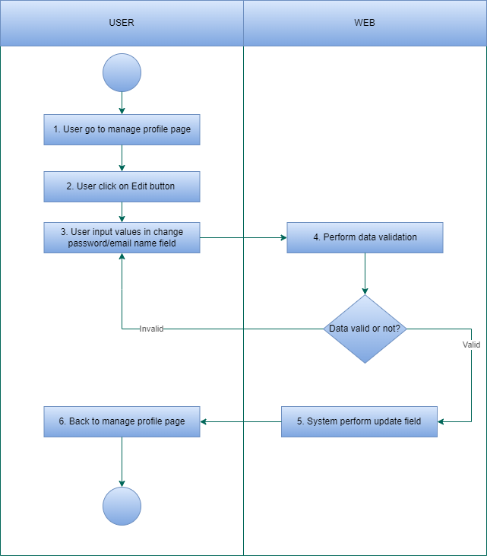

*Manage Profile as User*

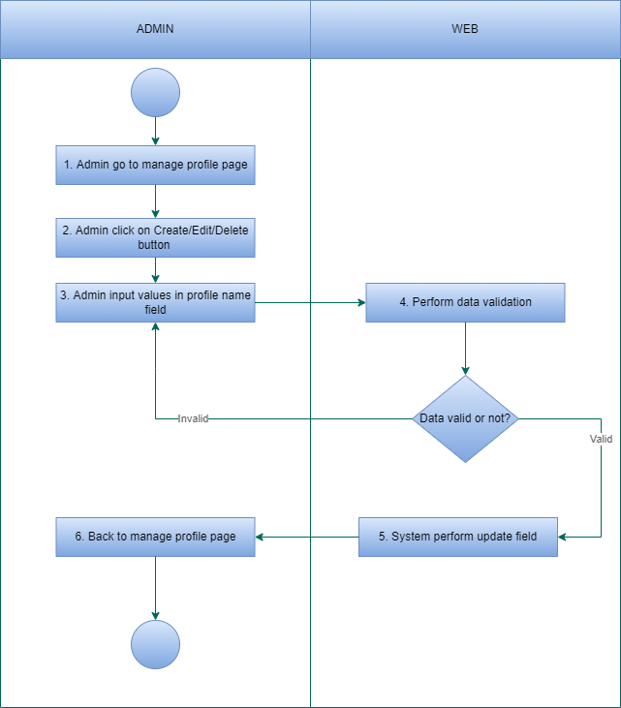

*Manage Profile as Admin*

### Detail description of the business flow

* Manage profile as User

- Index

Step 1: User go to manage profile page

Step 2: System executes a query to get all information of that user and show it on the page

- Edit

Step 1: User click on the edit button in the profile list (Index), system will navigate to edit information page

Step 2: User input data in the information name textbox (user can only allow to change email/ password)

Step 3: System perform data validation, if the data is valid,then go to next step

Step 4: System perform update new information

Step 5: System show a message on the screen: "Email has been changed" or “Password has been changed"

Step 6: Back to Index page

* Manage profile as Admin

- Index

Step 1: Admin go to manage profile page

Step 2: System executes a query to get all profile t of that user and show it on the page

- Create

Step 1: Admin click on Add button and go to add profile page

Step 2: Admin input data in the profile name textbox

Step 3: System perform data validation, if the data is valid, then go to the next step

Step 4: System perform insert new profile name

Step 5: System show a message on the screen: "Profile has been created"

Step 6: Back to Index page

-Edit

Step 1: Admin click on the edit button on any user in the profile list (Index), system will navigate to edit profile page

Step 2: Admin input data in the profile name textbox

Step 3: System perform data validation, if the data is valid, then go to next step

Step 4: System perform update new information

Step 5: System show a message on the screen: "Information has been changed"

Step 6: Back to Index page

-Delete

Step 1: Admin click on the edit button on any user in the profile list (Index), system will show popup

Step 2:

* If admin click on Accept, then move to Step 3
* If admin click on Deny , then move to Step 6

Step 3: System perform data validation, if the data is valid, then move to the next step

Step 4: System perform update field “Is deleted”

Step 5: System show a message on the screen:”Profile has been deleted”

Step 6: Back to index page

* Manage profile as Root

- Index

Step 1: Root go to manage profile page

Step 2: System executes a query to get all profile of that admin and show it on the page

- Create

Step 1: Root click on Add button and go to add profile page

Step 2: Root input data in the profile name textbox

Step 3: System perform data validation, if the data is valid, then go to the next step

Step 4: System perform insert new profile name

Step 5: System show a message on the screen: "Profile has been created"

Step 6: Back to Index page

-Edit

Step 1: Root click on the edit button on any admin in the profile list (Index), system will navigate to edit profile page

Step 2: Root input data in the profile name textbox

Step 3: System perform data validation, if the data is valid, then go to next step

Step 4: System perform update new information

Step 5: System show a message on the screen: "Information has been changed"

Step 6: Back to Index page

-Delete

Step 1: Root click on the edit button on any admin in the profile list (Index), system will show popup

Step 2:

* If root click on Accept, then move to Step 3
* If root click on Deny , then move to Step 6

Step 3: System perform data validation, if the data is valid, then move to the next step

Step 4: System perform update field “Is deleted”

Step 5: System show a message on the screen:”Profile has been deleted”

Step 6: Back to index page

### 3.8.5 Function Affected

|  |  |
| --- | --- |
| Affected function name | Detail description of the affect |
| None |  |

# Non-Functional Requirements

## Performance Requirements

This subsection specifies that the programmer must be familiar with the system functions and the business flow.

## Safety Requirements

Safety Requirements (Optional) refers to a solution that protects solution content or solution components from accidental or malicious access, use, modification, destruction, or disclosure.

|  |  |  |
| --- | --- | --- |
| **Title** | **Criteria** | **Note** |
| Privacy | Password and message encryption | The system should follow the encryption algorithm according to the data encryption standard. |

## Privacy Requirements

N/A

## Software Quality Requirements

N/A

# Appendix