

**ALTEK COMPANY PTE. LTD**

**HRM SOLUTION PLC**

**<PROJECT NAME>**

**HUMAN RESOURCE MANAGEMENT – SUB MODULE 4: HRM BUSINESS**

**Project Code: HRM-SM4**

**Document Number: v0.1.1**

**<Ho Chi Minh, 06/2022>**

|  |  |
| --- | --- |
|  | **SYSTEM REQUIREMENT SPECIFICATION** |

**REQUIREMENT INFORMATION:**

Requestor: …………………… Deparment: Product Management

Mobile, fax: …………………… Email: ………………………………

Start Time: ………………….. .. Finish Time Proposal: ………………

Type: 🞏 New 🞏 Upgrade

Priority: 🞏 Urgent 🞏 Normal

* + 1. **Project Information**
  1. ***Project Name:*** *…………………*
  2. ***Partner Name:*** *………….*
  3. ***Project Code:*** *………*
     1. **Overview**
  4. ***Current Status***

* 1. ***Proposal:*** 
     1. **Approval Information**

|  |  |  |
| --- | --- | --- |
| **REQUESTOR** | **REVIEWER** | **APPROVER** |

**Link Jira: ……………….**

**REVISE HISTORY**

*A – Create New, M – Edit, D – Delete

|  |  |  |  |  |  |  |
| --- | --- | --- | --- | --- | --- | --- |
| **Date** | **Change** | **A, M, D** | **Original** | **Old Version** | **Description change** | **New Version** |
|  |  |  |  |  |  |  |
|  |  |  |  |  |  |  |
|  |  |  |  |  |  |  |
|  |  |  |  |  |  |  |
|  |  |  |  |  |  |  |
|  |  |  |  |  |  |  |
|  |  |  |  |  |  |  |
|  |  |  |  |  |  |  |
|  |  |  |  |  |  |  |
|  |  |  |  |  |  |  |
|  |  |  |  |  |  |  |
|  |  |  |  |  |  |  |

**Content**

HUMAN RESOURCE MANAGEMENT – SUB MODULE 4: HRM BUSINESS 1

SYSTEM REQUIREMENT SPECIFICATION 3

REVISE HISTORY 4

1. INTRODUCTION 7

**1.1 Purpose 7**

**1.2 Scope 7**

**1.3. Definitions, Acronyms, and Abbreviations 8**

**1.2.1 Reference 8**

2. SYSTEM OVERVIEW 10

**2.1 Problem Statement 10**

**2.2 Purpose of system 10**

**2.3 Scope of system 10**

**2.3.1 Use case 10**

**2.3.2 Function 11**

**2.3.3 Overall model 14**

**2.3.4 System Authorization Table 14**

3. SPECIFIC REQUIREMENTS 14

**3.1 Login 15**

**3.1.1 General description 15**

**3.1.2 Login Screen 16**

**3.1.3 Business Flow Chart 17**

**3.1.4 Detail description of the business flow 18**

**3.2 Timekeeping 18**

**3.2.1 General description 18**

**3.2.2 Timekeeping Screen 19**

**3.2.3 Business Flow Chart 21**

**3.2.4 Detail description of the business flow 27**

**3.3.1 General description 30**

**3.3.2 Request Leave Screen 31**

**3.3.3 Business Flow Chart 34**

**3.3.4 Detail description of the business flow 40**

**3.4.1 General description 44**

**3.4.2 Manage Profile Screen 45**

**3.4.3 Business Flow Chart 48**

**3.4.4 Detail description of the business flow 50**

**3.4.5 Function Affected 53**

**3.5 Payroll 54**

**3.5.1 General description 54**

**3.5.2 Payroll Screen 55**

**3.5.3 Business Flow Chart 58**

**3.5.4 Detail description of the business flow 61**

**3.5.5 Function Affected 63**

4 Non-Functional Requirements 64

**4.1 Performance Requirements 64**

**4.2 Safety Requirements 64**

**4.3 Privacy Requirements 64**

**4.4 Software Quality Requirements 64**

5 Appendix 64

# INTRODUCTION

## Purpose

The purpose of HRM is to prevent these issues in the first place and maximize a company's performance by investing in the right people. Those who work in this field have the skills, knowledge and tools needed to find and employ top talent, help employees succeed in their

roles and ensure good working conditions. Depending on the organization, their responsibilities may include:

* Internal and external recruitment.
* Candidate selection.
* Employee onboarding and training.
* Employee performance assessment.
* Employee compensation.
* Organization development.
* Compliance with labor laws.
* Labor and employee relations.
* Employee recognition and engagement.
* Career development.

In large organizations, each area of HRM falls under the responsibility of one or more HR managers and other specialists, such as training and development managers, employment services managers, career counselors and so on. Small companies either outsource this process or handle it in house on a smaller scale. In general, the main functions of human resources management include staffing, employee orientation/training, employees welfare and employee retention.

## Scope

This section covers:

- Automate timesheet approval process of employees to analyse performance, estimate costs incurred across the organization under several parameters (employee, department, client, role, project or activity) and integrate seamlessly with payroll and other modules.

- Tone down the complexities in payroll processing with a complete array of payroll services by offering inbuilt accounting module, automated tax computations, frequent audit & reporting tool, tabular data storage, and configurable rule-based engine.

- Scope LMS comprise of an automated generation of employee annual leave calendar and leave allowance. Casual and medical leaves can also be requested by employees and processed within the system by the HR department. Leave allowance for every pay grade configured in the cost center is automatically activated by the system and included in the payslip of employees on their leave month.

## *1.3.* Definitions, Acronyms, and Abbreviations

Provide the definitions of all terms, acronyms, and abbreviations required to properly interpret the SRS. This information may be provided by reference to one or more appendices in the SRS or by reference to documents. This information may be provided by reference to an Appendix*.*

|  |  |
| --- | --- |
| Abbreviations | Detail |
| SRS | System Requirement Specification |
| HRM | Human Resource Management |
| BR | Business Rule |
| N/A | Not Applicable or Not Available |
| LMM | Leave Management Module |
| HR | Human Resources |
| …… | ………………… |

## Reference

In this subsection:

(1) Provide a complete list of all documents referenced elsewhere in the SRS

(2) Identify each document by title, report number (if applicable), date, and publishing organization

1. Specify the sources from which the references can be obtained.

This information can be provided by reference to an appendix or to another document.

# SYSTEM OVERVIEW

## Problem Statement

* Briefly state the cause and content of the problem to be done
* Based on the requirements of product owner as well as the actual survey status to come up with all the problems that need to be solved
* The problem stated here often arises from a certain management/business need in reality of the user and the problem is set out to hope that if the software is built, it will solve that problem.

## Purpose of system

## Scope of system

### Use case

Example:

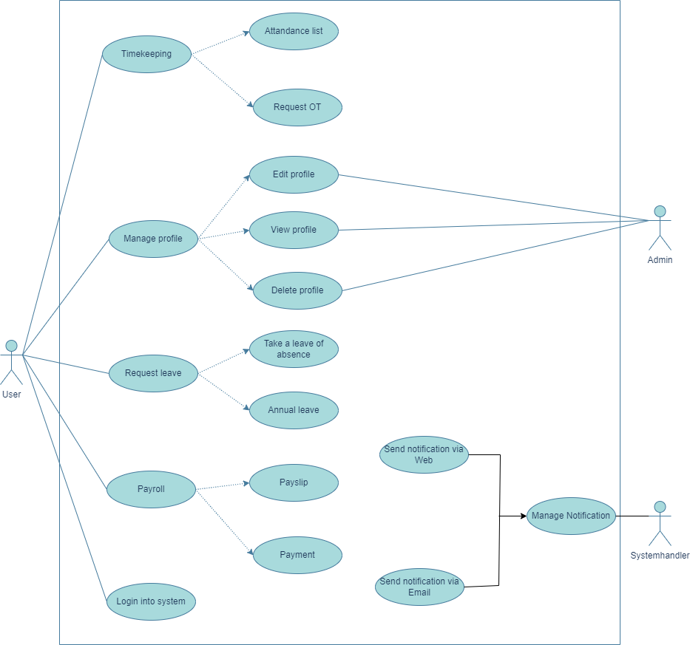

### Function

* + - 1. *Function List*

Example:

| No | Function Name | Fuction Code | Description |
| --- | --- | --- | --- |
|  | Login into system | SRS-01 | Allow login to the system and user can change password |
|  | Timekeeping | SRS-02 | Have 2 sub functions are Attandance list and Request OT |
|  | Request leave | SRS-03 | Have 2 sub functions are Take a leave of absence and Annual leave |
|  | Manage profile | SRS-04 | Allow to View/Edit/Delete Profile |
|  | Payroll | SRS-05 | Have 2 sub functions are Payslip and Payment |

* + - 1. *Functional Hierarchy*

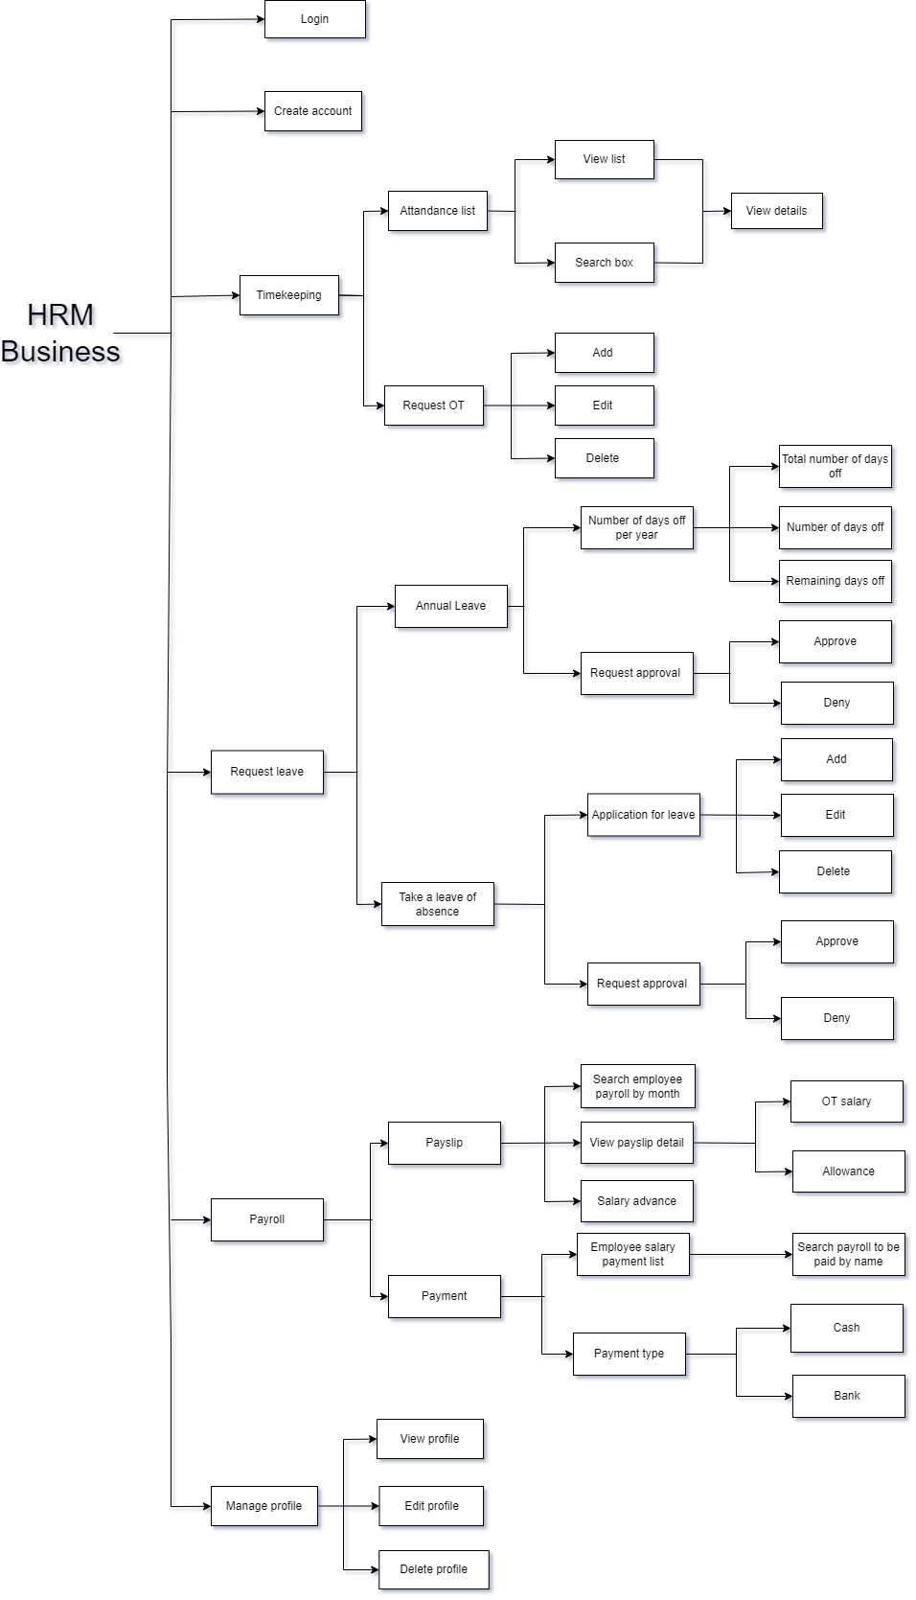

### Overall model

* + - 1. *Business Process Model*

Example:

* + - 1. *Entity Relationship Model (If any)*

Example:

* + - 1. *State Transition Model (If any)*

N/A

### System Authorization Table

Example:

|  |  |  |  |
| --- | --- | --- | --- |
| System | Role | Description | Screen |
| Document System | Admin | Allows access on all system functions | * System configuration * Records management * Report |
| User (HR) | Allows access on most system functions | * Records management * Report |
| User | Allows access on some system functions | * Report |

# SPECIFIC REQUIREMENTS

This section contains all the software requirements at a level of detail sufficient to enable designers to design a system to satisfy those requirements, and testers to test that the system satisfies those requirements. Throughout this section, every stated requirement should be externally perceivable by users, operators, or other external systems. These requirements should include at a minimum a description of every input (stimulus) into the system, every output (response) from the system and all functions performed by the system in response to an input or in support of an output.

## Login

### General description

|  |  |
| --- | --- |
| **Purpose** | Allow user to login into website |
| **Users** | User, admin and partner |
| **Users affected** | User, admin and partner |
| **Applicable channel** | HRM |
| **Function path** | HRM/Login |
| **Input Data** | User already have account can login into website |
| **Output Data** | System show website homepage |

### Login Screen

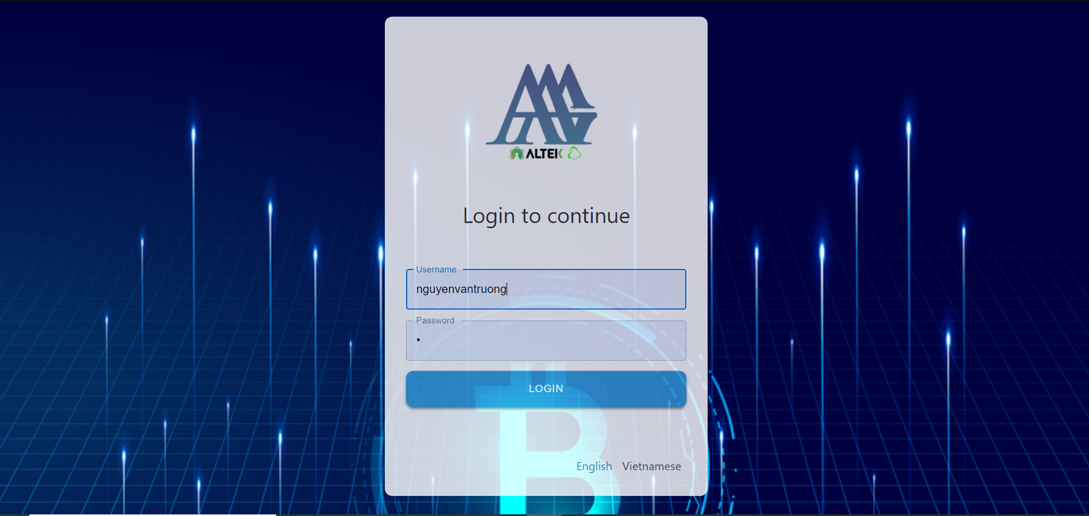

Screen description:

|  |  |  |  |  |  |  |
| --- | --- | --- | --- | --- | --- | --- |
| # | Name | Control Type | Edit | Obligatory | Default Value | Description |
| 1 | Username | Textfield | Yes | Yes | 8-50 characters | Required value between 8-50 characters |
| 2 | Password | Textfield | Yes | Yes | 8-16 characters | Required value between 8-16 characters |
| 3 | Login | Button | No | Yes | N/A | When user press this button, system will navigate to the hompage website if the username and password are correct, otherwise, it will give an error: "Username or Password is invalid" |
| 4 | English | Button | No | Yes | N/A | When user press this button, system will display all content in English |
| 5 | Vietnamese | Button | No | Yes | N/A | When user press this button, system will display all content in Vietnamese |

### Business Flow Chart

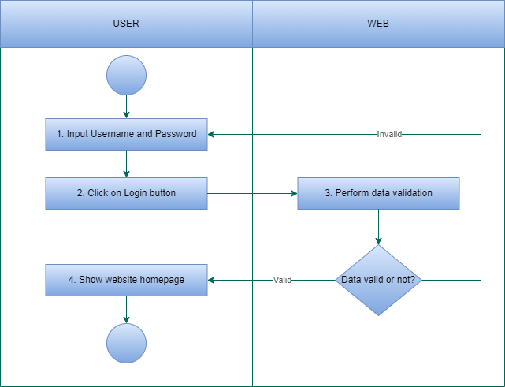

### Detail description of the business flow

Step 1: User login website

* If Username is incorrect/invalid, system show message:”Username is incorrect/invalid”
* If Password is incorrect/invalid, system show message:”Password is incorrect/invalid”
* If User don’t input Username or Password field, system show message: “User or Password is required”

If the input data is valid, go to the next step.

Step 2: System show website screen

***3.1.5 Function Affected***

|  |  |
| --- | --- |
| Affected function name | Detail description of the affect |
| None |  |

### 3.2 Timekeeping

### 3.2.1 General description

|  |  |
| --- | --- |
| **Purpose** | Have 2 sub functions are Attandance list and Request OT |
| **Users** | User, admin and partner |
| **Users affected** | User, admin and partner |
| **Applicable channel** | HRM |
| **Function path** | HRM/Timekeeping |
| **Input Data** | User already have account can login into website and perform request OT or attandance list |
| **Output Data** | System show website attendance list or allow to edit/create/delete request OT |

### Timekeeping Screen

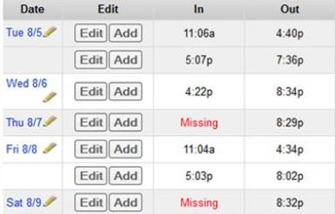

Screen description:

|  |  |  |  |  |  |  |
| --- | --- | --- | --- | --- | --- | --- |
| # | Name | Control Type | Edit | Obligatory | Default Value | Description |
| 1 | Date | Textfield | Yes | Yes | 50 characters | Required value below 50 characters |
| 2 | Edit | Button | Yes | Yes | N/A | When user press this button, system will navigate to the edit timekeeping page |
| 3 | Add | Button | No | Yes | N/A | When user press this button, system will navigate to the add timekeeping page |
| 4 | In | Button | No | Yes | N/A | System show the time employees has timekeeping when they come to the company |
| 5 | Out | Button | No | Yes | N/A | System show the time employees has timekeeping when they leave the company |

### Business Flow Chart

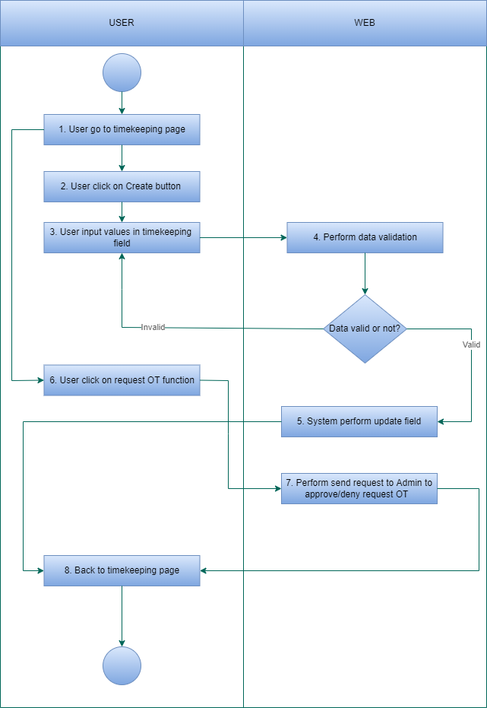

*Business Flow Chart Timekeeping as User*

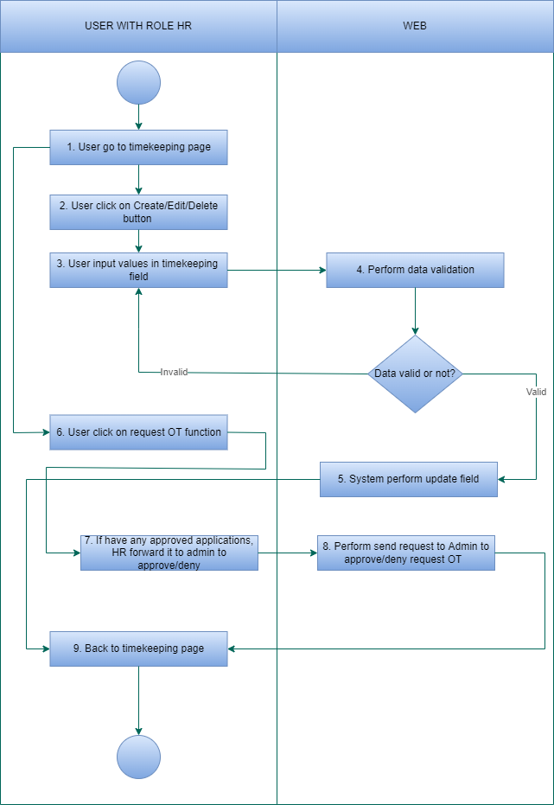

*Business Flow Chart Timekeeping as HR*

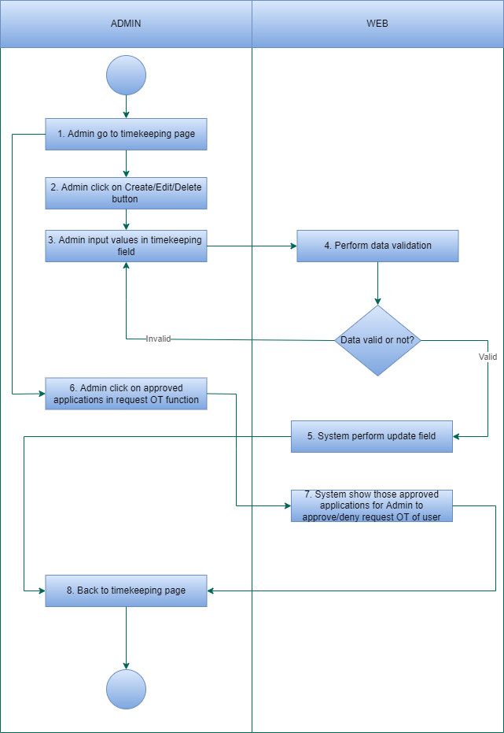

*Business Flow Chart Timekeeping as Admin*

### Detail description of the business flow

* As User

- Index:

Step 1: User login website

Step 2: User go to the Timekeeping page

Step 3: System executes a query to get all the timekeeping information of all user and show it on the page

- Create:

Step 1: User click on Add button, system will navigate to Add timekeeping page

Step 2: User input values in timekeeping name field

Step 3: System perform data validation, if the data is valid,then move to the next step

Step 4: System perform insert new timekeeping

Step 5: System show a message on the screen

Step 6: Back to index page

* As User role HR

- Index:

Step 1: User login website

Step 2: User go to the Timekeeping page

Step 3: System executes a query to get all the timekeeping information of that user and show it on the page

- Create:

Step 1: User (HR) click on Add button, system will navigate to Add timekeeping page

Step 2: User (HR) input values in timekeeping name field

Step 3: System perform data validation, if the data is valid,then move to the next step

Step 4: System perform insert new timekeeping

Step 5: System show a message on the screen

Step 6: Back to index page

- Edit:

Step 1: User (HR) click on Edit button on any timekeeping information of any user in the timekeeping list (Index), system will navigate to edit timekeeping page

Step 2: User (HR) input values in timekeeping name field

Step 3: System perform data validation, if the data is valid,then move to the next step

Step 4: System perform update new timekeeping name

Step 5: System show a message on the screen

Step 6: Back to index page

- Delete:

Step 1: User (HR) click on Delete button on any timekeeping information of any user in the timekeeping list (Index), system will show popup to confirm delete timekeeping information of that user or not

Step 2:

* If User (HR) click on Accept, then move to Step 3
* If User (HR) click on Deny , then move to Step 6

Step 3: System perform data validation, if the data is valid, then move to the next step

Step 4: System perform update field “Is deleted”

Step 5: System show a message on the screen:”User information has been deleted”

Step 6: Back to index page

- Request OT function:

Step 1: User request OT

Step 2: System will send that request to User (HR). However, user (HR) can only view that request but can not approve/deny. User (HR) must send that request to Admin so Admin will decide to approve/deny that request.

* As Admin

- Index:

Step 1: Admin login website

Step 2: Admin go to the Timekeeping page

Step 3: System executes a query to get all the timekeeping information of all user and show it on the page

- Create:

Step 1: Admin click on Add button, system will navigate to Add timekeeping page

Step 2: Admin input values in timekeeping name field

Step 3: System perform data validation, if the data is valid, then move to the next step

Step 4: System perform insert new timekeeping

Step 5: System show a message on the screen

Step 6: Back to index page

- Edit:

Step 1: Admin click on Edit button on any timekeeping information of any user in the timekeeping list (Index), system will navigate to edit timekeeping page

Step 2: Admin input values in timekeeping name field

Step 3: System perform data validation, if the data is valid, then move to the next step

Step 4: System perform update new timekeeping name

Step 5: System show a message on the screen

Step 6: Back to index page

- Delete:

Step 1: Admin click on Delete button on any timekeeping information of any user in the timekeeping list (Index), system will show popup to confirm delete timekeeping information of that user or not

Step 2:

* If Admin click on Accept, then move to Step 3
* If Admin click on Deny , then move to Step 6

Step 3: System perform data validation, if the data is valid, then move to the next step

Step 4: System perform update field “Is deleted”

Step 5: System show a message on the screen:”User information has been deleted”

Step 6: Back to index page

- Request OT function:

Step 1: User request OT

Step 2: System will send that request to User (HR). However, user (HR) can only view that request but can not approve/deny. User (HR) must send that request to Admin so Admin will decide to approve/deny that request.

Step 3: Admin will approve/deny that request and send back to user (HR). After that user (HR) will forward back to user. If Admin deny that request then must clearly state the reason.

***3.2.5 Function Affected***

|  |  |
| --- | --- |
| Affected function name | Detail description of the affect |
| None |  |

* 1. ***Request Leave***

### 3.3.1 General description

|  |  |
| --- | --- |
| **Purpose** | Have 2 sub functions are Take a leave of absence and Annual Leave |
| **Users** | User, admin and partner |
| **Users affected** | User, admin and partner |
| **Applicable channel** | HRM |
| **Function path** | HRM/Request_leave |
| **Input Data** | User already have account can login into website and perform take a leave of absence or annual leave |
| **Output Data** | System show number of days off per year (number of days off/remaining days off) or allow to edit/create/delete application for leave |

### Request Leave Screen

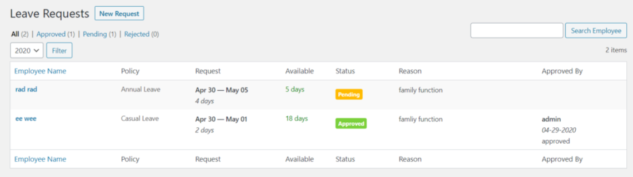

Screen description:

|  |  |  |  |  |  |  |
| --- | --- | --- | --- | --- | --- | --- |
| # | Name | Control Type | Edit | Obligatory | Default Value | Description |
| 1 | Employee Name | Text | Yes | Yes | 50 characters | System show user name |
| 2 | Policy | Text | Yes | Yes | Annual leave  Casual leave  Policy | System show type of policy |
| 3 | Request | Text | Yes | Yes | DD:MM:YYYY | System show the number days off of the user |
| 4 | Available | Text | Yes | Yes | 50 characters | System show the total days user request for leave |
| 5 | Status | Text | Yes | Yes | Pending  Approved  Denied | System show the status of the request |
| 6 | Reason | Text | Yes | Yes | 50 characters | System show the users reason for leaving |
| 7 | Approved By | Text | Yes | Yes | 50 characters | System show the name of admin that approve the request |
| 8 | Search box | Textbox | Yes | Yes | 50 characters | Allow to enter values lower than 50 characters |
| 9 | Search employees | Button | No | Yes | N/A | After user click on this button, system will search the information that user has inputed in search box |
| 10 | Dropdown button | Button | No | Yes | N/A | User can choose the year they want to filter |
| 11 | Filter | Button | No | Yes | N/A | After user click on this button, system will filter the information of the year user has chose in dropdown button |
| 12 | New Request | Button | No | Yes | N/A | After user click on this button, system will navigate to the add request leave page |

### Business Flow Chart

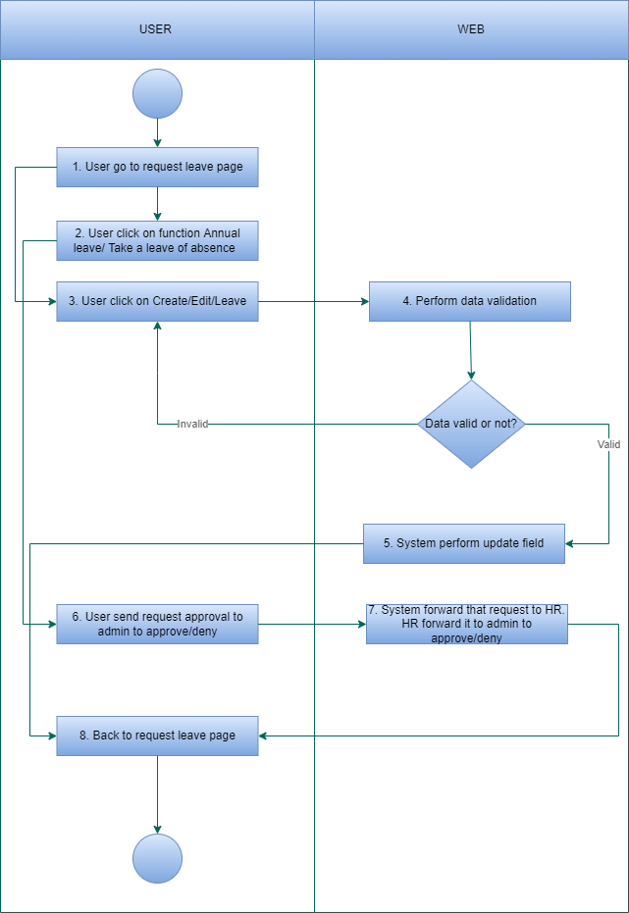

*Business Flow Chart Request Leave as User*

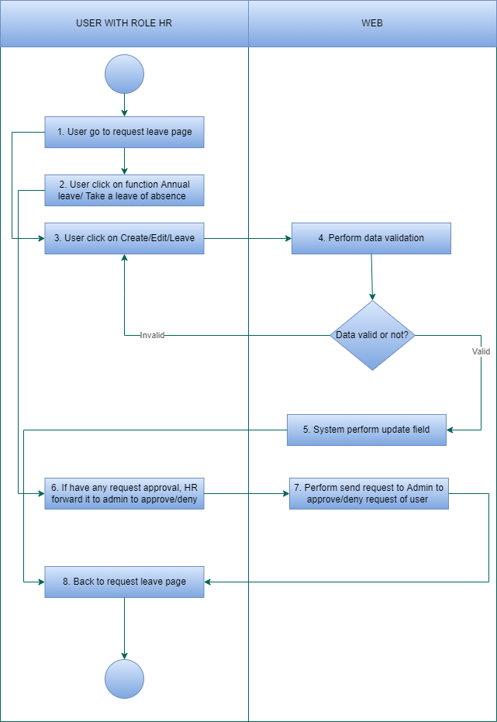

*Business Flow Chart Request Leave as HR*

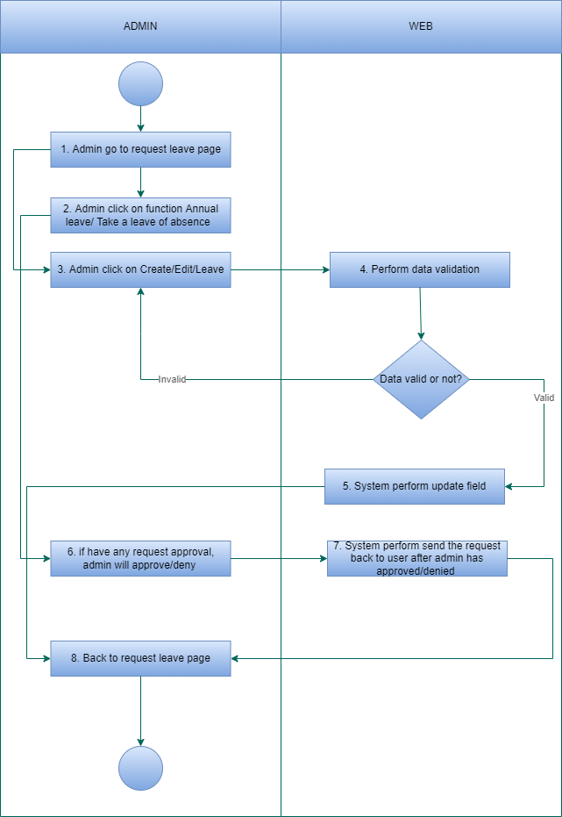

*Business Flow Chart Request Leave as Admin*

### Detail description of the business flow

* As User

- Index:

Step 1: User login website

Step 2: User go to the Request leave page

Step 3: System executes a query to get all the request leave information of that user and show it on the page

- Annual leave:

Step 1: User click on Annual leave function

Step 2: System show number of days off and that user remaining days off

- Create Take a leave of absence:

Step 1: User click on Add button, system will navigate to Add request leave page

Step 2: User click on Take a leave of absence function

Step 2: User input values in Take a leave of absence name field

Step 3: System perform data validation, if the data is valid, then move to the next step

Step 4: System perform insert new Take a leave of absence

Step 5: System show a message on the screen

Step 6: Back to index page

* As User role HR

- Index:

Step 1: User (HR) login website

Step 2: User (HR) go to the Request leave page

Step 3: System executes a query to get all the request leave information of all user and show it on the page

- Annual leave:

Step 1: User (HR) click on Annual leave function

Step 2: System show number of days off and all user remaining days off

- Create Take a leave of absence:

Step 1: User (HR) click on Add button, system will navigate to Add Take a leave of absence page

Step 2: User (HR) input values in Take a leave of absence name field

Step 3: System perform data validation, if the data is valid, then move to the next step

Step 4: System perform insert new Take a leave of absence

Step 5: System show a message on the screen

Step 6: Back to index page

- Edit Take a leave of absence:

Step 1: User (HR) click on Edit button on any Take a leave of absence information of any user in the Take a leave of absence list (Index), system will navigate to edit Request leave page

Step 2: User (HR) input values in Take a leave of absence name field

Step 3: System perform data validation, if the data is valid, then move to the next step

Step 4: System perform update new Take a leave of absence name

Step 5: System show a message on the screen

Step 6: Back to index page

- Delete Take a leave of absence:

Step 1: User (HR) click on Delete button on any Take a leave of absence information of any user in the Take a leave of absence list (Index), system will show popup to confirm delete Take a leave of absence information of that user or not

Step 2:

* If User (HR) click on Accept, then move to Step 3
* If User (HR) click on Deny , then move to Step 6

Step 3: System perform data validation, if the data is valid then move to the next step

Step 4: System perform update field “Is deleted”

Step 5: System show a message on the screen:”User information has been deleted”

Step 6: Back to index page

- Request approval:

Step 1: User request approval Annual leave/Take a leave of absence

Step 2: System will send that request to User (HR). However, user (HR) can only view that request but can’t approve/deny. User (HR) must send that request to Admin so Admin will decide to approve/deny that request.

* As Admin

- Index:

Step 1: Admin login website

Step 2: Admin go to the Request leave page

Step 3: System executes a query to get all the request leave information of all user and show it on the page

- Annual leave:

Step 1: Admin click on Annual leave function

Step 2: System show number of days off and all user remaining days off

- Create Take a leave of absence:

Step 1: Admin click on Add button, system will navigate to Add Take a leave of absence page

Step 2: Admin input values in timekeeping name field

Step 3: System perform data validation, if the data is valid, then move to the next step

Step 4: System perform insert new timekeeping

Step 5: System show a message on the screen

Step 6: Back to index page

- Edit Take a leave of absence:

Step 1: Admin click on Edit button on any Take a leave of absence information of any user in the Take a leave of absence list (Index), system will navigate to edit Take a leave of absence page

Step 2: Admin input values in Take a leave of absence name field

Step 3: System perform data validation, if the data is valid, then move to the next step

Step 4: System perform update new Take a leave of absence name

Step 5: System show a message on the screen

Step 6: Back to index page

- Delete Take a leave of absence:

Step 1: Admin click on Delete button on any Take a leave of absence information of any user in the Take a leave of absence list (Index), system will show popup to confirm delete Take a leave of absence information of that user or not

Step 2:

* If Admin click on Accept, then move to Step 3
* If Admin click on Deny , then move to Step 6

Step 3: System perform data validation, if the data is valid, then move to the next step

Step 4: System perform update field “Is deleted”

Step 5: System show a message on the screen:”User information has been deleted”

Step 6: Back to index page

- Request Annual leave/ Take a leave of absence function:

Step 1: User request Annual leave/ Take a leave of absence

Step 2: System will send that request to User (HR). However, user (HR) can only view that request but can’t approve/deny. User (HR) must send that request to Admin so Admin will decide to approve/deny that request.

Step 3: Admin will approve/deny that request and send back to user (HR). After that user (HR) will forward back to user. If Admin deny that request then must clearly state the reason.

***3.3.5 Function Affected***

|  |  |
| --- | --- |
| Affected function name | Detail description of the affect |
| None |  |

* 1. ***Manage Profile***

### 3.4.1 General description

|  |  |
| --- | --- |
| **Purpose** | Allow root,admin to Create/Edit/Delete profile of user |
| **Users** | User, admin and partner |
| **Users affected** | User, admin and partner |
| **Applicable channel** | HRM |
| **Function path** | HRM/Manage_profile |
| **Input Data** | Root,Admin can create/edit/delete profile of user |
| **Output Data** | System show profile of user after create/edit/delete |

### Manage Profile Screen

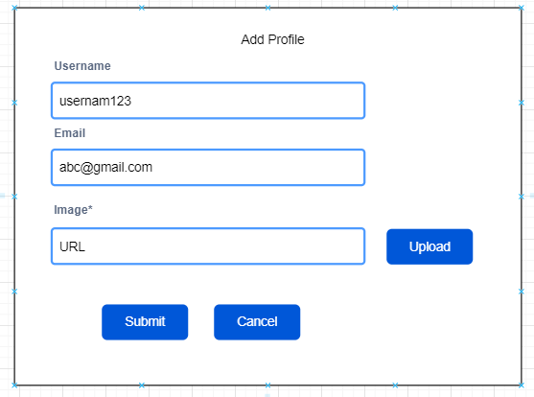

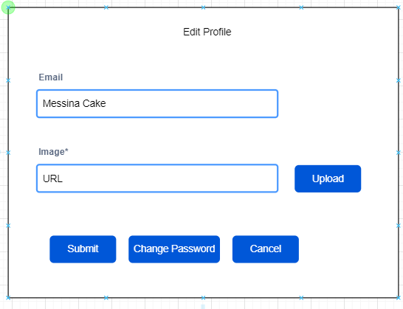

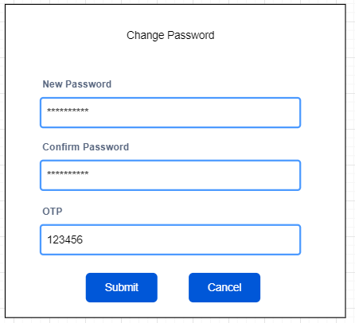

Screen description:

|  |  |  |  |  |  |  |
| --- | --- | --- | --- | --- | --- | --- |
| # | Name | Control Type | Edit | Obligatory | Default Value | Description |
| 1 | Username | Textbox | Yes | Yes | 8-50 characters | Required value must be between 8-50 characters |
| 2 | Email | Textbox | Yes | Yes | 8-50 characters | Required value must be between 8-50 characters |
| 3 | Imagine | Textbox | Yes | Yes | 100 characters | Required value must be shorter than 100 characters |
| 4 | New password | Textbox | Yes | Yes | 100 characters | Required value must be shorter than 100 characters |
| 5 | Confirm password | Textbox | Yes | Yes | 100 characters | Required value must be shorter than 100 characters |
| 6 | OTP | Textbox | Yes | Yes | 6 characters | Required value must be 6 characters |
| 7 | Upload | Button | No | Yes | N/A | After click on this button, system will navigate to user device folder for user to choose which folder to upload |
| 8 | Submit | Button | No | Yes | N/A | After click on this button, system will navigate to website screen |
| 9 | Cancel | Button | No | Yes | N/A | After click on this button, system will navigate back to Add/Edit/Delete profile screen |

### Business Flow Chart

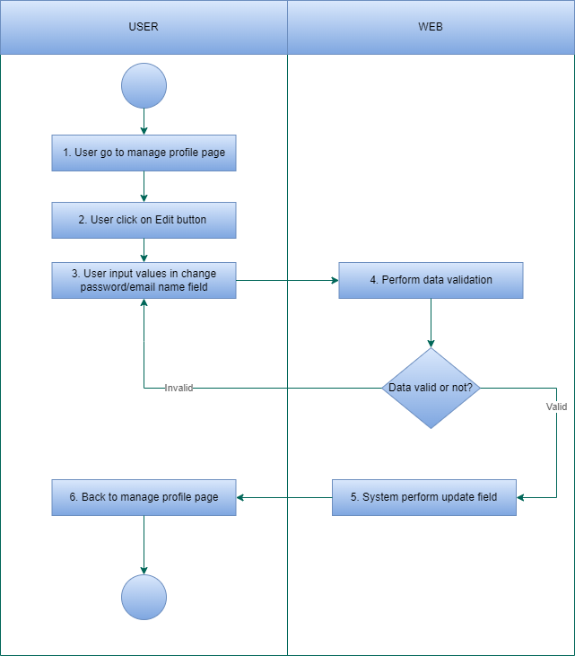

*Manage Profile as User*

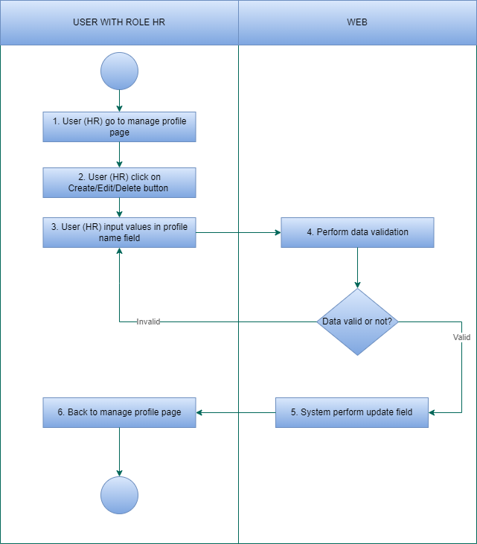

*Manage Profile as User (HR)*

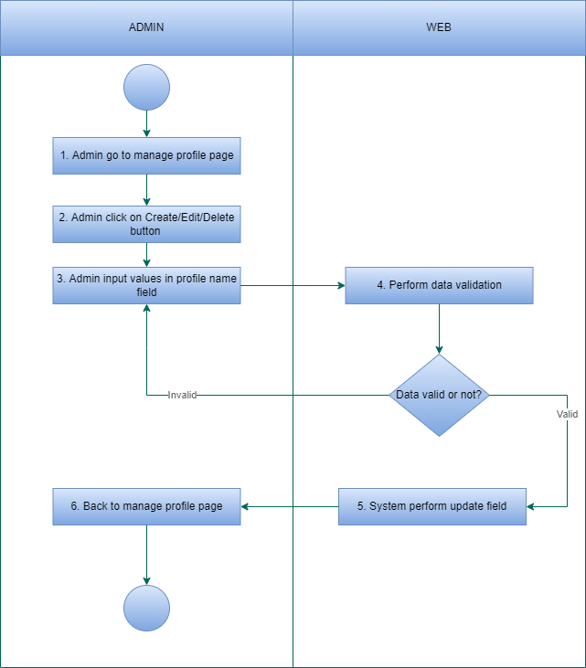

*Manage profile as Admin*

### Detail description of the business flow

* Manage profile as User

- Index

Step 1: User go to manage profile page

Step 2: System executes a query to get all information of that user and show it on the page

- Edit

Step 1: User click on the edit button in the profile list (Index), system will navigate to edit information page

Step 2: User input data in the information name textbox (user can only allow to change email/ password)

Step 3: System perform data validation, if the data is valid,then go to next step

Step 4: System perform update new information

Step 5: System show a message on the screen: "Email has been changed" or “Password has been changed"

Step 6: Back to Index page

* Manage profile as User (HR)

- Index

Step 1: User (HR) go to manage profile page

Step 2: System executes a query to get all profile t of that user and show it on the page

- Create

Step 1: User (HR) click on Add button and go to add profile page

Step 2: User (HR) input data in the profile name textbox

Step 3: System perform data validation, if the data is valid, then go to the next step

Step 4: System perform insert new profile name

Step 5: System show a message on the screen: "Profile has been created"

Step 6: Back to Index page

-Edit

Step 1: User (HR) click on the edit button on any user in the profile list (Index), system will navigate to edit profile page

Step 2: User (HR) input data in the profile name textbox

Step 3: System perform data validation, if the data is valid, then go to next step

Step 4: System perform update new information

Step 5: System show a message on the screen: "Information has been changed"

Step 6: Back to Index page

-Delete

Step 1: User (HR) click on the edit button on any user in the profile list (Index), system will show popup

Step 2:

* If User (HR) click on Accept, then move to Step 3
* If User (HR) click on Deny , then move to Step 6

Step 3: System perform data validation, if the data is valid, then move to the next step

Step 4: System perform update field “Is deleted”

Step 5: System show a message on the screen:”Profile has been deleted”

Step 6: Back to index page

* Manage profile as Admin

- Index

Step 1: Admin go to manage profile page

Step 2: System executes a query to get all profile of that admin and show it on the page

- Create

Step 1: Admin click on Add button and go to add profile page

Step 2: Admin input data in the profile name textbox

Step 3: System perform data validation, if the data is valid, then go to the next step

Step 4: System perform insert new profile name

Step 5: System show a message on the screen: "Profile has been created"

Step 6: Back to Index page

-Edit

Step 1: Admin click on the edit button on any admin in the profile list (Index), system will navigate to edit profile page

Step 2: Admin input data in the profile name textbox

Step 3: System perform data validation, if the data is valid, then go to next step

Step 4: System perform update new information

Step 5: System show a message on the screen: "Information has been changed"

Step 6: Back to Index page

-Delete

Step 1: Admin click on the edit button on any admin in the profile list (Index), system will show popup

Step 2:

* If Admin click on Accept, then move to Step 3
* If Admin click on Deny , then move to Step 6

Step 3: System perform data validation, if the data is valid, then move to the next step

Step 4: System perform update field “Is deleted”

Step 5: System show a message on the screen:”Profile has been deleted”

Step 6: Back to index page

### 3.4.5 Function Affected

|  |  |
| --- | --- |
| Affected function name | Detail description of the affect |
| None |  |

### 3.5 Payroll

### 3.5.1 General description

|  |  |
| --- | --- |
| **Purpose** | Have 2 sub function payslip and payment |
| **Users** | User, admin and partner |
| **Users affected** | User, admin and partner |
| **Applicable channel** | HRM |
| **Function path** | HRM/Payroll |
| **Input Data** | User click on Payroll page and can view detailed payslip |
| **Output Data** | System show detailed payslip |

### 3.5.2 Payroll Screen

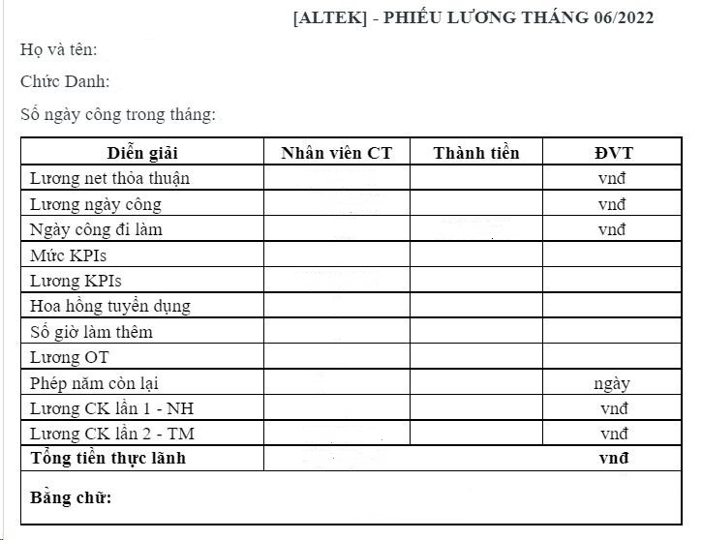

*Payslip function*

Screen description:

|  |  |  |  |  |  |  |
| --- | --- | --- | --- | --- | --- | --- |
| # | Name | Control Type | Edit | Obligatory | Default Value | Description |
| 1 | Name | Text | Yes | Yes | 50 characters | Show employee name |
| 2 | Job title | Text | Yes | Yes | 50 characters | Show employee department |
| 3 | Number of working days in the month | Text | Yes | Yes | 50 characters | Show the number of days employee has worked in the month |
| 4 | Explain | Textfield | No | Yes | 50 characters | Show the information in the payslip |
| 5 | Official staff | Textfield | No | Yes | 50 characters | Show name of the official employee in the payslip |
| 6 | Money | Textfield | Yes | Yes | 50 characters | Show the amount corresponding to the number of working days |
| 7 | Unit | Textfield | Yes | Yes | VNĐ | Show the employee salary unit |
| 8 | Salary agreement | Textfield | Yes | Yes | VNĐ | Show employee salary as agreed |
| 9 | Working day salary | Textfield | Yes | Yes | VNĐ | Show the employee salary for the number of working days |
| 10 | Working day | Textfield | Yes | Yes | 20 characters | Show the number of working days of the employee |
| 11 | KPI | Textfield | Yes | Yes | 20 characters | Show employee KPI level |
| 12 | KPI salary | Textfield | Yes | Yes | 20 characters | Show employee KPI salary |
| 13 | Recruitment commission | Textfield | Yes | Yes | 20 characters | Show recruitment commission |
| 14 | Overtime hours | Textfield | Yes | Yes | 20 characters | Show employee overtime hours |
| 15 | OT salary | Textfield | Yes | Yes | 20 characters | Show employee OT salary |
| 16 | Remaining number of annual leave days | Textfield | Yes | Yes | DD | Show the number of employee remaining annual leave |
| 17 | Banking | Textfield | Yes | Yes | VNĐ | Show the form of salary transfer to employee via banking |
| 18 | Cash | Textfield | Yes | Yes | VNĐ | Show the form of salary transfer to employee via cash |
| 19 | Total amount by number | Textfield | Yes | Yes | VNĐ | Show the actual total amount received in numbers |
| 20 | Total amount by text | Textfield | Yes | Yes | 80 characters | Show the actual total amount received in words |

### 3.5.3 Business Flow Chart

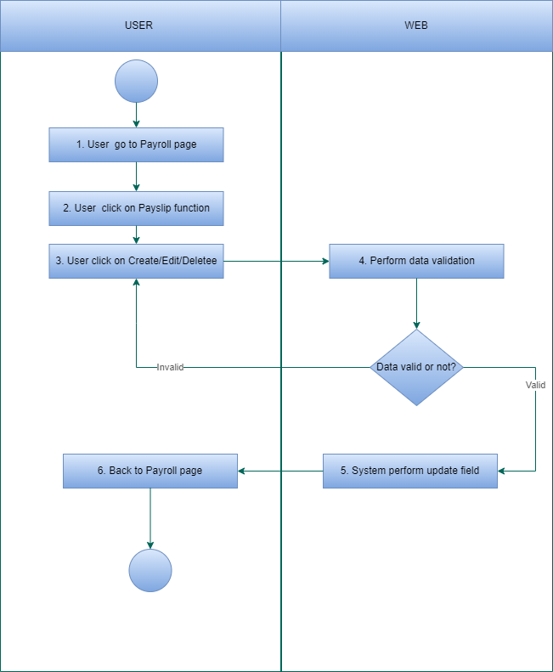

*Payroll as User*

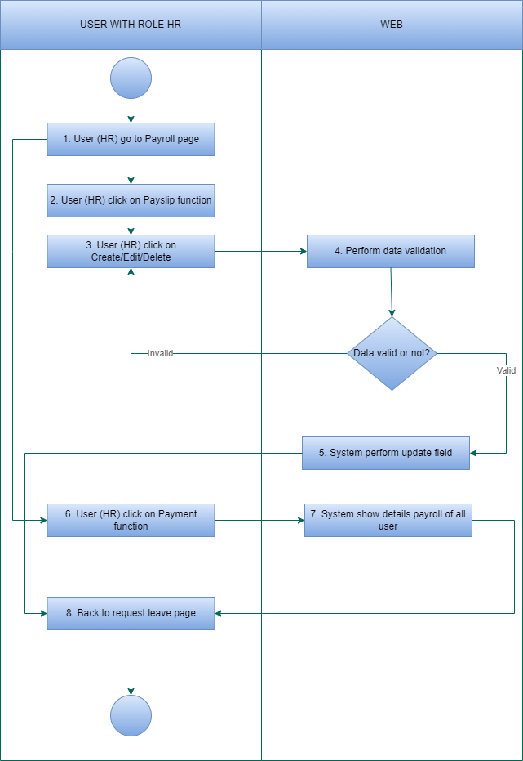

*Payroll as User (HR)*

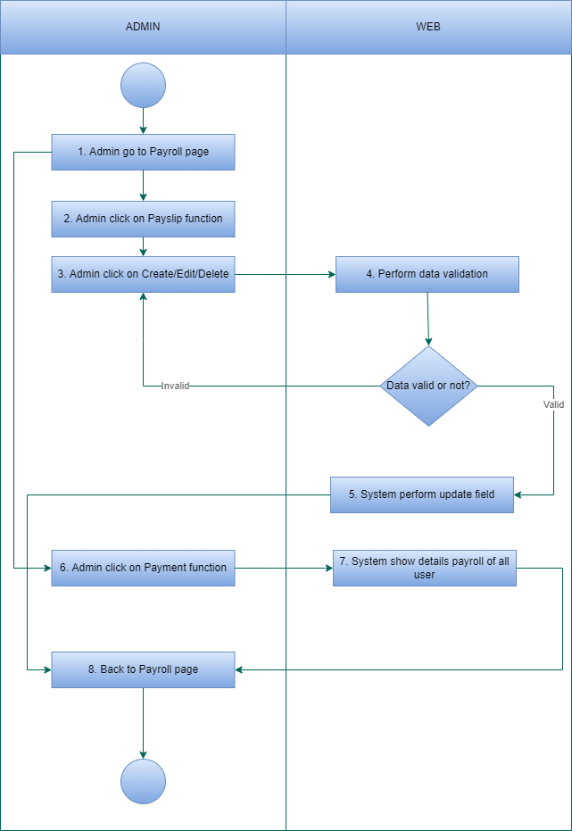

*Payroll as Admin*

### 3.5.4 Detail description of the business flow

* Payroll as User

- Index

Step 1: User go to payroll page

Step 2: System executes a query to get payroll of that user and show it on the page

Step 3: User click on payslip function

- Edit

Step 1: User click on the edit button in the payslip list (Index), system will navigate to edit payslip page

Step 2: User input data in the payslip name textbox

Step 3: System perform data validation, if the data is valid then go to next step

Step 4: System perform update new payslip

Step 5: System show a message on the screen

Step 6: Back to Index page

* Payroll as User (HR)

- Index

Step 1: User (HR) go to payroll page

Step 2: System executes a query to get payroll of all user and show it on the page

- Create:

Step 1: User (HR) click on Add button and go to add payslip/payment page

Step 2: User (HR) input data in payslip/payment name textbox

Step 3: System perform data validation, if the data is valid, then go to the next step

Step 4: System perform insert new payslip/payment

Step 5: System show a message on the screen: "Payslip/payment has been created"

Step 6: Back to Index page

- Edit:

Step 1: User (HR) click on the edit button on any user in the payslip/payment list (Index), system will navigate to edit profile page

Step 2: User (HR) input data in payslip/payment name textbox

Step 3: System perform data validation, if the data is valid, then go to next step

Step 4: System perform update new payslip/payment

Step 5: System show a message on the screen: "Payslip/payment has been changed"

Step 6: Back to Index page

- Delete:

Step 1: User (HR) click on the edit button on any user in payslip/payment list (Index), system will show popup

Step 2:

* If User (HR) click on Accept, then move to Step 3
* If User (HR) click on Deny, then move to Step 6

Step 3: System perform data validation, if the data is valid, then move to the next step

Step 4: System perform update field “Is deleted”

Step 5: System show a message on the screen:” Payslip/payment has been deleted”

Step 6: Back to index page

* Payroll as Admin

- Index

Step 1: Admin go to Payroll page

Step 2: System executes a query to get payroll of that admin and show it on the page

- Create

Step 1: Admin click on Add button and go to add payslip/payment page

Step 2: Admin input data in payslip/payment textbox

Step 3: System perform data validation, if the data is valid, then go to the next step

Step 4: System perform insert new payslip/payment name

Step 5: System show a message on the screen: "Payslip/payment has been created"

Step 6: Back to Index page

-Edit

Step 1: Admin click on the edit button on any admin in the payslip/payment list (Index), system will navigate to edit profile page

Step 2: Admin input data in the payslip/payment name textbox

Step 3: System perform data validation, if the data is valid, then go to next step

Step 4: System perform update new payslip/payment

Step 5: System show a message on the screen: "Payslip/payment has been changed"

Step 6: Back to Index page

-Delete

Step 1: Admin click on the edit button on any admin in the payslip/payment list (Index), system will show popup

Step 2:

* If Admin click on Accept, then move to Step 3
* If Admin click on Deny, then move to Step 6

Step 3: System perform data validation, if the data is valid, then move to the next step

Step 4: System perform update field “Is deleted”

Step 5: System show a message on the screen:” Payslip/payment has been deleted”

Step 6: Back to index page

### 3.5.5 Function Affected

|  |  |
| --- | --- |
| Affected function name | Detail description of the affect |
| None |  |

# Non-Functional Requirements

## Performance Requirements

This subsection specifies that the programmer must be familiar with the system functions and the business flow.

## Safety Requirements

Safety Requirements (Optional) refers to a solution that protects solution content or solution components from accidental or malicious access, use, modification, destruction, or disclosure.

|  |  |  |
| --- | --- | --- |
| **Title** | **Criteria** | **Note** |
| Privacy | Password and message encryption | The system should follow the encryption algorithm according to the data encryption standard. |

## Privacy Requirements

N/A

## Software Quality Requirements

N/A

# Appendix