

**Winform - App PLAY MUSIC**

**(PRN292)**

|  |  |
| --- | --- |
| **<PRN292>** | |
| **Group Members** | Vũ Xuân Lực – HE141117  Nguyễn Thành Long– HE140271 |
| **Supervisor** | Lecturer: Tạ Đình Tiến |

– Hanoi, August 2019 –

# I. Project Report

## 1. Status Report

|  |  |  |  |
| --- | --- | --- | --- |
| **#** | **Work Item** | **Status** | **Notes (Work Item in Details)** |
| 1 | Learn about available music applications | Completed | Research the requirements that the app music needs to have |
| 2 | Research the user's requirements | Completed | Research what requirements a user requires the system to have (Features) |
| 3 | Research about functional requirements | Completed | Research and design about screen processing flow, user decentralize, relationship design of systems-existing systems |
| 4 | Research about none- functional requirements | Completed | Set requirements about External interfaces,  Test quality app |
| 5 | Set notifications for system | Completed | Set notifications when a program executes features |

## 2. Team Involvements

|  |  |  |
| --- | --- | --- |
| **#** | **Task** | **Notes (Task Details, etc.)** |
| 1 | Register | Format input as email, name, password…etc.  Send mail to verification code. |
| 2 | Sign in | Exist in database will login success |
| 3 | Research songs by name and artists | Can search match, just have characters in name song |
| 4 | List songs, artists, album | Set requirements that, when the functions are to be performed, must comply with |
| 5 | Play music | Slider must run follow time of song when click song by list songs displayed |
| 6 | Pause music | Play music will pause, if click one more play music again |
| 7 | Next music, previous song | Click will next to song and previous song |
| 8 | Sound | Sound can increase or decrease |
| 9 | Auto next song | Then end song will auto next song |
| 10 | Now playing | Dialog now playing include avatar and name of song |
| 11 | Most listened | Display list views of songs |
| 13 | Music gender | Display list type gender |
| 14 | Play Lists |  |
| 15 | Favourite |  |
| 16 | Local music |  |

1. **Introduction**

Application music is a application utilities to play music, familiar with the most people. My application with name is VMUSIC, it’s include basic feature of a application as: play music, create album, create play list… VMUSIC use programming language C# -Three layer architecture, framework 4.0, IDE-Visual Studio 2019.

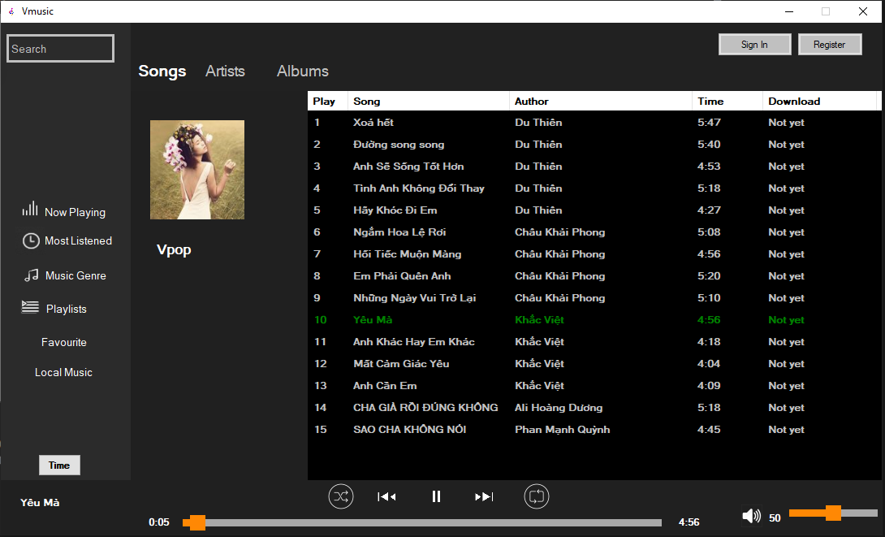

1. **Database (SQL server)**
2. **Task**
3. ***Register***

Click button [Register] from form Main, then form Register will display:

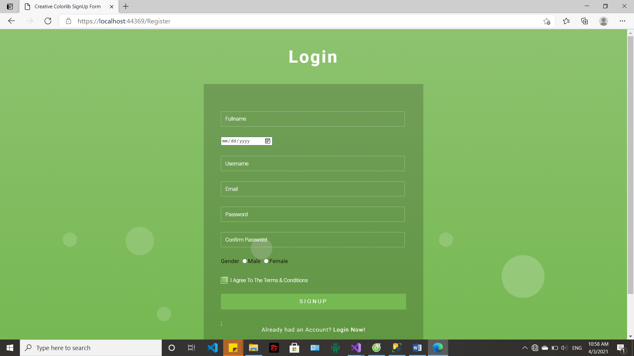

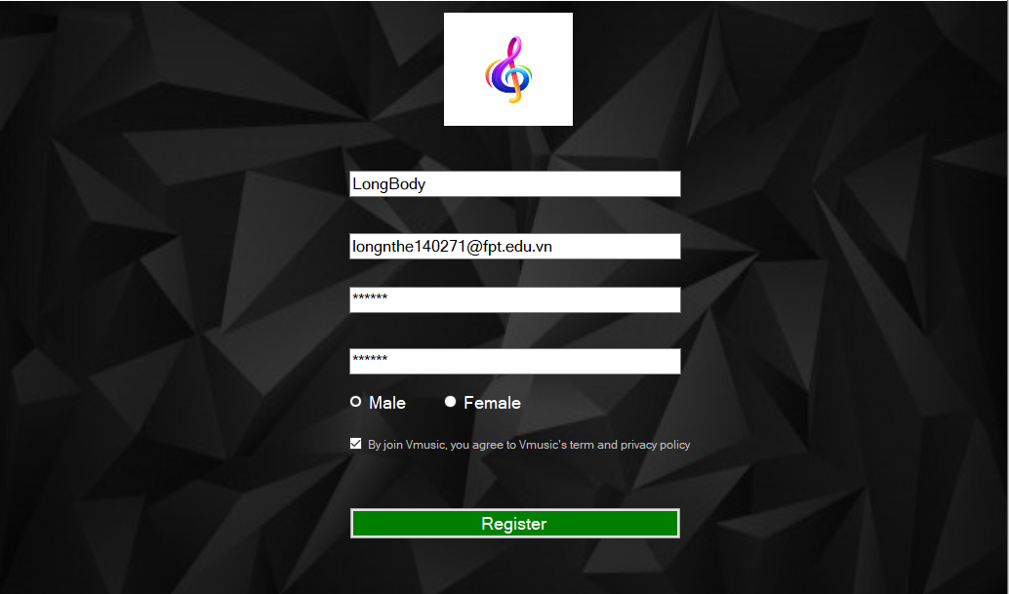

Fill this form, click button [Register] form verification will display:

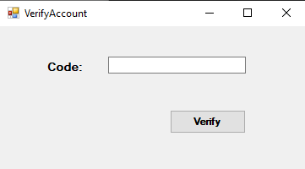

Code already sent your mail:

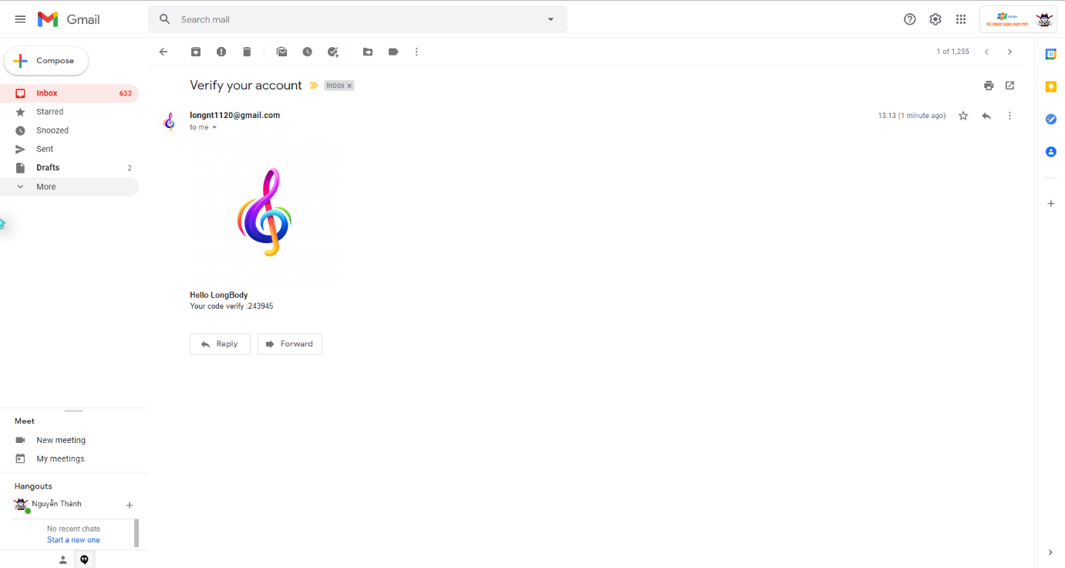

Then verify successful, your account can login App.

1. ***Login***

Click button [Login] from form Main, then form Login will display:

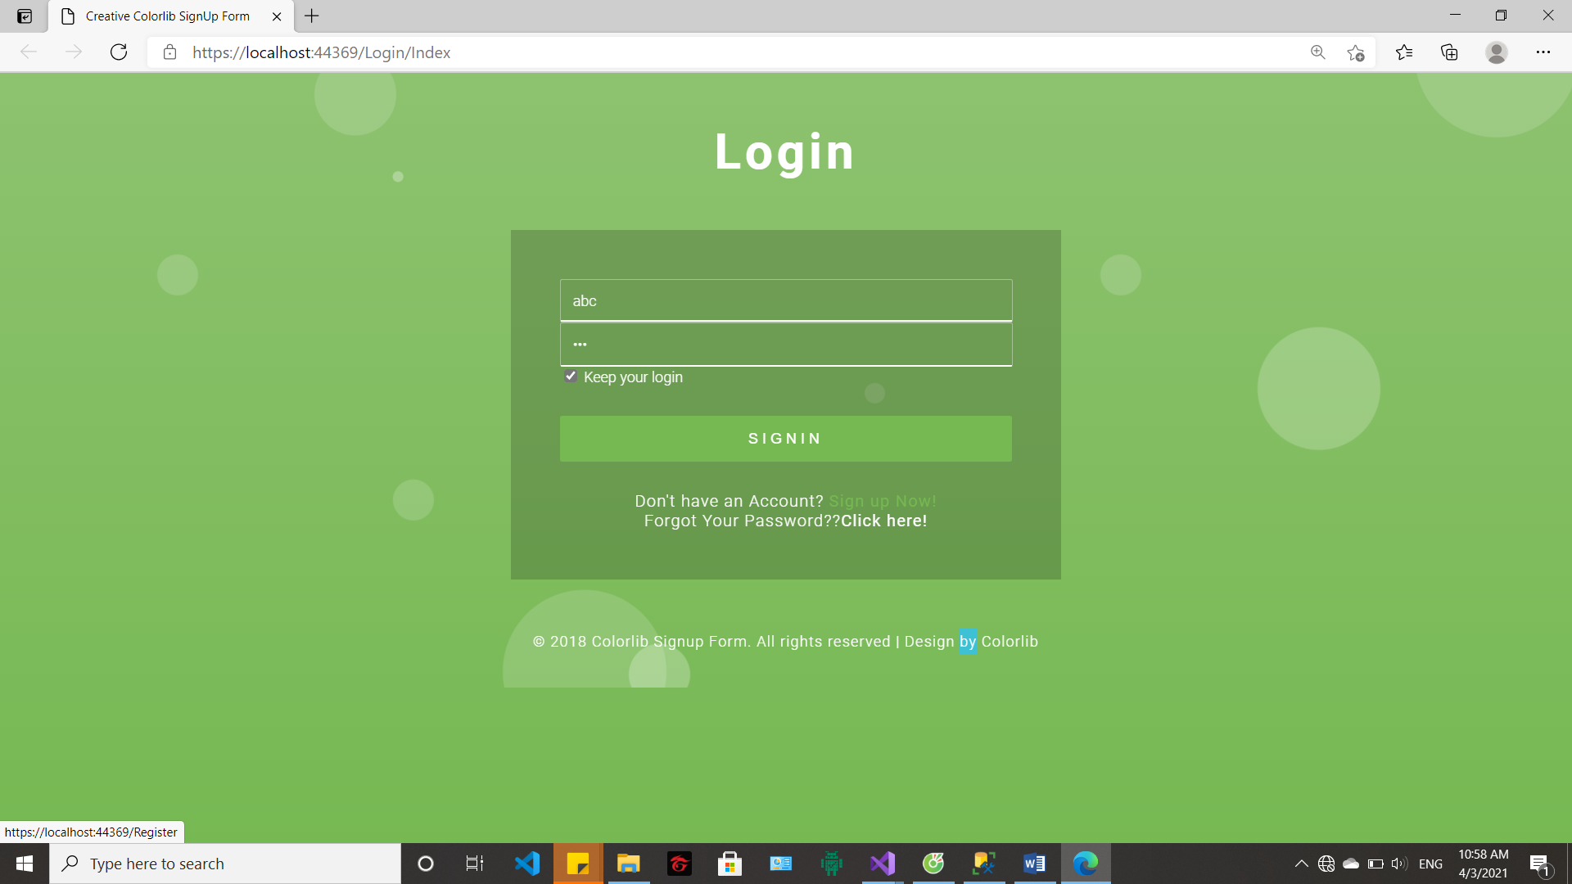

1. ***Research songs by name and artists***

Enter input search then click enter, list song relate will display:

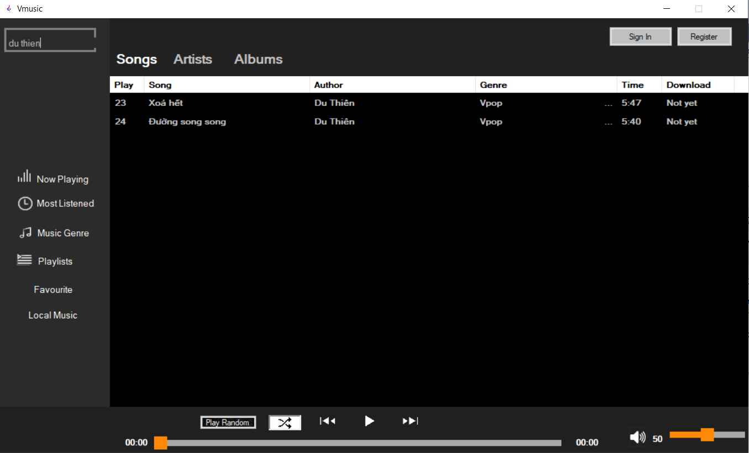

1. ***List songs, artists, album***

List songs:



List artists:

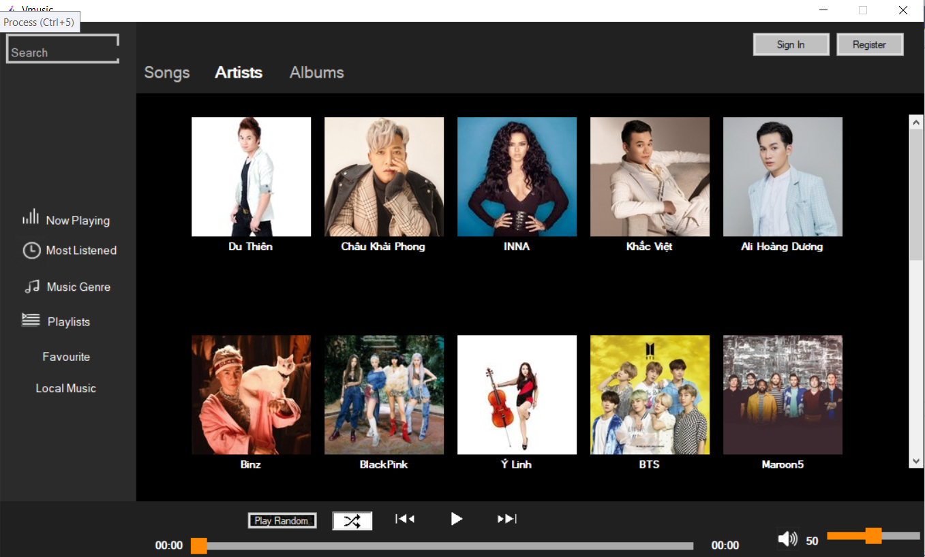

When click a artist, list songs by artist will display:

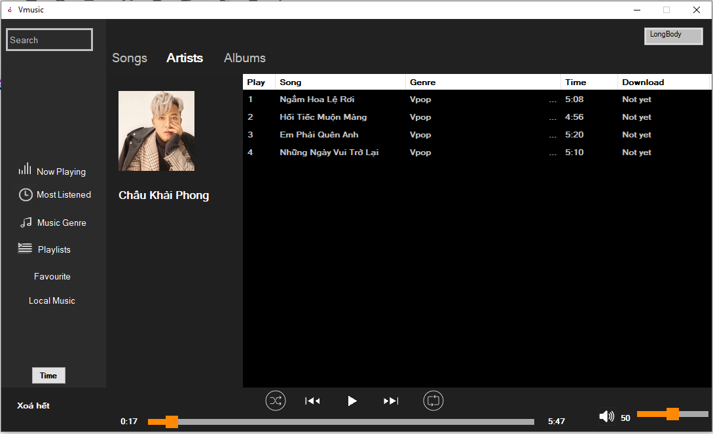

List album:

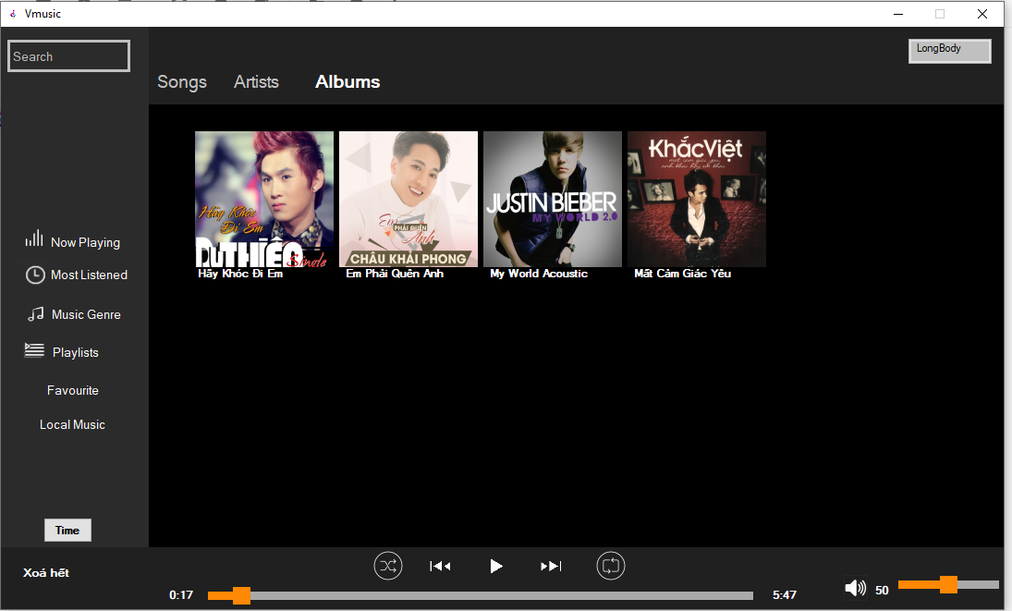

When click a album, list songs by album will display:

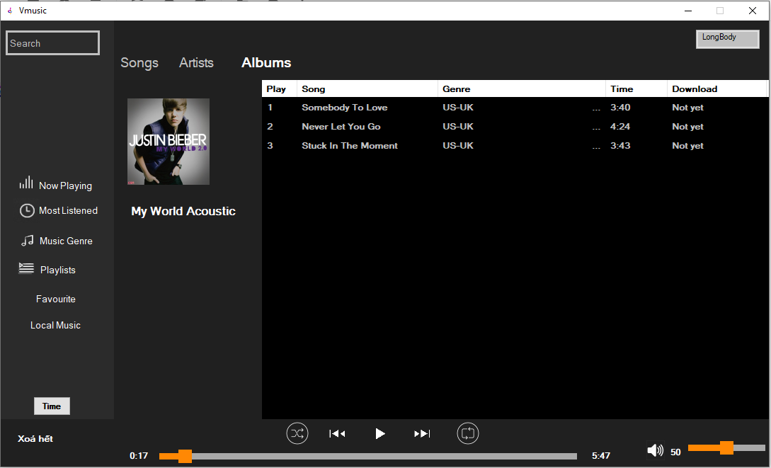

1. ***Play and pause music***

Play:

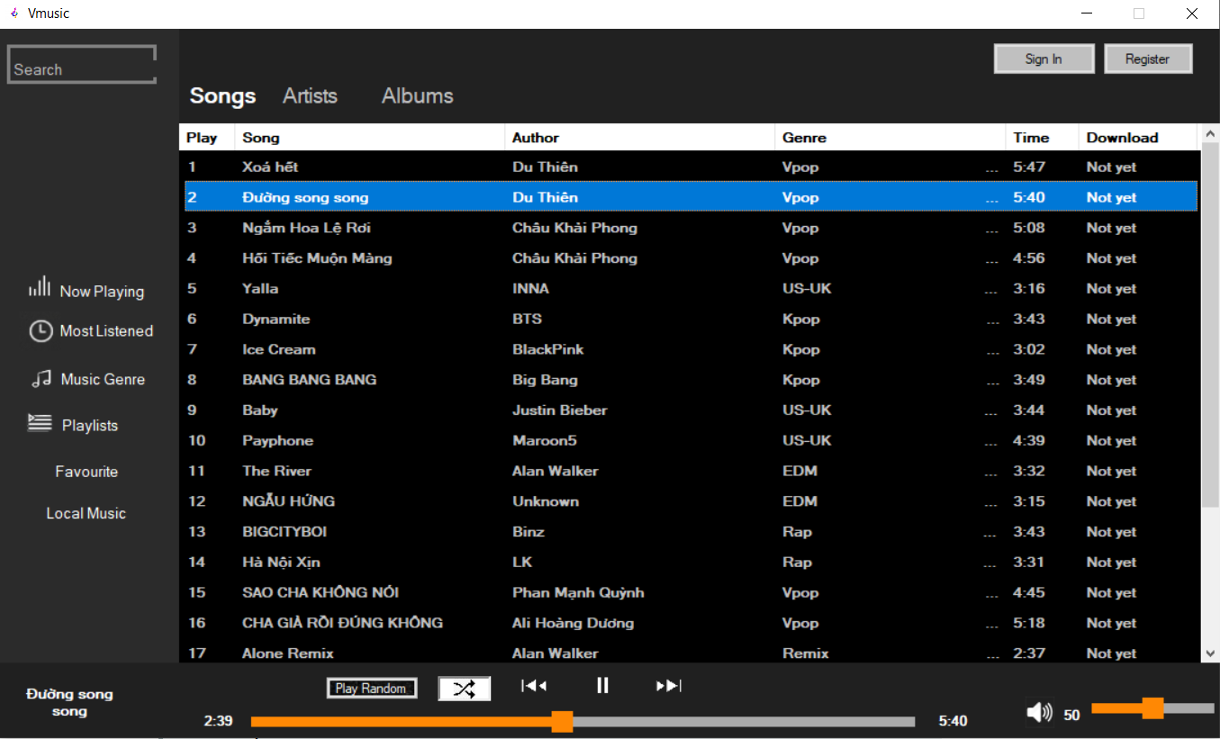

Pause:



1. ***Detail music genre***

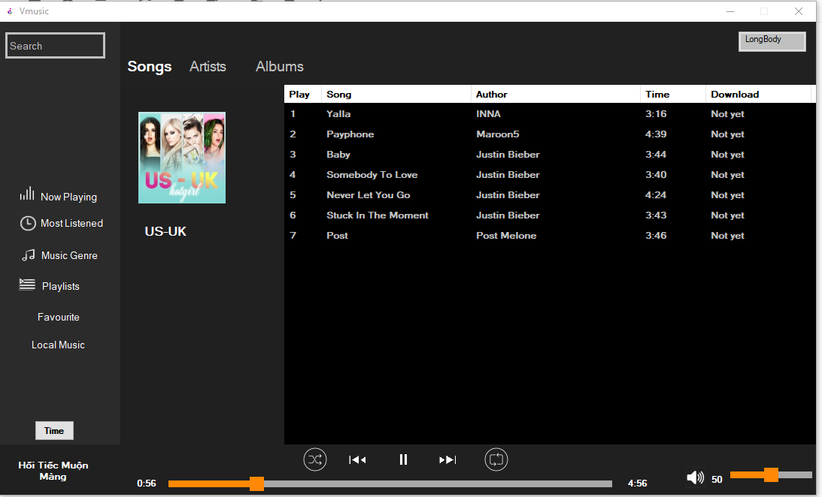

1. ***Add song to playlist***

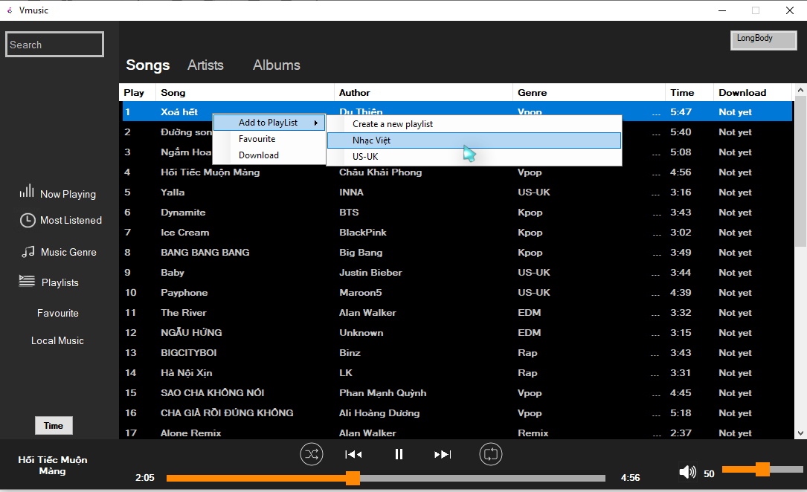

1. ***Form playlist***

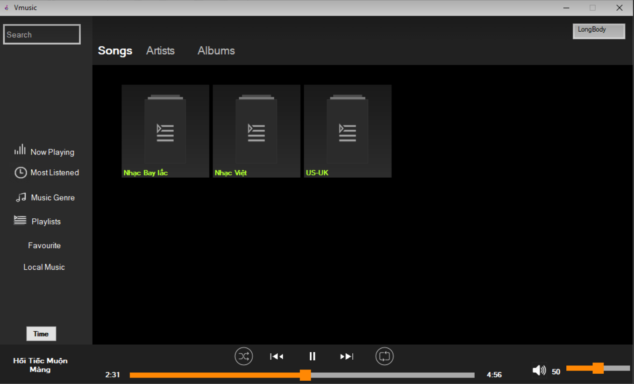

1. ***Play list detail***

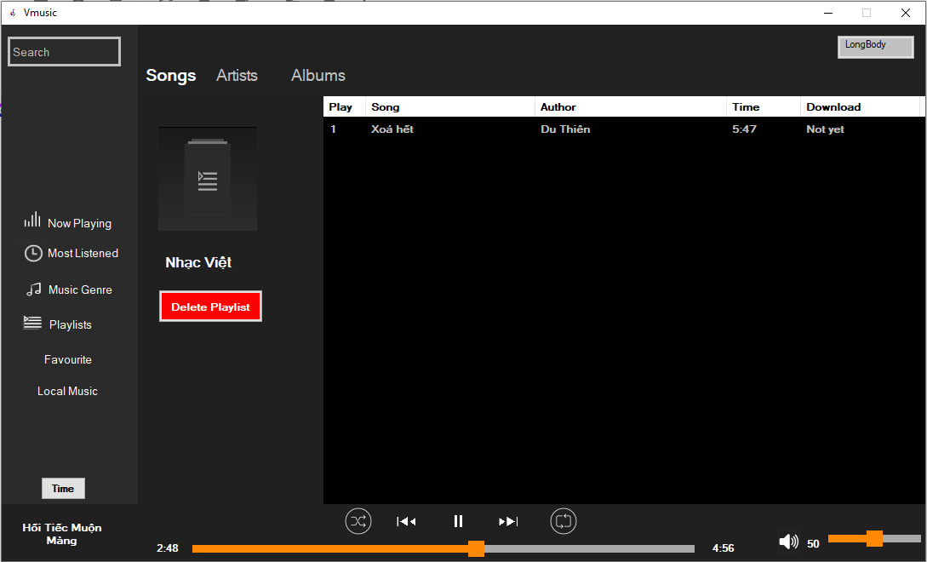

1. ***Add song to favourite***

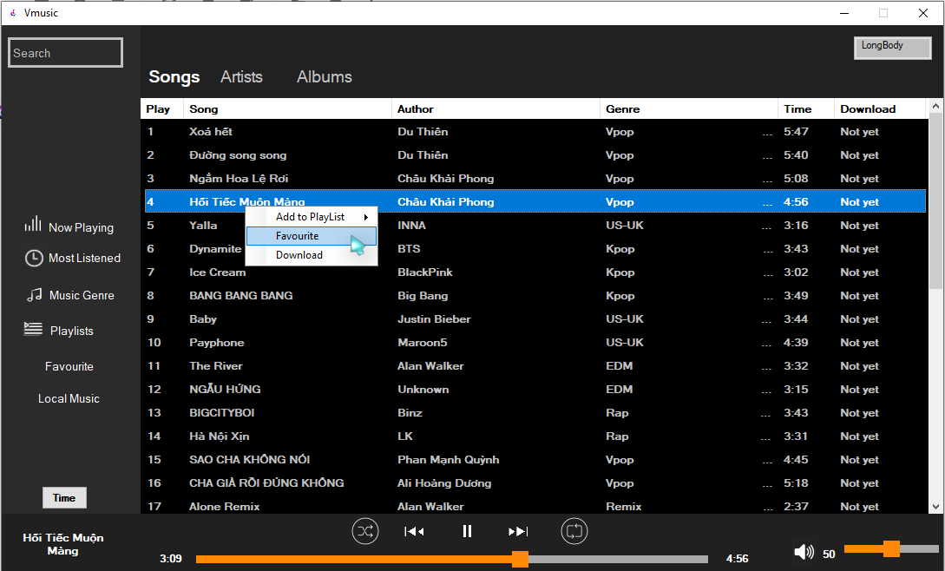

1. ***Add local song to app***

Add: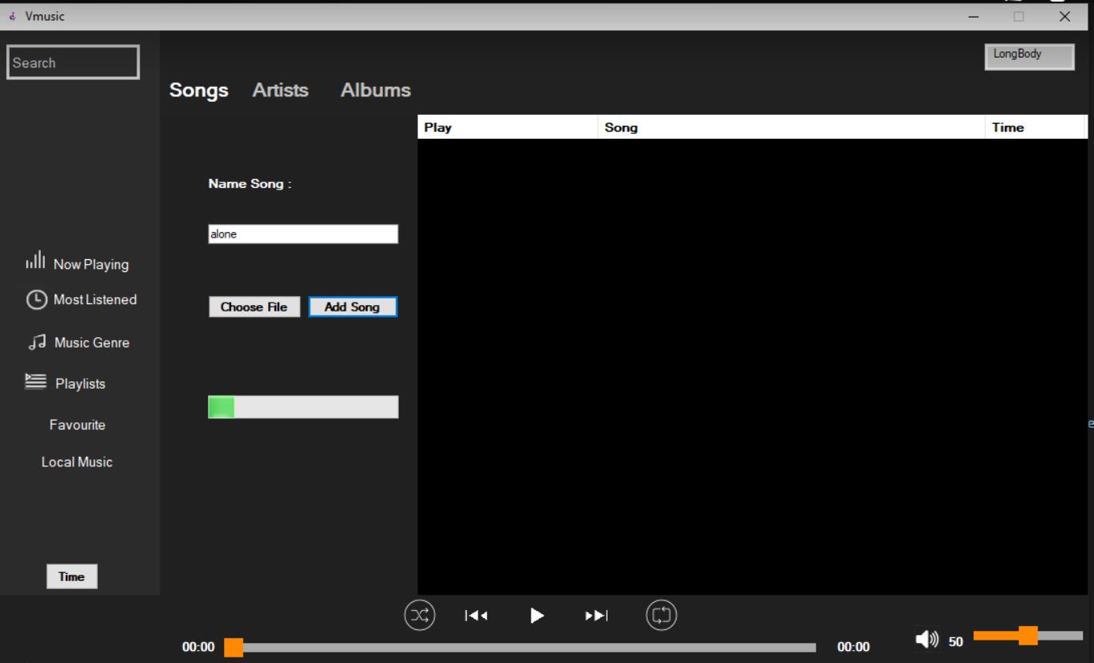

Succsess:

