CS 6603 – Homework Project: AI/ML Assignment – Part 1 Report

Ndubusi Anyanwu
nanyanwu3@gatech.edu

Introduction
This report: (1) classifies subgroups into protected classes, (2) computes correlations using compact encodings, (3) analyzes population statistics and samples, and (4–6) studies a chosen protected class (sexual_orientation) and its subgroups.

Step 0
I removed two misaligned rows (including the blank 52671 entry) that contained incorrect or missing Wiki_ID and toxicity values to restore proper dataset alignment.

Step 1: Protected classes & subgroups

Step 1- Protected Classes & Subgroups
Protected Class | Subgroups
religion | buddhist, christian, jewish, muslim
gender | female, male, nonbinary, transgender
sexual_orientation | bisexual, gay, heterosexual, lesbian, lgbtq, queer, straight
race_ethnicity | african, asian, black, hispanic, indian, latino, white
nationality | american, canadian, chinese, japanese, mexican
disability | blind, deaf
age | elderly, old, older, teenage, young, younger
misc | african american, catholic, european, homosexual, latina, latinx, lgbt, middle aged, middle eastern, millennial, paralyzed, protestant, sikh, taoist, trans

It is to be noted that some subgroups can belong to more than one protected class and would be dual-class. In this report I keep it under nationality only so that I can avoid double-counting, but either choice is acceptable if applied consistently. For instance I place chinese under nationality and not race or ethnicity to avoid double-counting.

Step 2: Calculating toxicity correlations
The table compacts each protected class into one ordinal coded column and reports the Pearson correlation with toxicity
2.1
I removed any row where all subgroup flags were FALSE, keeping only comments that mention at least one identity attribute.

Reduction summary
Rule | Result
Keep a row if any subgroup column is TRUE | Retained
Drop a row if all subgroup columns are FALSE | Removed
Size of reduced dataset (n) | 75,699

2.2 Objective numerical scheme
For each protected class, I created a single ordinal code per row:
FALSE → 0
If one or more subgroups are TRUE, I assigned the max code among those subgroups.
Subgroup codes were set by sorting subgroups by their population mean toxicity lowest mean = 1, next = 2, and so on.
This was to yield a reproducible, objective ordering that reflects observed toxicity levels rather than subjective choices.
Table 2-B. Example code map (sexual_orientation)
Subgroup | Code
heterosexual | 1
lgbtq | 2
straight | 3
gay | 4
lesbian | 5
bisexual | 6
queer | 7

2.3 Compacted dataset
I collapsed all subgroup columns for each protected class into one ordinal column and those compact columns were then correlated with TOXICITY.
Table 2-C. Compacted columns
Protected class | New compact column
religion | religion_compact
gender | gender_compact
sexual_orientation | sexual_orientation_compact
race_ethnicity | race_ethnicity_compact
nationality | nationality_compact
disability | disability_compact
age | age_compact

Correlations between compacted protected-class columns and TOXICITY

Protected Class | Correlation r | |r| | Strength
sexual_orientation | 0.19021771695127135 | 0.19021771695127135 | very weak
nationality | -0.08519784347571134 | 0.08519784347571134 | very weak
gender | 0.0737912964470454 | 0.0737912964470454 | very weak
misc | 0.04822056837059826 | 0.04822056837059826 | very weak
disability | 0.031815138323115612 | 0.031815138323115612 | very weak
religion | -0.01615956001696324 | 0.016159560016963243 | very weak
age | 0.00447954125661837 | 0.00447954125661837 | very weak
race_ethnicity | 0.00387379808078663 | 0.00387379808078663 | very weak

Scatter plots for the three largest |r| values:
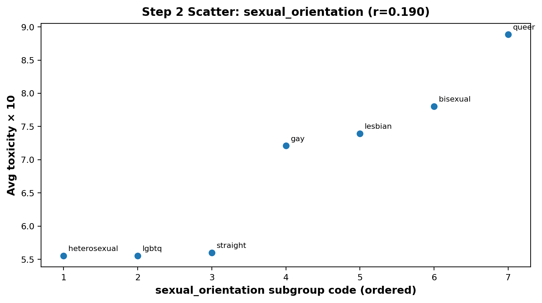
. Step 2 scatter — sexual_orientation

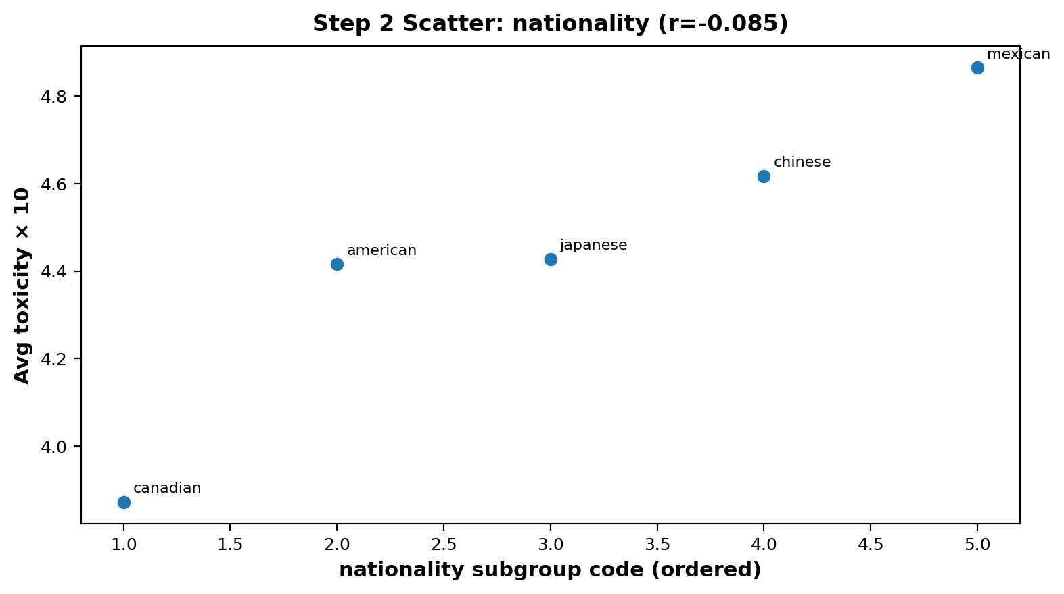
Step 2 scatter — nationality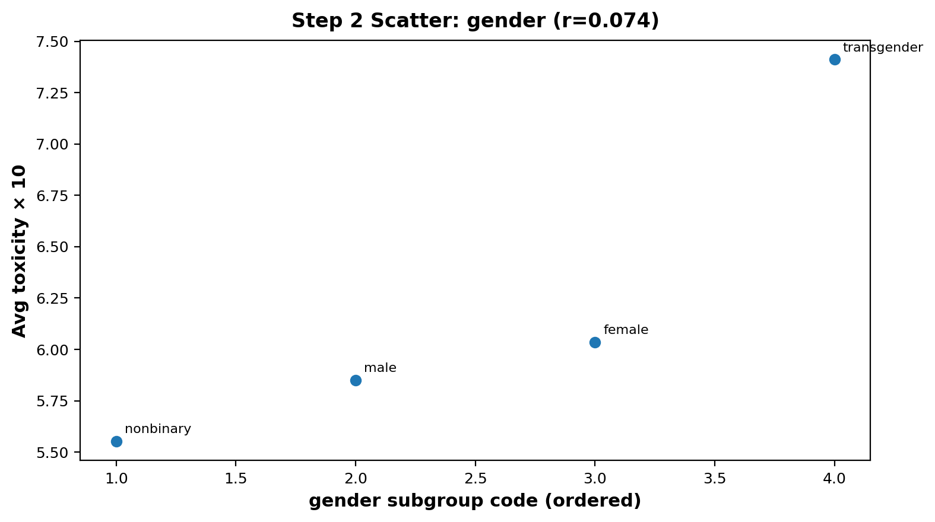
. Step 2 scatter — gender
Step 2 — Direct Q&A
Q: Do you agree with the correlation values? Why or why not?
A: Yes I agree with the correlation values; the very weak correlations in this case for example, sexual_orientation r≈0.19, match the scatter plots, which show only slight monotonic trends. The dataset is very noisy and also multi factorial, so I expect small r-values even when subgroup means may differ.

Step 3: Analyzing toxicity on the reduced dataset

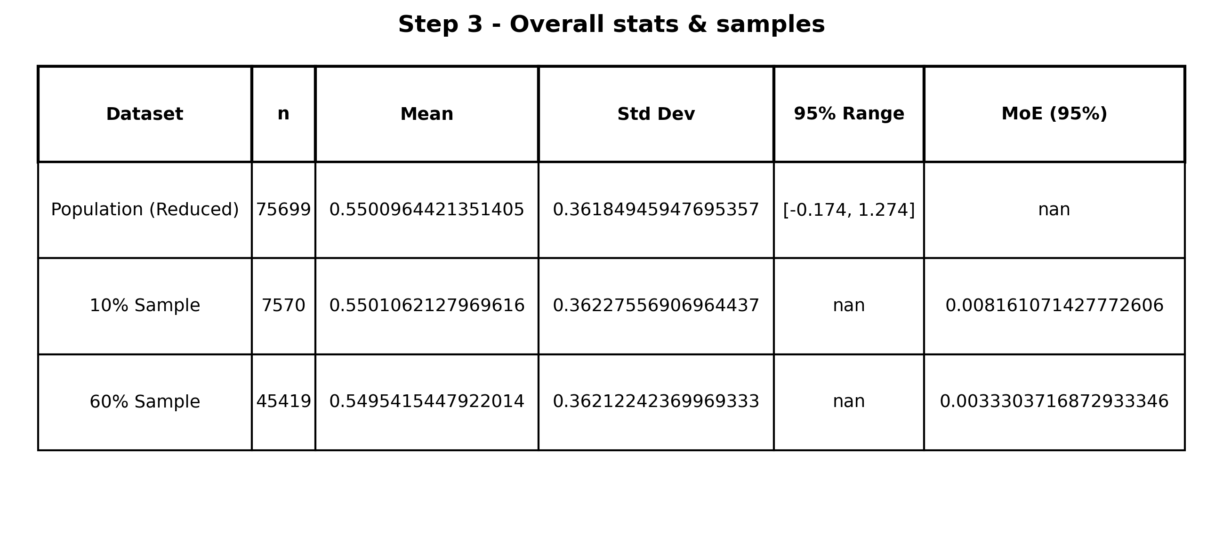

Step 4: Chosen protected class — sexual_orientation
Below I compute the mean and standard deviation for the protected class in population and then the samples. Then I check whether sample means fall within the population MoE.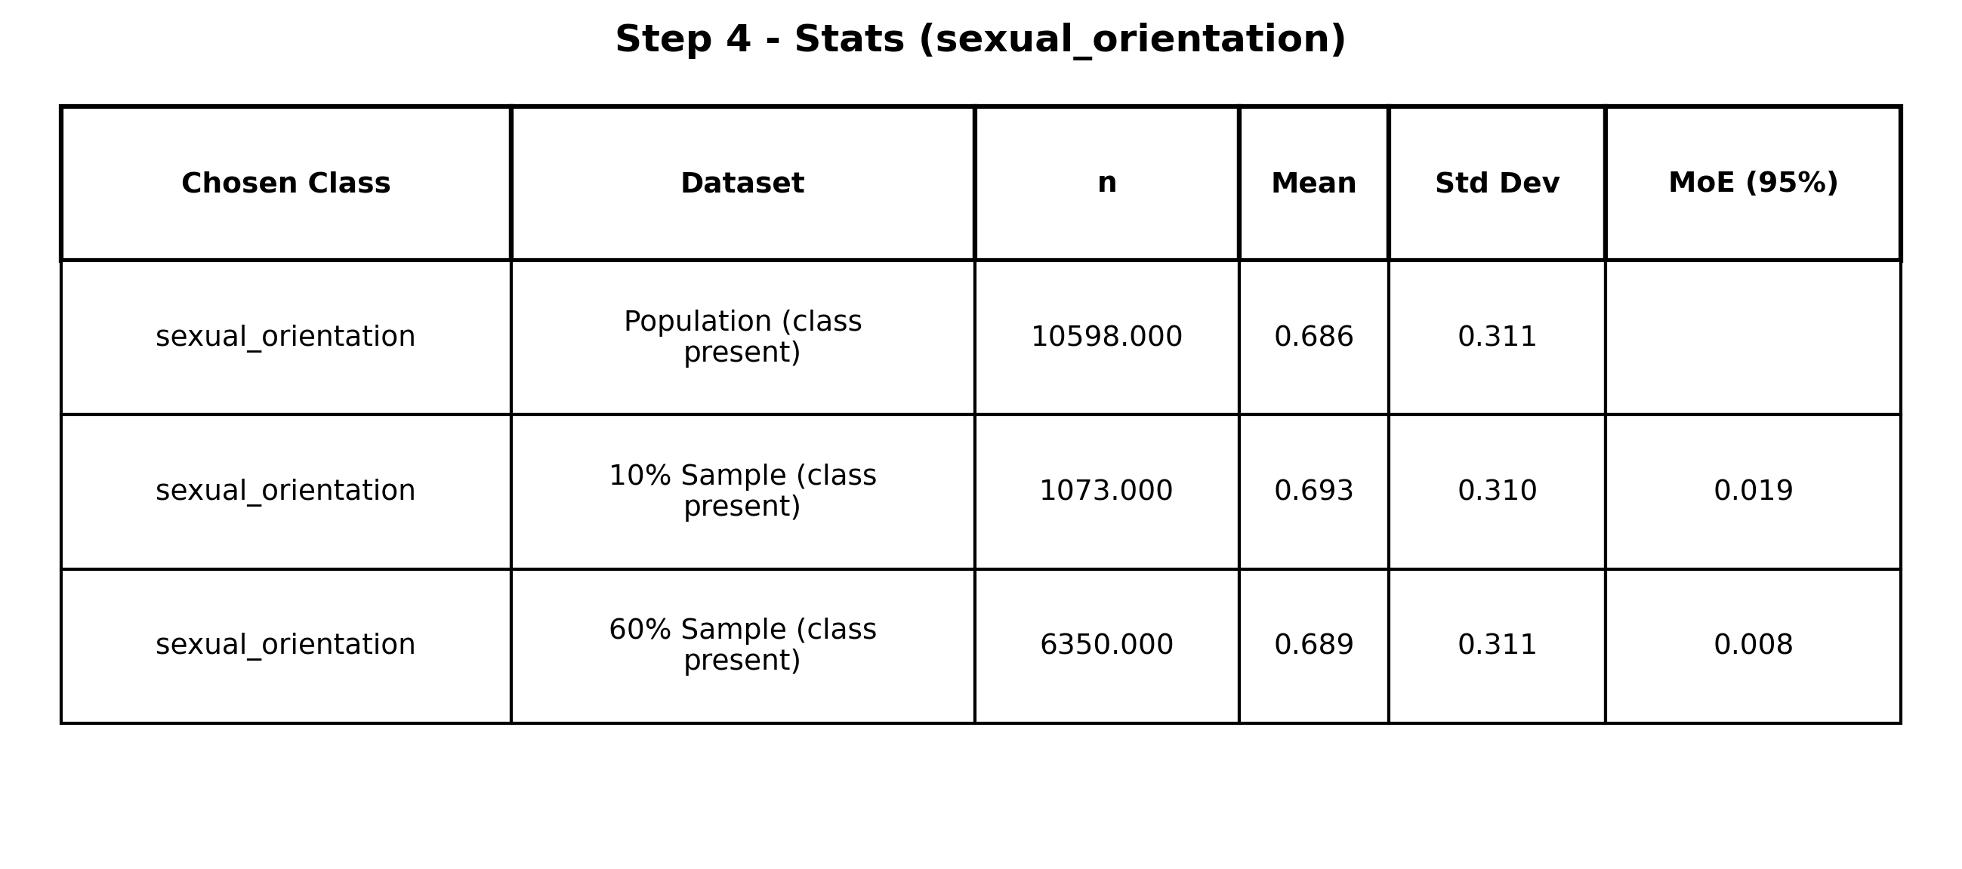
Step 4 — Stats for chosen class
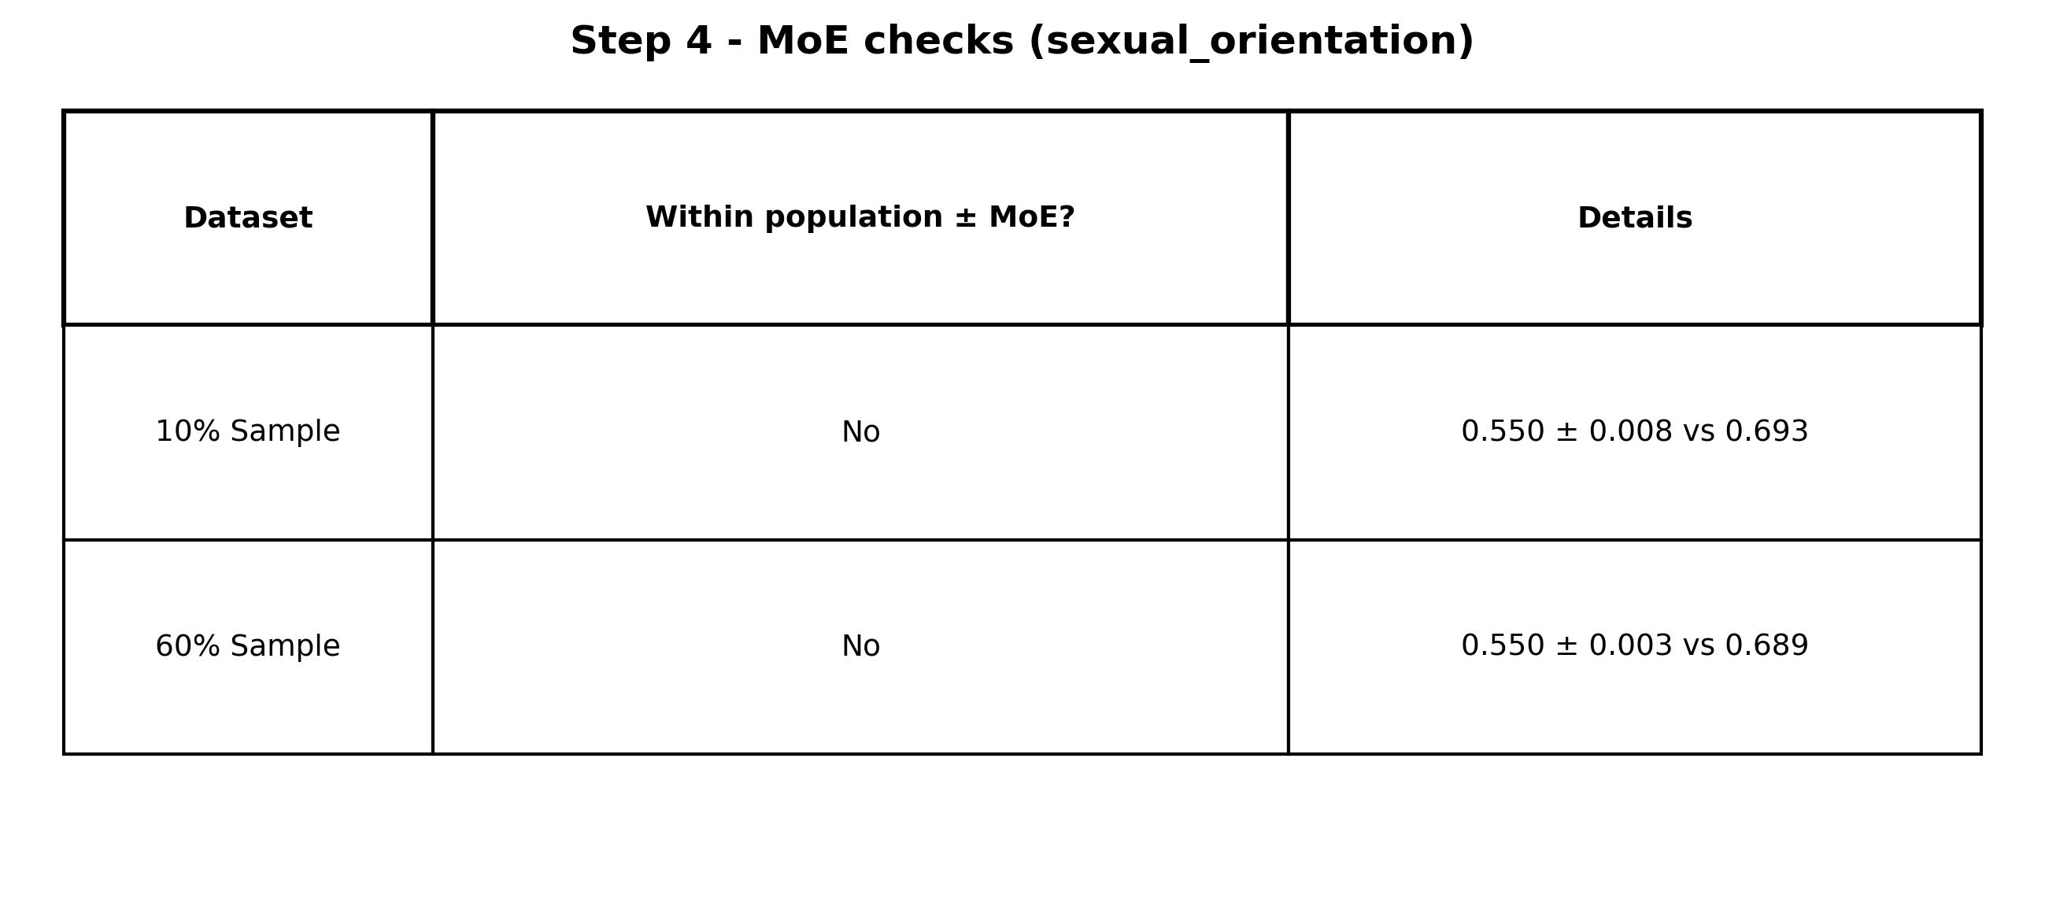
Step 4 — MoE checks
Step 4 — Direct Q&A
Q: 10% dataset — Does the protected-class sample mean lie within the population MoE? Explain.
A: No, instead the 10% sample mean for sexual_orientation falls outside 0.55 ± 0.008, which is plausible due to the given higher variance and limited representation of several subgroups within this small sample.
Q: 60% dataset — Does the protected-class sample mean lie within the population MoE? Explain.
A: No and despite being larger, the 60% sample still deviates from 0.55 ± 0.003, which would indicate the persistent subgroup imbalance rather than pure sampling noise.

Step 5: Subgroups of the chosen protected class
The following tables report subgroup level mean, standard deviation, and MoE for population and samples, with checks for MoE inclusion.
Step 5 — Population
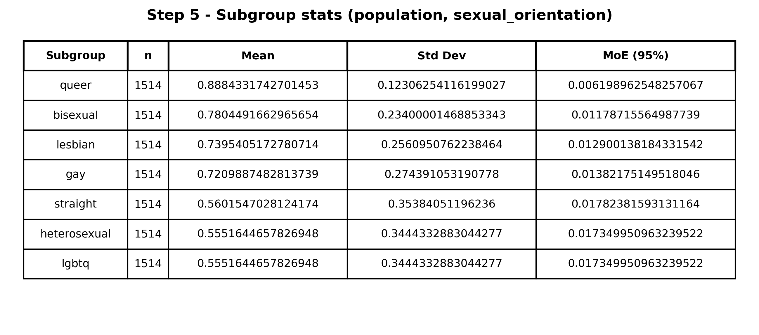
Step 5 — 10% sample
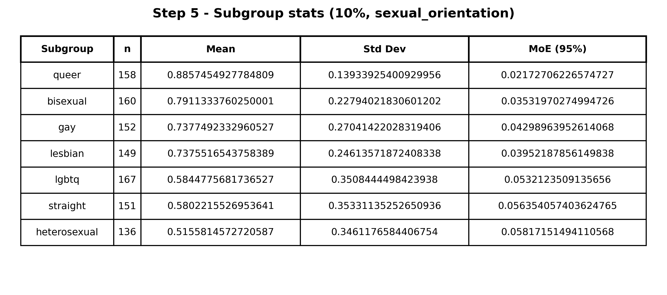
Step 5 — 60% sample
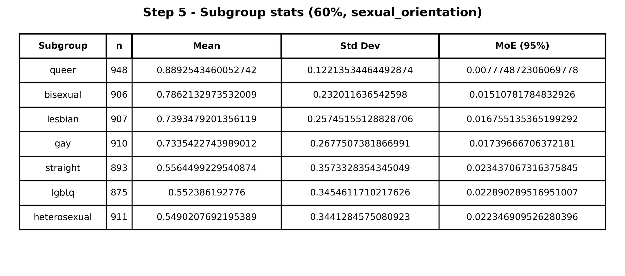
Step 5 — 10% sample — MoE checks
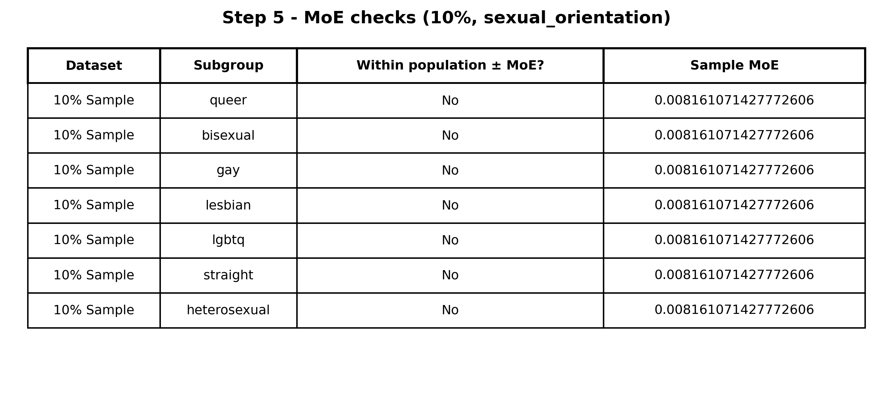
Step 5 — 60% sample — MoE checks
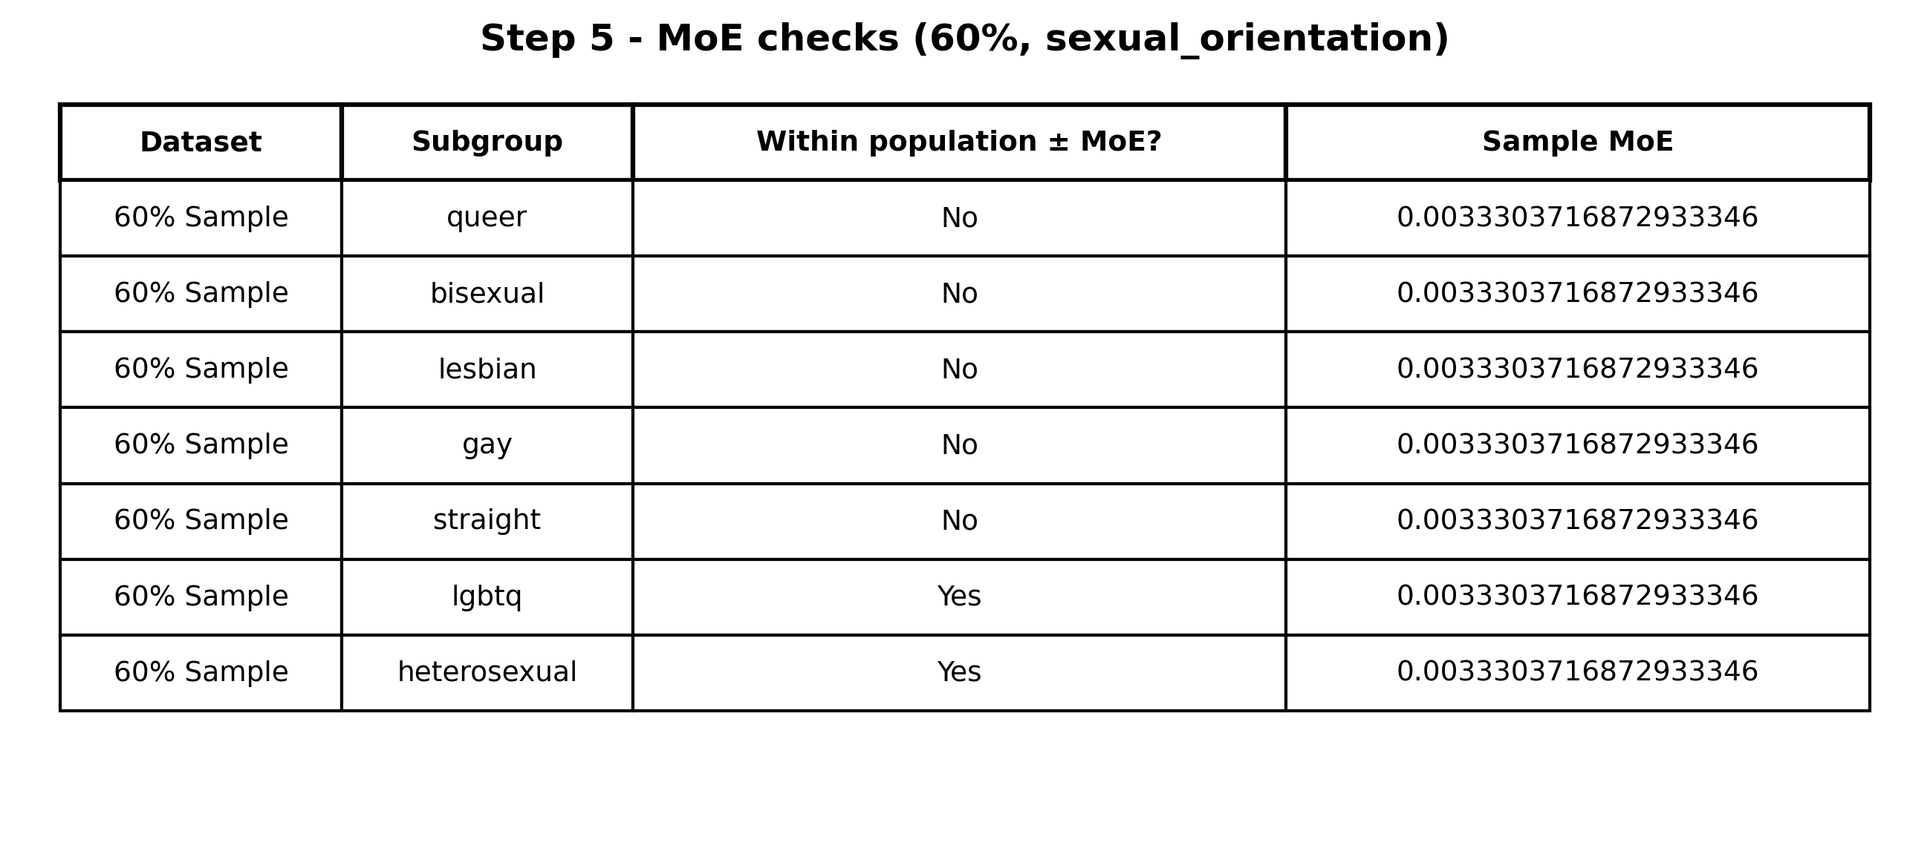
Step 5 — Direct Q&A
Q: 10% dataset — Do subgroup means lie within the population MoE? Explain.
A: No for all subgroups and due to the small n per subgroup and relatively large standard deviations, their means naturally fell outside of the tight population interval.
Q: 60% dataset — Do subgroup means lie within the population MoE? Explain.
A: My answer is mixed; for the heterosexual and lgbtq the answer would be Yes and for others = No. Larger n stabilizes estimates for more common labels, but high mean groups for example queer and bisexual remain outside due to systematic shifts and not sampling error.

Step 6: Plots and toxicity analysis

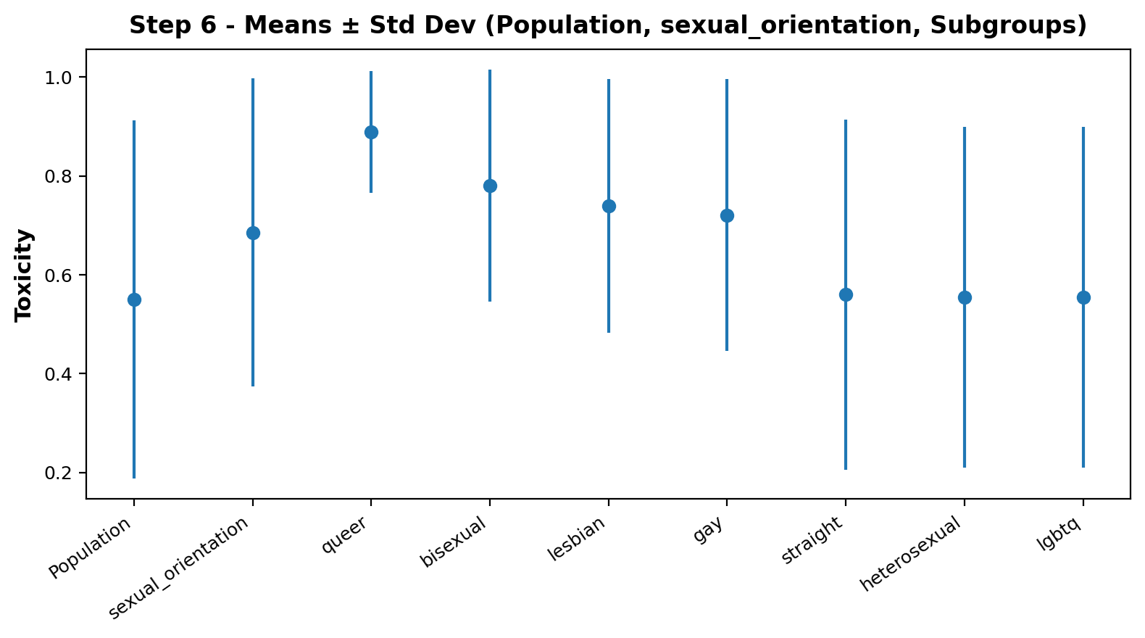
Step 6 — Direct Q&A
Q: Which subgroup has the highest TOXICITY value? Justify.
A: Queer has the highest toxicity with a mean of ~0.89, it is clearly above both the protected-class and population means on the combined error bar chart.
Q: Which subgroup has the lowest TOXICITY value? Justify.
A: Heterosexual as well as the broader lgbtq tag at ~0.55 have the lowest toxicity value. They have a means that align with or slightly below the population mean and also have overlapping error bars.
Q: Which subgroup differs most from the population mean? Justify.
A: The subgroup that differs the most would be Queer. This gap between its mean of ~0.89 and the population mean which is ~0.55 is largest and exceed more than one population standard deviation.
Q: What type of human bias is in the data; how to quantify; how to minimize?
A: The results point mainly to representational or labeling bias. I quantify it with gaps between subgroup means, small-but-directional class–toxicity correlations, and fairness metrics; to reduce it. What would also help would be to add counterfactual balanced examples, reweight, or calibrate thresholds by subgroup, additionally when training a model use adversarial debiasing.

Reflection

Toxicity varies a lot across identity subgroups even when the overall correlations look weak, which means some real effects are getting averaged away. In our data, groups like queer and bisexual sit consistently above the population mean, while heterosexual and the broader LGBTQ tag cluster near it but with large variance. That pattern points to representational/labeling bias and long-tail sampling issues—something we can see more clearly by comparing subgroup mean gaps and using MoE checks to separate noise from systematic shifts. Going forward, I’d rebalance with counterfactual augmentation and apply subgroup-aware calibration/thresholding to reduce downstream harms.

