HO CHI MINH CITY UNIVERSITY OF TECHNOLOGY AND EDUCATION
FACULTY OF ADVANCED TRAINING

SOFTWARE REQUIREMENTS SPECIFICATION
Gia Chuan Catalog and Price Assistant
COURSE IT PROJECT

PROJECT TOPIC
CATALOG AND PRICE QUESTION ANSWERING
USING RETRIEVAL AUGMENTED GENERATION
PriceApp

HO CHI MINH CITY
OCTOBER 2026
CONTENTS
CHAPTER 1 INTRODUCTION 3
1.1 Purpose of the document 3
1.2 Problem statement and objectives 3
1.3 Product scope 4
1.4 Actors and intended readers 4
1.5 Terms and document organization 5
CHAPTER 2 OVERALL DESCRIPTION 6
2.1 Business context and workflows 6
2.2 System architecture 7
2.3 Business data organization 8
2.4 RAG indexing workflow 9
2.5 Retrieval and answer generation 10
2.6 Knowledge and correctness constraints 11
CHAPTER 3 SPECIFIC REQUIREMENTS 12
3.1 Functional requirements 12
3.2 User interfaces and input data 13
3.3 API and external service interfaces 14
3.4 Nonfunctional requirements 15
3.5 Testing and validation 16
3.6 Maintenance and operation 18
CHAPTER 4 SYSTEM MODELS 20
4.1 Domain data model 20
4.2 Main interaction models 21
CHAPTER 5 TRACEABILITY AND REFERENCES 24
5.1 Requirements traceability 24
5.2 RAG configuration 25
5.3 Project references 25
5.4 Source code references 26

CHAPTER 1 INTRODUCTION

1.1 Purpose of the document
This Software Requirements Specification defines the scope, users, functions, data constraints and validation approach of Gia Chuan for the IT Project course. The project applies Retrieval Augmented Generation to Vietnamese catalog and price questions. Its objective is to connect natural language requests to verified product records and current store prices.
Gia Chuan, named PriceApp in the repository, supports staff who search for materials and prepare quotations, and customers who browse the public catalog, ask questions and submit order requests. The RAG assistant uses product names, aliases, specifications, attributes and packaging as its knowledge base. It can describe or compare only facts supported by retrieved records.
Current prices are read from PostgreSQL through prices.amount. In the active retrieval_first mode, the model receives the complete question, recent context and retrieved evidence, then selects relevant identifiers and writes an explanation. The server validates those identifiers and renders prices from fresh SQL rows. Direct catalog browsing remains available independently of AI question answering. [M1, M3, M14]

1.2 Problem statement and objectives
Hardware catalogs contain similar product names with different sizes, units, package quantities and price tiers. The same specification may have a retail price for a small pack and a wholesale price for a larger pack. Customers use familiar names, unaccented Vietnamese and shorthand such as 8x100, 1F5 or 1T2. The system must identify the relevant variant before showing its price or adding it to a quotation.
• Search products by name, alias and specification through an interface suitable for phones and counter sales.
• Answer Vietnamese questions about verified catalog facts, packaging and current prices, with supporting sources.
• Combine semantic retrieval, conversation context and current SQL evidence to handle product discovery, follow-up questions and factual comparisons.
• Prepare quotations and order requests using eligible price rows and support staff processing of customer requests.
• Allow authorized users to update prices, undo changes and administer the RAG index with appropriate access control.

1.3 Product scope

1.3.1 Functional scope
The application includes a staff counter, a public storefront, catalog question answering, quotation preparation, order requests, catalog and price maintenance, RAG index administration, answer feedback and read-only offline snapshots. Frontend and backend are separate workspaces. Supabase provides authentication, persistent storage and row-level access control.
The RAG corpus contains eligible Supabase catalog records. Embedding text is assembled from category and product names, descriptions, aliases, specifications, attributes and packaging. Source photographs may be retained as provenance for catalog rows, but image OCR transcripts are not used as RAG knowledge in the current implementation. [T3, M2]

1.3.2 Business and knowledge boundaries
Order requests record customer demand for later store confirmation. Online payment, shipment scheduling and inventory management are outside the current scope. The assistant does not establish load capacity, installation safety, compatibility or suitability unless the retrieved knowledge explicitly supports the claim. Product information and price lookup are the principal supported tasks.
Offline mode reads a previously stored device snapshot with its own synchronization timestamp. A snapshot does not replace current server checks for write operations. Catalog edits enqueue indexing work; price changes are read directly from SQL and do not require new embeddings.

1.4 Actors and intended readers
Table 1.1 Gia Chuan actors
Actor | Main needs and permissions
Customer | Browse the public catalog, ask questions, select items and submit order requests without a staff session.
Viewer | Sign in to read data within the granted scope; cannot edit prices or process customer orders.
Editor | Search, quote, create and process counter orders, and update or undo prices through authorized APIs.
Owner | Perform staff operations, maintain catalog records and administer RAG indexing, diagnostics and feedback.

The report is intended for the course assessor, frontend and backend developers, testers and application operators. The customer evidence scope represents public access; customer is not an additional internal account role alongside owner, editor and viewer. [M5]

1.5 Terms and document organization
Table 1.2 Project terminology
Term | Meaning in this project
SRS | Software Requirements Specification.
RAG | Retrieval Augmented Generation: generate an answer using retrieved evidence.
Catalog | Structured categories, products, aliases, variants, attributes and packaging.
Variant | A specific product specification identified by product_variants.id.
Embedding | A vector representation used for semantic retrieval; the backend requires 1,024 dimensions.
Chunk | Indexed catalog text with a stable key and content hash.
Lexical | Name, keyword, alias and specification search used by catalog screens and the legacy RAG path.
RRF | Rank fusion in the legacy path; not used by the active retrieval_first path.
Evidence packet | Permission-filtered catalog facts, price data and source identifiers supplied to the model.
RLS | PostgreSQL Row Level Security for database access control.
RPC | A database function used for consistent business validation and writes.
Generation | An index version published only after its build completes.
expectedVersion | The price version read by a client, used to detect stale writes.
Idempotency key | A submission identifier that allows safe retries without creating another order.
Snapshot | A device copy in IndexedDB with a synchronization timestamp for offline reading.

CHAPTER 2 OVERALL DESCRIPTION

2.1 Business context and workflows
Gia Chuan is a web application with staff and public storefront interfaces. Users may browse structured catalog data or ask a question in Vietnamese. Results distinguish the product family from an individual variant and show packaging, price tier, minimum quantity and provenance when available.

2.1.1 Staff search and quotation workflow
• Staff sign in, open the counter workspace and enter a product name, alias or specification.
• The application searches the catalog and shows eligible variants with the price rows visible to that user.
• Staff enter quantities in the smallest retail package. Price selection considers equivalent packages and minimum-quantity conditions to choose an eligible option.
• A quotation keeps the original selected price and package count. Its line total equals the selected package count multiplied by prices.amount.
• When a quotation becomes an order request, the server checks price eligibility and version again before saving.

2.1.2 Public browsing and ordering workflow
• A customer opens /shop and browses published products, variants, packages and prices.
• The customer selects an item or asks the assistant. Public question answering retrieves only publicly permitted evidence.
• The customer adds items to the cart, enters a name and phone number, and optionally supplies an address or note.
• The backend validates the request, prices and idempotency key and returns a receipt after successful creation.
• Authorized staff review the inbox and mark a request as contacted, confirmed or cancelled.

2.1.3 Catalog question answering workflow
The assistant keeps the complete current question and up to six recent messages. Gemini embedding-001 creates query vectors for semantic retrieval. The backend expands verified product groups within a configured context budget and reloads current catalog facts from SQL. The chat model interprets the question and selects evidence identifiers; the server checks the result before displaying an answer. [M11, M14, M15]

2.2 System architecture
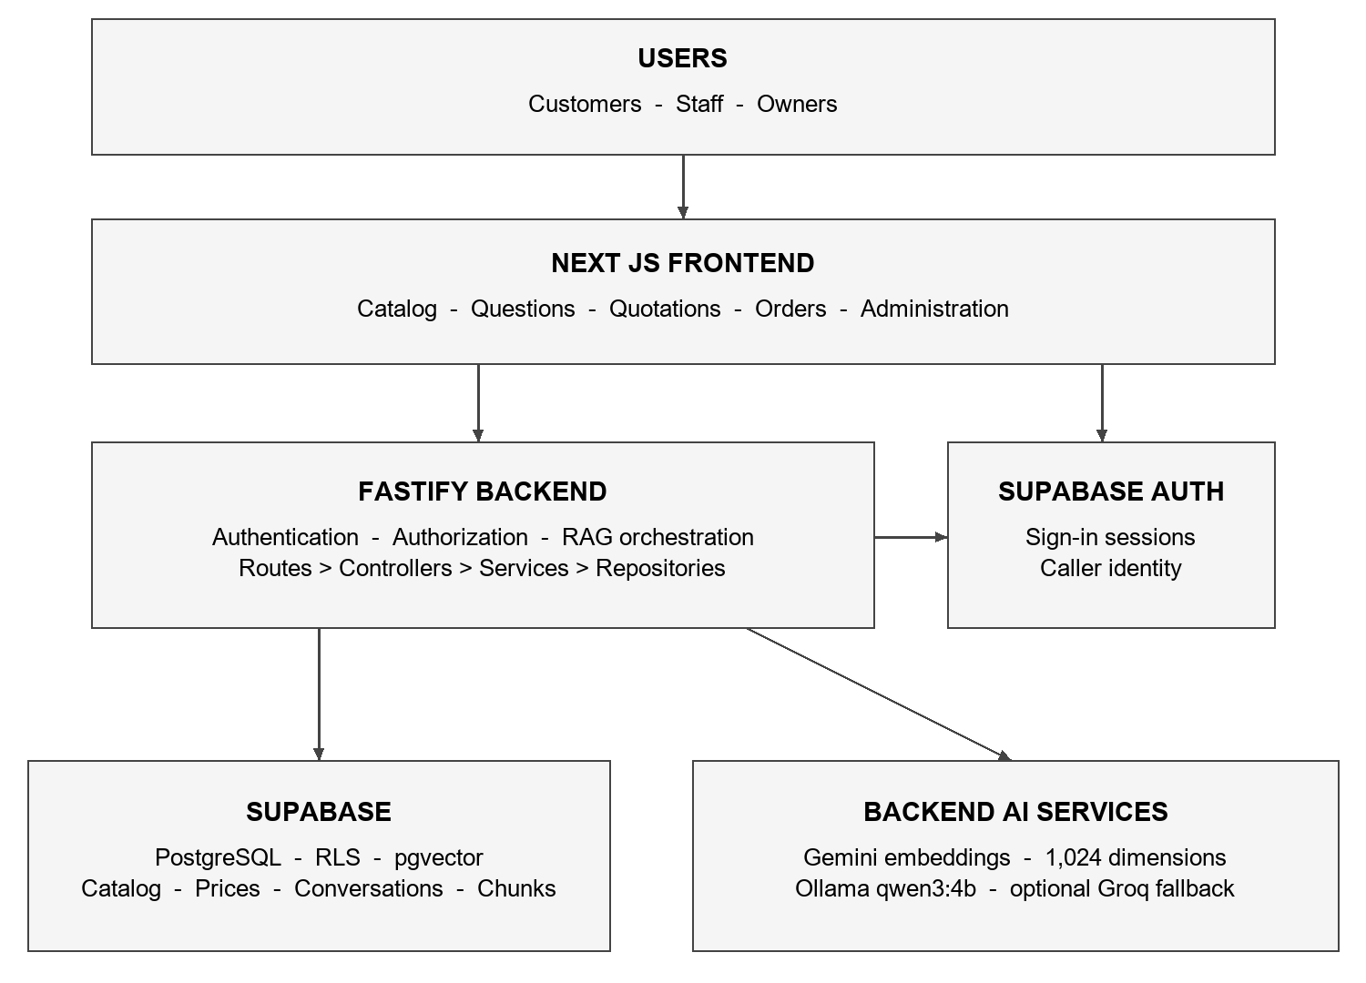
Figure 2.1 Gia Chuan system architecture
Frontend and backend are independent workspaces in one repository. The frontend uses the Next.js App Router. The Fastify backend separates routes, controllers, services, repositories and schemas. The browser uses Supabase Auth for staff sessions; business operations go through the API. Public endpoints have a separate data scope. [T1, T2]
The API verifies bearer tokens, determines roles and creates a Supabase client carrying the caller identity so database RLS remains effective. AI provider credentials are kept on the backend. A separate index worker uses a dedicated worker identity to process queued revisions.
Table 2.1 Technologies used
Component | Technology in the repository
Frontend | Next.js 16.4, React 19.2, TypeScript, Tailwind CSS 4 and Flowbite React.
API | Node.js 22.12 or later, Fastify 5, Zod 4 and TypeScript.
Data and identity | Supabase Auth, PostgreSQL, Storage, RLS and pgvector.
RAG | Gemini embedding-001 at 1,024 dimensions; Ollama qwen3:4b chat and optional Groq fallback.
Testing and offline data | Vitest, Playwright, SQL regression and IndexedDB through idb.

2.3 Business data organization
The main relationship is category to product to variant to packaging option to price row. A product may have several aliases and a variant may reference source pages. Prices are managed separately from embedding text so indexed knowledge does not freeze a sales amount that can later change. [M2, M6]
Table 2.2 Main data groups
Table group | Purpose and principal relationships
profiles | Supabase Auth account link, display name and owner/editor/viewer role.
categories, products | Product groups and common product information with active status.
product_aliases | Alternative product names used for discovery.
product_variants | Raw specification, display name, attributes, search text, verification and active status.
packaging_options | Package name, base quantity, unit and notes for a variant.
suppliers, price_lists | Supplier and list identity, activity and applicable list-type conditions.
prices, price_history | Amount, tier, minimum quantity, validity and version; audited changes and undo history.
source_pages, variant_sources | Source photographs and catalog provenance links; no OCR corpus in the current RAG path.
RAG chunks, runs and jobs | Catalog chunks, embeddings, fingerprints, checkpoints, generations and revisioned work.
RAG conversations and feedback | Conversation messages, referenced variants/prices and access-controlled feedback.
customer_order_requests and items | Customer details, processing state, selected price rows and creation receipts.

2.3.1 Catalog eligibility for RAG
Only active, verified variants belonging to active products and categories enter the catalog corpus. A source photograph is not mandatory. When present, the linked source page provides provenance; otherwise the verified product_variants record is the evidence reference. Unverified records are excluded from public evidence.

2.3.2 Current price eligibility
A price must be active, within its validity dates and associated with an active supplier. Visibility, price tier and minimum-quantity rules also apply. For this academic demonstration, eligible generated price rows may fill gaps where no suitable real price exists; amount is still read unchanged from SQL. Dealer prices are excluded from the public customer scope. No technical specification is fabricated to fill missing knowledge. [M3, M14]

2.4 RAG indexing workflow
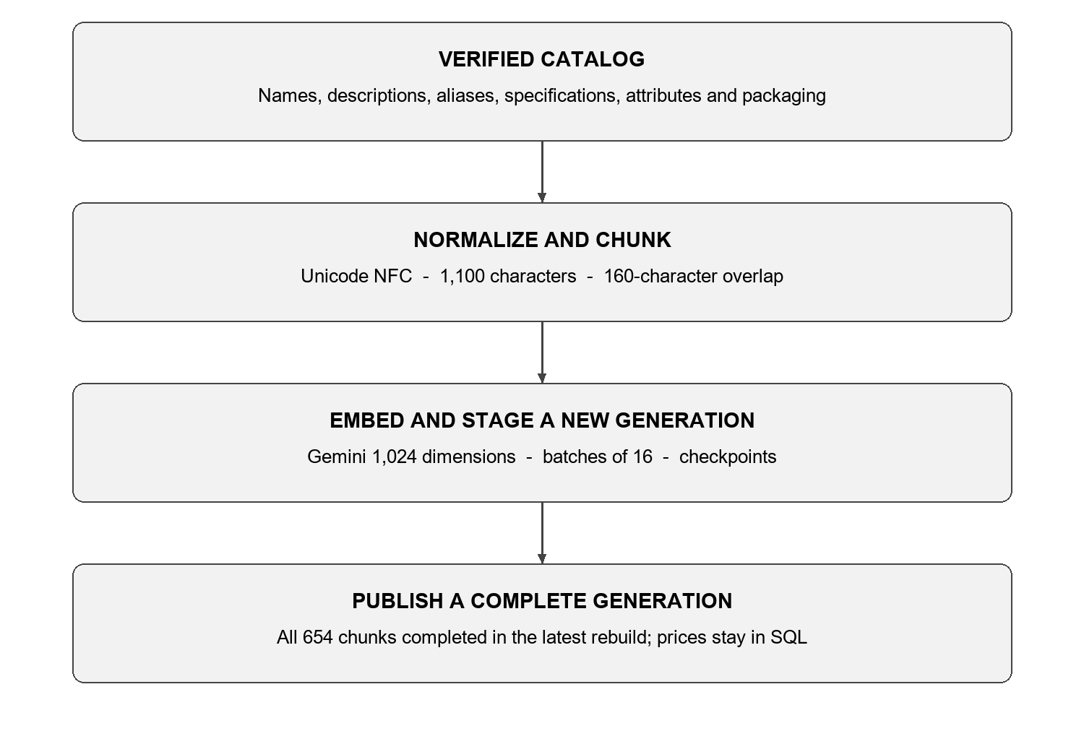
Figure 2.2 Catalog indexing workflow
The indexer reads eligible variants and constructs text from catalog fields. Encoded specification conventions may add a constrained explanation while retaining the original specification string. prices.amount is excluded from embedding text. [M2, M4]
The chunker normalizes Unicode to NFC, removes empty characters and blank lines, and splits at line or sentence boundaries. Its default maximum is 1,100 characters with 160 characters of overlap; these values are character counts, not token counts. Chunk keys use variant:<id>:<index>. Content hashes and model/chunker fingerprints determine vector reuse.
The indexer processes batches of 16 chunks, saves checkpoints and stages a new generation. Publication occurs only after the generation is complete. The worker claims revisioned jobs, maintains a lease and heartbeat and records completion or failure. Existing-vector lookups are limited to the current batch keys. The latest rebuild completed all 654 chunks using Gemini embedding-001; temporary quota limits were handled through checkpointed retries. [M2, M13, T12]

2.5 Retrieval and answer generation
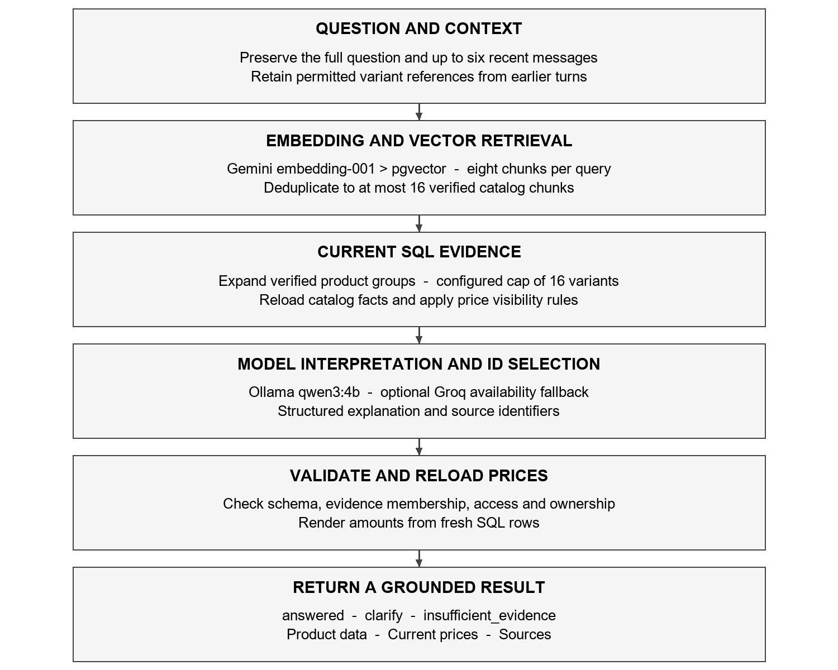
Figure 2.3 Vietnamese question answering workflow
In retrieval_first mode, the full question is embedded. With history, a second query combines the previous and current questions. Each query returns up to eight chunks; the server merges up to 16 with verified catalog metadata and similarity of at least 0.2. This path bypasses legacy planners and lexical filters. [M1, M14]
The server expands retrieved and referenced variants through verified catalog RPCs, batching at most eight IDs. Context is capped at 16 variants, prioritizing direct matches when truncated. Facts are reloaded from SQL; partial retrieval never proves complete catalog coverage.
Ollama qwen3:4b receives the question, recent messages and permission-filtered evidence and returns structured JSON. Groq is an optional one-attempt availability fallback. The server checks schema and evidence IDs, reloads prices and returns answer and cart data. Dependency failures may return 503; invalid output may request clarification. [M11, M14, M15, T12]

2.6 Knowledge and correctness constraints

2.6.1 Separate price data from language generation
Prices come from SQL rather than model memory. Do not divide prices.amount by pack size or replace it with an inferred unit price. Convert quantities only to select equivalent packages; totals remain the selected package count multiplied by unchanged amount. [T2, M3]
In a recorded check, bolt variant 47 with specification 8 ly x 3F cost VND 9,000 per retail pack of 10 sets and VND 70,000 per wholesale pack of 100 sets. These were SQL values at query time, not model-generated amounts or future price commitments. [T9, T12]

2.6.2 Constrained interpretation of specifications
The project interprets encoded F and T notation, for example 1F5 as 15 mm and 1T2 as 120 mm. Diameter and length interpretation applies only to recognized product classes. These conventions explain raw_specification without changing it or establishing engineering properties for other families. [M4]

2.6.3 Model output validation
The server validates output fields, evidence membership, price visibility and price-to-variant ownership. Valid selected prices are rendered from fresh SQL instead of monetary model prose. Semantic results are not exhaustive. A generic clarification can also mean output validation failed, not that the knowledge base has no match. [M14, M15]

CHAPTER 3 SPECIFIC REQUIREMENTS

3.1 Functional requirements
The requirements below describe behavior implemented by the repository modules. FR identifiers link requirements to implementation and validation groups. Public and internal permissions must be enforced at both API and database layers.
Table 3.1 Catalog and RAG functional requirements
ID | Function | Required behavior
FR-01 | Authentication and authorization | Verify staff sessions through Supabase Auth and enforce token/role checks. Customers use only public endpoints.
FR-02 | Catalog search | Find names, aliases, codes and specifications; distinguish product groups from variants and show permitted packaging and prices.
FR-03 | Vietnamese price questions | Select an eligible variant and current price rows, show unchanged amount, tier, packaging and source, and report missing data.
FR-04 | Specifications and packaging | Describe verified variants and attributes and support accented or unaccented wording and supported size notation.
FR-05 | Semantic product assistance | Retrieve evidence, interpret the full question and context, and explain or compare documented facts without inferring engineering properties.
FR-06 | Sources and feedback | Display verified catalog/source references and accept structured feedback with appropriate signed-handle and rate checks.
FR-07 | Conversation context | Supply up to six recent messages and referenced variants. Staff access their own conversations; public history remains in the web session.

Table 3.2 Business and administration requirements
ID | Function | Required behavior
FR-08 | Quotations | Choose eligible packages and quantities, consider equivalent base quantities, and calculate totals from package count and unchanged amount.
FR-09 | Public order requests | Accept contact details and priceId/version/quantity lines; validate prices and prevent duplicates using an idempotency key.
FR-10 | Counter order handling | Allow owner/editor users to create and review requests and update contacted, confirmed or cancelled status.
FR-11 | Price update and undo | Require amount, reason and expectedVersion. Authorized RPCs check consistency, record history and return a new version.
FR-12 | Catalog maintenance | Allow owners to update catalog records through validated operations; catalog changes enqueue indexing work.
FR-13 | Catalog reindexing | Allow an owner to request indexing and a worker to manage revisions, fingerprints, checkpoints and complete-generation publication.
FR-14 | RAG monitoring | Allow owners to inspect provider health, index progress, published chunks and feedback summaries.
FR-15 | Offline reading | Read saved IndexedDB snapshots and timestamps; do not write prices or submit orders while offline.

3.1.1 Responses to incomplete or failed operations
Invalid input, missing sessions, forbidden operations, price conflicts, rate limits and unavailable dependencies use corresponding API error codes. The interface should preserve user selections after a failed operation. Retrying the same order submission uses the same idempotency key so an existing receipt can be returned without creating another order. [T5, M8]

3.2 User interfaces and input data

3.2.1 Main workspaces
Table 3.3 Main interfaces
Interface | Content and actions
/shop | Public products, search, variants, packaging, cart, contact details and order submission.
/staff | Counter search, quantities, quotations and the owner/editor customer-order inbox.
/questions | Vietnamese catalog questions, answers, sources and conversation context.
/rag-admin | Owner index progress, published chunk browsing, service checks and feedback.

3.2.2 Input validation rules
Table 3.4 Selected validated input fields
Field | Backend validation
question | Trimmed length from 1 to 1,000 characters. Preserve the full question for embedding and generation.
New price | Finite, nonnegative amount up to 999,999,999,999 under priceUpdateSchema.
expectedVersion | Positive integer supplied with price writes and order price lines.
Price change reason | Trimmed length from 1 to 500 characters; required.
customerName | Trimmed length from 2 to 120 characters.
phone | Trimmed length from 8 to 24 characters, with supported phone punctuation.
Order items | From 1 to 50 lines; each has positive integer priceId/version and quantity greater than 0, at most 10,000.
idempotencyKey | A UUID retained when retrying the same order submission.
Address and notes | Optional; deliveryAddress up to 500 characters and deliveryNotes up to 1,000.

These limits are taken from the current schemas. Schema validation is an input boundary; write authorization, price validity and data consistency still require business and database checks. [M7, M8, M9]

3.3 API and external service interfaces
The API uses HTTP and JSON under /api/v1. OpenAPI contracts are generated from Zod schemas and the frontend consumes generated types. Internal routes require a bearer token; administrative routes add role requirements. [T2, M10]
Table 3.5 Business endpoint groups
Group | Method and path | Access
Catalog | GET /public/catalog  GET /catalog | Public / signed in
Question answering | POST /public/rag/query  POST /rag/query | Public / signed in
Feedback | POST /public/rag/feedback  POST /rag/conversations/:id/feedback | Valid handle / signed in
Conversations | POST or GET /rag/conversations  GET /rag/conversations/:id | Signed in; caller data
Customer orders | POST /public/order-requests | Public; validated and rate limited
Counter orders | GET or POST /customer-order-requests  PATCH /customer-order-requests/:id/status | owner/editor
Prices | POST /prices/:priceId/update  POST /prices/undo | owner/editor
Catalog changes | POST /catalog/update | owner
RAG administration | GET /admin/rag/health  GET or POST /admin/rag/index  GET /admin/rag/index-job  GET /admin/rag/feedback | owner
API health | GET /health | Public

3.3.1 Service dependencies
Gemini embedding-001 runs as a cloud embedding service with 1,024-dimensional, L2-normalized vectors. This frees local GPU memory for one chat model. The current chat profile uses Ollama qwen3:4b and an optional Groq fallback. Changing the chat model does not require rebuilding embeddings. Changing the embedding model or its transformation requires a compatible rebuild. The latest complete corpus contains 654 chunks. [M11, M15, T12]
The backend restricts CORS to configured origins. AI keys, signing secrets, tokens and database credentials must not enter the frontend bundle or repository. Request IDs and safe dependency diagnostics help relate interface failures to backend stages without logging private prompt content.

3.4 Nonfunctional requirements
Table 3.6 Nonfunctional requirements
ID | Requirement | Validation evidence
NFR-01 | Price integrity: preserve amount. Package conversion affects selection, not the stored amount or total rule. | Price selection, rendering, invoice and SQL regression tests.
NFR-02 | Access control: enforce API roles and database RLS. Public users cannot read dealer prices or private data. | Authentication, public RPC and database permission tests.
NFR-03 | Grounding: use eligible verified knowledge and validate model schema and evidence identifiers. | Retrieval, evidence, price ownership and citation tests.
NFR-04 | Concurrency: price updates and undo require expectedVersion; conflicts do not overwrite newer data. | Price service/repository and RPC tests.
NFR-05 | Safe retries: the same idempotency key returns the original receipt without resetting order status. | Order receipt regression and browser scenarios.
NFR-06 | Availability: attempt one configured cloud fallback for eligible chat failures. Distinguish provider errors from no-match answers. | Provider routing, failure diagnostics and offline tests.
NFR-07 | Observability: include request IDs and safe dependency-stage diagnostics; show index progress and published chunks. | Error middleware, health, index status and worker tests.
NFR-08 | Maintainability: version migrations, generate API contracts, and pass lint, type checks, unit tests and builds. | npm scripts, OpenAPI consistency and test suites.

3.4.1 Public endpoint resource limits
The public RAG route limits an IP to five questions per minute; public feedback is limited to ten submissions per hour. Public order creation allows five attempts per ten minutes. These counters are currently held in API process memory and therefore do not establish a cluster-wide limit across multiple deployed instances. [M10]

3.5 Testing and validation

3.5.1 Validation layers
The repository uses Vitest for frontend and backend logic, Playwright for browser behavior and SQL regression scripts for database permissions and consistency. Mocked API tests verify interface behavior and contracts but do not prove that a migration or RLS policy has been applied successfully to a live Supabase project. [T1, T4, T5]
Table 3.7 Validation scenarios
ID | Scenario | Expected check
TC-01 | Ask the price of a specific anchor without selecting a pack. | Identify the variant; show applicable retail/wholesale packages and SQL prices with sources.
TC-02 | Ask specifically for retail or wholesale pricing. | Select the correct tier and unchanged amount; never divide by the number of units per pack.
TC-03 | Ask for a pack of 10 using unaccented text or alternative size notation. | Interpret the supported notation and match package quantity and unit.
TC-04 | Ask about bolt specifications such as 1F5 or 1T2. | Find the correct variant and retain its original specification and documented interpretation.
TC-05 | Ask for a specification absent from the catalog. | Return missing-evidence or clarification status without fabricating an item, price or source.
TC-06 | Provide unverified chunks or unknown evidence identifiers. | Exclude invalid evidence or reject unsupported model output.
TC-07 | Primary chat fails with quota, 5xx, timeout or network error. | Attempt the configured cloud fallback once with its own credentials and unchanged evidence scope; fail clearly if unavailable.
TC-08 | Write a stale price version or use a viewer account. | Reject conflicts or unauthorized writes and preserve price/history consistency.
TC-09 | Retry an order after its processing state changes. | Return the initial creation receipt without creating another order or resetting status.
TC-10 | Access orders as owner, editor, viewer or anonymous user. | Only authorized owner/editor users may read and process the protected order data.
TC-11 | Edit catalog knowledge while indexing is in progress. | Publish only a complete generation and retain newer queued revisions.
TC-12 | Lose connectivity after saving a snapshot. | Allow timestamped read-only access without offline writes.

3.5.2 Recorded validation evidence
Live checks exercised Supabase retrieval and configured model services. The Gemini embedding rebuild completed 654 of 654 chunks and a fresh vector query returned eight results with 1,024 dimensions and unit L2 norm. A public RAG request selected the correct 8 ly x 3F bolt variant and its packaging. The model comparisons below are single-question probes on this machine rather than a controlled performance or quality benchmark. [T12]
Table 3.8 Latest RAG validation observations
Probe | Observation and scope
Gemini corpus rebuild | Generation 8 completed 654 of 654 chunks. Query vectors had 1,024 dimensions and unit L2 norm.
Current vector retrieval | A direct public query returned eight catalog chunks using gemini-embedding-001.
LM Studio 8B context experiment | Reducing expanded variants from 47 to 16 still took about 55 seconds on the tested question.
Ollama Qwen2.5 3B | The same question returned a clarification in 8.9 seconds; it did not produce a validated catalog answer.
Ollama Qwen3 4B | The probe answered in 34.3 seconds and selected variant 47 and the 10-set and 100-set packages.
Technical advice probe | An anchor/high-load suitability question returned a generic clarification in 26.3 seconds. This is not proof of a correct knowledge-based refusal or a valid technical recommendation.

The full npm run check completed successfully on 20 October 2026: lint, type checking, OpenAPI consistency and production builds passed, together with 472 backend tests, 84 frontend tests and two development-runner tests. Historical cleanup validation recorded 100 Playwright passes, 20 failures and 12 skips; that full browser suite was not rerun for the English report. Passing unit tests do not establish universal answer correctness or production readiness. [T10, T12]

3.5.3 Retrieval and embedding evaluation
Embedding evaluation should be separated from answer generation. evaluation-runner.ts and evaluation.ts support recallAt5, MRR and checks for variants, packages, price tiers, amounts, sources and latency. A defensible evaluation needs reviewed labels and separate tuning and test sets containing aliases, unaccented text, dimension notation, similar names and no-answer cases. No completed held-out benchmark establishes that Gemini embedding-001 is more accurate than bge-m3; the cloud migration was made to reduce local memory demand. [T6, M12, T12]

3.6 Maintenance and operation

3.6.1 Configuration and startup checks
The frontend defaults to port 3000 and the API to port 4000. npm run dev starts the two workspaces; the RAG worker runs separately through npm run dev:worker --workspace backend. /api/v1/health checks API process availability. RAG health and index views cover provider connectivity and indexing state. Backend environment changes require restarting the running backend process. [T1, T3]

3.6.2 Change validation workflow
• Run lint, type checking and unit tests for affected workspaces.
• Check generated OpenAPI contracts and production builds for interface or packaging errors.
• Run relevant browser flows and record failures or skips caused by missing integration conditions.
• For permission or RPC changes, use SQL regression on a test database and roll back test data when appropriate.
• Add a new versioned migration instead of editing an applied one, and keep all credentials outside version control.

3.6.3 Knowledge synchronization and failure diagnosis
After catalog edits, monitor indexing progress and published chunks. Only a complete generation becomes active. Fingerprints identify incompatible model or chunker changes. Reloading current SQL facts prevents stale indexed text from becoming the displayed truth, but an outdated index can still reduce discovery recall. Price changes do not need an embedding rebuild.
Diagnose failures by stage: authentication, conversation access, Supabase retrieval, embedding, generation and output validation. Cloud embedding and Groq have quotas. If the embedding service or all configured chat providers are unavailable, the API may return RAG_UNAVAILABLE; this is distinct from a valid no-match result. Source-validity failures may produce a generic clarification and require inspection before attributing the failure to missing knowledge. [T9, T12]

3.6.4 Recorded deployment scope
This is an academic project and demonstration, not a production acceptance claim. Current scope prioritizes catalog, specification, packaging and price questions. In recent local probes, advice about anchors, wall materials and high loads did not produce a validated recommendation. The catalog does not establish those engineering properties, and generic fallback responses may also reflect model-output failures. Earlier staff-session and browser issues remain historical limitations unless individually revalidated. [T10, T12]

CHAPTER 4 SYSTEM MODELS

4.1 Domain data model
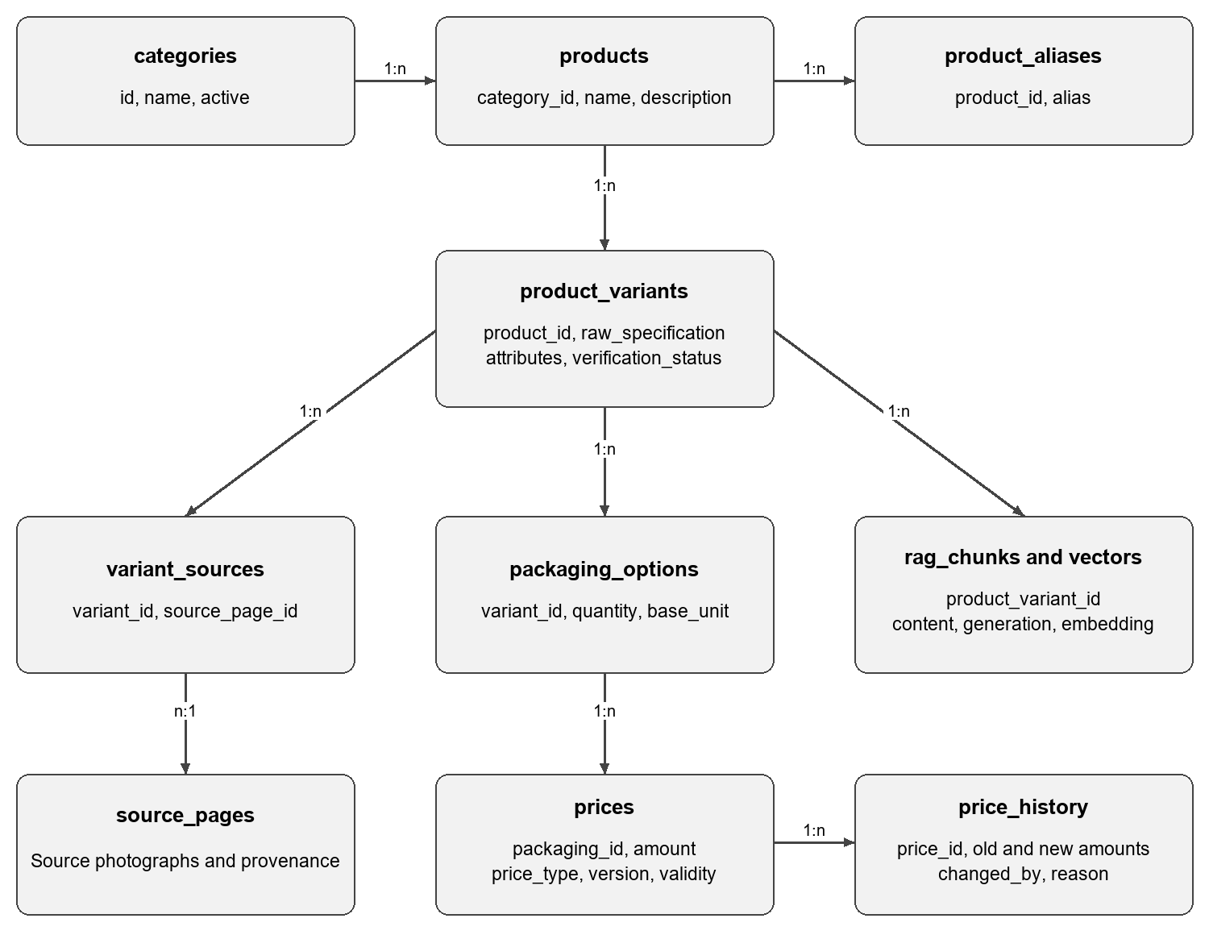
Figure 4.1 Catalog price and RAG data relationships
Figure 4.1 shows the main relationships in the product lookup domain. Categories contain products; products contain variants and aliases. Variants own packaging options, provenance links and indexed knowledge. A price belongs to a packaging option and its history records audited changes. [M6]
Order data is managed separately. A request stores customer information and processing status; each line retains the validated item, package, quantity, price and total. Conversation, feedback, generation and job tables support RAG operation without replacing the catalog and price relationships used by sales workflows.
This separation allows price updates without losing product provenance or forcing a new embedding run. Catalog knowledge changes instead use the generation and fingerprint mechanisms to identify and publish a consistent index.

4.2 Main interaction models

4.2.1 Price question sequence
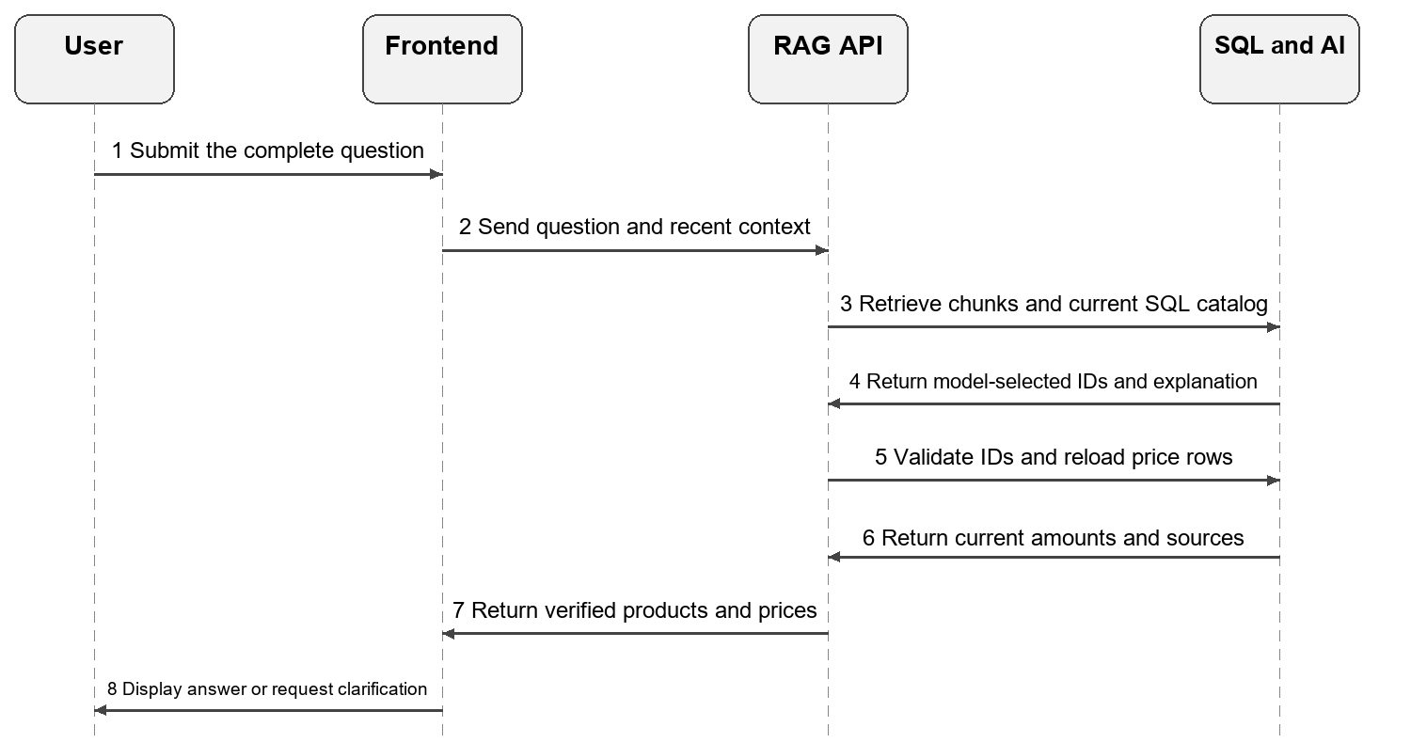
Figure 4.2 Price question sequence in retrieval first mode
The price question flow uses embedding and chat services to understand a request, but the model does not determine amount. It selects identifiers; the server validates them and reloads SQL price rows. Missing packaging, incomplete specifications or unsupported claims require clarification rather than an invented price. [M3, M14]

4.2.2 Generated answer sequence
The frontend sends the complete question and recent context. Gemini embeddings locate relevant catalog chunks in Supabase. The backend rebuilds evidence from current SQL, then Ollama generates structured output, with optional Groq fallback for eligible availability errors. The server checks schema, evidence IDs and price access, reloads selected amounts and returns the answer with sources. Legacy planner, lexical and RRF modules remain in the repository but are not the active retrieval_first path.

4.2.3 Indexing sequence
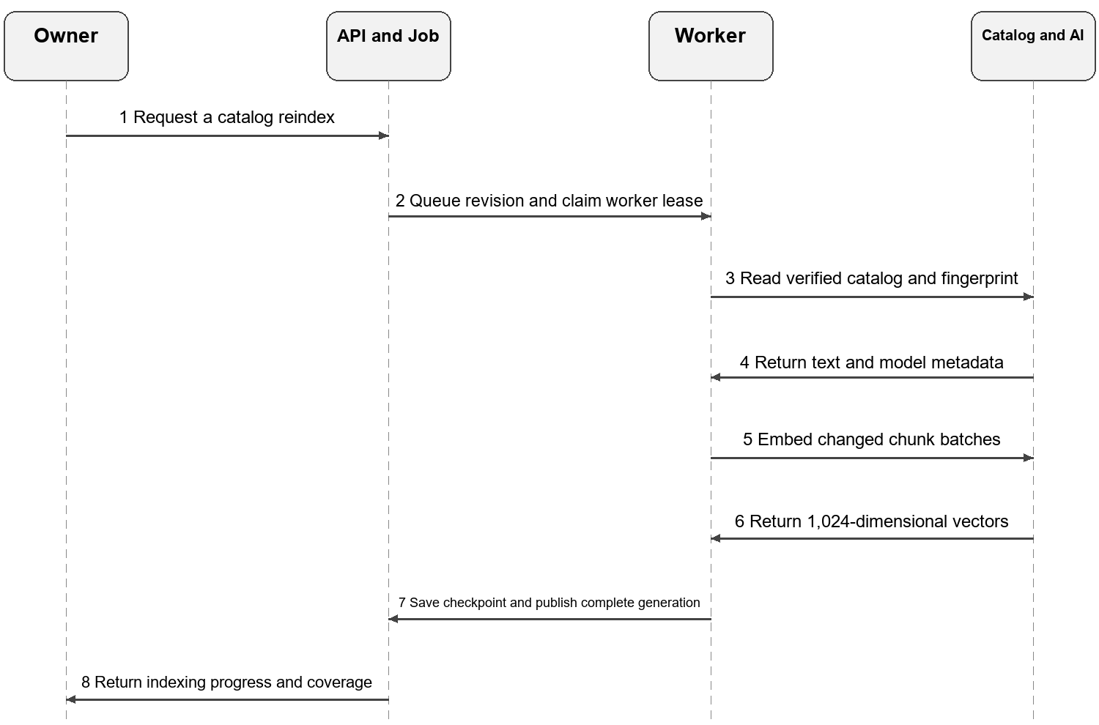
Figure 4.3 Index job processing sequence
The worker processes multiple batches under a claimed job with lease and heartbeat checks. Checkpoints prevent incomplete work from being reported as complete, while hashes and fingerprints permit compatible vector reuse. The final sequence column groups catalog access and embedding for readability; they remain separate dependencies in the implementation. [M2, M13]

4.2.4 Order request sequence
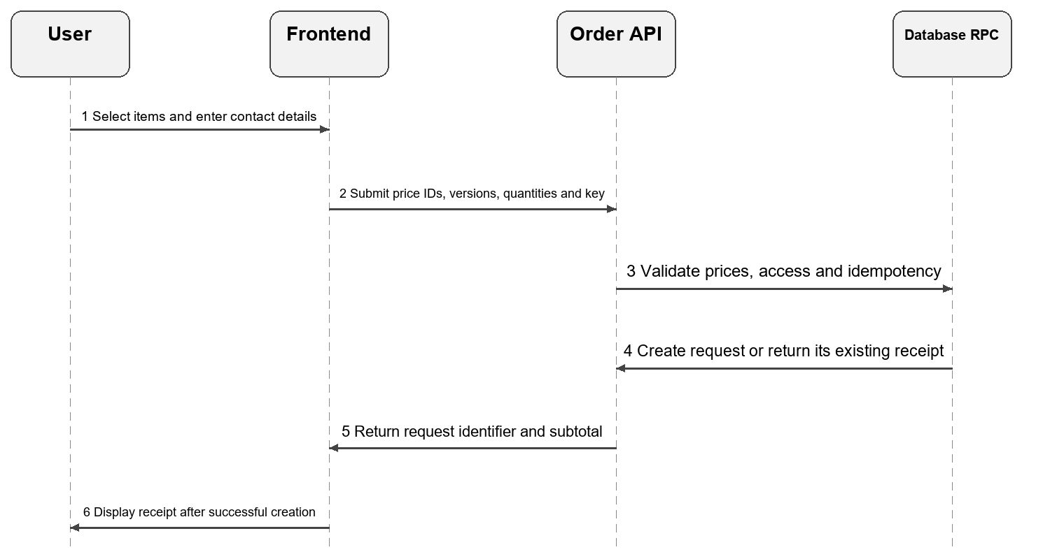
Figure 4.4 Order request submission sequence
The interface retains the cart or quotation until it receives a valid receipt. Reusing the same submission key returns the original creation receipt even when the order has subsequently been contacted or confirmed. The server verifies price and version rather than trusting totals sent by the browser. [T5, M8]

4.2.5 Price update sequence
An owner or editor opens a price and submits amount, expectedVersion and a reason. The API authenticates and authorizes the request. An audited RPC locks and checks the row, updates amount and version, and records history. The interface then synchronizes the returned values. A stale version stops at a conflict instead of silently overwriting a newer price.

CHAPTER 5 TRACEABILITY AND REFERENCES

5.1 Requirements traceability
The matrices link requirements to implementation modules and validation groups. TC identifiers refer to Table 3.7. Tests are organized in backend/tests, frontend/tests/unit, frontend/tests/e2e and tests/scripts; database regression scripts are in supabase/tests. Executed checks are distinguished from tests that merely exist in the repository.
Table 5.1 Catalog RAG and quotation traceability
ID | Principal modules | Validation
FR-01 | middleware/authenticate, require-role; services/auth | TC-08, TC-10; authentication and route tests
FR-02 | Catalog service/repository; frontend search | TC-03, TC-05; parser and catalog tests
FR-03 | retrieval-first-rag; provider; price-answer | TC-01 to TC-03, TC-05; price and query tests
FR-04 | retrieval-first-rag; retrieved-context; catalog-specification | TC-03 to TC-04; query and variant-list tests
FR-05 | retrieval-first-rag; provider; retrieved-context; compact-context | TC-06 to TC-07; grounding and provider tests
FR-06 | citations; rag-feedback; public feedback handle | TC-06; citation and feedback tests
FR-07 | rag-conversations; recent history; price-question-assistant | Conversation and variant-reference tests
FR-08 | select-price; invoice-price-review | TC-02; pricing and invoice tests

Table 5.2 Order price and operation traceability
ID | Principal modules | Validation
FR-09 | Customer order schema/controller/repository; RPC | TC-09; route and SQL regression
FR-10 | Customer order routes; inbox and status | TC-09 to TC-10; browser and permission checks
FR-11 | Price service/repository; audited RPC | TC-08; price tests and SQL guards
FR-12 | catalogUpdateSchema; catalog update RPC | Schema, catalog operation and SQL tests
FR-13 | rag-index.service; rag-index-worker | TC-11; index and worker tests
FR-14 | rag-health; index-job-status; rag-feedback | Health, status and feedback tests
FR-15 | frontend/features/offline/cache | TC-12; offline and browser scenarios

5.2 RAG configuration
Table 5.3 Core settings and rules
Setting | Configured value or implementation rule
Corpus | Active verified catalog; prices and OCR transcripts are excluded from embedding text.
Chunker | catalog-1100-overlap160-v5; at most 1,100 characters with 160-character overlap.
Embedding | Gemini embedding-001; 1,024 dimensions with L2 normalization for documents and queries.
Index batch | 16 chunks with content hashes, fingerprints, checkpoints and atomic generation publication.
Retrieval and context | Up to eight chunks per query, merged to 16; similarity at least 0.2; configured context limit 16 variants and up to six recent messages.
Model output | Structured status, explanation, selectedVariantIds, selectedPriceIds, listedProductIds, listingMode and evidenceIds.
Price authority | Current SQL values, checked again before rendering. Price changes do not wait for the index.
Chat and fallback | Ollama qwen3:4b; optional Groq openai/gpt-oss-120b on eligible availability failures. No recursive fallback loop.
Memory and token budget | Cloud embeddings free local GPU memory. Context truncation is explicit; Ollama keep_alive is configured to 15m.

5.3 Project references
Paths below are relative to price-app and support architecture, behavior and validation claims. Reports from 18 and 19 October describe historical configurations. Current deployment settings and the latest validation are recorded in the 20 October report and backend/.env.example. [T12]
Table 5.4 Project documents
ID | Document and evidence
T1 | README.md  Product identity, workspaces, counter workflows, startup and check commands.
T2 | docs/architecture.md  Web/API boundaries, authentication, RLS, price and offline rules.
T3 | RAG_SETUP.md  Catalog corpus, indexing and provider setup; consult the current environment example for the active profile.
T4 | docs/reports/2026-10-18-rag-prompt-smoke-test.md  Historical prompt, search, regression and browser observations.
T5 | docs/reports/2026-10-18-customer-orders.md  Orders, idempotent receipts and database access corrections.
T6 | backend/docs/RAG_EVALUATION.md  Evaluation inputs, labels and runner use.
T7 | docs/superpowers/plans/2026-10-18-catalog-only-rag.md  Catalog-only scope and historical validation boundaries.
T8 | docs/workspace-runbook.md  Frontend/backend operation and integration checks.
T9 | docs/reports/2026-10-19-groq-fallback.md  Historical provider fallback and token-limit probes.
T10 | docs/reports/2026-10-19-project-cleanup-validation.md  Test organization and historical browser results.
T11 | docs/reports/2026-10-19-retrieval-first-rag.md; 2026-10-19-wheel-rag-citations.md  Original-question retrieval, context and source-ID validation.
T12 | docs/reports/2026-10-20-rag-final-validation.md  Current configuration, complete index, full check and scoped live probes.

5.4 Source code references
Table 5.5 Implementation modules used as evidence
ID | Implementation reference
M1 | backend/src/services/rag-query.service.ts
M2 | backend/src/services/rag-index.service.ts; backend/src/rag/chunking.ts
M3 | backend/src/rag/price-answer.ts; frontend/src/features/pricing/select-price.ts
M4 | backend/src/rag/catalog-specification.ts
M5 | backend/src/rag/retrieved-context.ts; citations.ts; services/retrieval-first-rag.ts
M6 | supabase/migrations; catalog and price schema
M7 | backend/src/services/retrieval-first-rag.ts; rag-conversations.service.ts; legacy query-plan.ts and rank.ts
M8 | backend/src/schemas/customer-orders.schema.ts; customer order routes/repository
M9 | backend/src/schemas/prices.schema.ts; services/prices.service.ts
M10 | backend/src/routes/v1; middleware; openapi/contract.ts
M11 | backend/src/rag/provider.ts; config/env.ts
M12 | backend/src/rag/evaluation.ts; evaluation-runner.ts
M13 | backend/src/services/rag-index-worker.ts
M14 | backend/src/services/retrieval-first-rag.ts; rag-conversations.service.ts; frontend/src/components/price-question-assistant.tsx
M15 | backend/src/rag/retrieved-context.ts; compact-context.ts; backend/tests/rag/groq-fallback.test.ts; retrieved-context.test.ts

Where a row lists several files in the same directory, later file names use the directory prefix shown by the first path. This index supports comparison between documented requirements and the implementation during project assessment.

