**Project X- Group 3**

**Step 1**

sudo yum install java-1.8.0-openjdk-devel wget -y

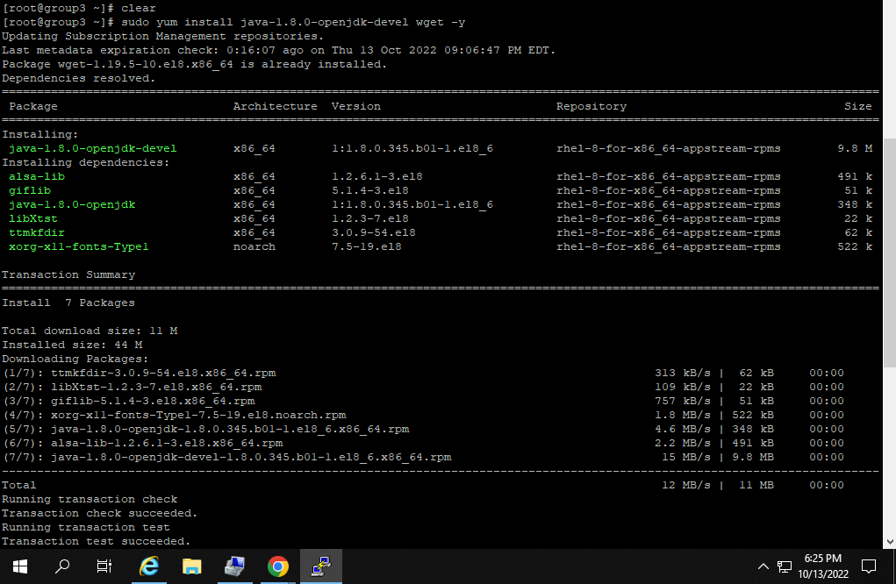

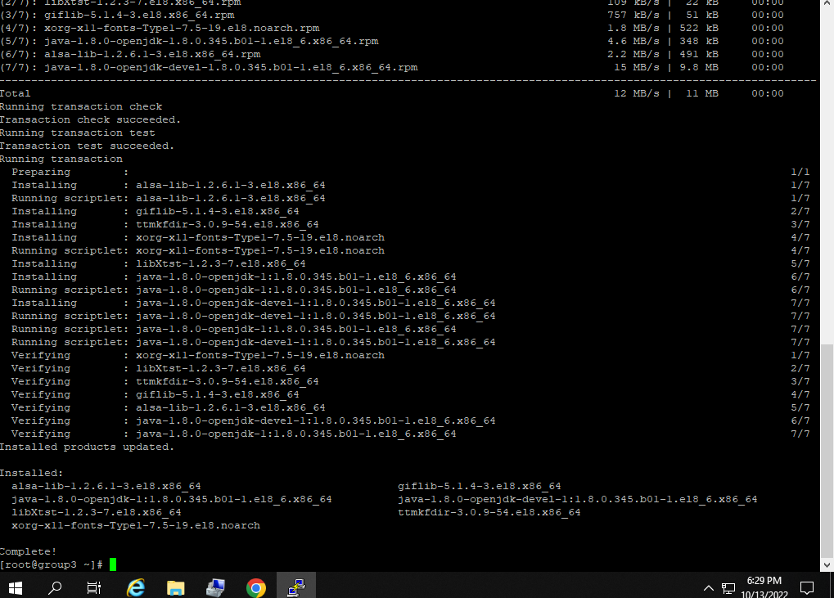

**Step 2**

sudo useradd -m -U -d /opt/tomcat -s /bin/false tomcat

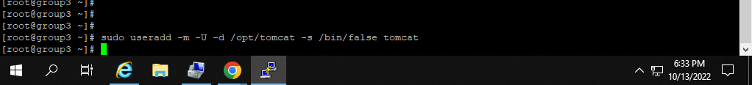

**Step 3**

wget https://apache.osuosl.org/tomcat/tomcat-10/v10.1.1/bin/apache-tomcat-10.1.1.tar.gz

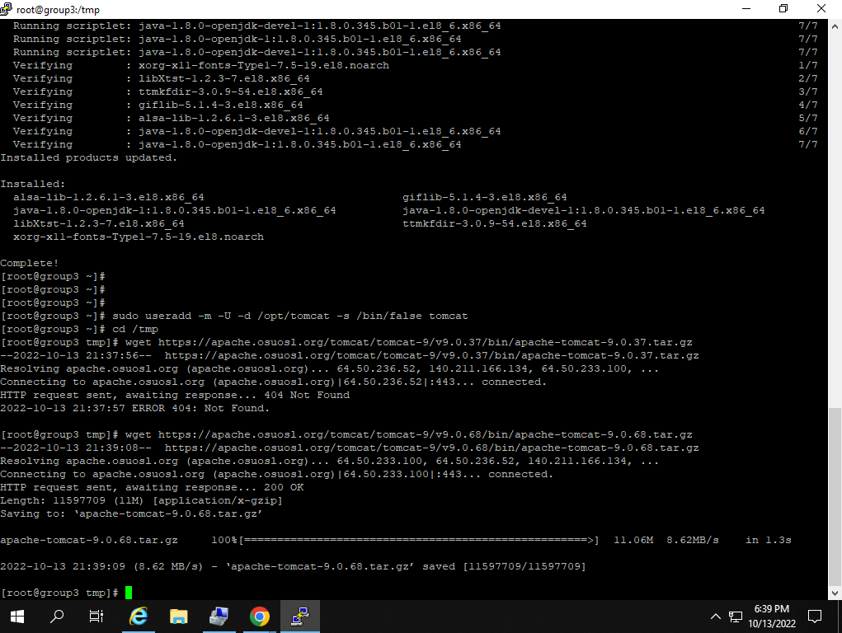

**Step 4**

tar -xf apache-tomcat-10.1.1.tar.gz

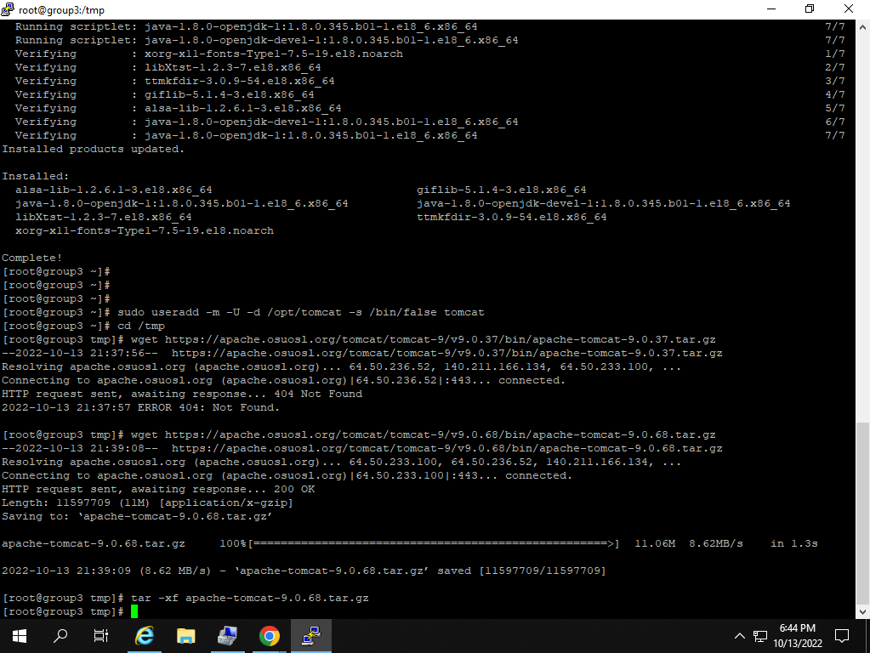

**Step 6**

sudo mv apache-tomcat-10.1.1 /opt/tomcat/

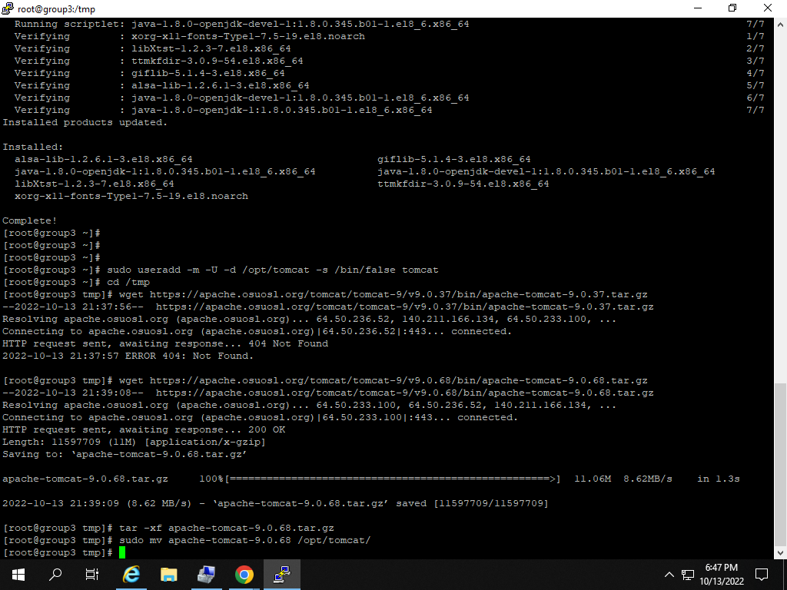

sudo firewall-cmd --zone=public --permanent --add-port=8080/tcp

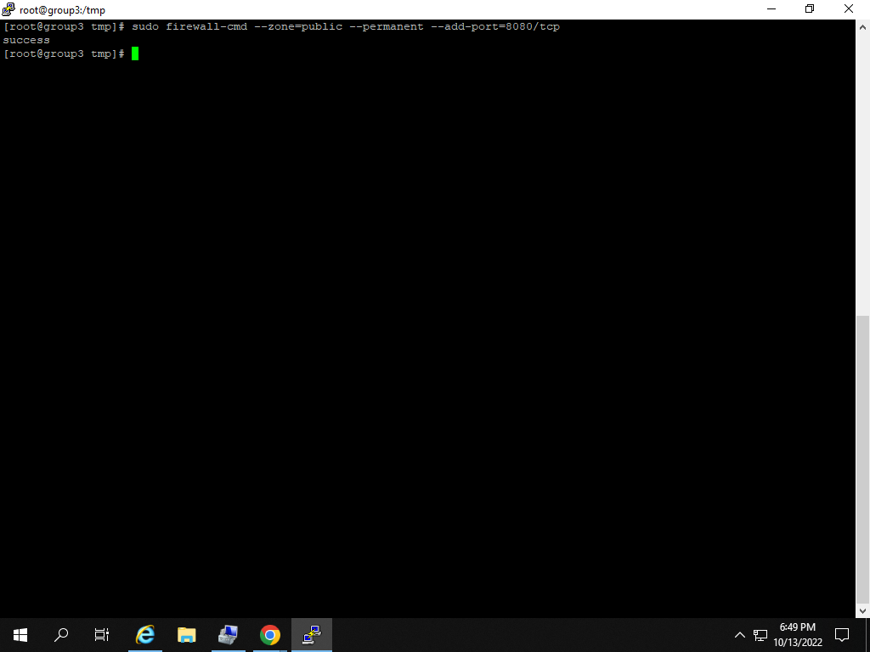

/opt/tomcat/bin/catalina.sh start

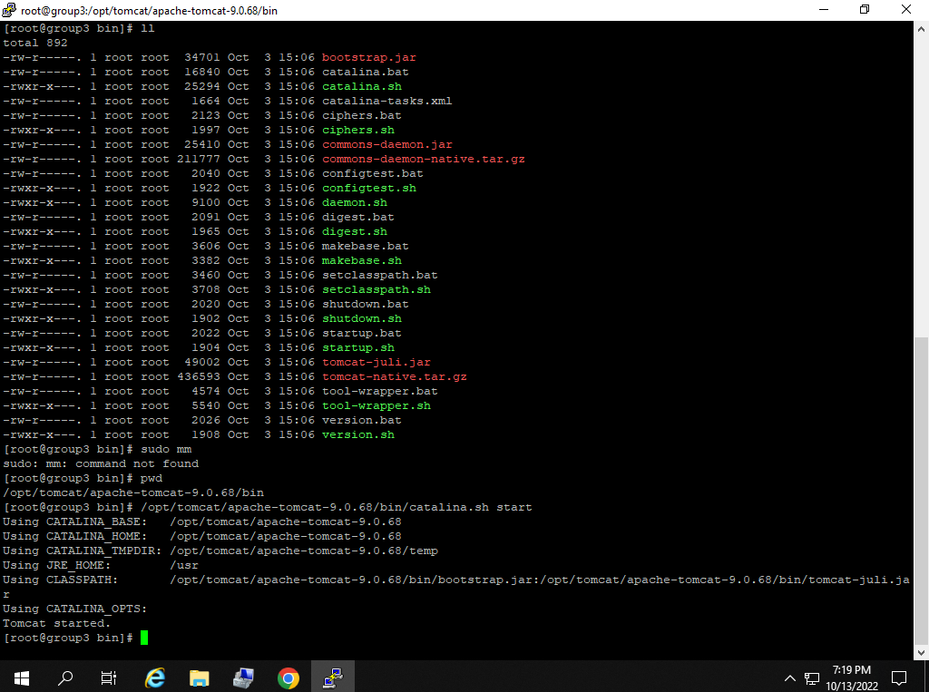

**Final Step**

