**Ways to learn Forex trading basics for beginners**

Everybody has their own method of learning Forex trading, which is why it’s very hard to find a universal guide.  
   
In most cases, traders find success stories from all over the world and try to include some of the used strategies in their own methods. However, this could prove very risky, simply because most success stories are about people risking quite a lot and getting lucky in the market.  
 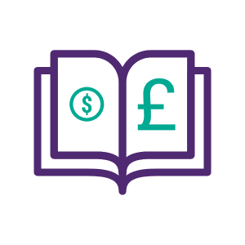  
 It may take more time but ways to learn about Forex trading for beginners are usually recommended to be as risk-free as possible. But they do sometimes boil down to 3 strategies.

* Learning through online guides
* Copying successful traders
* Learning while trading and making mistakes

All three of these have their advantages and disadvantages, but let’s focus on some tried and tested strategies.

**Learning for free**

It might sound surprising, but learning Forex trading for free is a definite possibility. The methods that beginners use in this case usually have something to do with [demo accounts](https://www.axiory.com/trading-resources/trading-psychology/fx-demo-account) and no deposit bonuses. But what are these things?  
   
A demo account is pretty much a real account where you can place trades, exchange currencies and even have some kind of payout. However, trading on demo accounts is not done with real funds. The company that owns the demo account gives traders virtual currencies to trade with and learn as they go. It’s something like a sandbox for beginners.  
   
A no deposit bonus is a classic answer on how to trade with Forex for beginners in most cases. Newcomers to the markets tend to find a company that has this service and goes for it immediately. Sure it may be trading for free, but there are reasons why it’s not very effective.  
   
You see, when a trader has nothing to lose, they are in a completely different mood. They are more open to risk and don’t do too much research. Because of this, they don’t really learn too much from this strategy and end up wasting time and energy.

**Common mistakes that beginners make**

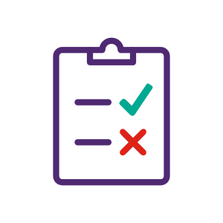

No matter which strategy you as a trader choose, chances are that you will make at least some mistakes on the journey. It’s nothing to be ashamed of and nothing to fear as well. It happens almost all the time, and people with decades of Forex trading experience tend to make mistakes as well.  
   
However, this doesn’t mean that Forex trading strategies for beginners cannot be planned with the most common mistakes in mind. Here are some mistakes that are usually made by beginners.

**No prior research**

Forex may be a market that is mostly influenced by supply and demand, but it also changes according to what’s going on in the world. Let’s take Brexit as an example. When the UK first announced that they were leaving the European Union, a lot of traders believed that it would hurt the economy, so they started selling a lot of GBP. This increased supply and decreased demand. Because of this, the exchange rate was changed, and those that didn’t consider Brexit as an influencer didn’t really see a successful week. A daily dose of new information is essential when trading risky trades.

**Not following a trend**

A trend could be almost anything. It usually starts when a large part of the market starts agreeing on something. Let’s bring the Brexit example back. Imagine there was a trader that refused to believe that the UK economy would go down. He or she could have been absolutely correct, but would still not be successful on the market. A very important thing people consider when they try to learn to trade Forex for beginners is that no matter how wrong a trend is, it always influences supply and demand as long as enough people follow it. When traders don’t follow it, they usually end up having a terrible trading experience.

**Trading unknown currencies**

This mistake is usually made when a specific currency pair has a good history. For example, those that traded this pair managed to achieve huge payouts in the past. This encourages new traders to try it themselves, only to find out that the “good past” had its reasons, and those reasons are now gone. Trading currencies that a trader knows nothing about is usually considered a bad idea.

**No weekly/monthly goals**

Goals may not be essential for being successful in the market, but they are very useful when traders are trying to stay motivated. For example, achieving the goal for the past week, no matter how small it was is always very pleasant. While not reaching it gives a unique opportunity to see what the mistakes were. When people try to learn Forex trading for beginners, it’s not uncommon to see them set small daily goals to keep track of their progress.

**Leverage**

[Leverage](https://www.axiory.com/trading-resources/trading-terms/what-is-leverage) is undoubtedly a very useful tool when trading Forex, but it’s also very dangerous. The simplest way to explain leverage is to call it a loan from your broker. Basically what happens is that the broker increases the amount you can trade by 10, 100 or even 1000 and then takes a percentage from your payout if it’s successful. If it’s not, then there’s a chance that a trader’s whole account will be wiped out in just 1 trade. It’s usually recommended for beginners to stay away from leverage during the first 6-12 months of their trading.

**Quick navigation**

* [**Trading Forex for beginners summarized**](https://www.axiory.com/trading-resources/basics/forex-trading-for-beginners#Trading%20Forex%20for%20beginners%20summarized0)
* [**Ways to learn Forex trading basics for beginners**](https://www.axiory.com/trading-resources/basics/forex-trading-for-beginners#Ways%20to%20learn%20Forex%20trading%20basics%20for%20beginners1)
* [**Learning for free**](https://www.axiory.com/trading-resources/basics/forex-trading-for-beginners#Learning%20for%20free2)
* [**Common mistakes that beginners make**](https://www.axiory.com/trading-resources/basics/forex-trading-for-beginners#Common%20mistakes%20that%20beginners%20make3)
* [**No prior research**](https://www.axiory.com/trading-resources/basics/forex-trading-for-beginners#No%20prior%20research5)
* [**Not following a trend**](https://www.axiory.com/trading-resources/basics/forex-trading-for-beginners#Not%20following%20a%20trend6)
* [**Trading unknown currencies**](https://www.axiory.com/trading-resources/basics/forex-trading-for-beginners#Trading%20unknown%20currencies7)
* [**No weekly/monthly goals**](https://www.axiory.com/trading-resources/basics/forex-trading-for-beginners#No%20weekly/monthly%20goals8)
* [**Leverage**](https://www.axiory.com/trading-resources/basics/forex-trading-for-beginners#Leverage9)

**START TRADING IN 10 MINUTES**

Apply everything you’ve learnt on a real trading account with up to 1:777 leverage, negative balance protection and outstanding support.

[**GET STARTED**](https://www.axiory.com/register/)

**5 key steps to getting started with Forex trading**

Although all the previous information was more or less enough to start off, it’s still important that we summarize it all here. Ways on how to trade Forex for beginners can be a bit confusing, which is why breaking them down into 5 key steps is essential. Here’s what people usually do.  
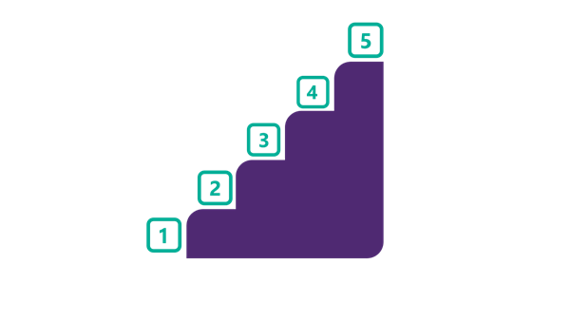

**Finding a reliable service provider**

Forex trading is always done through a middleman. That middleman is usually a Forex broker. These companies come in various shapes and sizes, so the trading experience can be very different depending on which one a trader chooses. Going for a company that is licensed and has good customer reviews is mostly considered as the first step towards success.

**Starting to trading with your own funds**

Although demo accounts and no deposit bonuses provide risk-free trading, it’s important to consider how a trader’s psychology is developed. If you learn on the basis of not being afraid to take risks, it could turn out very badly when you start trading with your own funds for the first time. One of the primary Forex trading lessons for beginners is that fearing risk is an advantage and not an issue. This advantage is only gained through putting something you own on the line.

**Only using funds you can afford**

Forex trading almost always starts off as a hobby or a side-job. Beginners and veterans usually calculate how much they can deposit and not be too affected if they don’t get any payout from it.

**Choosing a preferred software**

There are dozens of types of software that traders can choose from. Most of them are designed to be very similar so that switching is not a problem. But choosing one and sticking to it is usually considered a good idea because you get to learn the software only once.

**Trying new strategies immediately**

Almost every trading Forex tutorial gives traders access to new strategies. Although it may seem that you understood the strategy from the first try, people usually apply these new strategies to their official account immediately. By trying the strategy in a real environment, rather than a demo account always helps in remembering the result.

**Forex trading for beginners - FAQ**

**How do I learn Forex trading step by step?**

There are many different approaches to how to start trading Forex in a sustainable way, whether it's gathering theoretical knowledge in the first place, using demo account, or starting live trading right away.   
  
Usually, the first step many traders take for learning Forex step by step is gathering initial theoretical knowledge. The online trading community is full of educational materials, be it e-books, tutorial articles, videos on demand, online courses, or webinars. They explore various trading aspects starting from currency pairs all the way to technical and economic indicators.   
  
Another useful way to learn Forex trading step by step for free is to use a demo account. It allows you to trade just about any currency pair without any financial commitment. And if you want to take it to the next level, you can always turn this demo account into a live account, which introduces more realism into your trades.

**How do I choose a service provider?**

Service providers are usually chosen based on taste and preferences. However, most people tend to pay a lot of attention to a company’s license. If they don’t have it, it could mean that they were not found worthy of one by the local government. In most cases, this is a sign that you should start searching for another one.

Other ways include looking at how many software systems they have for their customers, how much general market information they provide, what their previous customer score is and etc.

But no matter how the company may look on the surface, it’s still up to your preference as a trader if you want to start trading with them.

**How do I do research?**

Research is done by gathering information. People sometimes call it news Forex trading because it relies on fresh news so much.

What people tend to do is visit various websites that talk about the Forex industry. They look at the fresh news and try to determine what could happen in the market based on a new event in the world.

The news can be political, it could be about economics, or it could be in no way connected to the Forex market. It’s up to you to determine if this specific event could have influence over your currency pairs. This is mostly done by analyzing what has happened in the past with the same event, and what is being planned for the future.

Or you could simply analyze what the majority of the market will believe, and follow that trend.

**What software should I choose?**

There are dozens of software types for beginner traders, but the majority of them are hard to see in the current market trends.

One reason why software is important when learning how to start Forex trading is because of how complicated it could be. You see, every software has its extra feature that helps them stand out. It could be dozens of screens that you can look at, or it could be automated trades that you can set.

Regardless though, it’s likely that the most common software you will find is MetaTrader 4 or MetaTrader 5. These two are the most popular in the market right now, with the majority of brokers using them.

**What types of Forex trading software is there?**

There are 3 types of software. They all have their names besides 1 and are optimized on Forex trading for newbies. There’s the WebTrader that can be used in your web browser. There’s the MobileTrader that can be used on any mobile device such as a smartphone or a tablet. And there’s the Desktop version which you will have to download and install on your PC or Mac.

Thankfully all of the software is designed to work well on both Android and iOS, so it won’t be hard finding something that suits your choice of brands.

**Which currency pairs should I trade?**

This also depends on where you live and how much knowledge you have about specific currencies. In most cases, beginner traders usually go for EUR/USD if they’re not sure about their native currency, or can’t find a broker that has a pair for them.

The EUR/USD is considered as one of the most stable ones in the market, which is why it has the most traders. Having two of the largest economies back this currency pair usually guarantees that there will be no huge changes in a single day. This pair can be found in almost every beginners' guide to Forex trading and deservedly so.

**Why shouldn’t I use leverage?**

Leverage is a very useful tool, especially in Forex where exchange rates change very slowly and not too often. However, it could be extremely dangerous too if the broker that provides this leverage does not provide a margin call.

A margin call is when the broker automatically closes your trade if it’s too unsuccessful. If there is no margin call, there’s always a risk that you could end up owing the broker the funds it gave to you.

As a beginner, it’s best to avoid leverage completely before you learn at least a couple of high-chance strategies.

**Why is trading with my own funds less risky?**

This could be a bit hard to understand at first, but it all comes to learning how to control your emotions when trading.

You see, when a tutorial Forex trading experience takes the risk out of the learning process, you could end up thinking that it’s very easy. The reality is that Forex trading is one of the hardest things one can do and succeed at.

The tutorial helps you not care about the funds you use for trades, and therefore be a bit more liberal with how you use them.

But, when you use your hard-earned money, the risk starts to affect you and makes you a lot more careful. This method is usually done with very little amounts so that the risk is kept to a minimum.