NAME: Victor Irungu
ADM: BSE-05-0006/2025
ASSIGNMENT 2: Object Oriented Programming 2.
- Bird Button: Makes a radio button with the label "Bird". When you pick it, it shows the bird picture and displays the message "You selected Bird".
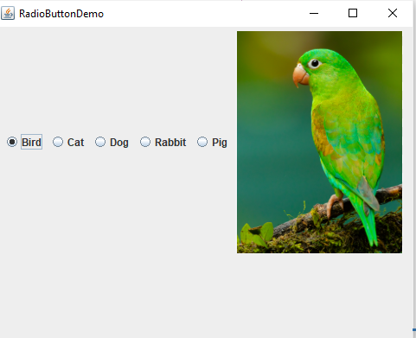

- Cat Button: Makes a radio button labeled "Cat".
When you choose it, it shows the cat image and displays the message "You selected Cat".
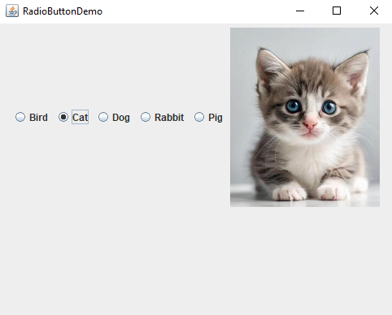

- Dog Button: Makes a radio button labeled "Dog".
When you select it, it shows the dog image and displays the message "You selected Dog".
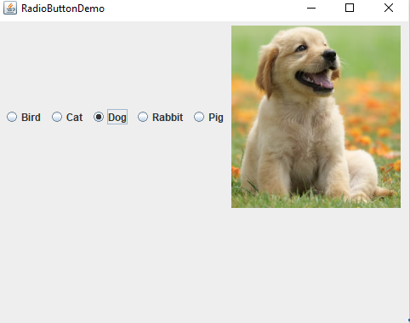

- Rabbit Button: Makes a radio button labeled "Rabbit".
When you choose it, it shows the rabbit image and displays the message "You selected Rabbit".
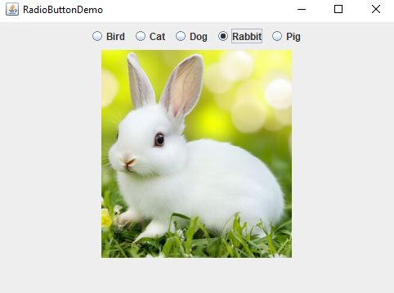

- Pig Button: Makes a radio button labeled "Pig".
It is selected automatically when the program starts, showing the pig image and displaying the message "You selected Pig" when it is chosen.
